[NHSRC]
MP-Mandla
[ Analysis 2009-10]

MADHYA PRADESH- MANDLA Dist.- Summary-Apr'09 to Mar'10
ANC
ANC Registration against Expected Pregnancies | 67% | TT1 given to Pregnant women against ANC Registraion | 51%
3 ANC Check ups against ANC Reigtrations | 90% | 100 IFA Tablets given to Pregnant women against ANC Registraion | 87%
Deliveries
Unreported Deliveries against Estimated Deliveries | 34.0% | HOME Deliveries( SBA& Non SBA) against Estimated Deliveries | 18.7%
Institutional Deliveries against Estimated Deliveries | 47.3% | HOME Deliveries( SBA& Non SBA) against Reported Deliveries | 28.3%
Institutional Deliveries against Reported Deliveries | 71.7% | C Section Deliveries against Institutional Deliveries( Pvt & Pub) | 1%
Births & Neonates Care
Live Births Reported against Estimated Live Births | 67% | New borns weighed against Reported Live Births | 75%
Still Births (Reported) | 299 | New borns weighed less than 2.5 kgs against newborns weighed | 28%
Sex Ratio at Birh | 993 | New borns breastfed within one hr of Birth against Reported live Births | 61%
Child Immunisation( 0 to 11 mnths)
BCG given against Expected Live Births | 70% | Measles given against Expected Live Births | 68%
OPV3 given against Expected Live Births | 68% | Fully Immunised Children against Expected Live Births | 67%
DPT3 given against Expected Live Births | 68%
Family Planning
Family Plannig Methods Users ( Sterilisations(Male &Female)+IUD+ Condom pieces/72 + OCP Cycles/13) | 25,077 | IUD Insertions against reported FP Methods | 8%
Sterilisation against reported FP Methods | 36% | Condom Users against reported FP Methods | 33%
 |  | OCP Users against reported FP Methods | 24%
Other Services
OPD | 215,186 | Major Operations | 1,254
IPD | 30,859 | Minor Operations | 2,402

MADHYA PRADESH- MANDLA Dist.- Deliveries Apr'09 to Mar'10
Total Population | 1,062,679 | Expected Deliveries |  | 30,796
Home SBA | Home Non SBA | Institutional | Total Deliveries Reported | Unreported Deliveries
4,535 | 1,212 | 14,581 | 20,328 | 10,468
Home SBA % | Home Non SBA% | Institutional % | Total Deliveries Reported % | Unreported Deliveries %
15% | 4% | 47% | 66% | 34%

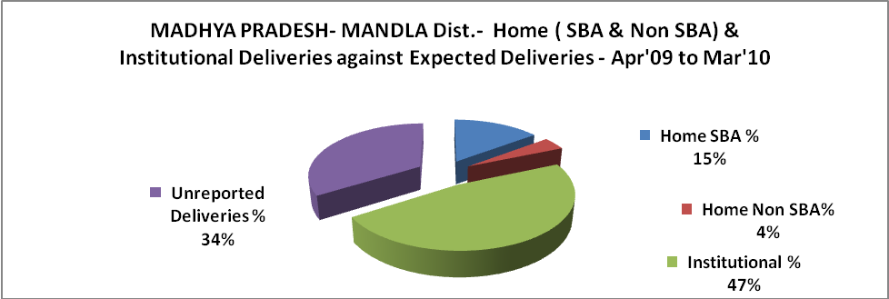

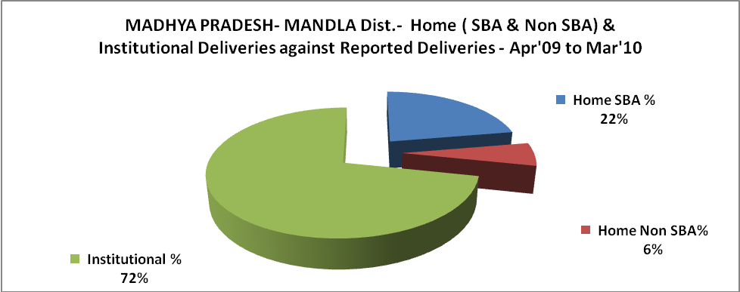
MADHYA PRADESH- MANDLA Dist.- C sections & Complicated Deliveries Apr'09 to Mar'10
 | Institutional Deliveries (Public) | Institutional Deliveries (Pvt)
 | 14,581 | -
C Section | 67 | 14
C Section% | 0% | -
Complicated Pregnacies attended | 541 | -
Complicated Pregnacies attended % | 4% | -

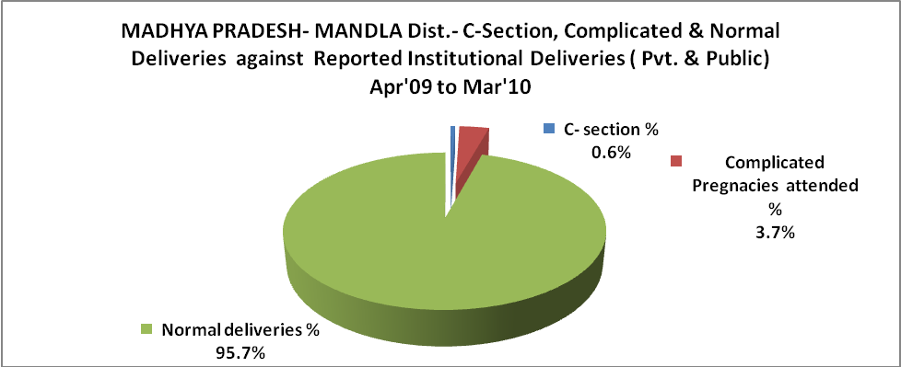

MADHYA PRADESH- MANDLA Dist.- Complicated Pregnancies & Deliveries Treated - Apr'09 to Mar'10
Reported Deliveries |  |  | Reported ANC Reigtration
20,328 |  |  | 21,948
Complicated Pregnancies attended | Complicated Pregnancies Rate | C - Section Deliveries | PNC Maternal Complications | Abortions | Still Births
541 | 2% | 81 | 212 | 456 | 299
Complicated Deliveries Treated with |  |  |  | No Of Eclampsia cases Treated | No Of severe anemia cases treated
IV Antibiotics | IV antihypertensive/Magsulph injection | IV Oxytocis | Blood Transfusion | No Of Eclampsia cases Treated | No Of severe anemia cases treated
20 | 2 | 6 | 9 | 47 | 992

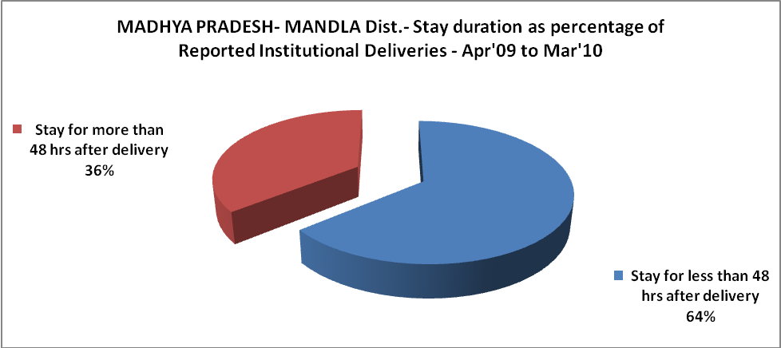

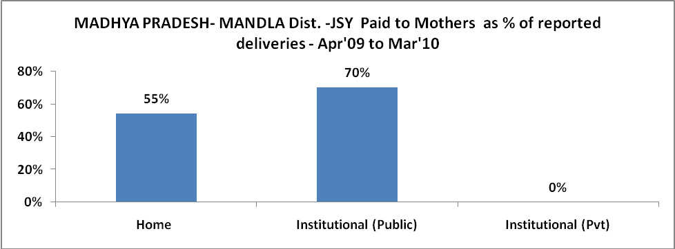

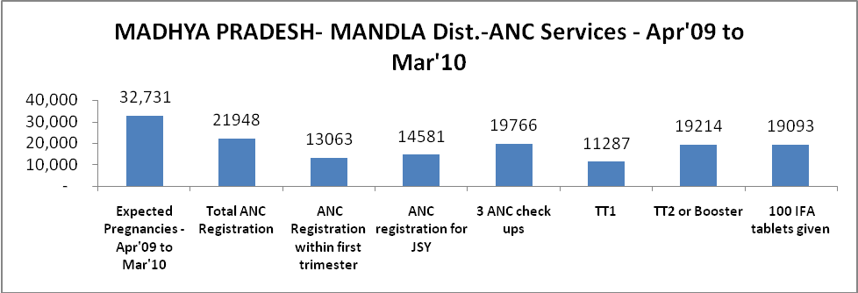

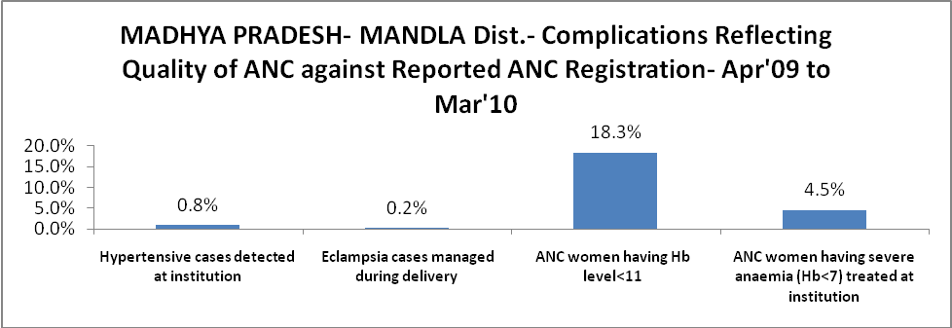

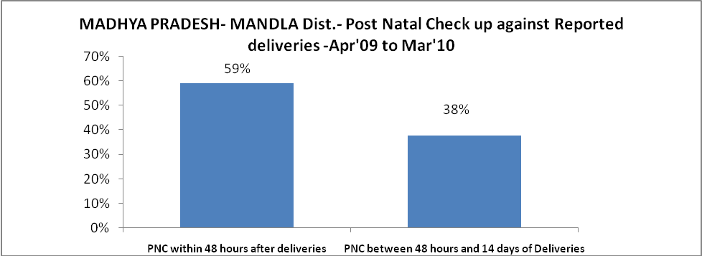

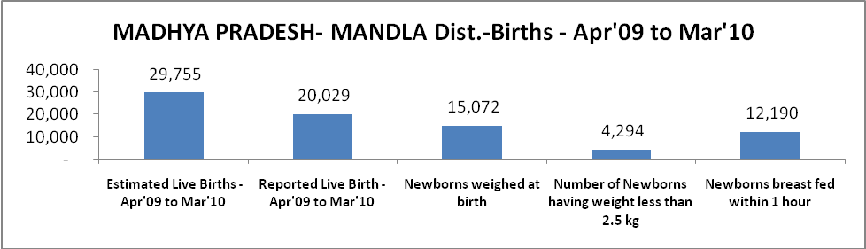

MADHYA PRADESH- MANDLA Dist. - Births - Apr'09 to Mar'10
Live Birth - Males | Live Birth - females | Live Birth - Total | Sex Ratio at birth | Still Birth | Abortion( Induced/Spontaneous
10,048 | 9,981 | 20,029 | 993 | 299 | 456

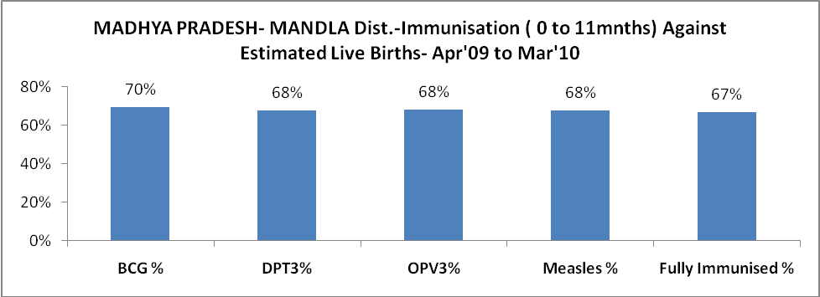

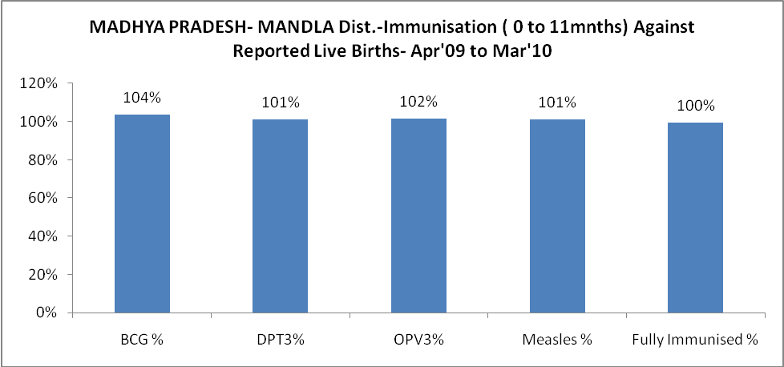

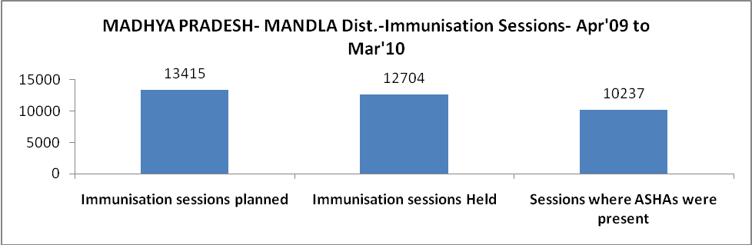

MADHYA PRADESH- MANDLA Dist.- Apr'09 to Mar'10
Total Abortions | Abortion Rate
714 | 2.2%

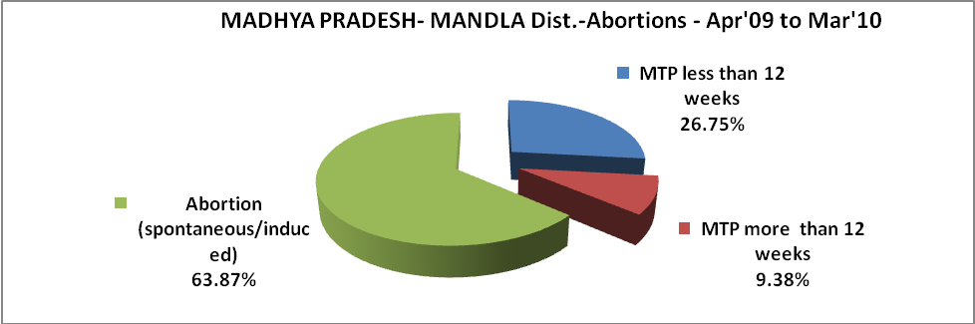

MADHYA PRADESH- MANDLA Dist.- Apr'09 to Mar'10
Total OPD | Total RTI/STI cases
215,186 | 2,166

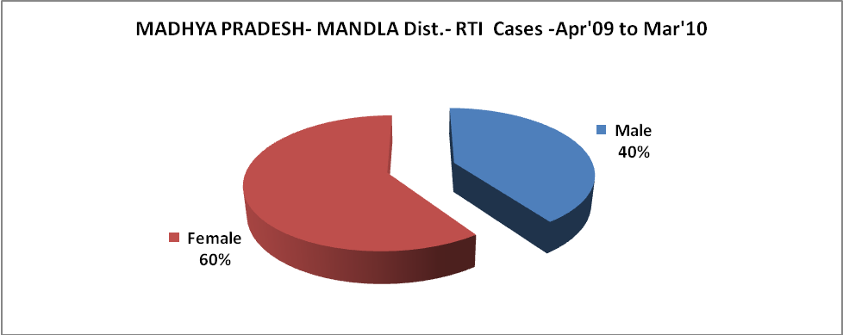

MADHYA PRADESH- MANDLA Dist.-Sterilisations - Apr'09 to Mar'10
 | Reported | %age of Reported Sterilisation
Total Sterilisation | 9,006 | -
NSV | 875 | 10%
Laproscopic | 8,129 | 90%
MiniLap | 2 | 0%
Post Partum | - | 0%
Male Sterilisation | 875 | 10%
Female Sterilisation | 8,131 | 90%

MADHYA PRADESH- MANDLA Dist.-FP Methods - Apr'09 to Mar'10
 | Reported | %age of All Reported FP Methods
Total Reported FP Methodd (All types) Users | 25,077 | -
Sterilisations | 9,006 | 36%
IUD | 1,898 | 8%
Condom Users | 8,272 | 33%
OCP Users | 5,900 | 24%
Limiting Methods | 9,006 | 36%
Spacing Methods | 16,071 | 64%

MADHYA PRADESH- MANDLA Dist.- Service Delivery - Apr'09 to Mar'10
Operation major (General and spinal anaesthesia) | Operation minor (No or local anaesthesia) | AYUSH | Dental Procedures | Adolescent counselling services | Total OPD | Total IPD
1,254 | 2,402 | - | 619 | 294 | 215,186 | 30,859
Operation major (General and spinal anaesthesia) as %ge of OPD | Operation minor (No or local anaesthesia)as %ge of OPD | AYUSH as %ge of OPD | Dental Procedures as %ge of OPD | Adolescent counselling services as %ge of OPD | IPD as percentage of OPD
0.6% | 1.1% | 0.0% | 0.3% | 0.1% | 14%

MADHYA PRADESH- MANDLA Dist.- Lab Services - Apr'09 to Mar'10
Total OPD | Total HB tested | Total HIV Tested | Total Population
215,186 | 9,300 | 1,786 | 1,062,679
HB test conducted as %age of OPD | HB<7gm as %age of HB tested | HIV test conducted as %age of OPD | HIV positive as %age of HIV tested | Blood Smear Examined as % of Population
4.3% | 3.2% | 0.8% | 1.6% | 8.9%

MADHYA PRADESH- MANDLA Dist.- Childhood Disease - Vaccine Preventable -Apr'09 to Mar'10
Diphtheria | Pertussis | Tetanus Neonatorum | Tetanus others | Polio | Measles
0 | 0 | 0 | 0 | 0 | 45
MADHYA PRADESH- MANDLA Dist.-Childhood Disease - Others - Apr'09 to Mar'10
Diarrhoea and dehydration | Malaria | Number admitted with Respiratory Infections
3,551 | 9,543 | 787

MADHYA PRADESH- MANDLA Dist.- Infant & Child Deaths - Apr'09 to Mar'10
Infant Deaths within 24 hrs of birth | Infant Deaths between 24hrs & under 1 week | Infant Deaths between 1 week & under 1 month | Child Deaths between 1 month & under 1 year | Child Deaths between 1yr under 5years | Total Deaths
64 | 107 | 47 | 677 | 915 | 1810

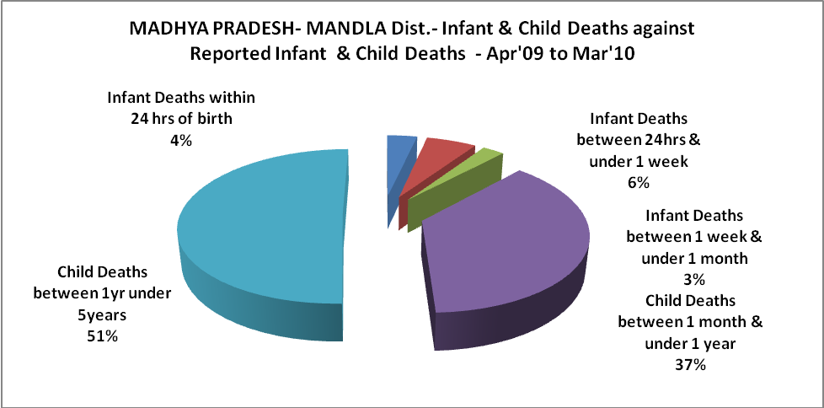

MADHYA PRADESH- MANDLA Dist.- Causes of Infant & Child Deaths - Apr'09 to Mar'10
Sepsis |  |  | Asphyxia |  |  | LBW
Up to 1 Weeks of Birth | Between 1 week & 4 weeks of birth | Total | Up to 1 Weeks of Birth | Between 1 week & 4 weeks of birth | Total | Up to 1 Weeks of Birth | Between 1 week & 4 weeks of birth | Total
3 | 5 | 8 | 0 | 0 | 0 | 5 | 6 | 11
Pneumonia |  |  | Diarrhoea |  |  | Fever related
Between 1 month and 11 months | Between 1 year & 5 years | Total | Between 1 month and 11 months | Between 1 year & 5 years | Total | Between 1 month and 11 months | Between 1 year & 5 years | Total
245 | 411 | 656 | 187 | 231 | 418 | 37 | 127 | 164
Others |  |  | Measles |  |  | Others
Up to 1 Weeks of Birth | Between 1 week & 4 weeks of birth | Total | Between 1 month and 11 months | Between 1 year & 5 years | Total | Between 1 month and 11 months | Between 1 year & 5 years | Total
99 | 36 | 135 | 3 | 4 | 7 | 205 | 142 | 347

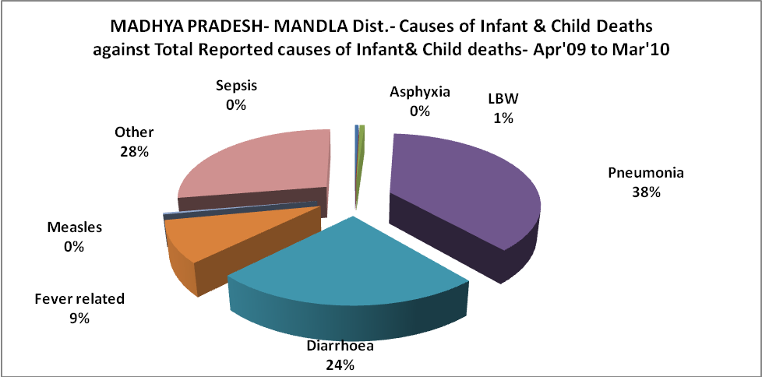

MADHYA PRADESH- MANDLA Dist.- Maternal Deaths & Causes - Apr'09 to Mar'10
Abortion |  |  | Obstructed/prolonged labour |  |  | Severe hypertesnion/fits
6-14 yrs | 15-55 yrs. | Total | 6-14 yrs | 15-55 yrs. | Total | 6-14 yrs | 15-55 yrs. | Total
0 | 0 | 0 | 0 | 0 | 0 | 0 | 0 | 0
Bleeding |  |  | High Fever |  |  | Other Causes
6-14 yrs | 15-55 yrs. | Total | 6-14 yrs | 15-55 yrs. | Total | 6-14 yrs | 15-55 yrs. | Total
0 | 0 | 0 | 0 | 0 | 0 | 0 | 0 | 0

MADHYA PRADESH- MANDLA Dist.-Causes of Deaths in 6 to 55yrs age group - Apr'09 to Mar'10
Diarrhoel Diseases |  |  |  | Tuberculosis |  |  |  | Respiratory Diseases( Other than TB)
6-14 yrs | 15-55 yrs. | Above 55yrs | Total | 6-14 yrs | 15-55 yrs. | Above 55yrs | Total | 6-14 yrs | 15-55 yrs. | Above 55yrs | Total
268 | 186 | 240 | 694 | 0 | 0 | 0 | 0 | 0 | 0 | 0 | 0
Malaria |  |  |  | Other fever Related |  |  |  | HIV/Aids
6-14 yrs | 15-55 yrs. | Above 55yrs | Total | 6-14 yrs | 15-55 yrs. | Above 55yrs | Total | 6-14 yrs | 15-55 yrs. | Above 55yrs | Total
0 | 0 | 0 | 0 | 0 | 14 | 21 | 35 | 0 | 0 | 0 | 0
Heart Disease/Hypertenion related |  |  |  | Neurological Disease including strokes |  |  |  | Trauma/Accidents/ Burn Cases
6-14 yrs | 15-55 yrs. | Above 55yrs | Total | 6-14 yrs | 15-55 yrs. | Above 55yrs | Total | 6-14 yrs | 15-55 yrs. | Above 55yrs | Total
0 | 1 | 0 | 1 | 1 | 24 | 17 | 42 | 0 | 0 | 0 | 0
Suicide |  |  |  | Animal Bites & Stings
6-14 yrs | 15-55 yrs. | Above 55yrs | Total | 6-14 yrs | 15-55 yrs. | Above 55yrs | Total
0 | 0 | 0 | 0 | 0 | 0 | 0 | 0

