[NHSRC]
MP-Mandsaur
[ Analysis 2009-10]

MADHYA PRADESH- MANDSAUR Dist.- Summary-Apr'09 to Mar'10
ANC
ANC Registration against Expected Pregnancies | 93% | TT1 given to Pregnant women against ANC Registraion | 84%
3 ANC Check ups against ANC Reigtrations | 81% | 100 IFA Tablets given to Pregnant women against ANC Registraion | 94%
Deliveries
Unreported Deliveries against Estimated Deliveries | 26.1% | HOME Deliveries( SBA& Non SBA) against Estimated Deliveries | 11.1%
Institutional Deliveries against Estimated Deliveries | 62.8% | HOME Deliveries( SBA& Non SBA) against Reported Deliveries | 15.0%
Institutional Deliveries against Reported Deliveries | 85.0% | C Section Deliveries against Institutional Deliveries( Pvt & Pub) | 4%
Births & Neonates Care
Live Births Reported against Estimated Live Births | 78% | New borns weighed against Reported Live Births | 109%
Still Births (Reported) | 519 | New borns weighed less than 2.5 kgs against newborns weighed | 3%
Sex Ratio at Birh | 935 | New borns breastfed within one hr of Birth against Reported live Births | 108%
Child Immunisation( 0 to 11 months)
BCG given against Expected Live Births | 93% | Measles given against Expected Live Births | 87%
OPV3 given against Expected Live Births | 87% | Fully Immunised Children against Expected Live Births | 87%
DPT3 given against Expected Live Births | 87%
Family Planning
Family Plannig Methods Users ( Sterilisations(Male &Female)+IUD+ Condom pieces/72 + OCP Cycles/13) | 69,308 | IUD Insertions against reported FP Methods | 11%
Sterilisation against reported FP Methods | 9% | Condom Users against reported FP Methods | 65%
 |  | OCP Users against reported FP Methods | 15%
Other Services
OPD | 422,457 | Major Operations | 3,621
IPD | 40,787 | Minor Operations | 2,026

MADHYA PRADESH- MANDSAUR Dist.- Deliveries Apr'09 to Mar'10
Total Population | 1,406,683 | Expected Deliveries |  | 40,766
Home SBA | Home Non SBA | Institutional | Total Deliveries Reported | Unreported Deliveries
- | 4,513 | 25,615 | 30,128 | 10,638
Home SBA % | Home Non SBA% | Institutional % | Total Deliveries Reported % | Unreported Deliveries %
0% | 11% | 63% | 74% | 26%

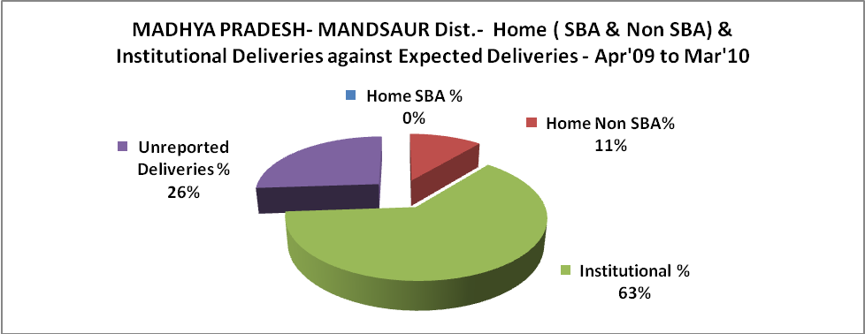

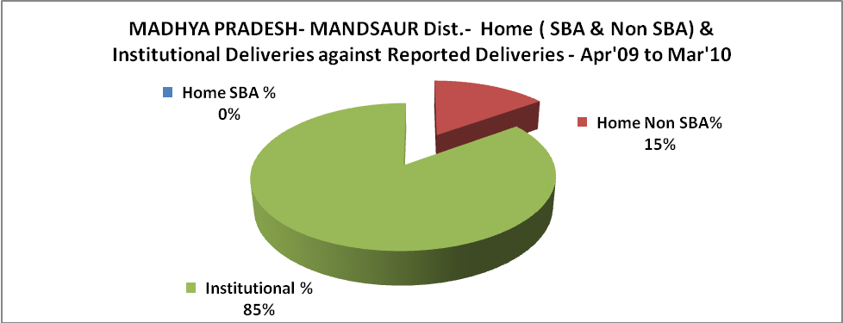

MADHYA PRADESH- MANDSAUR Dist.- C sections & Complicated Deliveries Apr'09 to Mar'10
 | Institutional Deliveries (Public) | Institutional Deliveries (Pvt)
 | 23,999 | 1,616
C Section | 891 | 230
C Section% | 4% | 14%
Complicated Pregnacies attended | 2,987 | 98
Complicated Pregnacies attended % | 12% | 6%

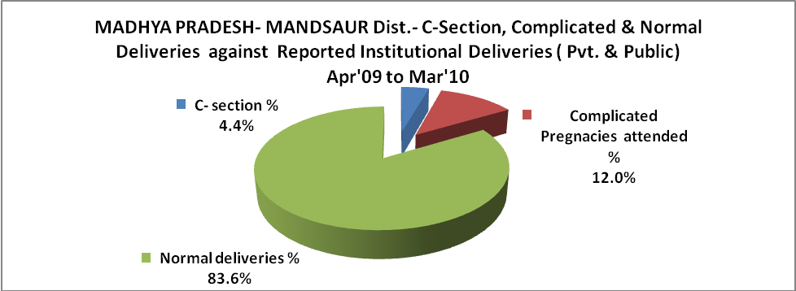

MADHYA PRADESH- MANDSAUR Dist.- Complicated Pregnancies & Deliveries Treated - Apr'09 to Mar'10
Reported Deliveries |  |  | Reported ANC Reigtration
30,128 |  |  | 40,196
Complicated Pregnancies attended | Complicated Pregnancies Rate | C - Section Deliveries | PNC Maternal Complications | Abortions | Still Births
3,085 | 7% | 1,121 | 340 | 437 | 519
Complicated Deliveries Treated with |  |  |  | No Of Eclampsia cases Treated | No Of severe anemia cases treated
IV Antibiotics | IV antihypertensive/Magsulph injection | IV Oxytocis | Blood Transfusion | No Of Eclampsia cases Treated | No Of severe anemia cases treated
149 | 62 | 44 | - | 133 | 47

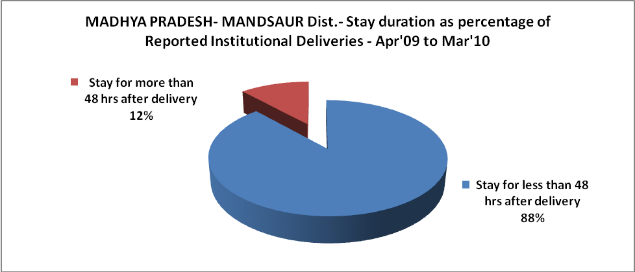

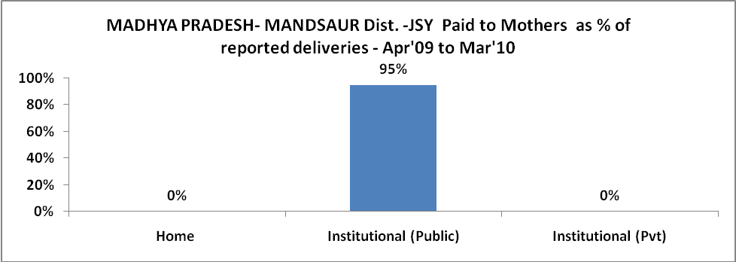

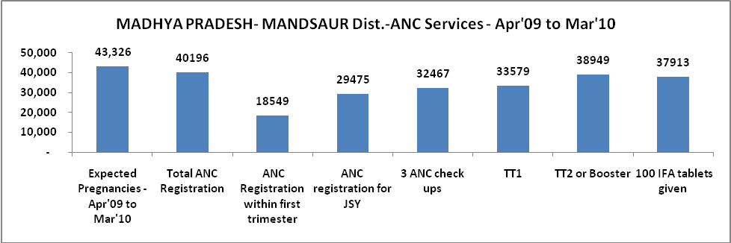

l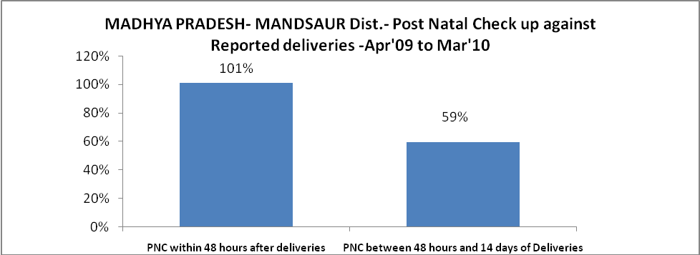

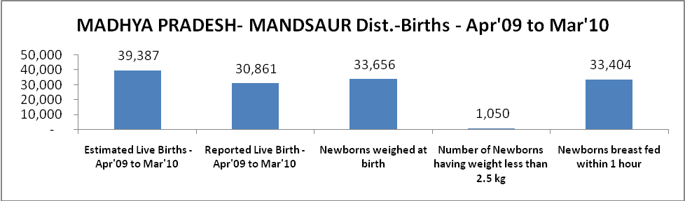

MADHYA PRADESH- MANDSAUR Dist. - Births - Apr'09 to Mar'10
Live Birth - Males | Live Birth - females | Live Birth - Total | Sex Ratio at birth | Still Birth | Abortion( Induced/Spontaneous
15,950 | 14,911 | 30,861 | 935 | 519 | 437

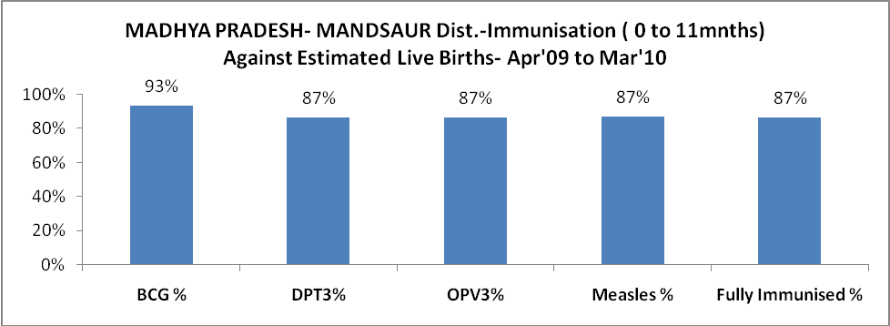

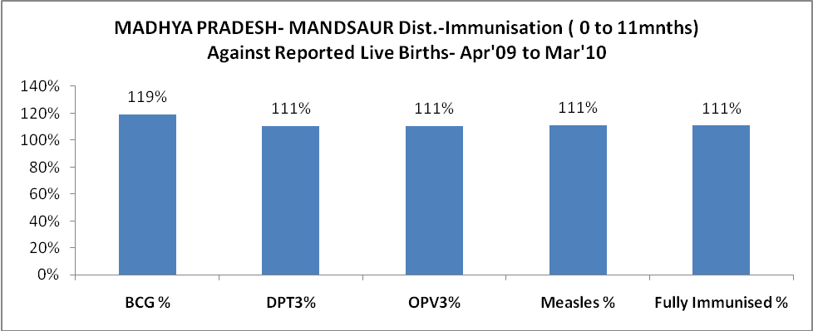

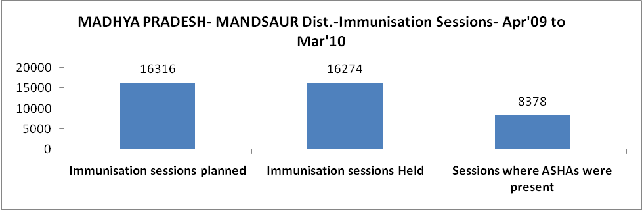

MADHYA PRADESH- MANDSAUR Dist.- Apr'09 to Mar'10
Total Abortions | Abortion Rate
663 | 1.5%

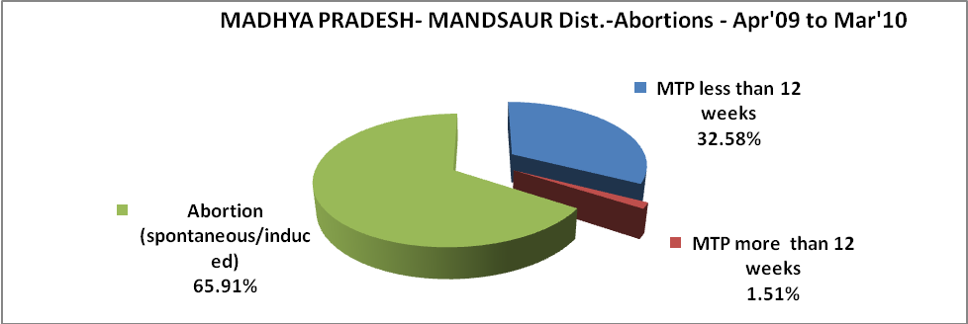

MADHYA PRADESH- MANDSAUR Dist.- Apr'09 to Mar'10
Total OPD | Total RTI/STI cases
422,457 | 11,313

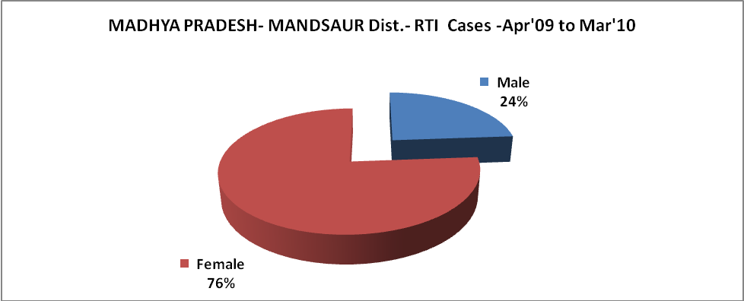

MADHYA PRADESH- MANDSAUR Dist.-Sterilisations - Apr'09 to Mar'10
 | Reported | %age of Reported Sterilisation
Total Sterilisation | 6,439 | -
NSV | 276 | 4%
Laproscopic | 270 | 4%
MiniLap | 3,053 | 47%
Post Partum | 2,840 | 44%
Male Sterilisation | 276 | 4%
Female Sterilisation | 6,163 | 96%
MADHYA PRADESH- MANDSAUR Dist.-FP Methods - Apr'09 to Mar'10
 | Reported | %age of All Reported FP Methods
Total Reported FP Methodd (All types) Users | 69,308 | -
Sterilisations | 6,439 | 9%
IUD | 7,311 | 11%
Condom Users | 45,293 | 65%
OCP Users | 10,264 | 15%
Limiting Methods | 6,439 | 9%
Spacing Methods | 62,869 | 91%

MADHYA PRADESH- MANDSAUR Dist.- Service Delivery - Apr'09 to Mar'10
Operation major (General and spinal anaesthesia) | Operation minor (No or local anaesthesia) | AYUSH | Dental Procedures | Adolescent counselling services | Total OPD | Total IPD
3,621 | 2,026 | 364 | 1,703 | 2,794 | 422,457 | 40,787
Operation major (General and spinal anaesthesia) as %ge of OPD | Operation minor (No or local anaesthesia)as %ge of OPD | AYUSH as %ge of OPD | Dental Procedures as %ge of OPD | Adolescent counselling services as %ge of OPD | IPD as percentage of OPD
0.9% | 0.5% | 0.1% | 0.4% | 0.7% | 10%

MADHYA PRADESH- MANDSAUR Dist.- Lab Services - Apr'09 to Mar'10
Total OPD | Total HB tested | Total HIV Tested | Total Population
422,457 | 23,911 | 7,418 | 1,406,683
HB test conducted as %age of OPD | HB<7gm as %age of HB tested | HIV test conducted as %age of OPD | HIV positive as %age of HIV tested | Blood Smear Examined as % of Population
5.7% | 14.7% | 1.8% | 1.9% | 10.5%
MADHYA PRADESH- MANDSAUR Dist.- Childhood Disease - Vaccine Preventable -Apr'09 to Mar'10
Diphtheria | Pertussis | Tetanus Neonatorum | Tetanus others | Polio | Measles
0 | 0 | 0 | 16 | 0 | 0
MADHYA PRADESH- MANDSAUR Dist.-Childhood Disease - Others - Apr'09 to Mar'10
Diarrhoea and dehydration | Malaria | Number admitted with Respiratory Infections
26,212 | 74 | 20,937
MADHYA PRADESH- MANDSAUR Dist.- Infant & Child Deaths - Apr'09 to Mar'10
Infant Deaths within 24 hrs of birth | Infant Deaths between 24hrs & under 1 week | Infant Deaths between 1 week & under 1 month | Child Deaths between 1 month & under 1 year | Child Deaths between 1yr under 5years | Total Deaths
0 | 254 | 135 | 134 | 102 | 625

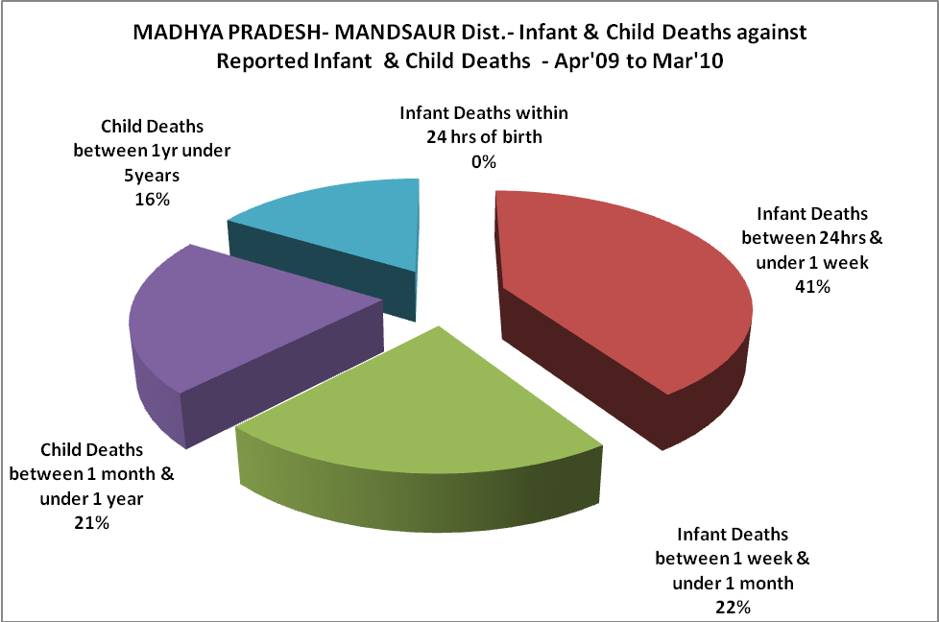

MADHYA PRADESH- MANDSAUR Dist.- Causes of Infant & Child Deaths - Apr'09 to Mar'10
Sepsis |  |  | Asphyxia |  |  | LBW
Up to 1 Weeks of Birth | Between 1 week & 4 weeks of birth | Total | Up to 1 Weeks of Birth | Between 1 week & 4 weeks of birth | Total | Up to 1 Weeks of Birth | Between 1 week & 4 weeks of birth | Total
0 | 0 | 0 | 0 | 0 | 0 | 9 | 0 | 9
Pneumonia |  |  | Diarrhoea |  |  | Fever related
Between 1 month and 11 months | Between 1 year & 5 years | Total | Between 1 month and 11 months | Between 1 year & 5 years | Total | Between 1 month and 11 months | Between 1 year & 5 years | Total
3 | 1 | 4 | 0 | 1 | 1 | 0 | 0 | 0
Others |  |  | Measles |  |  | Others
Up to 1 Weeks of Birth | Between 1 week & 4 weeks of birth | Total | Between 1 month and 11 months | Between 1 year & 5 years | Total | Between 1 month and 11 months | Between 1 year & 5 years | Total
245 | 135 | 380 | 0 | 0 | 0 | 131 | 100 | 231

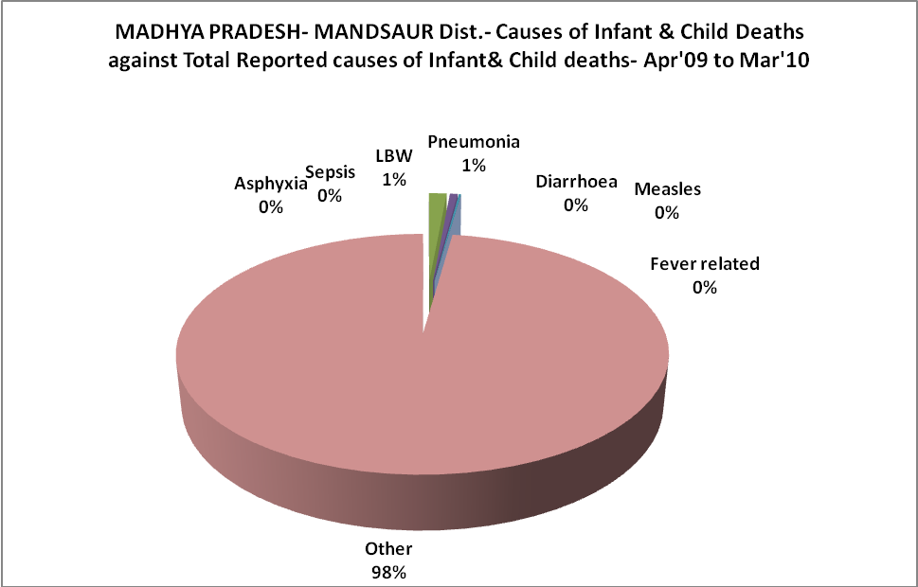

MADHYA PRADESH- MANDSAUR Dist.- Maternal Deaths & Causes - Apr'09 to Mar'10
Abortion |  |  | Obstructed/prolonged labour |  |  | Severe hypertesnion/fits
6-14 yrs | 15-55 yrs. | Total | 6-14 yrs | 15-55 yrs. | Total | 6-14 yrs | 15-55 yrs. | Total
0 | 0 | 0 | 0 | 0 | 0 | 0 | 0 | 0
Bleeding |  |  | High Fever |  |  | Other Causes
6-14 yrs | 15-55 yrs. | Total | 6-14 yrs | 15-55 yrs. | Total | 6-14 yrs | 15-55 yrs. | Total
0 | 0 | 0 | 0 | 0 | 0 | 0 | 9 | 9

MADHYA PRADESH- MANDSAUR Dist.-Causes of Deaths in 6 to 55yrs age group - Apr'09 to Mar'10
Diarrhoel Diseases |  |  |  | Tuberculosis |  |  |  | Respiratory Diseases( Other than TB)
6-14 yrs | 15-55 yrs. | Above 55yrs | Total | 6-14 yrs | 15-55 yrs. | Above 55yrs | Total | 6-14 yrs | 15-55 yrs. | Above 55yrs | Total
0 | 0 | 0 | 0 | 0 | 0 | 18 | 18 | 0 | 5 | 45 | 50
Malaria |  |  |  | Other fever Related |  |  |  | HIV/Aids
6-14 yrs | 15-55 yrs. | Above 55yrs | Total | 6-14 yrs | 15-55 yrs. | Above 55yrs | Total | 6-14 yrs | 15-55 yrs. | Above 55yrs | Total
0 | 0 | 0 | 0 | 0 | 15 | 41 | 56 | 0 | 0 | 0 | 0
Heart Disease/Hypertenion related |  |  |  | Neurological Disease including strokes |  |  |  | Trauma/Accidents/ Burn Cases
6-14 yrs | 15-55 yrs. | Above 55yrs | Total | 6-14 yrs | 15-55 yrs. | Above 55yrs | Total | 6-14 yrs | 15-55 yrs. | Above 55yrs | Total
0 | 34 | 60 | 94 | 0 | 10 | 52 | 62 | 0 | 0 | 4 | 4
Suicide |  |  |  | Animal Bites & Stings
6-14 yrs | 15-55 yrs. | Above 55yrs | Total | 6-14 yrs | 15-55 yrs. | Above 55yrs | Total
0 | 0 | 0 | 0 | 0 | 0 | 0 | 0

