[NHSRC]
MP-Morena
[ Analysis 2009-10]

MADHYA PRADESH- MORENA Dist.- Summary-Apr'09 to Mar'10
ANC
ANC Registration against Expected Pregnancies | 93% | TT1 given to Pregnant women against ANC Registraion | 87%
3 ANC Check ups against ANC Reigtrations | 63% | 100 IFA Tablets given to Pregnant women against ANC Registraion | 82%
Deliveries
Unreported Deliveries against Estimated Deliveries | 14.7% | HOME Deliveries( SBA& Non SBA) against Estimated Deliveries | 1.9%
Institutional Deliveries against Estimated Deliveries | 83.4% | HOME Deliveries( SBA& Non SBA) against Reported Deliveries | 2.2%
Institutional Deliveries against Reported Deliveries | 97.8% | C Section Deliveries against Institutional Deliveries( Pvt & Pub) | 1%
Births & Neonates Care
Live Births Reported against Estimated Live Births | 87% | New borns weighed against Reported Live Births | 92%
Still Births (Reported) | 473 | New borns weighed less than 2.5 kgs against newborns weighed | 21%
Sex Ratio at Birh | 874 | New borns breastfed within one hr of Birth against Reported live Births | 81%
Child Immunisation( 0 to 11 months)
BCG given against Expected Live Births | 86% | Measles given against Expected Live Births | 86%
OPV3 given against Expected Live Births | 83% | Fully Immunised Children against Expected Live Births | 78%
DPT3 given against Expected Live Births | 84%
Family Planning
Family Plannig Methods Users ( Sterilisations(Male &Female)+IUD+ Condom pieces/72 + OCP Cycles/13) | 66,664 | IUD Insertions against reported FP Methods | 18%
Sterilisation against reported FP Methods | 13% | Condom Users against reported FP Methods | 61%
 |  | OCP Users against reported FP Methods | 8%
Other Services
OPD | 139,450 | Major Operations | 8
IPD | 10,479 | Minor Operations | 22

MADHYA PRADESH- MORENA Dist.- Deliveries Apr'09 to Mar'10
Total Population | 1,893,554 | Expected Deliveries |  | 54,875
Home SBA | Home Non SBA | Institutional | Total Deliveries Reported | Unreported Deliveries
225 | 811 | 45,785 | 46,821 | 8,054
Home SBA % | Home Non SBA% | Institutional % | Total Deliveries Reported % | Unreported Deliveries %
0% | 1% | 83% | 85% | 15%

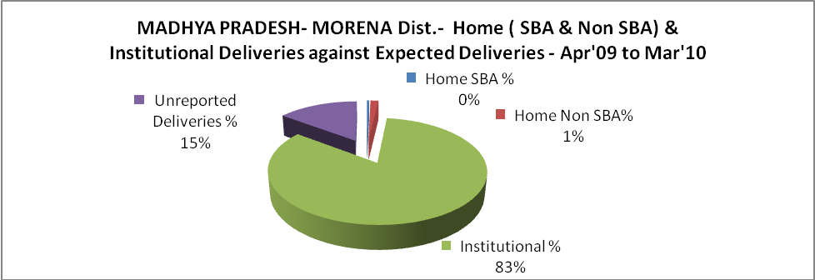

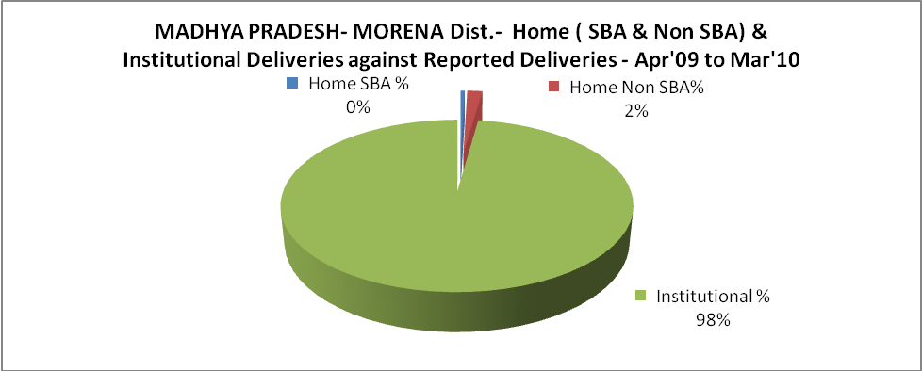

MADHYA PRADESH- MORENA Dist.- C sections & Complicated Deliveries Apr'09 to Mar'10
 | Institutional Deliveries (Public) | Institutional Deliveries (Pvt)
 | 41,793 | 3,992
C Section | 83 | 293
C Section% | 0% | 7%
Complicated Pregnacies attended | 3,030 | 4
Complicated Pregnacies attended % | 7% | 0%

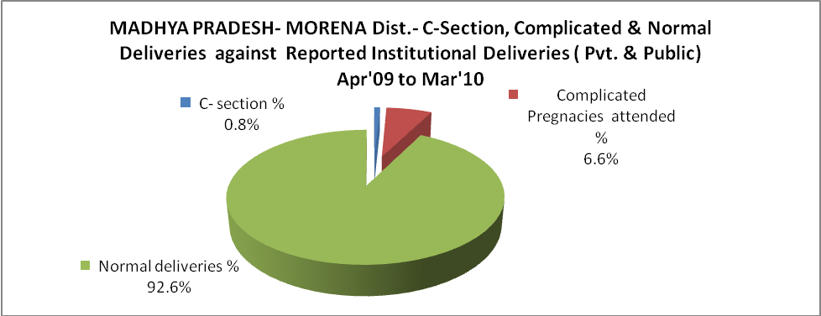

MADHYA PRADESH- MORENA Dist.- Complicated Pregnancies & Deliveries Treated - Apr'09 to Mar'10
Reported Deliveries |  |  | Reported ANC Reigtration
46,821 |  |  | 54,205
Complicated Pregnancies attended | Complicated Pregnancies Rate | C - Section Deliveries | PNC Maternal Complications | Abortions | Still Births
3,034 | 5% | 376 | 259 | 393 | 473
Complicated Deliveries Treated with |  |  |  | No Of Eclampsia cases Treated | No Of severe anemia cases treated
IV Antibiotics | IV antihypertensive/Magsulph injection | IV Oxytocis | Blood Transfusion | No Of Eclampsia cases Treated | No Of severe anemia cases treated
1,518 | 220 | 286 | 8 | 82 | 600

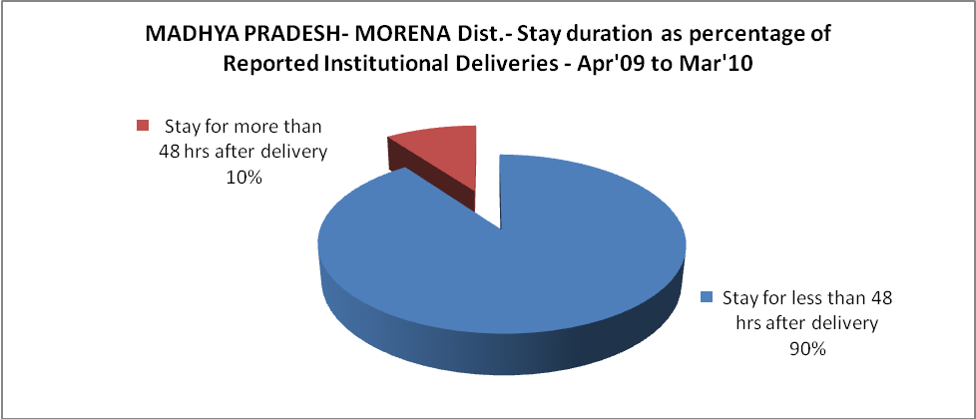

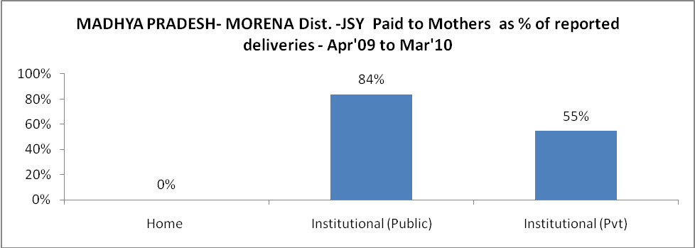

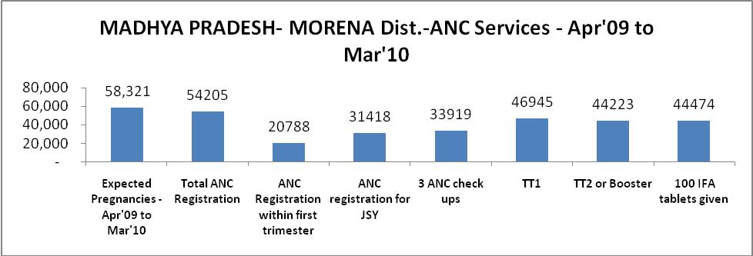

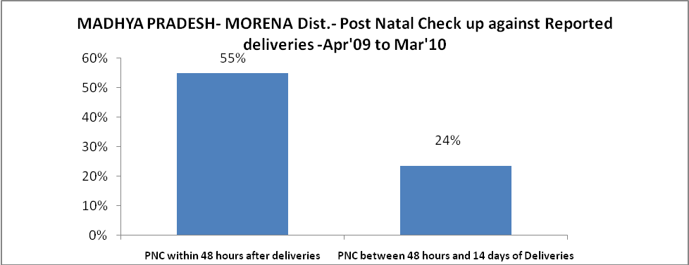

l

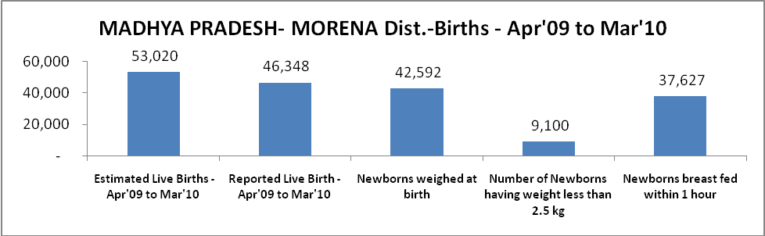

MADHYA PRADESH- MORENA Dist. - Births - Apr'09 to Mar'10
Live Birth - Males | Live Birth - females | Live Birth - Total | Sex Ratio at birth | Still Birth | Abortion( Induced/Spontaneous
24,726 | 21,622 | 46,348 | 874 | 473 | 393

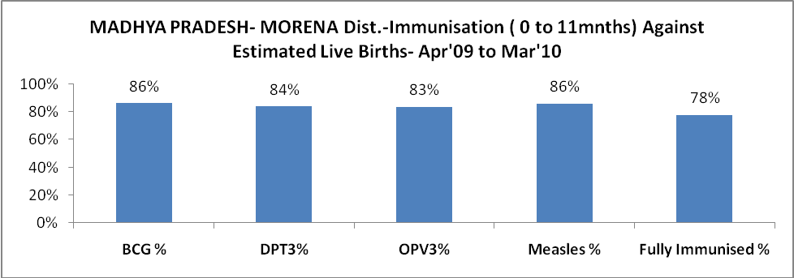

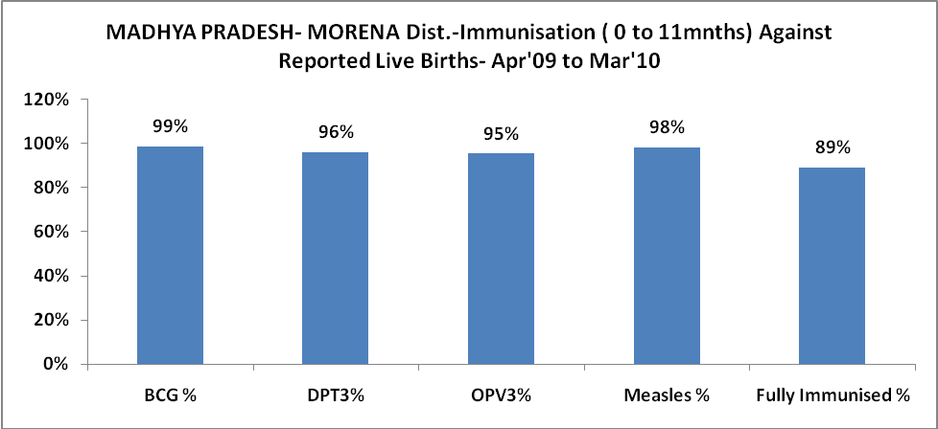

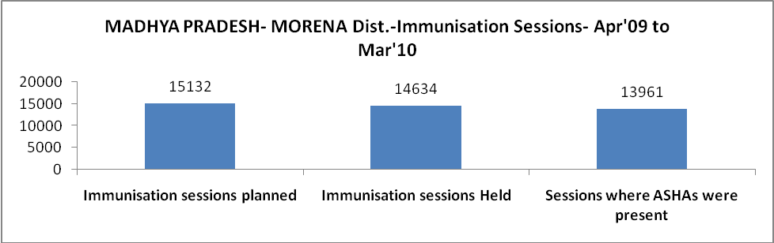

MADHYA PRADESH- MORENA Dist.- Apr'09 to Mar'10
Total Abortions | Abortion Rate
623 | 1.1%

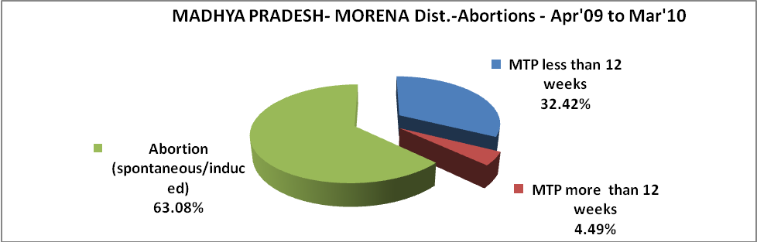

MADHYA PRADESH- MORENA Dist.- Apr'09 to Mar'10
Total OPD | Total RTI/STI cases
139,450 | 11,762

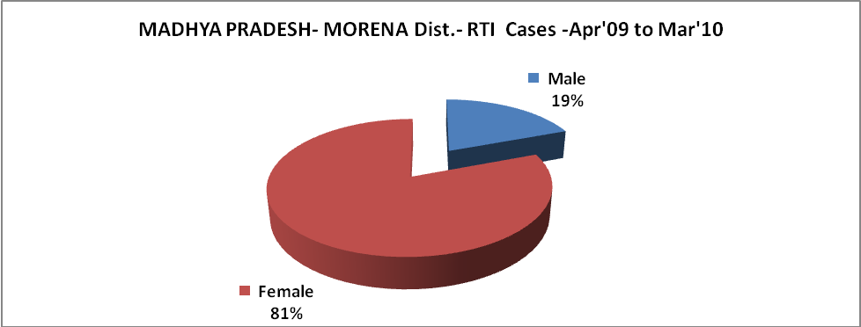

MADHYA PRADESH- MORENA Dist.-Sterilisations - Apr'09 to Mar'10
 | Reported | %age of Reported Sterilisation
Total Sterilisation | 8,542 | -
NSV | 77 | 1%
Laproscopic | 8,465 | 99%
MiniLap | - | 0%
Post Partum | - | 0%
Male Sterilisation | 77 | 1%
Female Sterilisation | 8,465 | 99%
MADHYA PRADESH- MORENA Dist.-FP Methods - Apr'09 to Mar'10
 | Reported | %age of All Reported FP Methods
Total Reported FP Methodd (All types) Users | 66,664 | -
Sterilisations | 8,542 | 13%
IUD | 12,288 | 18%
Condom Users | 40,530 | 61%
OCP Users | 5,304 | 8%
Limiting Methods | 8,542 | 13%
Spacing Methods | 58,122 | 87%

MADHYA PRADESH- MORENA Dist.- Service Delivery - Apr'09 to Mar'10
Operation major (General and spinal anaesthesia) | Operation minor (No or local anaesthesia) | AYUSH | Dental Procedures | Adolescent counselling services | Total OPD | Total IPD
8 | 22 | 762 | 9 | 936 | 139,450 | 10,479
Operation major (General and spinal anaesthesia) as %ge of OPD | Operation minor (No or local anaesthesia)as %ge of OPD | AYUSH as %ge of OPD | Dental Procedures as %ge of OPD | Adolescent counselling services as %ge of OPD | IPD as percentage of OPD
0.0% | 0.0% | 0.5% | 0.0% | 0.7% | 8%

MADHYA PRADESH- MORENA Dist.- Lab Services - Apr'09 to Mar'10
Total OPD | Total HB tested | Total HIV Tested | Total Population
139,450 | 23,592 | 2,999 | 1,893,554
HB test conducted as %age of OPD | HB<7gm as %age of HB tested | HIV test conducted as %age of OPD | HIV positive as %age of HIV tested | Blood Smear Examined as % of Population
16.9% | 2.8% | 2.2% | 1.2% | 5.1%
MADHYA PRADESH- MORENA Dist.- Childhood Disease - Vaccine Preventable -Apr'09 to Mar'10
Diphtheria | Pertussis | Tetanus Neonatorum | Tetanus others | Polio | Measles
0 | 0 | 1 | 0 | 0 | 35
MADHYA PRADESH- MORENA Dist.-Childhood Disease - Others - Apr'09 to Mar'10
Diarrhoea and dehydration | Malaria | Number admitted with Respiratory Infections
10,456 | 16,107 | 2,064
MADHYA PRADESH- MORENA Dist.- Infant & Child Deaths - Apr'09 to Mar'10
Infant Deaths within 24 hrs of birth | Infant Deaths between 24hrs & under 1 week | Infant Deaths between 1 week & under 1 month | Child Deaths between 1 month & under 1 year | Child Deaths between 1yr under 5years | Total Deaths
160 | 118 | 78 | 57 | 98 | 511

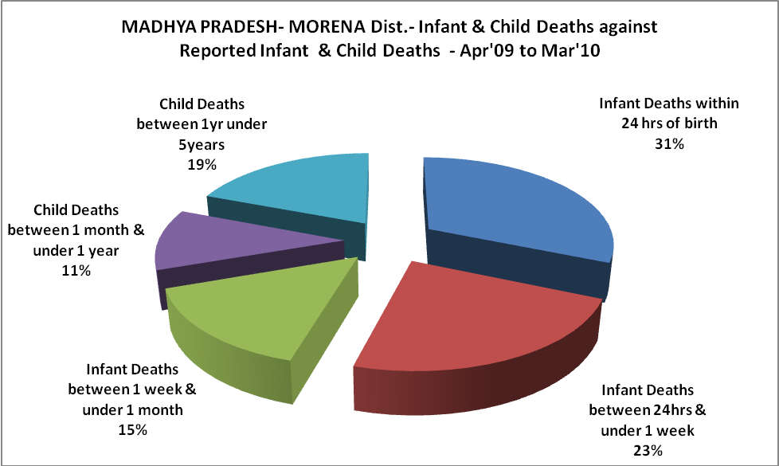

MADHYA PRADESH- MORENA Dist.- Causes of Infant & Child Deaths - Apr'09 to Mar'10
Sepsis |  |  | Asphyxia |  |  | LBW
Up to 1 Weeks of Birth | Between 1 week & 4 weeks of birth | Total | Up to 1 Weeks of Birth | Between 1 week & 4 weeks of birth | Total | Up to 1 Weeks of Birth | Between 1 week & 4 weeks of birth | Total
12 | 4 | 16 | 7 | 0 | 7 | 41 | 51 | 92
Pneumonia |  |  | Diarrhoea |  |  | Fever related
Between 1 month and 11 months | Between 1 year & 5 years | Total | Between 1 month and 11 months | Between 1 year & 5 years | Total | Between 1 month and 11 months | Between 1 year & 5 years | Total
1 | 8 | 9 | 1 | 3 | 4 | 2 | 4 | 6
Others |  |  | Measles |  |  | Others
Up to 1 Weeks of Birth | Between 1 week & 4 weeks of birth | Total | Between 1 month and 11 months | Between 1 year & 5 years | Total | Between 1 month and 11 months | Between 1 year & 5 years | Total
58 | 23 | 81 | 0 | 0 | 0 | 53 | 83 | 136

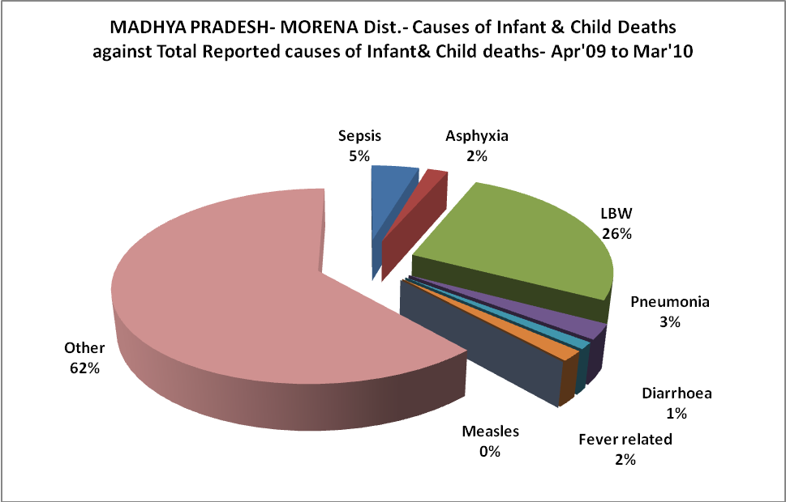

MADHYA PRADESH- MORENA Dist.- Maternal Deaths & Causes - Apr'09 to Mar'10
Abortion |  |  | Obstructed/prolonged labour |  |  | Severe hypertesnion/fits
6-14 yrs | 15-55 yrs. | Total | 6-14 yrs | 15-55 yrs. | Total | 6-14 yrs | 15-55 yrs. | Total
0 | 0 | 0 | 0 | 0 | 0 | 0 | 0 | 0
Bleeding |  |  | High Fever |  |  | Other Causes
6-14 yrs | 15-55 yrs. | Total | 6-14 yrs | 15-55 yrs. | Total | 6-14 yrs | 15-55 yrs. | Total
0 | 1 | 1 | 0 | 0 | 0 | 0 | 3 | 3

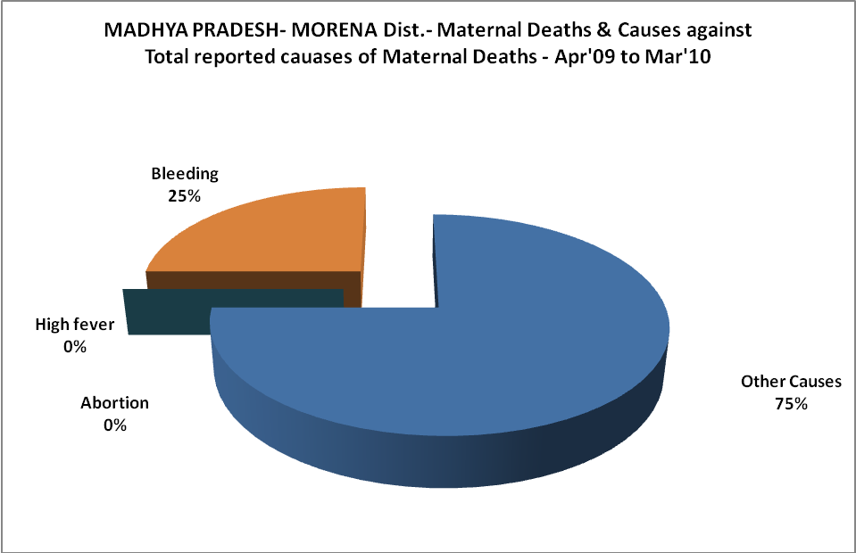

MADHYA PRADESH- MORENA Dist.-Causes of Deaths in 6 to 55yrs age group - Apr'09 to Mar'10
Diarrhoel Diseases |  |  |  | Tuberculosis |  |  |  | Respiratory Diseases( Other than TB)
6-14 yrs | 15-55 yrs. | Above 55yrs | Total | 6-14 yrs | 15-55 yrs. | Above 55yrs | Total | 6-14 yrs | 15-55 yrs. | Above 55yrs | Total
3 | 49 | 35 | 87 | 1 | 48 | 28 | 77 | 0 | 10 | 20 | 30
Malaria |  |  |  | Other fever Related |  |  |  | HIV/Aids
6-14 yrs | 15-55 yrs. | Above 55yrs | Total | 6-14 yrs | 15-55 yrs. | Above 55yrs | Total | 6-14 yrs | 15-55 yrs. | Above 55yrs | Total
1 | 1 | 0 | 2 | 32 | 98 | 203 | 333 | 0 | 2 | 21 | 23
Heart Disease/Hypertenion related |  |  |  | Neurological Disease including strokes |  |  |  | Trauma/Accidents/ Burn Cases
6-14 yrs | 15-55 yrs. | Above 55yrs | Total | 6-14 yrs | 15-55 yrs. | Above 55yrs | Total | 6-14 yrs | 15-55 yrs. | Above 55yrs | Total
0 | 6 | 29 | 35 | 0 | 10 | 31 | 41 | 0 | 0 | 0 | 0
Suicide |  |  |  | Animal Bites & Stings
6-14 yrs | 15-55 yrs. | Above 55yrs | Total | 6-14 yrs | 15-55 yrs. | Above 55yrs | Total
0 | 1 | 0 | 1 | 0 | 0 | 0 | 0

