[NHSRC]
MP-Gwalior
[ Analysis 2009-10]

MADHYA PRADESH- GWALIOR Dist.- Summary-Apr'09 to Mar'10
ANC
ANC Registration against Expected Pregnancies | 87% | TT1 given to Pregnant women against ANC Registraion | 67%
3 ANC Check ups against ANC Reigtrations | 69% | 100 IFA Tablets given to Pregnant women against ANC Registraion | 92%
Deliveries
Unreported Deliveries against Estimated Deliveries | 31.9% | HOME Deliveries( SBA& Non SBA) against Estimated Deliveries | 1.4%
Institutional Deliveries against Estimated Deliveries | 66.7% | HOME Deliveries( SBA& Non SBA) against Reported Deliveries | 2.1%
Institutional Deliveries against Reported Deliveries | 97.9% | C Section Deliveries against Institutional Deliveries( Pvt & Pub) | 13%
Births & Neonates Care
Live Births Reported against Estimated Live Births | 73% | New borns weighed against Reported Live Births | 98%
Still Births (Reported) | 227 | New borns weighed less than 2.5 kgs against newborns weighed | 6%
Sex Ratio at Birh | 853 | New borns breastfed within one hr of Birth against Reported live Births | 97%
Child Immunisation( 0 to 11 mnths)
BCG given against Expected Live Births | 75% | Measles given against Expected Live Births | 73%
OPV3 given against Expected Live Births | 60% | Fully Immunised Children against Expected Live Births | 69%
DPT3 given against Expected Live Births | 60%
Family Planning
Family Plannig Methods Users ( Sterilisations(Male &Female)+IUD+ Condom pieces/72 + OCP Cycles/13) | 28,842 | IUD Insertions against reported FP Methods | 33%
Sterilisation against reported FP Methods | 31% | Condom Users against reported FP Methods | 26%
 |  | OCP Users against reported FP Methods | 11%
Other Services
OPD | 4,35,238 | Major Operations | 104
IPD | 11,739 | Minor Operations | 1,567

MADHYA PRADESH- GWALIOR Dist.- Deliveries Apr'09 to Mar'10
Total Population | 19,39,819 | Expected Deliveries |  | 56,216
Home SBA | Home Non SBA | Institutional | Total Deliveries Reported | Unreported Deliveries
271 | 514 | 37,490 | 38,275 | 17,941
Home SBA % | Home Non SBA% | Institutional % | Total Deliveries Reported % | Unreported Deliveries %
0% | 1% | 67% | 68% | 32%

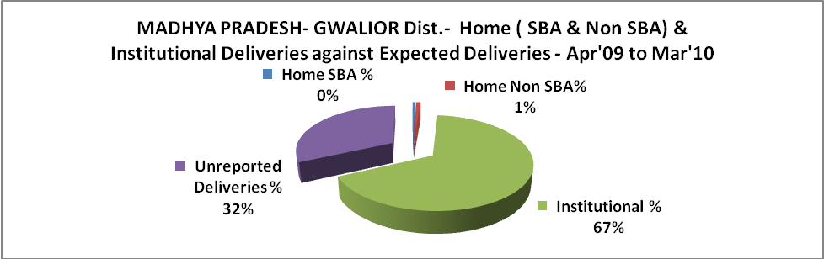

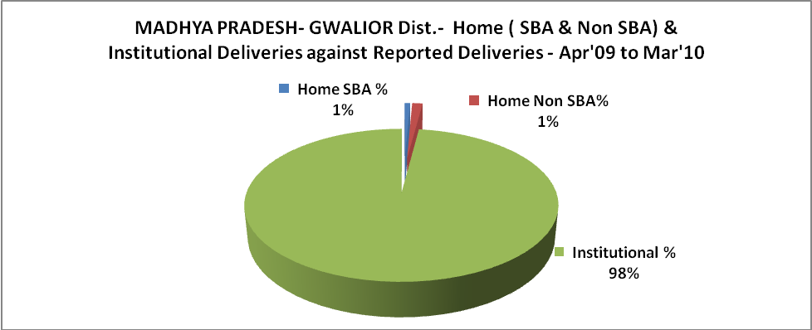

MADHYA PRADESH- GWALIOR Dist.- C sections & Complicated Deliveries Apr'09 to Mar'10
 | Institutional Deliveries (Public) | Institutional Deliveries (Pvt)
 | 29,808 | 7,682
C Section | 1,981 | 3,058
C Section% | 7% | 40%
Complicated Pregnacies attended | 1,071 | -
Complicated Pregnacies attended % | 4% | 0%

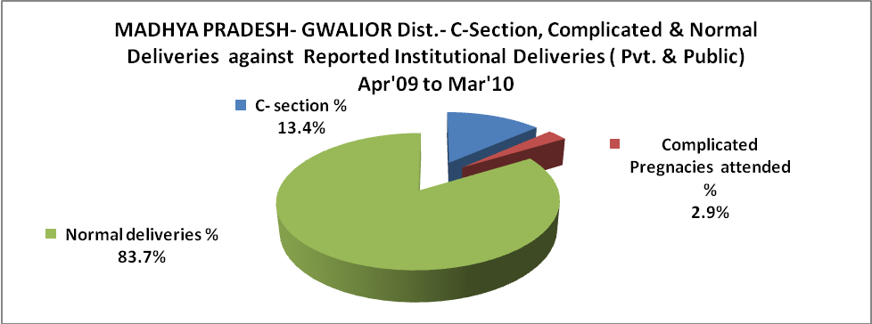

MADHYA PRADESH- GWALIOR Dist.- Complicated Pregnancies & Deliveries Treated - Apr'09 to Mar'10
Reported Deliveries |  |  | Reported ANC Reigtration
38,275 |  |  | 51,752
Complicated Pregnancies attended | Complicated Pregnancies Rate | C - Section Deliveries | PNC Maternal Complications | Abortions | Still Births
1,071 | 2% | 5,039 | 90 | 136 | 227
Complicated Deliveries Treated with |  |  |  | No Of Eclampsia cases Treated | No Of severe anemia cases treated
IV Antibiotics | IV antihypertensive/Magsulph injection | IV Oxytocis | Blood Transfusion | No Of Eclampsia cases Treated | No Of severe anemia cases treated
2,589 | 22 | 2,524 | 2 | 51 | 1,004

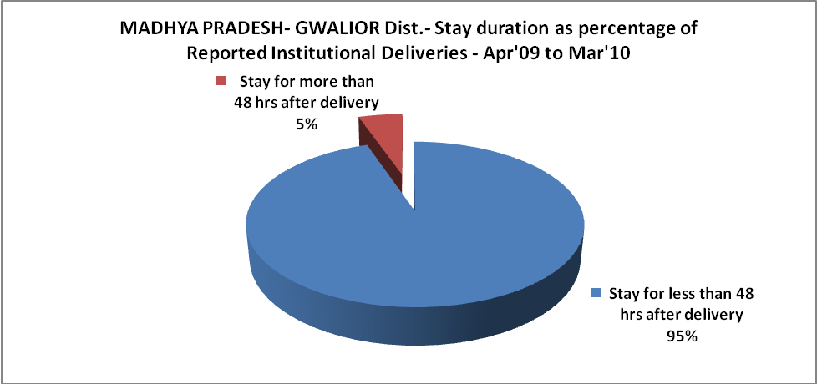

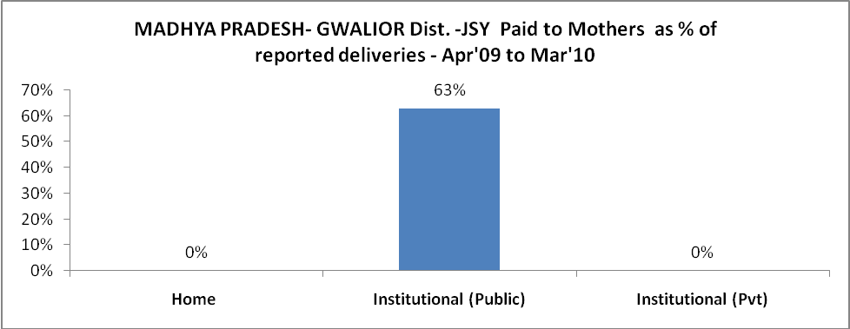

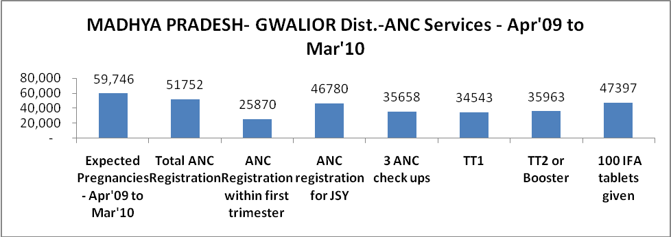

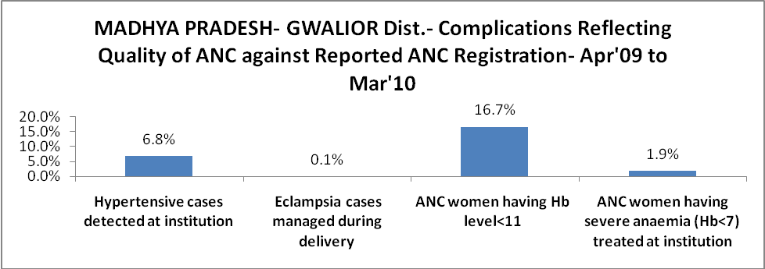

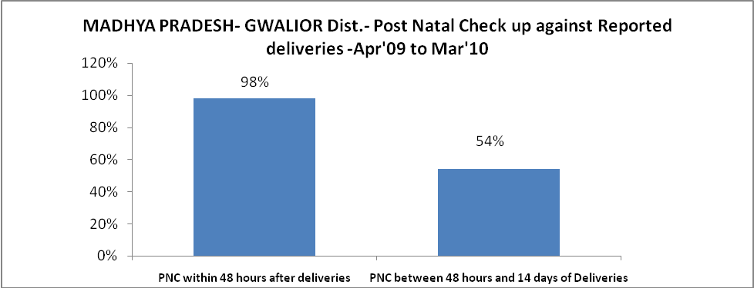

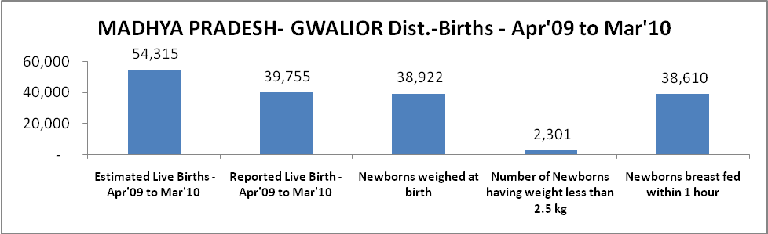

MADHYA PRADESH- GWALIOR Dist. - Births - Apr'09 to Mar'10
Live Birth - Males | Live Birth - females | Live Birth - Total | Sex Ratio at birth | Still Birth | Abortion( Induced/Spontaneous
21,455 | 18,300 | 39,755 | 853 | 227 | 136

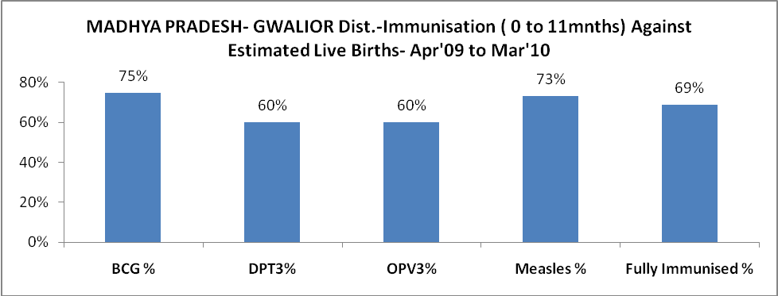

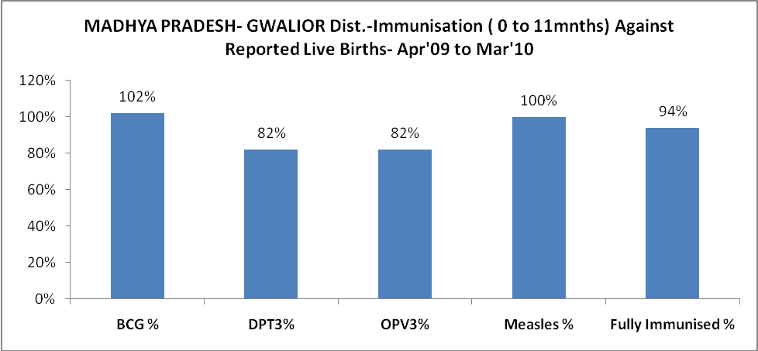

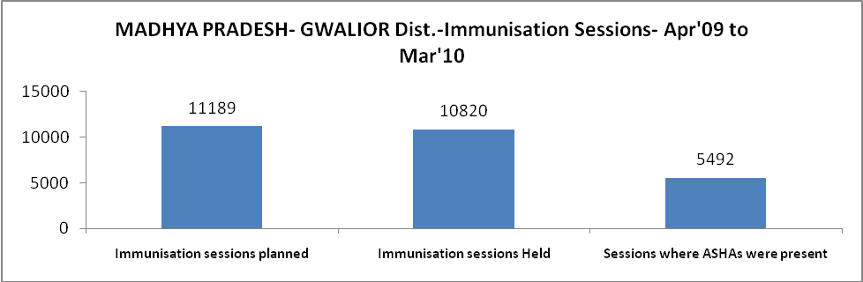

MADHYA PRADESH- GWALIOR Dist.- Apr'09 to Mar'10
Total Abortions | Abortion Rate
593 | 1.0%

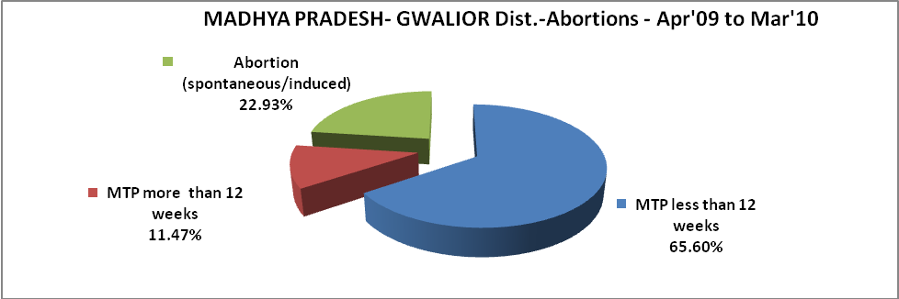

MADHYA PRADESH- GWALIOR Dist.- Apr'09 to Mar'10
Total OPD | Total RTI/STI cases
4,35,238 | 7,024

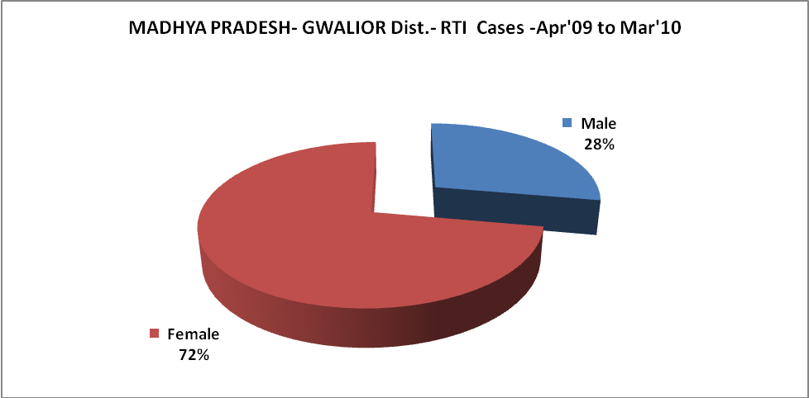

l

MADHYA PRADESH- GWALIOR Dist.-Sterilisations - Apr'09 to Mar'10
 | Reported | %age of Reported Sterilisation
Total Sterilisation | 8,901 | -
NSV | 1,042 | 12%
Laproscopic | 7,044 | 79%
MiniLap | 746 | 8%
Post Partum | 69 | 1%
Male Sterilisation | 1,042 | 12%
Female Sterilisation | 7,859 | 88%
MADHYA PRADESH- GWALIOR Dist.-FP Methods - Apr'09 to Mar'10
 | Reported | %age of All Reported FP Methods
Total Reported FP Methodd (All types) Users | 28,842 | -
Sterilisations | 8,901 | 31%
IUD | 9,484 | 33%
Condom Users | 7,424 | 26%
OCP Users | 3,032 | 11%
Limiting Methods | 8,901 | 31%
Spacing Methods | 19,941 | 69%

MADHYA PRADESH- GWALIOR Dist.- Service Delivery - Apr'09 to Mar'10
Operation major (General and spinal anaesthesia) | Operation minor (No or local anaesthesia) | AYUSH | Dental Procedures | Adolescent counselling services | Total OPD | Total IPD
104 | 1,567 | 14,037 | 5,151 | 670 | 4,35,238 | 11,739
Operation major (General and spinal anaesthesia) as %ge of OPD | Operation minor (No or local anaesthesia)as %ge of OPD | AYUSH as %ge of OPD | Dental Procedures as %ge of OPD | Adolescent counselling services as %ge of OPD | IPD as percentage of OPD
0.0% | 0.4% | 3.2% | 1.2% | 0.2% | 3%

MADHYA PRADESH- GWALIOR Dist.- Lab Services - Apr'09 to Mar'10
Total OPD | Total HB tested | Total HIV Tested | Total Population
4,35,238 | 12,241 | 3,723 | 19,39,819
HB test conducted as %age of OPD | HB<7gm as %age of HB tested | HIV test conducted as %age of OPD | HIV positive as %age of HIV tested | Blood Smear Examined as % of Population
2.8% | 4.4% | 0.9% | 0.2% | 3.4%
MADHYA PRADESH- GWALIOR Dist.- Childhood Disease - Vaccine Preventable -Apr'09 to Mar'10
Diphtheria | Pertussis | Tetanus Neonatorum | Tetanus others | Polio | Measles
89 | 8 | 0 | 0 | 0 | 85
MADHYA PRADESH- GWALIOR Dist.-Childhood Disease - Others - Apr'09 to Mar'10
Diarrhoea and dehydration | Malaria | Number admitted with Respiratory Infections
3,884 | 2,151 | 223
MADHYA PRADESH- GWALIOR Dist.- Infant & Child Deaths - Apr'09 to Mar'10
Infant Deaths within 24 hrs of birth | Infant Deaths between 24hrs & under 1 week | Infant Deaths between 1 week & under 1 month | Child Deaths between 1 month & under 1 year | Child Deaths between 1yr under 5years | Total Deaths
4 | 126 | 97 | 62 | 44 | 333

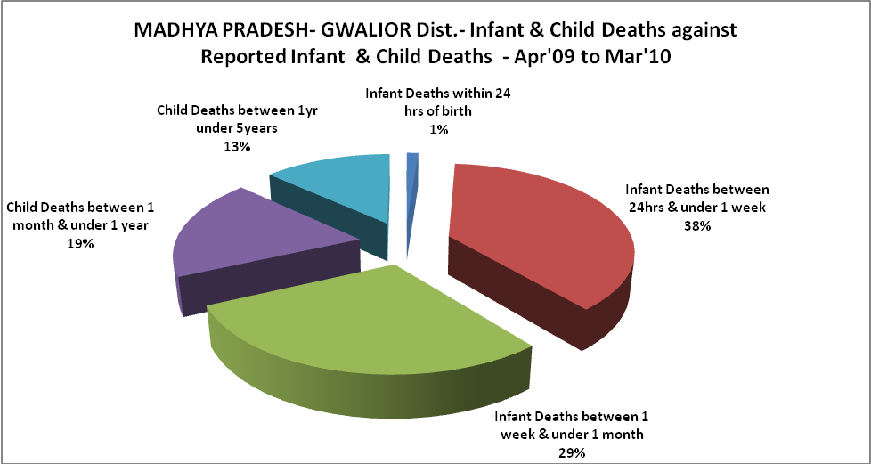

MADHYA PRADESH- GWALIOR Dist.- Causes of Infant & Child Deaths - Apr'09 to Mar'10
Sepsis |  |  | Asphyxia |  |  | LBW
Up to 1 Weeks of Birth | Between 1 week & 4 weeks of birth | Total | Up to 1 Weeks of Birth | Between 1 week & 4 weeks of birth | Total | Up to 1 Weeks of Birth | Between 1 week & 4 weeks of birth | Total
17 | 25 | 42 | 8 | 12 | 20 | 31 | 17 | 48
Pneumonia |  |  | Diarrhoea |  |  | Fever related
Between 1 month and 11 months | Between 1 year & 5 years | Total | Between 1 month and 11 months | Between 1 year & 5 years | Total | Between 1 month and 11 months | Between 1 year & 5 years | Total
3 | 1 | 4 | 2 | 0 | 2 | 5 | 4 | 9
Others |  |  | Measles |  |  | Others
Up to 1 Weeks of Birth | Between 1 week & 4 weeks of birth | Total | Between 1 month and 11 months | Between 1 year & 5 years | Total | Between 1 month and 11 months | Between 1 year & 5 years | Total
70 | 43 | 113 | 0 | 0 | 0 | 52 | 39 | 91

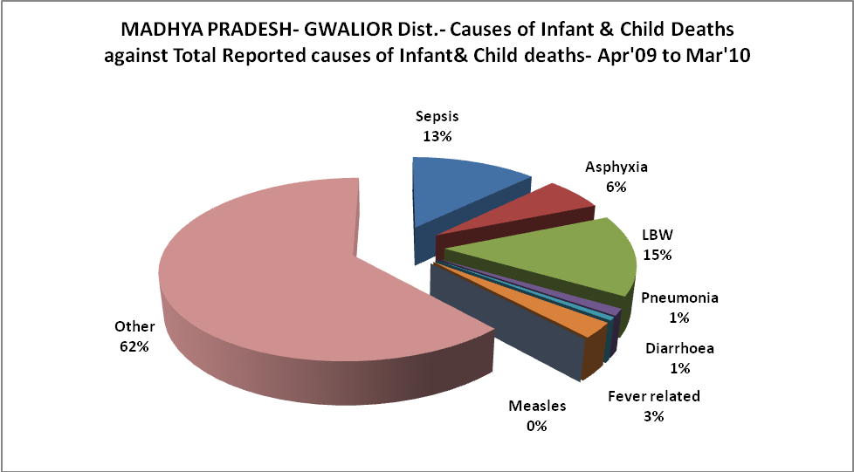

MADHYA PRADESH- GWALIOR Dist.- Maternal Deaths & Causes - Apr'09 to Mar'10
Abortion |  |  | Obstructed/prolonged labour |  |  | Severe hypertesnion/fits
6-14 yrs | 15-55 yrs. | Total | 6-14 yrs | 15-55 yrs. | Total | 6-14 yrs | 15-55 yrs. | Total
0 | 0 | 0 | 0 | 1 | 1 | 0 | 0 | 0
Bleeding |  |  | High Fever |  |  | Other Causes
6-14 yrs | 15-55 yrs. | Total | 6-14 yrs | 15-55 yrs. | Total | 6-14 yrs | 15-55 yrs. | Total
0 | 0 | 0 | 0 | 0 | 0 | 0 | 0 | 0

MADHYA PRADESH- GWALIOR Dist.-Causes of Deaths in 6 to 55yrs age group - Apr'09 to Mar'10
Diarrhoel Diseases |  |  |  | Tuberculosis |  |  |  | Respiratory Diseases( Other than TB)
6-14 yrs | 15-55 yrs. | Above 55yrs | Total | 6-14 yrs | 15-55 yrs. | Above 55yrs | Total | 6-14 yrs | 15-55 yrs. | Above 55yrs | Total
2 | 0 | 0 | 2 | 2 | 1 | 1 | 4 | 0 | 1 | 0 | 1
Malaria |  |  |  | Other fever Related |  |  |  | HIV/Aids
6-14 yrs | 15-55 yrs. | Above 55yrs | Total | 6-14 yrs | 15-55 yrs. | Above 55yrs | Total | 6-14 yrs | 15-55 yrs. | Above 55yrs | Total
0 | 0 | 0 | 0 | 6 | 5 | 23 | 34 | 0 | 0 | 0 | 0
Heart Disease/Hypertenion related |  |  |  | Neurological Disease including strokes |  |  |  | Trauma/Accidents/ Burn Cases
6-14 yrs | 15-55 yrs. | Above 55yrs | Total | 6-14 yrs | 15-55 yrs. | Above 55yrs | Total | 6-14 yrs | 15-55 yrs. | Above 55yrs | Total
0 | 0 | 0 | 0 | 0 | 0 | 0 | 0 | 0 | 0 | 1 | 1
Suicide |  |  |  | Animal Bites & Stings
6-14 yrs | 15-55 yrs. | Above 55yrs | Total | 6-14 yrs | 15-55 yrs. | Above 55yrs | Total
0 | 0 | 0 | 0 | 0 | 0 | 0 | 0

