[NHSRC]
MP-Harda
[ Analysis 2009-10]

MADHYA PRADESH- HARDA Dist.- Summary-Apr'09 to Mar'10
ANC
ANC Registration against Expected Pregnancies | 93% | TT1 given to Pregnant women against ANC Registraion | 68%
3 ANC Check ups against ANC Reigtrations | 87% | 100 IFA Tablets given to Pregnant women against ANC Registraion | 81%
Deliveries
Unreported Deliveries against Estimated Deliveries | 16.5% | HOME Deliveries( SBA& Non SBA) against Estimated Deliveries | 30.0%
Institutional Deliveries against Estimated Deliveries | 53.5% | HOME Deliveries( SBA& Non SBA) against Reported Deliveries | 35.9%
Institutional Deliveries against Reported Deliveries | 64.1% | C Section Deliveries against Institutional Deliveries( Pvt & Pub) | 2%
Births & Neonates Care
Live Births Reported against Estimated Live Births | 85% | New borns weighed against Reported Live Births | 91%
Still Births (Reported) | 169 | New borns weighed less than 2.5 kgs against newborns weighed | 59%
Sex Ratio at Birh | 899 | New borns breastfed within one hr of Birth against Reported live Births | 81%
Child Immunisation( 0 to 11 mnths)
BCG given against Expected Live Births | 89% | Measles given against Expected Live Births | 88%
OPV3 given against Expected Live Births | 85% | Fully Immunised Children against Expected Live Births | 83%
DPT3 given against Expected Live Births | 85%
Family Planning
Family Plannig Methods Users ( Sterilisations(Male &Female)+IUD+ Condom pieces/72 + OCP Cycles/13) | 29,422 | IUD Insertions against reported FP Methods | 12%
Sterilisation against reported FP Methods | 12% | Condom Users against reported FP Methods | 57%
 |  | OCP Users against reported FP Methods | 18%
Other Services
OPD | 1,28,167 | Major Operations | 366
IPD | 17,950 | Minor Operations | 710

MADHYA PRADESH- HARDA Dist.- Deliveries Apr'09 to Mar'10
Total Population | 5,63,791 | Expected Deliveries |  | 16,339
Home SBA | Home Non SBA | Institutional | Total Deliveries Reported | Unreported Deliveries
4,734 | 164 | 8,741 | 13,639 | 2,700
Home SBA % | Home Non SBA% | Institutional % | Total Deliveries Reported % | Unreported Deliveries %
29% | 1% | 53% | 83% | 17%

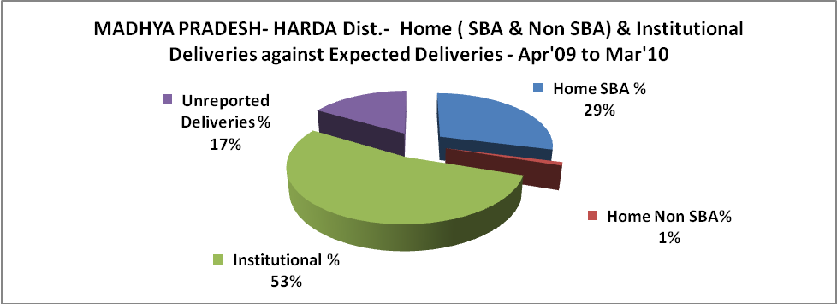

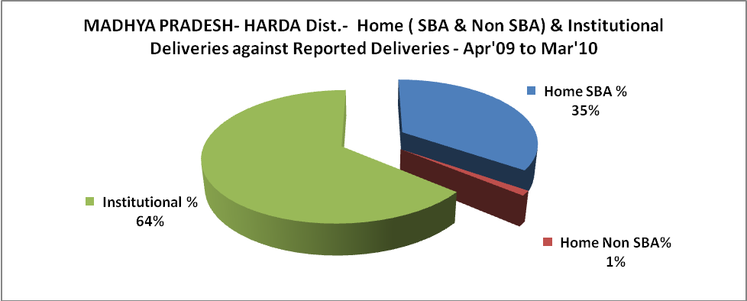

MADHYA PRADESH- HARDA Dist.- C sections & Complicated Deliveries Apr'09 to Mar'10
 | Institutional Deliveries (Public) | Institutional Deliveries (Pvt)
 | 8,741 | -
C Section | 184 | -
C Section% | 2% | 0%
Complicated Pregnacies attended | 268 | -
Complicated Pregnacies attended % | 3% | 0%

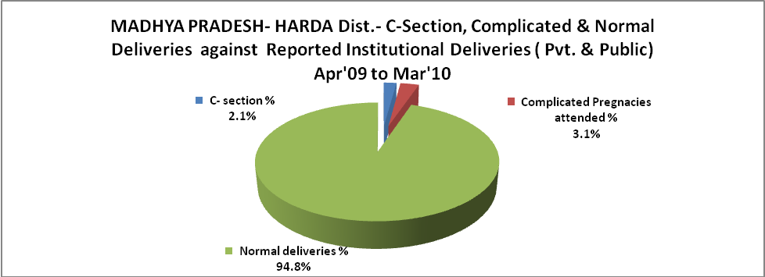

MADHYA PRADESH- HARDA Dist.- Complicated Pregnancies & Deliveries Treated - Apr'09 to Mar'10
Reported Deliveries |  |  | Reported ANC Reigtration
13,639 |  |  | 16,174
Complicated Pregnancies attended | Complicated Pregnancies Rate | C - Section Deliveries | PNC Maternal Complications | Abortions | Still Births
268 | 2% | 184 | 365 | 443 | 169
Complicated Deliveries Treated with |  |  |  | No Of Eclampsia cases Treated | No Of severe anemia cases treated
IV Antibiotics | IV antihypertensive/Magsulph injection | IV Oxytocis | Blood Transfusion | No Of Eclampsia cases Treated | No Of severe anemia cases treated
- | - | - | - | - | 68

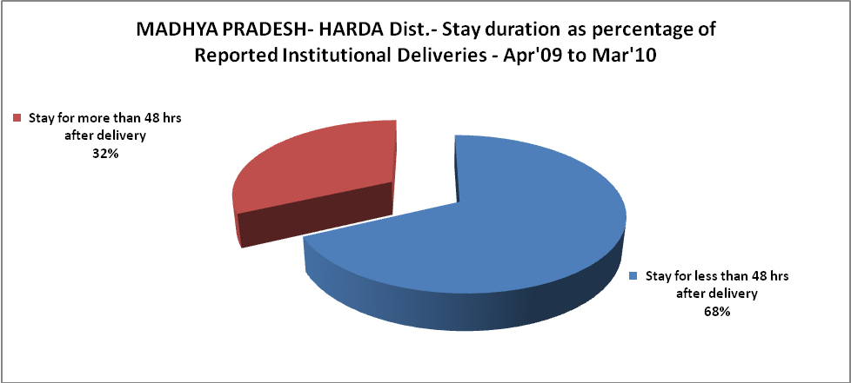

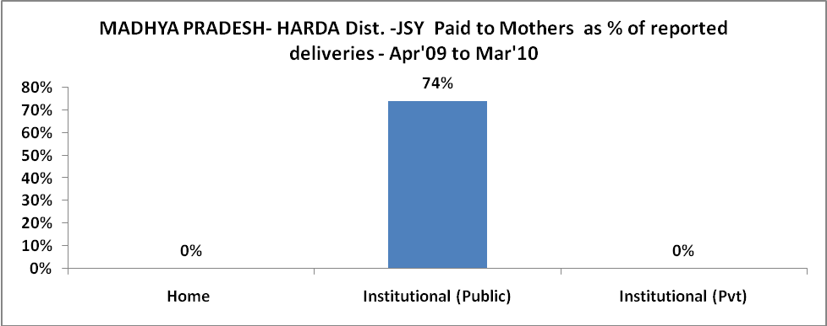

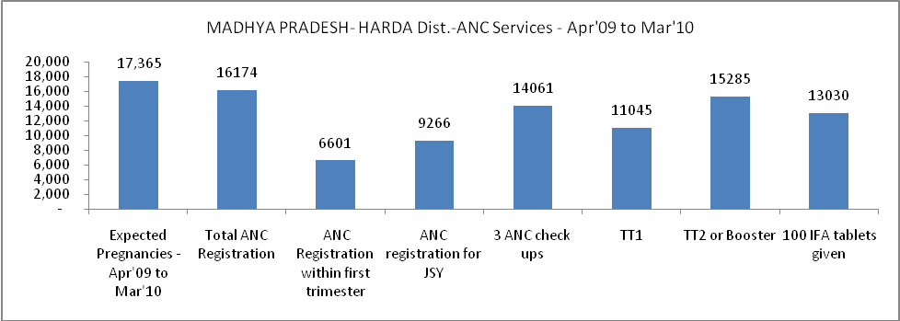

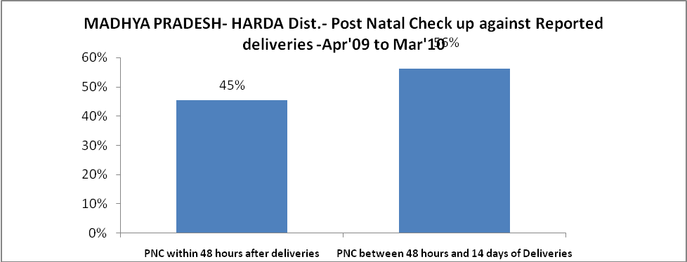

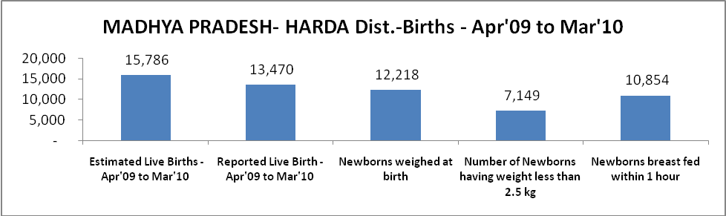

MADHYA PRADESH- HARDA Dist. - Births - Apr'09 to Mar'10
Live Birth - Males | Live Birth - females | Live Birth - Total | Sex Ratio at birth | Still Birth | Abortion( Induced/Spontaneous
7,095 | 6,375 | 13,470 | 899 | 169 | 443

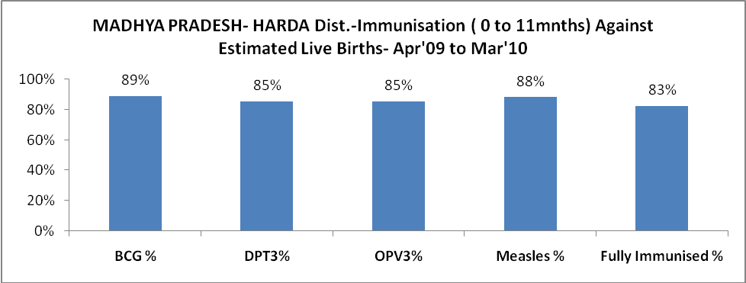

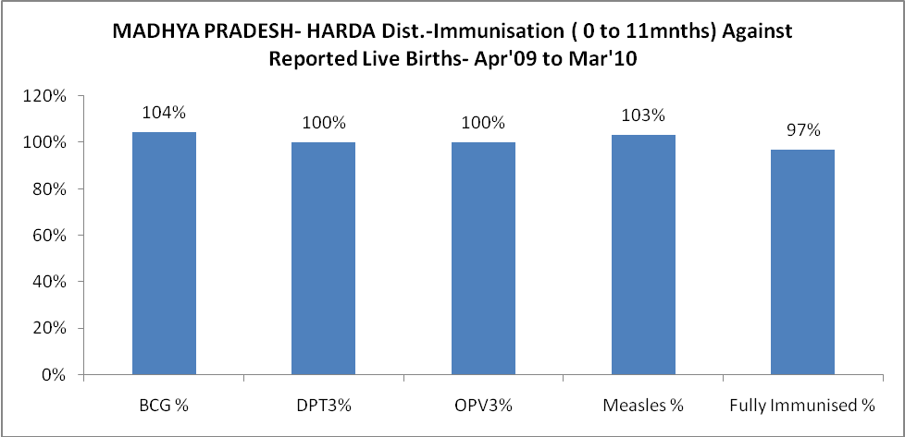

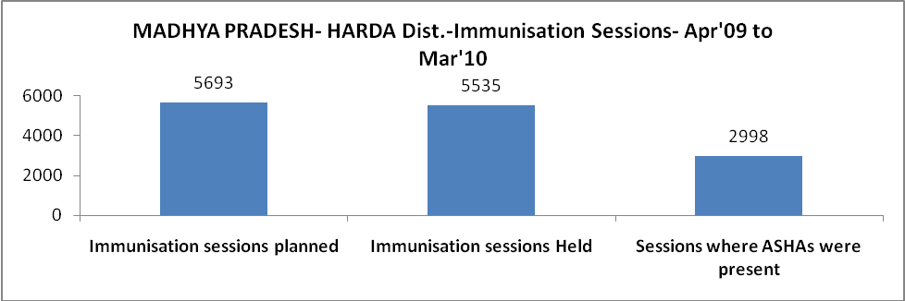

MADHYA PRADESH- HARDA Dist.- Apr'09 to Mar'10
Total Abortions | Abortion Rate
513 | 3.0%

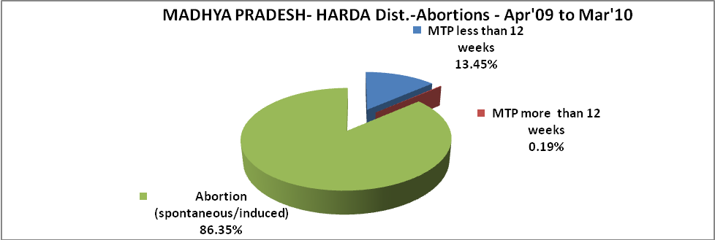

MADHYA PRADESH- HARDA Dist.- Apr'09 to Mar'10
Total OPD | Total RTI/STI cases
1,28,167 | 7,195

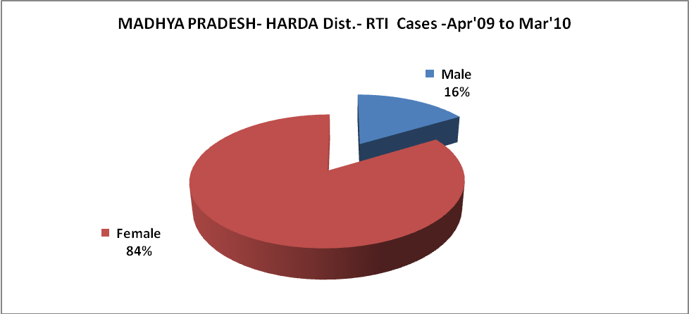

MADHYA PRADESH- HARDA Dist.-Sterilisations - Apr'09 to Mar'10
 | Reported | %age of Reported Sterilisation
Total Sterilisation | 3,560 | -
NSV | 216 | 6%
Laproscopic | 3,161 | 89%
MiniLap | 148 | 4%
Post Partum | 35 | 1%
Male Sterilisation | 216 | 6%
Female Sterilisation | 3,344 | 94%
MADHYA PRADESH- HARDA Dist.-FP Methods - Apr'09 to Mar'10
 | Reported | %age of All Reported FP Methods
Total Reported FP Methodd (All types) Users | 29,422 | -
Sterilisations | 3,560 | 12%
IUD | 3,531 | 12%
Condom Users | 16,908 | 57%
OCP Users | 5,423 | 18%
Limiting Methods | 3,560 | 12%
Spacing Methods | 25,862 | 88%

MADHYA PRADESH- HARDA Dist.- Service Delivery - Apr'09 to Mar'10
Operation major (General and spinal anaesthesia) | Operation minor (No or local anaesthesia) | AYUSH | Dental Procedures | Adolescent counselling services | Total OPD | Total IPD
366 | 710 | 3,219 | 4,116 | 390 | 1,28,167 | 17,950
Operation major (General and spinal anaesthesia) as %ge of OPD | Operation minor (No or local anaesthesia)as %ge of OPD | AYUSH as %ge of OPD | Dental Procedures as %ge of OPD | Adolescent counselling services as %ge of OPD | IPD as percentage of OPD
0.3% | 0.6% | 2.5% | 3.2% | 0.3% | 14%

MADHYA PRADESH- HARDA Dist.- Lab Services - Apr'09 to Mar'10
Total OPD | Total HB tested | Total HIV Tested | Total Population
1,28,167 | 5,525 | 4,025 | 5,63,791
HB test conducted as %age of OPD | HB<7gm as %age of HB tested | HIV test conducted as %age of OPD | HIV positive as %age of HIV tested | Blood Smear Examined as % of Population
4.3% | 4.9% | 3.1% | 0.5% | 9.8%
MADHYA PRADESH- HARDA Dist.- Childhood Disease - Vaccine Preventable -Apr'09 to Mar'10
Diphtheria | Pertussis | Tetanus Neonatorum | Tetanus others | Polio | Measles
0 | 0 | 0 | 3 | 0 | 47
MADHYA PRADESH- HARDA Dist.-Childhood Disease - Others - Apr'09 to Mar'10
Diarrhoea and dehydration | Malaria | Number admitted with Respiratory Infections
9,962 | 21 | 1,783
MADHYA PRADESH- HARDA Dist.- Infant & Child Deaths - Apr'09 to Mar'10
Infant Deaths within 24 hrs of birth | Infant Deaths between 24hrs & under 1 week | Infant Deaths between 1 week & under 1 month | Child Deaths between 1 month & under 1 year | Child Deaths between 1yr under 5years | Total Deaths
14 | 68 | 23 | 82 | 20 | 207

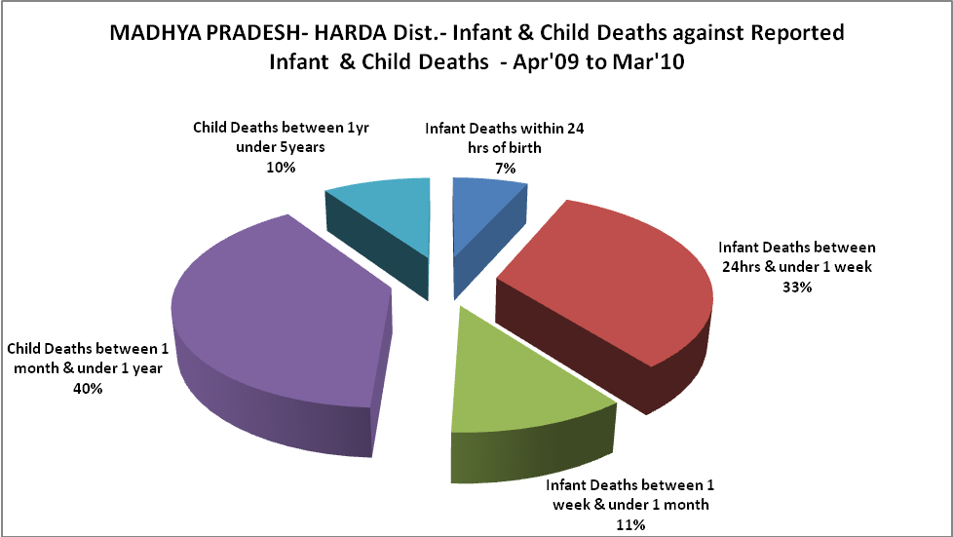

MADHYA PRADESH- HARDA Dist.- Causes of Infant & Child Deaths - Apr'09 to Mar'10
Sepsis |  |  | Asphyxia |  |  | LBW
Up to 1 Weeks of Birth | Between 1 week & 4 weeks of birth | Total | Up to 1 Weeks of Birth | Between 1 week & 4 weeks of birth | Total | Up to 1 Weeks of Birth | Between 1 week & 4 weeks of birth | Total
10 | 2 | 12 | 21 | 4 | 25 | 9 | 4 | 13
Pneumonia |  |  | Diarrhoea |  |  | Fever related
Between 1 month and 11 months | Between 1 year & 5 years | Total | Between 1 month and 11 months | Between 1 year & 5 years | Total | Between 1 month and 11 months | Between 1 year & 5 years | Total
21 | 3 | 24 | 1 | 0 | 1 | 14 | 1 | 15
Others |  |  | Measles |  |  | Others
Up to 1 Weeks of Birth | Between 1 week & 4 weeks of birth | Total | Between 1 month and 11 months | Between 1 year & 5 years | Total | Between 1 month and 11 months | Between 1 year & 5 years | Total
28 | 13 | 41 | 0 | 0 | 0 | 46 | 16 | 62

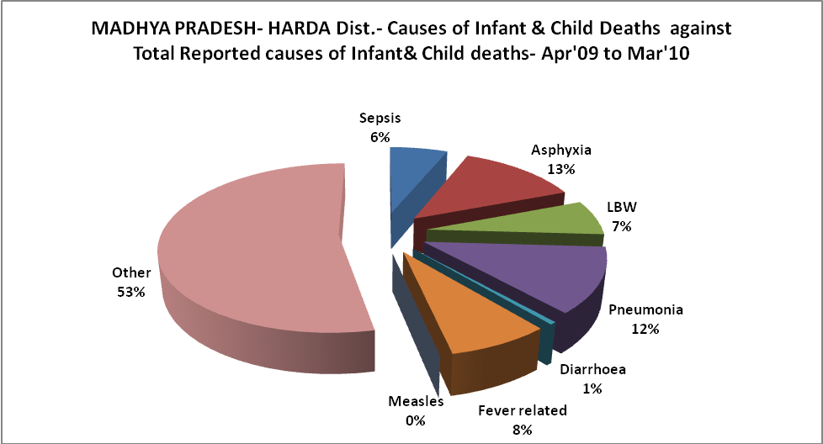
L

MADHYA PRADESH- HARDA Dist.- Maternal Deaths & Causes - Apr'09 to Mar'10
Abortion |  |  | Obstructed/prolonged labour |  |  | Severe hypertesnion/fits
6-14 yrs | 15-55 yrs. | Total | 6-14 yrs | 15-55 yrs. | Total | 6-14 yrs | 15-55 yrs. | Total
0 | 0 | 0 | 0 | 1 | 1 | 0 | 2 | 2
Bleeding |  |  | High Fever |  |  | Other Causes
6-14 yrs | 15-55 yrs. | Total | 6-14 yrs | 15-55 yrs. | Total | 6-14 yrs | 15-55 yrs. | Total
0 | 3 | 3 | 0 | 1 | 1 | 0 | 1 | 1

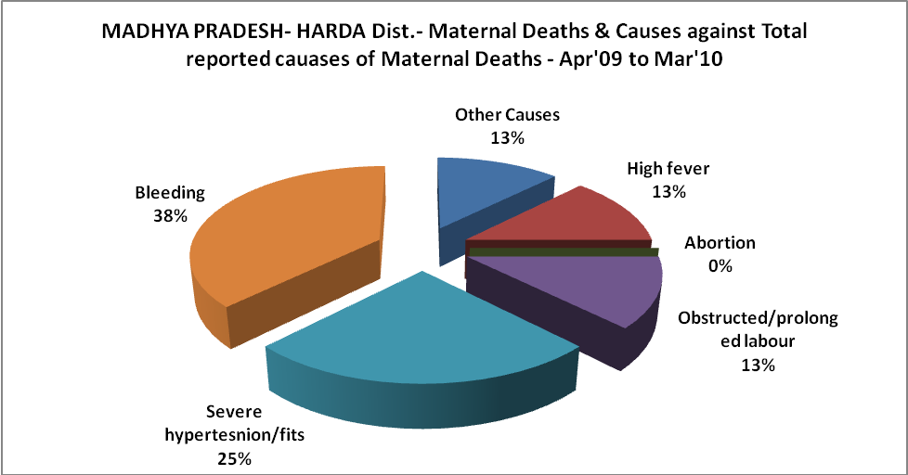

MADHYA PRADESH- HARDA Dist.-Causes of Deaths in 6 to 55yrs age group - Apr'09 to Mar'10
Diarrhoel Diseases |  |  |  | Tuberculosis |  |  |  | Respiratory Diseases( Other than TB)
6-14 yrs | 15-55 yrs. | Above 55yrs | Total | 6-14 yrs | 15-55 yrs. | Above 55yrs | Total | 6-14 yrs | 15-55 yrs. | Above 55yrs | Total
2 | 2 | 1 | 5 | 1 | 7 | 4 | 12 | 2 | 11 | 28 | 41
Malaria |  |  |  | Other fever Related |  |  |  | HIV/Aids
6-14 yrs | 15-55 yrs. | Above 55yrs | Total | 6-14 yrs | 15-55 yrs. | Above 55yrs | Total | 6-14 yrs | 15-55 yrs. | Above 55yrs | Total
1 | 0 | 0 | 1 | 5 | 7 | 7 | 19 | 0 | 0 | 0 | 0
Heart Disease/Hypertenion related |  |  |  | Neurological Disease including strokes |  |  |  | Trauma/Accidents/ Burn Cases
6-14 yrs | 15-55 yrs. | Above 55yrs | Total | 6-14 yrs | 15-55 yrs. | Above 55yrs | Total | 6-14 yrs | 15-55 yrs. | Above 55yrs | Total
3 | 28 | 50 | 81 | 3 | 5 | 5 | 13 | 2 | 18 | 2 | 22
Suicide |  |  |  | Animal Bites & Stings
6-14 yrs | 15-55 yrs. | Above 55yrs | Total | 6-14 yrs | 15-55 yrs. | Above 55yrs | Total
0 | 12 | 0 | 12 | 4 | 4 | 1 | 9
