[NHSRC]
MP-Hosangabad
[ Analysis 2009-10]

MADHYA PRADESH- HOSHANGABAD Dist.- Summary-Apr'09 to Mar'10
ANC
ANC Registration against Expected Pregnancies | 77% | TT1 given to Pregnant women against ANC Registraion | 79%
3 ANC Check ups against ANC Reigtrations | 76% | 100 IFA Tablets given to Pregnant women against ANC Registraion | 82%
Deliveries
Unreported Deliveries against Estimated Deliveries | 33.5% | HOME Deliveries( SBA& Non SBA) against Estimated Deliveries | 9.2%
Institutional Deliveries against Estimated Deliveries | 57.4% | HOME Deliveries( SBA& Non SBA) against Reported Deliveries | 13.8%
Institutional Deliveries against Reported Deliveries | 86.2% | C Section Deliveries against Institutional Deliveries( Pvt & Pub) | 13%
Births & Neonates Care
Live Births Reported against Estimated Live Births | 68% | New borns weighed against Reported Live Births | 89%
Still Births (Reported) | 378 | New borns weighed less than 2.5 kgs against newborns weighed | 18%
Sex Ratio at Birh | 955 | New borns breastfed within one hr of Birth against Reported live Births | 88%
Child Immunisation( 0 to 11 mnths)
BCG given against Expected Live Births | 81% | Measles given against Expected Live Births | 70%
OPV3 given against Expected Live Births | 70% | Fully Immunised Children against Expected Live Births | 70%
DPT3 given against Expected Live Births | 70%
Family Planning
Family Plannig Methods Users ( Sterilisations(Male &Female)+IUD+ Condom pieces/72 + OCP Cycles/13) | 55,712 | IUD Insertions against reported FP Methods | 11%
Sterilisation against reported FP Methods | 12% | Condom Users against reported FP Methods | 61%
 |  | OCP Users against reported FP Methods | 16%
Other Services
OPD | 429,485 | Major Operations | 704
IPD | 40,770 | Minor Operations | 1,555

MADHYA PRADESH- HOSHANGABAD Dist.- Deliveries Apr'09 to Mar'10
Total Population | 1,288,309 | Expected Deliveries |  | 37,335
Home SBA | Home Non SBA | Institutional | Total Deliveries Reported | Unreported Deliveries
3 | 3,415 | 21,414 | 24,832 | 12,503
Home SBA % | Home Non SBA% | Institutional % | Total Deliveries Reported % | Unreported Deliveries %
0% | 9% | 57% | 67% | 33%

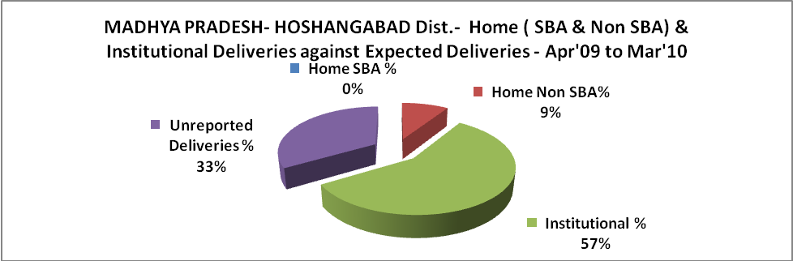

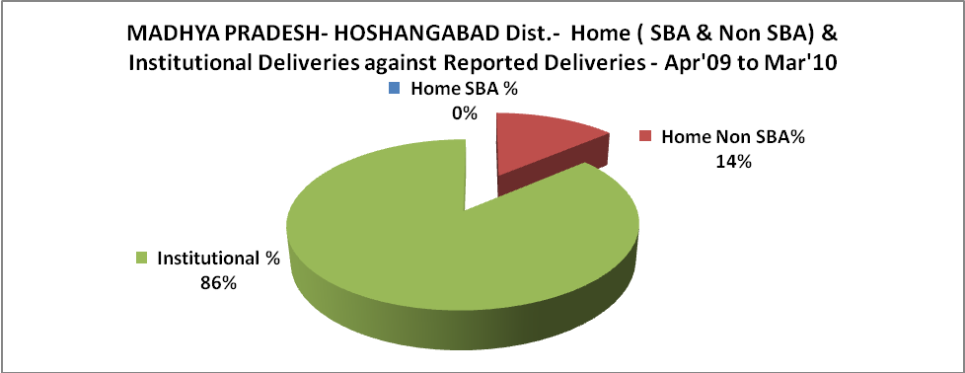

MADHYA PRADESH- HOSHANGABAD Dist.- C sections & Complicated Deliveries Apr'09 to Mar'10
 | Institutional Deliveries (Public) | Institutional Deliveries (Pvt)
 | 16,485 | 4,929
C Section | 589 | 2,211
C Section% | 4% | 45%
Complicated Pregnacies attended | 983 | -
Complicated Pregnacies attended % | 6% | 0%

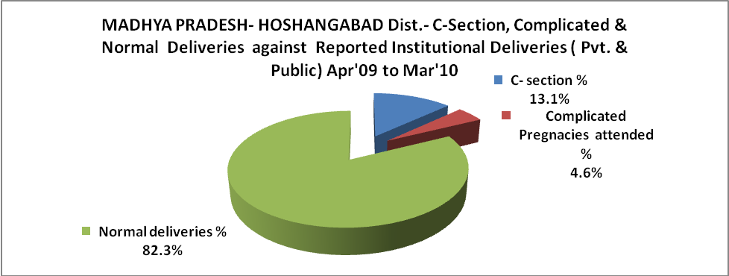

MADHYA PRADESH- HOSHANGABAD Dist.- Complicated Pregnancies & Deliveries Treated - Apr'09 to Mar'10
Reported Deliveries |  |  | Reported ANC Reigtration
24,832 |  |  | 30,591
Complicated Pregnancies attended | Complicated Pregnancies Rate | C - Section Deliveries | PNC Maternal Complications | Abortions | Still Births
983 | 2% | 2,800 | 138 | 287 | 378
Complicated Deliveries Treated with |  |  |  | No Of Eclampsia cases Treated | No Of severe anemia cases treated
IV Antibiotics | IV antihypertensive/Magsulph injection | IV Oxytocis | Blood Transfusion | No Of Eclampsia cases Treated | No Of severe anemia cases treated
250 | 56 | 127 | 167 | 92 | 394

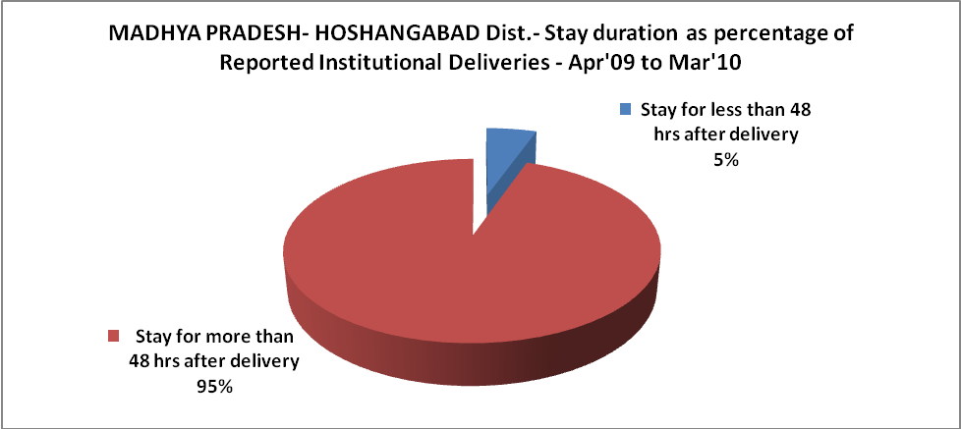

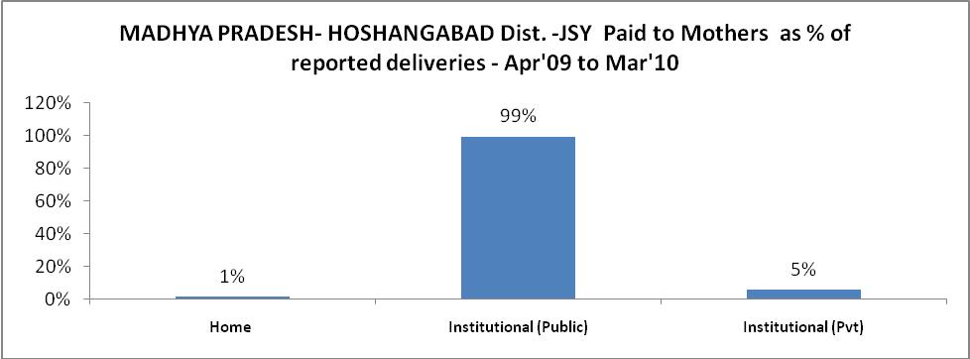

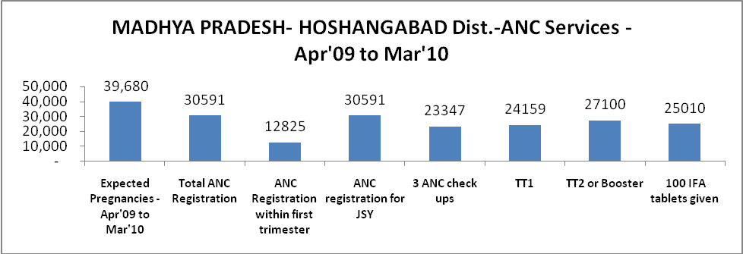

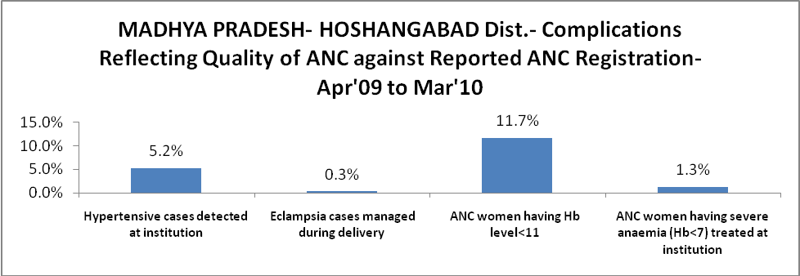

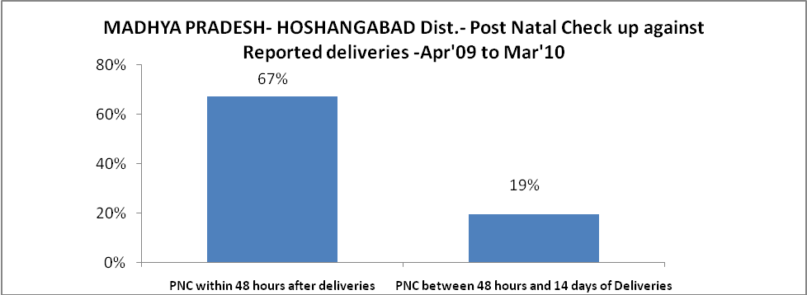

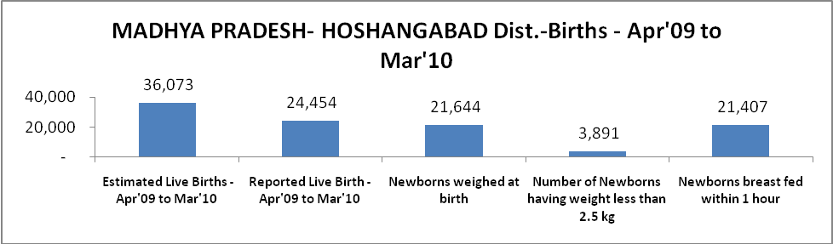

MADHYA PRADESH- HOSHANGABAD Dist. - Births - Apr'09 to Mar'10
Live Birth - Males | Live Birth - females | Live Birth - Total | Sex Ratio at birth | Still Birth | Abortion( Induced/Spontaneous
12,508 | 11,946 | 24,454 | 955 | 378 | 287

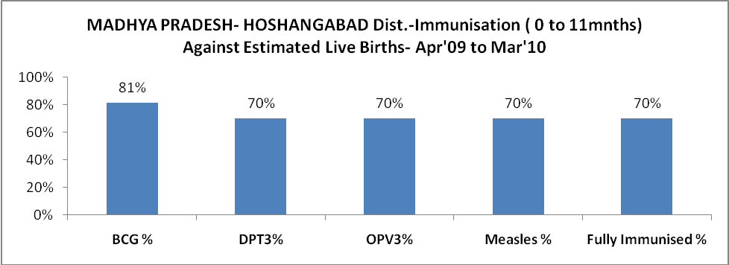

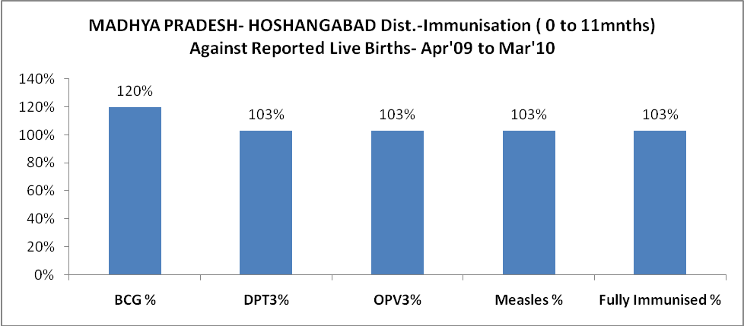

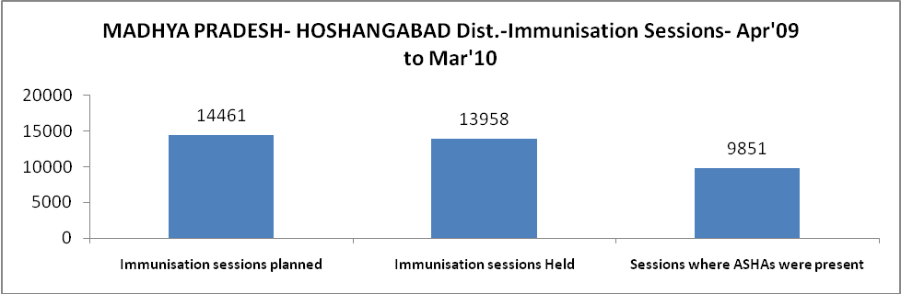

MADHYA PRADESH- HOSHANGABAD Dist.- Apr'09 to Mar'10
Total Abortions | Abortion Rate
559 | 1.4%

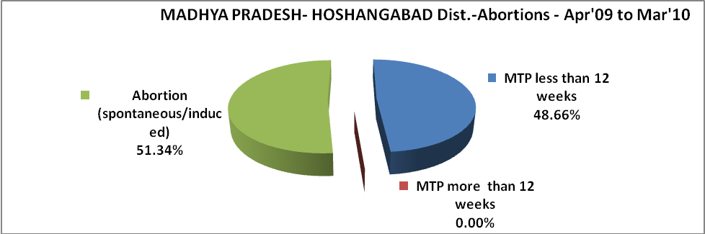

MADHYA PRADESH- HOSHANGABAD Dist.- Apr'09 to Mar'10
Total OPD | Total RTI/STI cases
429,485 | 10,560

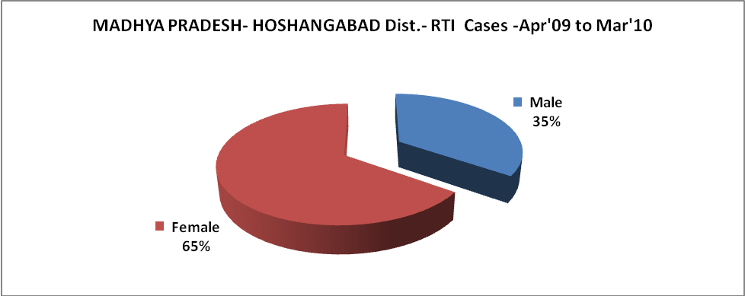

MADHYA PRADESH- HOSHANGABAD Dist.-Sterilisations - Apr'09 to Mar'10
 | Reported | %age of Reported Sterilisation
Total Sterilisation | 6,732 | -
NSV | 137 | 2%
Laproscopic | 5,832 | 87%
MiniLap | - | 0%
Post Partum | 763 | 11%
Male Sterilisation | 137 | 2%
Female Sterilisation | 6,595 | 98%

MADHYA PRADESH- HOSHANGABAD Dist.-FP Methods - Apr'09 to Mar'10
 | Reported | %age of All Reported FP Methods
Total Reported FP Methodd (All types) Users | 55,712 | -
Sterilisations | 6,732 | 12%
IUD | 6,022 | 11%
Condom Users | 34,019 | 61%
OCP Users | 8,939 | 16%
Limiting Methods | 6,732 | 12%
Spacing Methods | 48,980 | 88%

MADHYA PRADESH- HOSHANGABAD Dist.- Service Delivery - Apr'09 to Mar'10
Operation major (General and spinal anaesthesia) | Operation minor (No or local anaesthesia) | AYUSH | Dental Procedures | Adolescent counselling services | Total OPD | Total IPD
704 | 1,555 | 1,451 | - | 58 | 429,485 | 40,770
Operation major (General and spinal anaesthesia) as %ge of OPD | Operation minor (No or local anaesthesia)as %ge of OPD | AYUSH as %ge of OPD | Dental Procedures as %ge of OPD | Adolescent counselling services as %ge of OPD | IPD as percentage of OPD
0.2% | 0.4% | 0.3% | 0.0% | 0.0% | 9%

MADHYA PRADESH- HOSHANGABAD Dist.- Lab Services - Apr'09 to Mar'10
Total OPD | Total HB tested | Total HIV Tested | Total Population
429,485 | 18,211 | 5,120 | 1,288,309
HB test conducted as %age of OPD | HB<7gm as %age of HB tested | HIV test conducted as %age of OPD | HIV positive as %age of HIV tested | Blood Smear Examined as % of Population
4.2% | 5.9% | 1.2% | 0.4% | 18.3%

MADHYA PRADESH- HOSHANGABAD Dist.- Childhood Disease - Vaccine Preventable -Apr'09 to Mar'10
Diphtheria | Pertussis | Tetanus Neonatorum | Tetanus others | Polio | Measles
0 | 0 | 0 | 0 | 0 | 0
MADHYA PRADESH- HOSHANGABAD Dist.-Childhood Disease - Others - Apr'09 to Mar'10
Diarrhoea and dehydration | Malaria | Number admitted with Respiratory Infections
2,030 | 87 | 19

MADHYA PRADESH- HOSHANGABAD Dist.- Infant & Child Deaths - Apr'09 to Mar'10
Infant Deaths within 24 hrs of birth | Infant Deaths between 24hrs & under 1 week | Infant Deaths between 1 week & under 1 month | Child Deaths between 1 month & under 1 year | Child Deaths between 1yr under 5years | Total Deaths
58 | 80 | 28 | 24 | 45 | 235

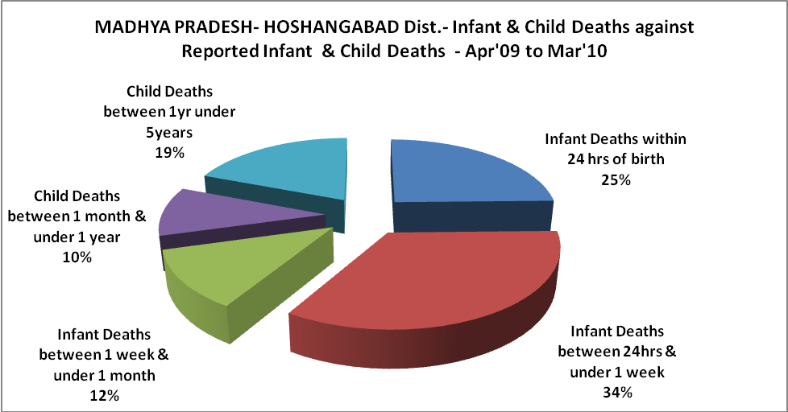

MADHYA PRADESH- HOSHANGABAD Dist.- Causes of Infant & Child Deaths - Apr'09 to Mar'10
Sepsis |  |  | Asphyxia |  |  | LBW
Up to 1 Weeks of Birth | Between 1 week & 4 weeks of birth | Total | Up to 1 Weeks of Birth | Between 1 week & 4 weeks of birth | Total | Up to 1 Weeks of Birth | Between 1 week & 4 weeks of birth | Total
21 | 7 | 28 | 1 | 0 | 1 | 8 | 0 | 8
Pneumonia |  |  | Diarrhoea |  |  | Fever related
Between 1 month and 11 months | Between 1 year & 5 years | Total | Between 1 month and 11 months | Between 1 year & 5 years | Total | Between 1 month and 11 months | Between 1 year & 5 years | Total
0 | 4 | 4 | 2 | 5 | 7 | 2 | 8 | 10
Others |  |  | Measles |  |  | Others
Up to 1 Weeks of Birth | Between 1 week & 4 weeks of birth | Total | Between 1 month and 11 months | Between 1 year & 5 years | Total | Between 1 month and 11 months | Between 1 year & 5 years | Total
50 | 21 | 71 | 0 | 0 | 0 | 20 | 28 | 48

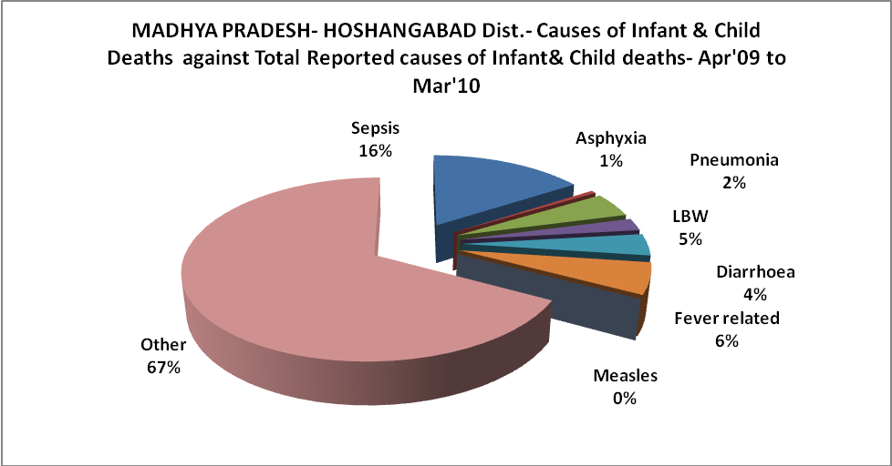

MADHYA PRADESH- HOSHANGABAD Dist.- Maternal Deaths & Causes - Apr'09 to Mar'10
Abortion |  |  | Obstructed/prolonged labour |  |  | Severe hypertesnion/fits
6-14 yrs | 15-55 yrs. | Total | 6-14 yrs | 15-55 yrs. | Total | 6-14 yrs | 15-55 yrs. | Total
0 | 0 | 0 | 0 | 0 | 0 | 0 | 0 | 0
Bleeding |  |  | High Fever |  |  | Other Causes
6-14 yrs | 15-55 yrs. | Total | 6-14 yrs | 15-55 yrs. | Total | 6-14 yrs | 15-55 yrs. | Total
0 | 0 | 0 | 0 | 0 | 0 | 0 | 0 | 0

MADHYA PRADESH- HOSHANGABAD Dist.-Causes of Deaths in 6 to 55yrs age group - Apr'09 to Mar'10
Diarrhoel Diseases |  |  |  | Tuberculosis |  |  |  | Respiratory Diseases( Other than TB)
6-14 yrs | 15-55 yrs. | Above 55yrs | Total | 6-14 yrs | 15-55 yrs. | Above 55yrs | Total | 6-14 yrs | 15-55 yrs. | Above 55yrs | Total
1 | 1 | 0 | 2 | 0 | 0 | 1 | 1 | 0 | 6 | 5 | 11
Malaria |  |  |  | Other fever Related |  |  |  | HIV/Aids
6-14 yrs | 15-55 yrs. | Above 55yrs | Total | 6-14 yrs | 15-55 yrs. | Above 55yrs | Total | 6-14 yrs | 15-55 yrs. | Above 55yrs | Total
0 | 0 | 0 | 0 | 11 | 35 | 65 | 111 | 0 | 0 | 0 | 0
Heart Disease/Hypertenion related |  |  |  | Neurological Disease including strokes |  |  |  | Trauma/Accidents/ Burn Cases
6-14 yrs | 15-55 yrs. | Above 55yrs | Total | 6-14 yrs | 15-55 yrs. | Above 55yrs | Total | 6-14 yrs | 15-55 yrs. | Above 55yrs | Total
0 | 8 | 58 | 66 | 0 | 2 | 11 | 13 | 0 | 3 | 1 | 4
Suicide |  |  |  | Animal Bites & Stings
6-14 yrs | 15-55 yrs. | Above 55yrs | Total | 6-14 yrs | 15-55 yrs. | Above 55yrs | Total
0 | 0 | 0 | 0 | 1 | 0 | 1 | 2

