NHSRC
Maharashtra – Mumbai Subarbs
Analysis: Apr 2009 – Mar 2010

Maharashtra-Mumbai (Suburbans)- Summary-Apr'09 to Mar'10
ANC
ANC Registration against Expected Pregnancies | 94% | TT1 given to Pregnant women against ANC Registration | 60%
3 ANC Check ups against ANC Registrations | 8% | 100 IFA Tablets given to Pregnant women against ANC Registration | 47%
Deliveries
Unreported Deliveries against Estimated Deliveries | 68.5% | HOME Deliveries( SBA& Non SBA) against Estimated Deliveries | 0.6%
Institutional Deliveries against Estimated Deliveries | 30.9% | HOME Deliveries( SBA& Non SBA) against Reported Deliveries | 1.8%
Institutional Deliveries against Reported Deliveries | 98.2% | C Section Deliveries against Institutional Deliveries( Pvt & Pub) | 37%
Births & Neonates Care
Live Births Reported against Estimated Live Births | 63% | New borns weighed against Reported Live Births | 86%
Still Births (Reported) | 1,688 | New borns weighed less than 2.5 kgs against newborns weighed | 41%
Sex Ratio at Birth | 919 | New borns breastfed within one hr of Birth against Reported live Births | 0%
Child Immunization( 0 to 11 months)
BCG given against Expected Live Births | 101% | Measles given against Expected Live Births | 97%
OPV3 given against Expected Live Births | 109% | Fully Immunized Children against Expected Live Births | 97%
DPT3 given against Expected Live Births | 109%
Family Planning
Family Planning Methods Users ( Sterilizations(Male &Female)+IUD+ Condom pieces/72 + OCP Cycles/13) | 198,232 | IUD Insertions against reported FP Methods | 22%
Sterilization against reported FP Methods | 19% | Condom Users against reported FP Methods | 52%
 |  | OCP Users against reported FP Methods | 7%
Other Services
OPD | - | Major Operations | -
IPD | - | Minor Operations | -
`

Maharashtra-Mumbai (Suburbans)- Deliveries Apr'09 to Mar'10
Total Population | 10,149,186 | Expected Deliveries |  | 184,668
Home SBA | Home Non SBA | Institutional | Total Deliveries Reported | Unreported Deliveries
1,038 | 1 | 57,063 | 58,102 | 126,566
Home SBA % | Home Non SBA% | Institutional % | Total Deliveries Reported % | Unreported Deliveries %
1% | 0% | 31% | 31% | 69%

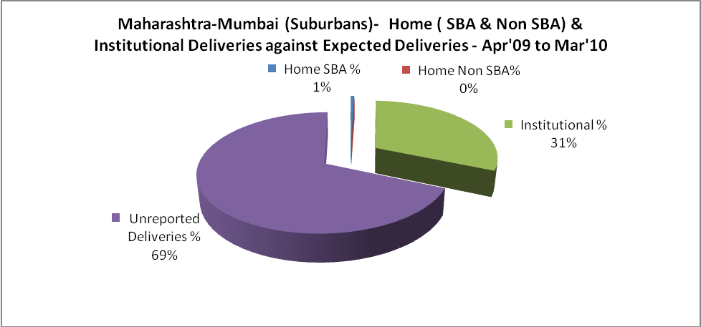

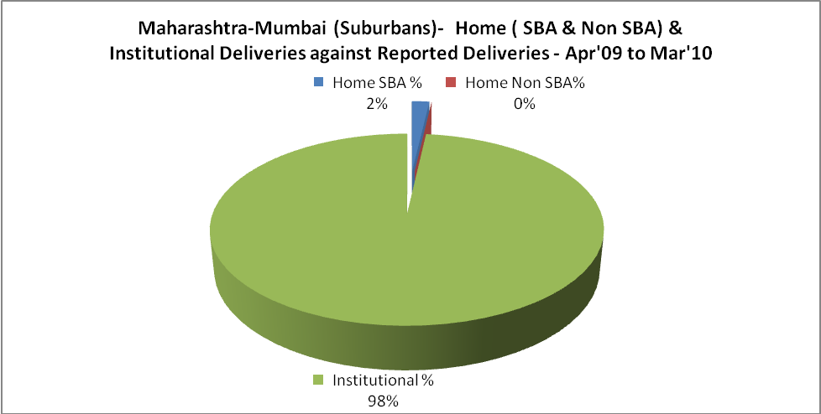

Maharashtra-Mumbai (Suburbans)- C sections & Complicated Deliveries Apr'09 to Mar'10
 | Institutional Deliveries (Public) | Institutional Deliveries (Pvt)
 | 51,778 | 5,285
C Section | 21,004 | -
C Section% | 41% | 0%
Complicated Pregnancies attended | 2,331 | 340
Complicated Pregnancies attended % | 5% | 6%

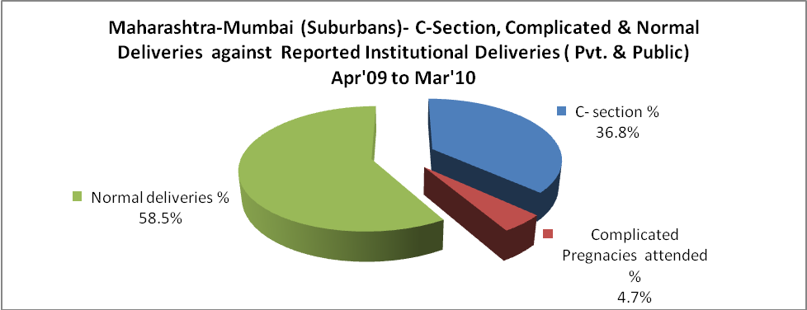

Maharashtra-Mumbai (Suburbans)- Complicated Pregnancies & Deliveries Treated - Apr'09 to Mar'10
Reported Deliveries |  |  | Reported ANC Registration
58,102 |  |  | 187,116
Complicated Pregnancies attended | Complicated Pregnancies Rate | C - Section Deliveries | PNC Maternal Complications | Abortions | Still Births
2,671 | 1% | 21,004 | - | 1,213 | 1,688
Complicated Deliveries Treated with |  |  |  | No Of Eclampsia cases Treated | No Of severe anemia cases treated
IV Antibiotics | IV antihypertensive/Magsulph injection | IV Oxytocis | Blood Transfusion | No Of Eclampsia cases Treated | No Of severe anemia cases treated
- | - | - | - | - | -

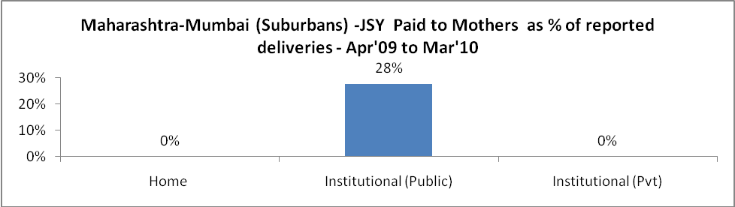

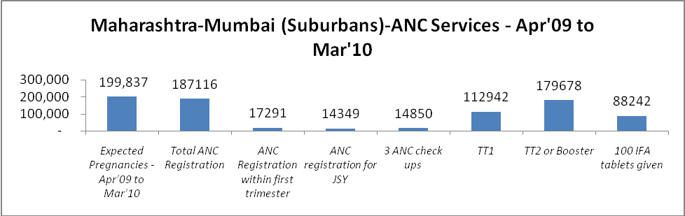

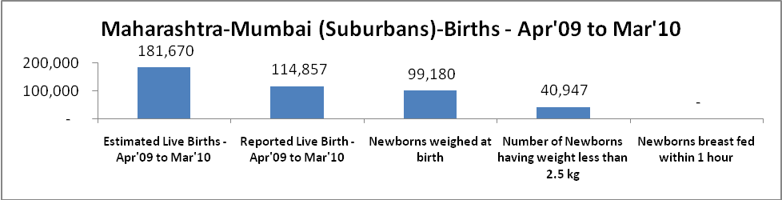

Maharashtra-Mumbai (Suburbans) - Births - Apr'09 to Mar'10
Live Birth - Males | Live Birth - females | Live Birth - Total | Sex Ratio at birth | Still Birth | Abortion( Induced/Spontaneous
59,841 | 55,016 | 114,857 | 919 | 1,688 | 1,213

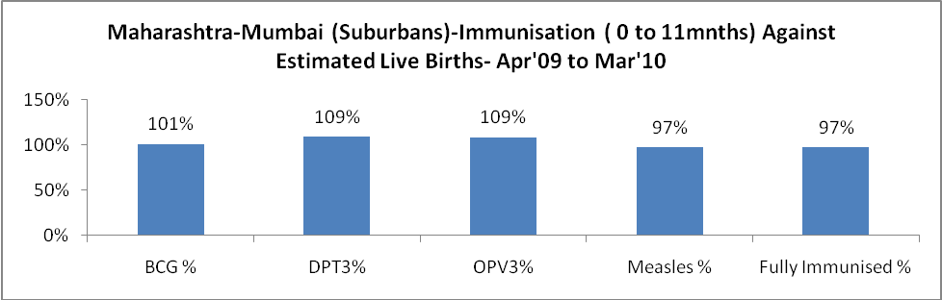

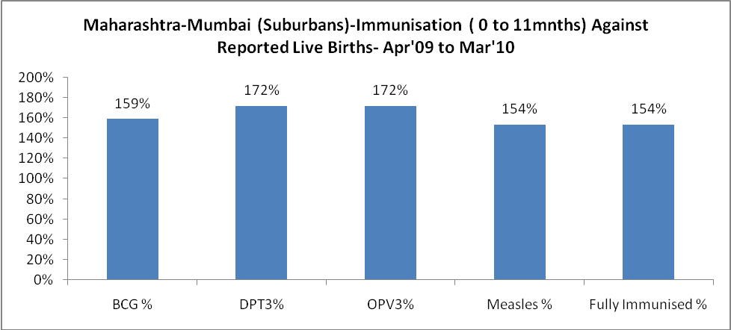

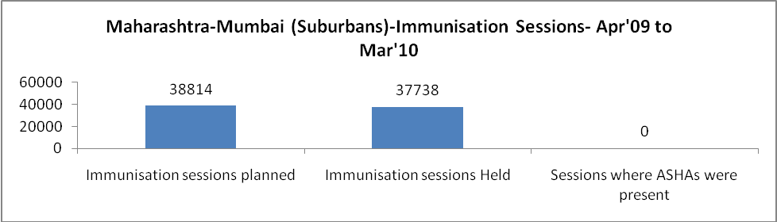

Maharashtra-Mumbai (Suburbans)- Apr'09 to Mar'10
Total Abortions | Abortion Rate
10,567 | 5.3%

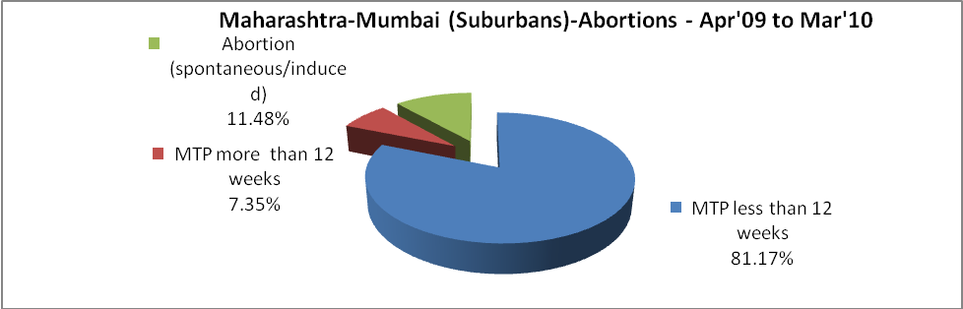

Maharashtra-Mumbai (Suburbans)- Apr'09 to Mar'10
Total OPD | Total RTI/STI cases
- | 2,854

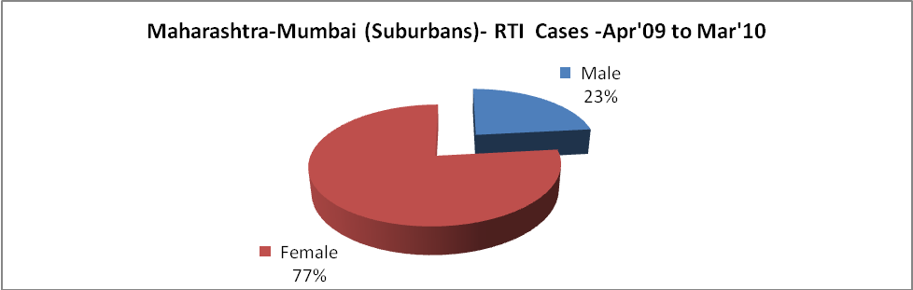

Maharashtra-Mumbai (Suburbans)-Sterilisations - Apr'09 to Mar'10
 | Reported | %age of Reported Sterilization
Total Sterilization | 38,358 | -
NSV | 3,927 | 10%
Laparoscopic | 17,488 | 46%
MiniLap | 13,023 | 34%
Post Partum | 3,920 | 10%
Male Sterilization | 3,927 | 10%
Female Sterilization | 34,431 | 90%

Maharashtra-Mumbai (Suburbans)-FP Methods - Apr'09 to Mar'10
 | Reported | %age of All Reported FP Methods
Total Reported FP Method (All types) Users | 198,232 | -
Sterilizations | 38,358 | 19%
IUD | 43,061 | 22%
Condom Users | 102,638 | 52%
OCP Users | 14,175 | 7%
Limiting Methods | 38,358 | 19%
Spacing Methods | 159,874 | 81%

Maharashtra-Mumbai (Suburbans)- Lab Services - Apr'09 to Mar'10
Total OPD | Total HB tested | Total HIV Tested | Total Population
- | - | - | 10,149,186
HB test conducted as %age of OPD | HB<7gm as %age of HB tested | HIV test conducted as %age of OPD | HIV positive as %age of HIV tested | Blood Smear Examined as % of Population
0.0% | 0.0% | 0.0% | 0.0% | 5.0%

Maharashtra-Mumbai (Suburbans)- Childhood Disease - Vaccine Preventable -Apr'09 to Mar'10
Diphtheria | Pertussis | Tetanus Neonatorum | Tetanus others | Polio | Measles
0 | 0 | 0 | 0 | 0 | 0
Maharashtra-Mumbai (Suburbans)-Childhood Disease - Others - Apr'09 to Mar'10
Diarrhoea and dehydration | Malaria | Number admitted with Respiratory Infections
- | - | -

Maharashtra-Mumbai (Suburbans)- Infant & Child Deaths - Apr'09 to Mar'10
Infant Deaths within 24 hrs of birth | Infant Deaths between 24hrs & under 1 week | Infant Deaths between 1 week & under 1 month | Child Deaths between 1 month & under 1 year | Child Deaths between 1yr under 5years | Total Deaths
0 | 0 | 0 | 0 | 0 | 0

Maharashtra-Mumbai (Suburbans)- Causes of Infant & Child Deaths - Apr'09 to Mar'10
Sepsis |  |  | Asphyxia |  |  | LBW
Up to 1 Weeks of Birth | Between 1 week & 4 weeks of birth | Total | Up to 1 Weeks of Birth | Between 1 week & 4 weeks of birth | Total | Up to 1 Weeks of Birth | Between 1 week & 4 weeks of birth | Total
0 | 0 | 0 | 0 | 0 | 0 | 0 | 0 | 0
Pneumonia |  |  | Diarrhoea |  |  | Fever related
Between 1 month and 11 months | Between 1 year & 5 years | Total | Between 1 month and 11 months | Between 1 year & 5 years | Total | Between 1 month and 11 months | Between 1 year & 5 years | Total
0 | 0 | 0 | 0 | 0 | 0 | 0 | 0 | 0
Others |  |  | Measles |  |  | Others
Up to 1 Weeks of Birth | Between 1 week & 4 weeks of birth | Total | Between 1 month and 11 months | Between 1 year & 5 years | Total | Between 1 month and 11 months | Between 1 year & 5 years | Total
0 | 0 | 0 | 0 | 0 | 0 | 0 | 0 | 0

Maharashtra-Mumbai (Suburbans)- Maternal Deaths & Causes - Apr'09 to Mar'10
Abortion |  |  | Obstructed/prolonged labour |  |  | Severe hypertension/fits
6-14 yrs | 15-55 yrs. | Total | 6-14 yrs | 15-55 yrs. | Total | 6-14 yrs | 15-55 yrs. | Total
0 | 0 | 0 | 0 | 0 | 0 | 0 | 0 | 0
Bleeding |  |  | High Fever |  |  | Other Causes
6-14 yrs | 15-55 yrs. | Total | 6-14 yrs | 15-55 yrs. | Total | 6-14 yrs | 15-55 yrs. | Total
0 | 0 | 0 | 0 | 0 | 0 | 0 | 0 | 0

Maharashtra-Mumbai (Suburbans)-Causes of Deaths in 6 to 55yrs age group - Apr'09 to Mar'10
Diarrhoel Diseases |  |  |  | Tuberculosis |  |  |  | Respiratory Diseases( Other than TB)
6-14 yrs | 15-55 yrs. | Above 55yrs | Total | 6-14 yrs | 15-55 yrs. | Above 55yrs | Total | 6-14 yrs | 15-55 yrs. | Above 55yrs | Total
0 | 0 | 0 | 0 | 0 | 0 | 0 | 0 | 0 | 0 | 0 | 0
Malaria |  |  |  | Other fever Related |  |  |  | HIV/Aids
6-14 yrs | 15-55 yrs. | Above 55yrs | Total | 6-14 yrs | 15-55 yrs. | Above 55yrs | Total | 6-14 yrs | 15-55 yrs. | Above 55yrs | Total
0 | 0 | 0 | 0 | 0 | 0 | 0 | 0 | 0 | 0 | 0 | 0
Heart Disease/Hypertension related |  |  |  | Neurological Disease including strokes |  |  |  | Trauma/Accidents/ Burn Cases
6-14 yrs | 15-55 yrs. | Above 55yrs | Total | 6-14 yrs | 15-55 yrs. | Above 55yrs | Total | 6-14 yrs | 15-55 yrs. | Above 55yrs | Total
0 | 0 | 0 | 0 | 0 | 0 | 0 | 0 | 0 | 0 | 0 | 0
Suicide |  |  |  | Animal Bites & Stings
6-14 yrs | 15-55 yrs. | Above 55yrs | Total | 6-14 yrs | 15-55 yrs. | Above 55yrs | Total
0 | 0 | 0 | 0 | 0 | 0 | 0 | 0

