NHSRC
Maharashtra – Nagpur
Analysis: Apr 2009 – Mar 2010

Maharashtra-Nagpur- Summary-Apr'09 to Mar'10
ANC
ANC Registration against Expected Pregnancies | 105% | TT1 given to Pregnant women against ANC Registration | 57%
3 ANC Check ups against ANC Registrations | 34% | 100 IFA Tablets given to Pregnant women against ANC Registration | 40%
Deliveries
Unreported Deliveries against Estimated Deliveries | 57.3% | HOME Deliveries( SBA& Non SBA) against Estimated Deliveries | 2.0%
Institutional Deliveries against Estimated Deliveries | 40.7% | HOME Deliveries( SBA& Non SBA) against Reported Deliveries | 4.6%
Institutional Deliveries against Reported Deliveries | 95.4% | C Section Deliveries against Institutional Deliveries( Pvt & Pub) | 4%
Births & Neonates Care
Live Births Reported against Estimated Live Births | 50% | New borns weighed against Reported Live Births | 46%
Still Births (Reported) | 960 | New borns weighed less than 2.5 kgs against newborns weighed | 37%
Sex Ratio at Birth | 882 | New borns breastfed within one hr of Birth against Reported live Births | 0%
Child Immunization( 0 to 11 months)
BCG given against Expected Live Births | 87% | Measles given against Expected Live Births | 87%
OPV3 given against Expected Live Births | 87% | Fully Immunized Children against Expected Live Births | 91%
DPT3 given against Expected Live Births | 88%
Family Planning
Family Planning Methods Users ( Sterilizations(Male &Female)+IUD+ Condom pieces/72 + OCP Cycles/13) | 56,503 | IUD Insertions against reported FP Methods | 32%
Sterilization against reported FP Methods | 38% | Condom Users against reported FP Methods | 17%
 |  | OCP Users against reported FP Methods | 13%
Other Services
OPD | 393,272 | Major Operations | 1,294
IPD | - | Minor Operations | 1,679
`
Maharashtra-Nagpur- Deliveries Apr'09 to Mar'10
Total Population | 4,776,451 | Expected Deliveries |  | 86,909
Home SBA | Home Non SBA | Institutional | Total Deliveries Reported | Unreported Deliveries
1,136 | 560 | 35,384 | 37,080 | 49,829
Home SBA % | Home Non SBA% | Institutional % | Total Deliveries Reported % | Unreported Deliveries %
1% | 1% | 41% | 43% | 57%

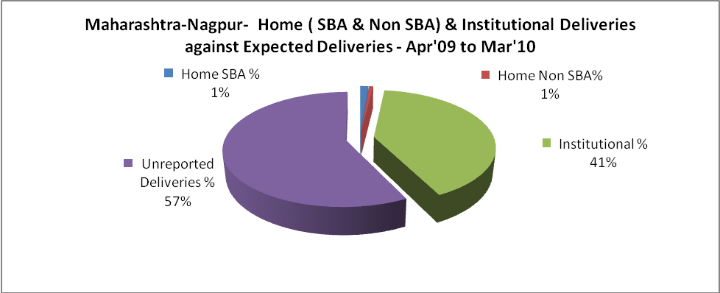

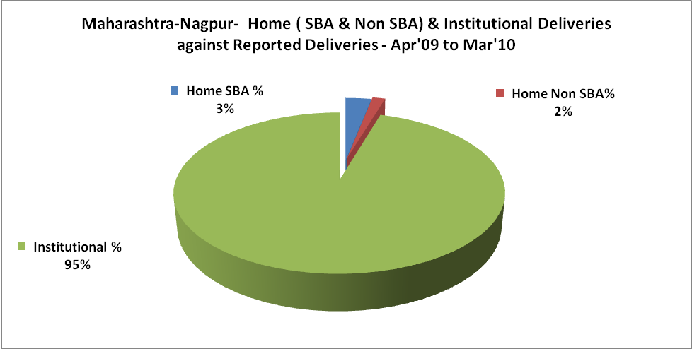

Maharashtra-Nagpur- C sections & Complicated Deliveries Apr'09 to Mar'10
 | Institutional Deliveries (Public) | Institutional Deliveries (Pvt)
 | 34,569 | 815
C Section | 978 | 275
C Section% | 3% | 34%
Complicated Pregnancies attended | 1,133 | 136
Complicated Pregnancies attended % | 3% | 17%

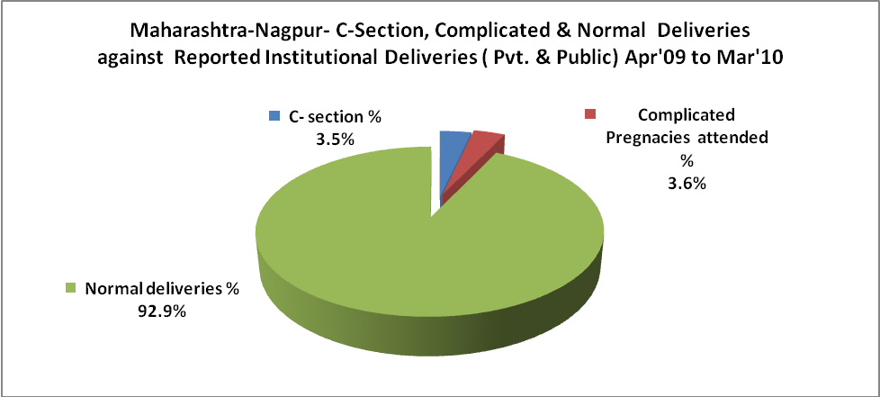

Maharashtra-Nagpur- Complicated Pregnancies & Deliveries Treated - Apr'09 to Mar'10
Reported Deliveries |  |  | Reported ANC Registration
37,080 |  |  | 98,465
Complicated Pregnancies attended | Complicated Pregnancies Rate | C - Section Deliveries | PNC Maternal Complications | Abortions | Still Births
1,269 | 1% | 1,253 | - | 1,726 | 960
Complicated Deliveries Treated with |  |  |  | No Of Eclampsia cases Treated | No Of severe anemia cases treated
IV Antibiotics | IV antihypertensive/Magsulph injection | IV Oxytocis | Blood Transfusion | No Of Eclampsia cases Treated | No Of severe anemia cases treated
- | - | - | 5 | - | 1,105

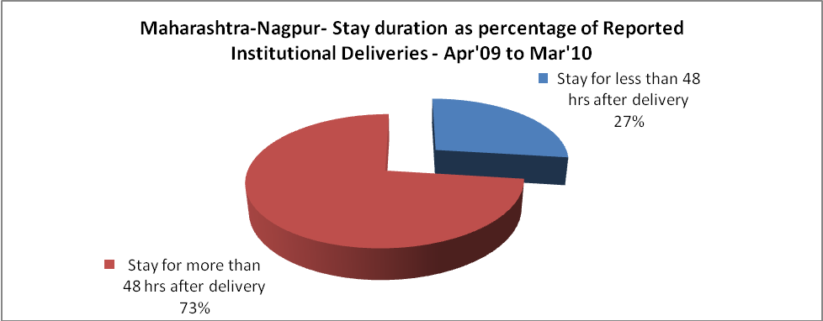

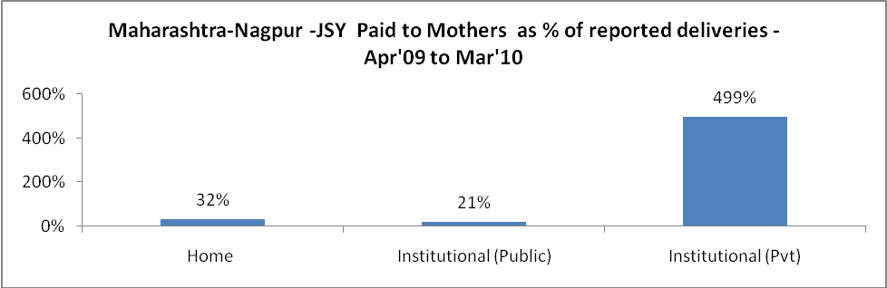

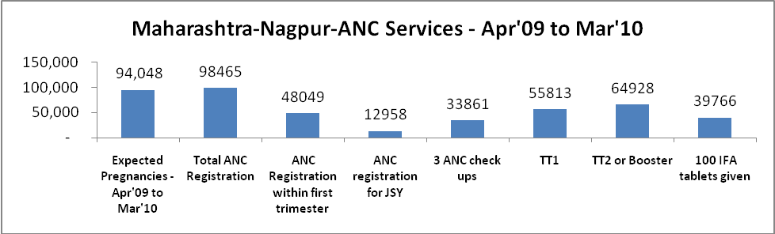

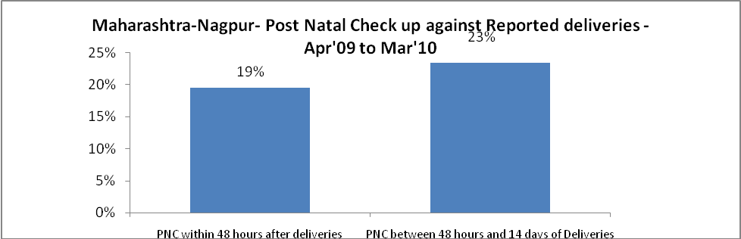

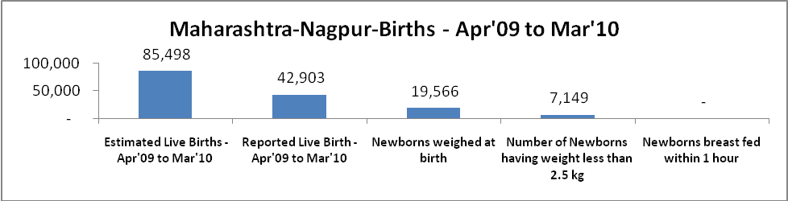

Maharashtra-Nagpur - Births - Apr'09 to Mar'10
Live Birth - Males | Live Birth - females | Live Birth - Total | Sex Ratio at birth | Still Birth | Abortion( Induced/Spontaneous
22,800 | 20,103 | 42,903 | 882 | 960 | 1,726

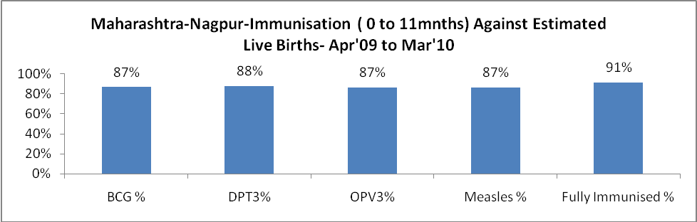

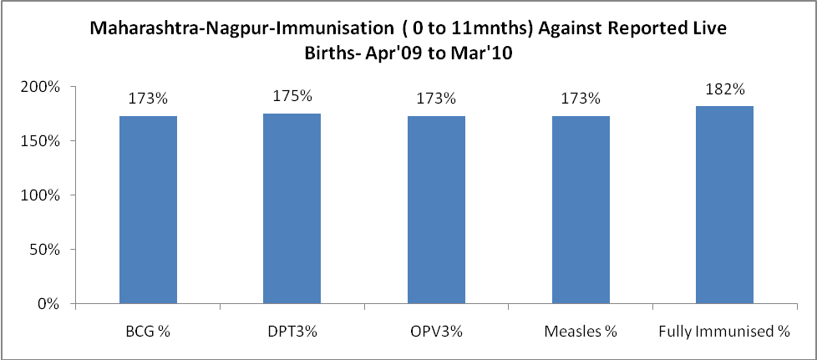

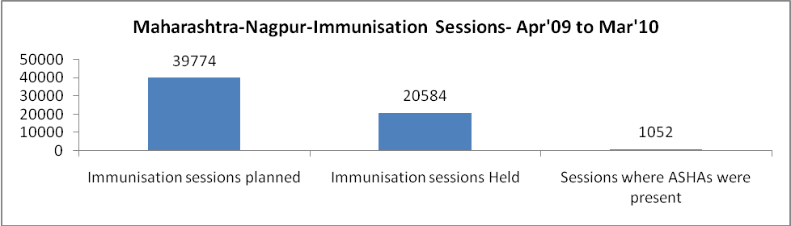

Maharashtra-Nagpur- Apr'09 to Mar'10
Total Abortions | Abortion Rate
3,371 | 3.6%

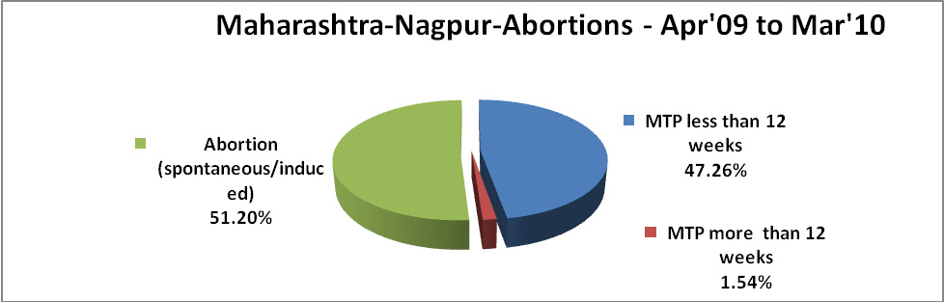

Maharashtra-Nagpur- Apr'09 to Mar'10
Total OPD | Total RTI/STI cases
393,272 | 4,679

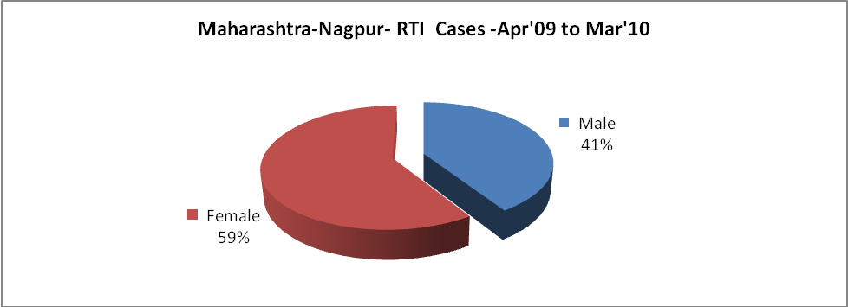

Maharashtra-Nagpur-Sterilisations - Apr'09 to Mar'10
 | Reported | %age of Reported Sterilization
Total Sterilization | 21,740 | -
NSV | 1,609 | 7%
Laparoscopic | 6,092 | 28%
MiniLap | 10,092 | 46%
Post Partum | 3,947 | 18%
Male Sterilization | 1,609 | 7%
Female Sterilization | 20,131 | 93%

Maharashtra-Nagpur-FP Methods - Apr'09 to Mar'10
 | Reported | %age of All Reported FP Methods
Total Reported FP Method (All types) Users | 56,503 | -
Sterilizations | 21,740 | 38%
IUD | 18,029 | 32%
Condom Users | 9,655 | 17%
OCP Users | 7,079 | 13%
Limiting Methods | 21,740 | 38%
Spacing Methods | 34,763 | 62%

Maharashtra-Nagpur- Service Delivery - Apr'09 to Mar'10
Operation major (General and spinal anaesthesia) | Operation minor (No or local anaesthesia) | AYUSH | Dental Procedures | Adolescent counselling services | Total OPD | Total IPD
1,294 | 1,679 | 24 | 18 | 18 | 393,272 | -
Operation major (General and spinal anaesthesia) as %ge of OPD | Operation minor (No or local anaesthesia)as %ge of OPD | AYUSH as %ge of OPD | Dental Procedures as %ge of OPD | Adolescent counselling services as %ge of OPD | IPD as percentage of OPD
0.3% | 0.4% | 0.0% | 0.0% | 0.0% | 0%

Maharashtra-Nagpur- Lab Services - Apr'09 to Mar'10
Total OPD | Total HB tested | Total HIV Tested | Total Population
393,272 | 7,988 | - | 4,776,451
HB test conducted as %age of OPD | HB<7gm as %age of HB tested | HIV test conducted as %age of OPD | HIV positive as %age of HIV tested | Blood Smear Examined as % of Population
2.0% | 0.0% | 0.0% | 0.0% | 7.4%

Maharashtra-Nagpur- Childhood Disease - Vaccine Preventable -Apr'09 to Mar'10
Diphtheria | Pertussis | Tetanus Neonatorum | Tetanus others | Polio | Measles
0 | 0 | 0 | 2 | 0 | 4
Maharashtra-Nagpur-Childhood Disease - Others - Apr'09 to Mar'10
Diarrhoea and dehydration | Malaria | Number admitted with Respiratory Infections
1 | - | -

Maharashtra-Nagpur- Infant & Child Deaths - Apr'09 to Mar'10
Infant Deaths within 24 hrs of birth | Infant Deaths between 24hrs & under 1 week | Infant Deaths between 1 week & under 1 month | Child Deaths between 1 month & under 1 year | Child Deaths between 1yr under 5years | Total Deaths
12 | 53 | 15 | 32 | 70 | 182

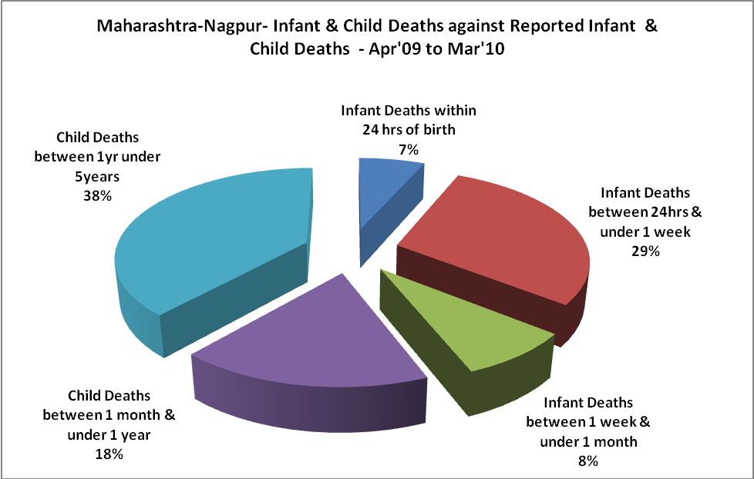

Maharashtra-Nagpur- Causes of Infant & Child Deaths - Apr'09 to Mar'10
Sepsis |  |  | Asphyxia |  |  | LBW
Up to 1 Weeks of Birth | Between 1 week & 4 weeks of birth | Total | Up to 1 Weeks of Birth | Between 1 week & 4 weeks of birth | Total | Up to 1 Weeks of Birth | Between 1 week & 4 weeks of birth | Total
0 | 0 | 0 | 0 | 0 | 0 | 0 | 0 | 0
Pneumonia |  |  | Diarrhoea |  |  | Fever related
Between 1 month and 11 months | Between 1 year & 5 years | Total | Between 1 month and 11 months | Between 1 year & 5 years | Total | Between 1 month and 11 months | Between 1 year & 5 years | Total
0 | 0 | 0 | 0 | 0 | 0 | 0 | 0 | 0
Others |  |  | Measles |  |  | Others
Up to 1 Weeks of Birth | Between 1 week & 4 weeks of birth | Total | Between 1 month and 11 months | Between 1 year & 5 years | Total | Between 1 month and 11 months | Between 1 year & 5 years | Total
53 | 15 | 68 | 0 | 0 | 0 | 32 | 70 | 102

Maharashtra-Nagpur- Maternal Deaths & Causes - Apr'09 to Mar'10
Abortion |  |  | Obstructed/prolonged labour |  |  | Severe hypertension/fits
6-14 yrs | 15-55 yrs. | Total | 6-14 yrs | 15-55 yrs. | Total | 6-14 yrs | 15-55 yrs. | Total
0 | 0 | 0 | 0 | 0 | 0 | 0 | 0 | 0
Bleeding |  |  | High Fever |  |  | Other Causes
6-14 yrs | 15-55 yrs. | Total | 6-14 yrs | 15-55 yrs. | Total | 6-14 yrs | 15-55 yrs. | Total
0 | 0 | 0 | 0 | 0 | 0 | 0 | 6 | 6

Maharashtra-Nagpur-Causes of Deaths in 6 to 55yrs age group - Apr'09 to Mar'10
Diarrhoel Diseases |  |  |  | Tuberculosis |  |  |  | Respiratory Diseases( Other than TB)
6-14 yrs | 15-55 yrs. | Above 55yrs | Total | 6-14 yrs | 15-55 yrs. | Above 55yrs | Total | 6-14 yrs | 15-55 yrs. | Above 55yrs | Total
0 | 0 | 0 | 0 | 0 | 0 | 0 | 0 | 0 | 0 | 0 | 0
Malaria |  |  |  | Other fever Related |  |  |  | HIV/Aids
6-14 yrs | 15-55 yrs. | Above 55yrs | Total | 6-14 yrs | 15-55 yrs. | Above 55yrs | Total | 6-14 yrs | 15-55 yrs. | Above 55yrs | Total
0 | 0 | 0 | 0 | 0 | 0 | 0 | 0 | 0 | 0 | 0 | 0
Heart Disease/Hypertension related |  |  |  | Neurological Disease including strokes |  |  |  | Trauma/Accidents/ Burn Cases
6-14 yrs | 15-55 yrs. | Above 55yrs | Total | 6-14 yrs | 15-55 yrs. | Above 55yrs | Total | 6-14 yrs | 15-55 yrs. | Above 55yrs | Total
0 | 0 | 0 | 0 | 0 | 0 | 0 | 0 | 0 | 0 | 0 | 0
Suicide |  |  |  | Animal Bites & Stings
6-14 yrs | 15-55 yrs. | Above 55yrs | Total | 6-14 yrs | 15-55 yrs. | Above 55yrs | Total
0 | 0 | 0 | 0 | 0 | 0 | 0 | 0

