NHSRC
Maharashtra – Nanded
Analyisis: Apr 2009 – Mar 2010

Maharashtra-Nanded- Summary-Apr'09 to Mar'10
ANC
ANC Registration against Expected Pregnancies | 112% | TT1 given to Pregnant women against ANC Registration | 56%
3 ANC Check ups against ANC Registrations | 76% | 100 IFA Tablets given to Pregnant women against ANC Registration | 69%
Deliveries
Unreported Deliveries against Estimated Deliveries | -8.6% | HOME Deliveries( SBA& Non SBA) against Estimated Deliveries | 7.0%
Institutional Deliveries against Estimated Deliveries | 101.6% | HOME Deliveries( SBA& Non SBA) against Reported Deliveries | 6.4%
Institutional Deliveries against Reported Deliveries | 93.6% | C Section Deliveries against Institutional Deliveries( Pvt & Pub) | 6%
Births & Neonates Care
Live Births Reported against Estimated Live Births | 108% | New borns weighed against Reported Live Births | 88%
Still Births (Reported) | 1,336 | New borns weighed less than 2.5 kgs against newborns weighed | 12%
Sex Ratio at Birth | 881 | New borns breastfed within one hr of Birth against Reported live Births | 85%
Child Immunization( 0 to 11 months)
BCG given against Expected Live Births | 119% | Measles given against Expected Live Births | 96%
OPV3 given against Expected Live Births | 101% | Fully Immunized Children against Expected Live Births | 89%
DPT3 given against Expected Live Births | 101%
Family Planning
Family Planning Methods Users ( Sterilizations(Male &Female)+IUD+ Condom pieces/72 + OCP Cycles/13) | 45,328 | IUD Insertions against reported FP Methods | 17%
Sterilization against reported FP Methods | 36% | Condom Users against reported FP Methods | 29%
 |  | OCP Users against reported FP Methods | 18%
Other Services
OPD | 598,725 | Major Operations | -
IPD | - | Minor Operations | -
`
Maharashtra-Nanded- Deliveries Apr'09 to Mar'10
Total Population | 3,376,904 | Expected Deliveries |  | 61,444
Home SBA | Home Non SBA | Institutional | Total Deliveries Reported | Unreported Deliveries
2,724 | 1,576 | 62,435 | 66,735 | (5,291)
Home SBA % | Home Non SBA% | Institutional % | Total Deliveries Reported % | Unreported Deliveries %
4% | 3% | 102% | 109% | -9%

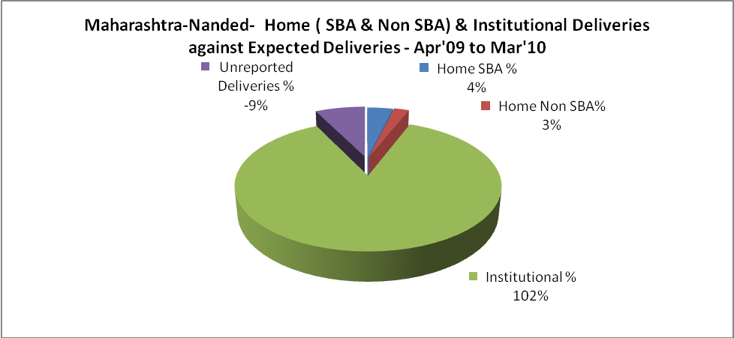

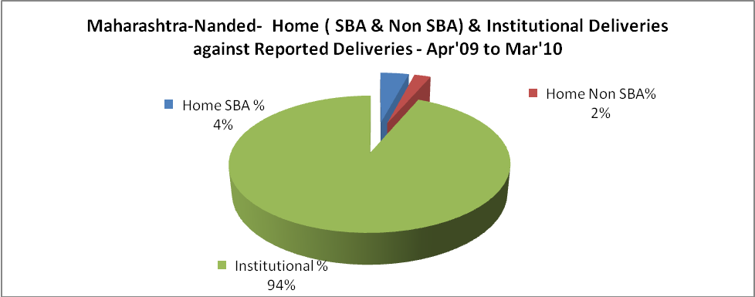

Maharashtra-Nanded- C sections & Complicated Deliveries Apr'09 to Mar'10
 | Institutional Deliveries (Public) | Institutional Deliveries (Pvt)
 | 27,752 | 34,683
C Section | 1,660 | 1,969
C Section% | 6% | 6%
Complicated Pregnancies attended | 2,324 | 350
Complicated Pregnancies attended % | 8% | 1%

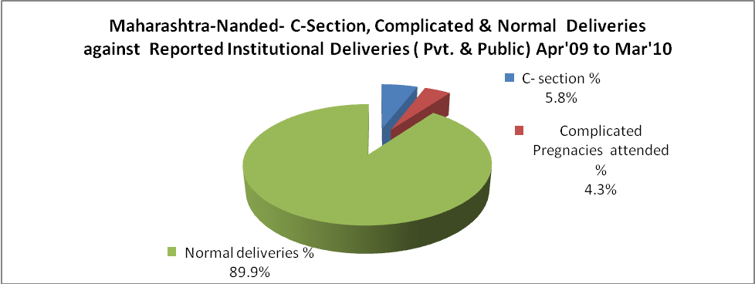

Maharashtra-Nanded- Complicated Pregnancies & Deliveries Treated - Apr'09 to Mar'10
Reported Deliveries |  |  | Reported ANC Registration
66,735 |  |  | 74,182
Complicated Pregnancies attended | Complicated Pregnancies Rate | C - Section Deliveries | PNC Maternal Complications | Abortions | Still Births
2,674 | 4% | 3,629 | 1,014 | 3,058 | 1,336
Complicated Deliveries Treated with |  |  |  | No Of Eclampsia cases Treated | No Of severe anemia cases treated
IV Antibiotics | IV antihypertensive/Magsulph injection | IV Oxytocis | Blood Transfusion | No Of Eclampsia cases Treated | No Of severe anemia cases treated
- | - | - | - | - | -

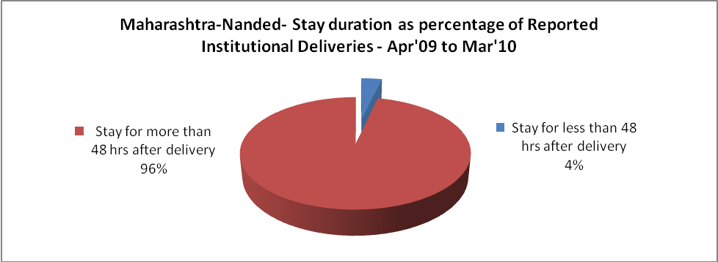

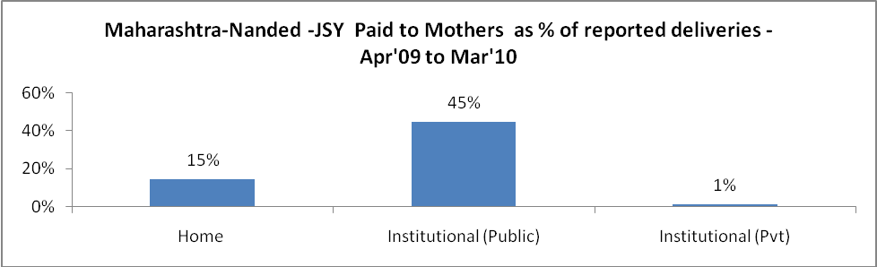

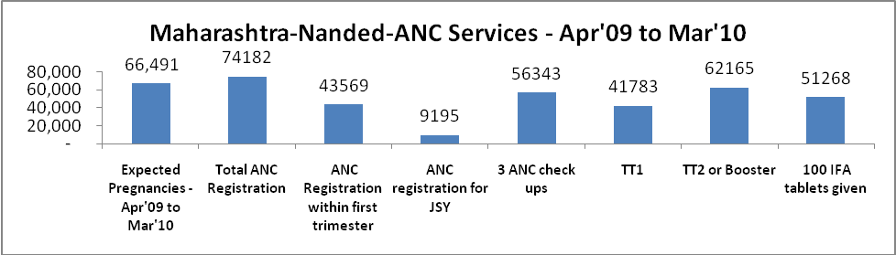

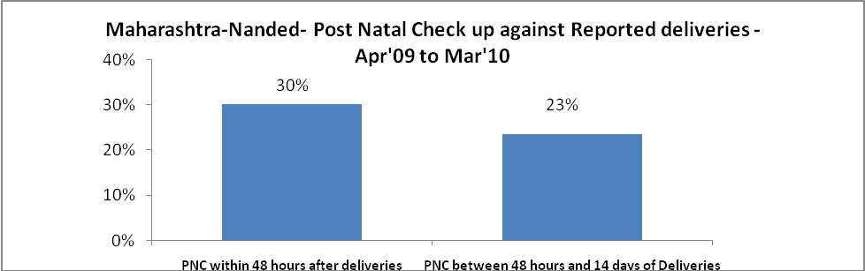

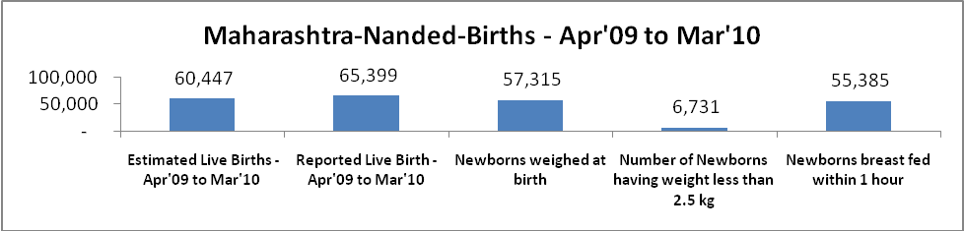

Maharashtra-Nanded - Births - Apr'09 to Mar'10
Live Birth - Males | Live Birth - females | Live Birth - Total | Sex Ratio at birth | Still Birth | Abortion( Induced/Spontaneous
34,766 | 30,633 | 65,399 | 881 | 1,336 | 3,058

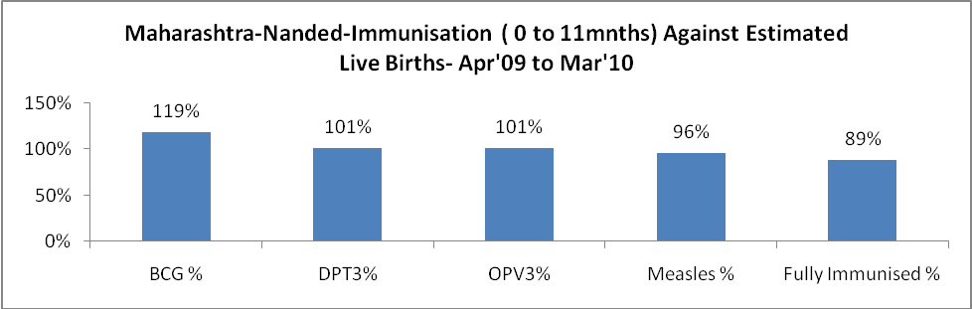

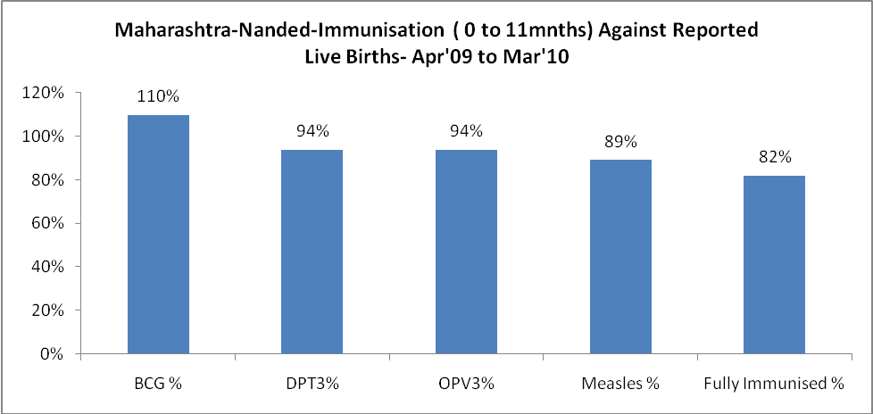

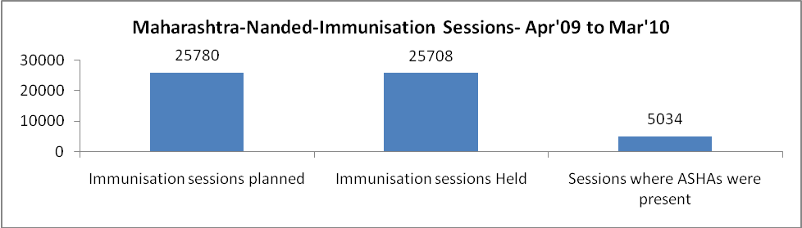

Maharashtra-Nanded- Apr'09 to Mar'10
Total Abortions | Abortion Rate
4,022 | 6.0%

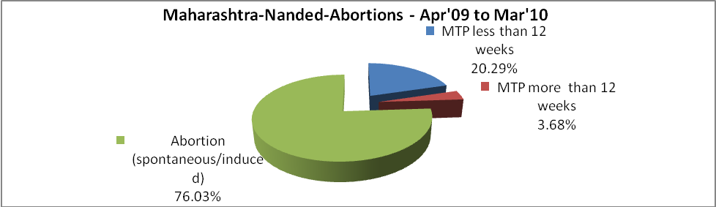

Maharashtra-Nanded- Apr'09 to Mar'10
Total OPD | Total RTI/STI cases
598,725 | 7,054

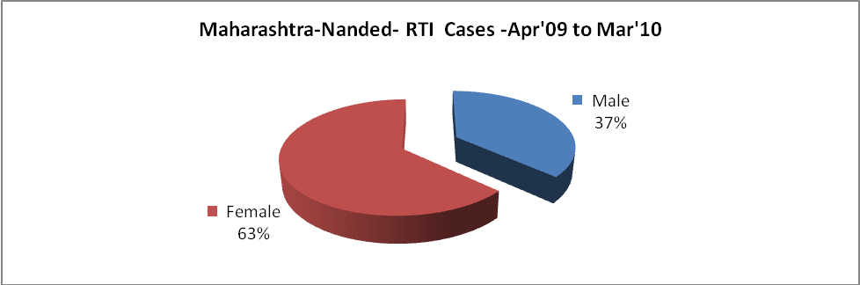

Maharashtra-Nanded-Sterilizations - Apr'09 to Mar'10
 | Reported | %age of Reported Sterilization
Total Sterilization | 16,313 | -
NSV | 331 | 2%
Laparoscopic | 1,286 | 8%
MiniLap | 12,109 | 74%
Post Partum | 2,587 | 16%
Male Sterilization | 331 | 2%
Female Sterilization | 15,982 | 98%

Maharashtra-Nanded-FP Methods - Apr'09 to Mar'10
 | Reported | %age of All Reported FP Methods
Total Reported FP Method (All types) Users | 45,328 | -
Sterilizations | 16,313 | 36%
IUD | 7,756 | 17%
Condom Users | 12,938 | 29%
OCP Users | 8,321 | 18%
Limiting Methods | 16,313 | 36%
Spacing Methods | 29,015 | 64%

Maharashtra-Nanded- Service Delivery - Apr'09 to Mar'10
Operation major (General and spinal anaesthesia) | Operation minor (No or local anaesthesia) | AYUSH | Dental Procedures | Adolescent counselling services | Total OPD | Total IPD
- | - | - | - | - | 598,725 | -
Operation major (General and spinal anaesthesia) as %ge of OPD | Operation minor (No or local anaesthesia)as %ge of OPD | AYUSH as %ge of OPD | Dental Procedures as %ge of OPD | Adolescent counselling services as %ge of OPD | IPD as percentage of OPD
0.0% | 0.0% | 0.0% | 0.0% | 0.0% | 0%

Maharashtra-Nanded- Lab Services - Apr'09 to Mar'10
Total OPD | Total HB tested | Total HIV Tested | Total Population
598,725 | 16,795 | - | 3,376,904
HB test conducted as %age of OPD | HB<7gm as %age of HB tested | HIV test conducted as %age of OPD | HIV positive as %age of HIV tested | Blood Smear Examined as % of Population
2.8% | 0.0% | 0.0% | 0.0% | 9.0%

Maharashtra-Nanded- Childhood Disease - Vaccine Preventable -Apr'09 to Mar'10
Diphtheria | Pertussis | Tetanus Neonatorum | Tetanus others | Polio | Measles
0 | 20 | 0 | 4 | 1 | 56
Maharashtra-Nanded-Childhood Disease - Others - Apr'09 to Mar'10
Diarrhoea and dehydration | Malaria | Number admitted with Respiratory Infections
792 | 30 | 476

Maharashtra-Nanded- Infant & Child Deaths - Apr'09 to Mar'10
Infant Deaths within 24 hrs of birth | Infant Deaths between 24hrs & under 1 week | Infant Deaths between 1 week & under 1 month | Child Deaths between 1 month & under 1 year | Child Deaths between 1yr under 5years | Total Deaths
146 | 2 | 4 | 0 | 0 | 152

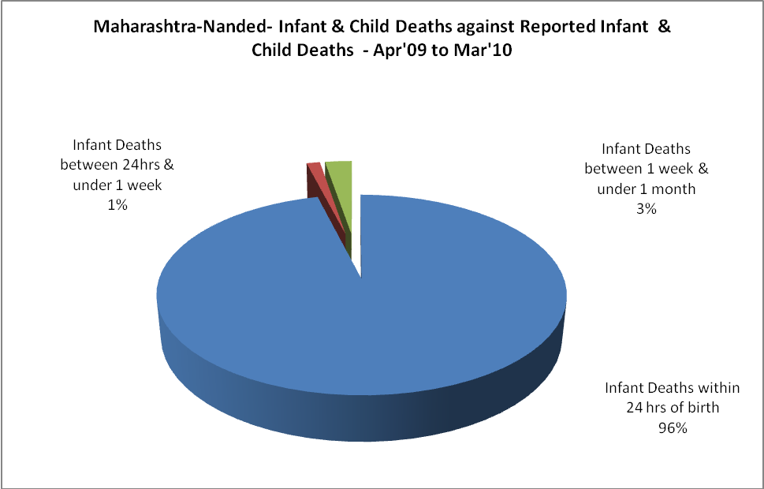

Maharashtra-Nanded- Causes of Infant & Child Deaths - Apr'09 to Mar'10
Sepsis |  |  | Asphyxia |  |  | LBW
Up to 1 Weeks of Birth | Between 1 week & 4 weeks of birth | Total | Up to 1 Weeks of Birth | Between 1 week & 4 weeks of birth | Total | Up to 1 Weeks of Birth | Between 1 week & 4 weeks of birth | Total
2 | 0 | 2 | 0 | 0 | 0 | 0 | 4 | 4
Pneumonia |  |  | Diarrhoea |  |  | Fever related
Between 1 month and 11 months | Between 1 year & 5 years | Total | Between 1 month and 11 months | Between 1 year & 5 years | Total | Between 1 month and 11 months | Between 1 year & 5 years | Total
0 | 0 | 0 | 0 | 0 | 0 | 0 | 0 | 0
Others |  |  | Measles |  |  | Others
Up to 1 Weeks of Birth | Between 1 week & 4 weeks of birth | Total | Between 1 month and 11 months | Between 1 year & 5 years | Total | Between 1 month and 11 months | Between 1 year & 5 years | Total
0 | 0 | 0 | 0 | 0 | 0 | 0 | 0 | 0

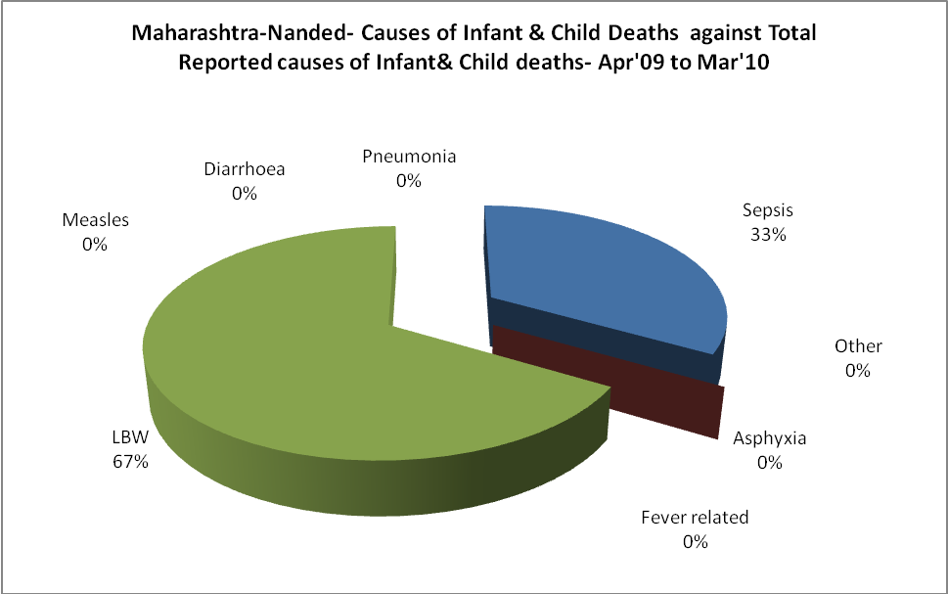

Maharashtra-Nanded-Causes of Deaths in 6 to 55yrs age group - Apr'09 to Mar'10
Diarrhoel Diseases |  |  |  | Tuberculosis |  |  |  | Respiratory Diseases( Other than TB)
6-14 yrs | 15-55 yrs. | Above 55yrs | Total | 6-14 yrs | 15-55 yrs. | Above 55yrs | Total | 6-14 yrs | 15-55 yrs. | Above 55yrs | Total
0 | 0 | 0 | 0 | 0 | 0 | 0 | 0 | 0 | 0 | 0 | 0
Malaria |  |  |  | Other fever Related |  |  |  | HIV/Aids
6-14 yrs | 15-55 yrs. | Above 55yrs | Total | 6-14 yrs | 15-55 yrs. | Above 55yrs | Total | 6-14 yrs | 15-55 yrs. | Above 55yrs | Total
0 | 0 | 0 | 0 | 0 | 0 | 0 | 0 | 0 | 0 | 0 | 0
Heart Disease/Hypertension related |  |  |  | Neurological Disease including strokes |  |  |  | Trauma/Accidents/ Burn Cases
6-14 yrs | 15-55 yrs. | Above 55yrs | Total | 6-14 yrs | 15-55 yrs. | Above 55yrs | Total | 6-14 yrs | 15-55 yrs. | Above 55yrs | Total
0 | 0 | 0 | 0 | 0 | 0 | 0 | 0 | 0 | 0 | 0 | 0
Suicide |  |  |  | Animal Bites & Stings
6-14 yrs | 15-55 yrs. | Above 55yrs | Total | 6-14 yrs | 15-55 yrs. | Above 55yrs | Total
0 | 0 | 0 | 0 | 0 | 0 | 0 | 0

