NHSRC
Maharashtra – Nandurbar
Analysis: Apr 2009 – Mar 2010

Maharashtra-Nandurbar- Summary-Apr'09 to Mar'10
ANC
ANC Registration against Expected Pregnancies | 103% | TT1 given to Pregnant women against ANC Registration | 69%
3 ANC Check ups against ANC Registrations | 89% | 100 IFA Tablets given to Pregnant women against ANC Registration | 70%
Deliveries
Unreported Deliveries against Estimated Deliveries | 0.0% | HOME Deliveries( SBA& Non SBA) against Estimated Deliveries | 43.1%
Institutional Deliveries against Estimated Deliveries | 56.9% | HOME Deliveries( SBA& Non SBA) against Reported Deliveries | 43.1%
Institutional Deliveries against Reported Deliveries | 56.9% | C Section Deliveries against Institutional Deliveries( Pvt & Pub) | 1%
Births & Neonates Care
Live Births Reported against Estimated Live Births | 108% | New borns weighed against Reported Live Births | 89%
Still Births (Reported) | 857 | New borns weighed less than 2.5 kgs against newborns weighed | 10%
Sex Ratio at Birth | 911 | New borns breastfed within one hr of Birth against Reported live Births | 0%
Child Immunization( 0 to 11 months)
BCG given against Expected Live Births | 115% | Measles given against Expected Live Births | 110%
OPV3 given against Expected Live Births | 107% | Fully Immunized Children against Expected Live Births | 120%
DPT3 given against Expected Live Births | 108%
Family Planning
Family Planning Methods Users ( Sterilizations(Male &Female)+IUD+ Condom pieces/72 + OCP Cycles/13) | 19,242 | IUD Insertions against reported FP Methods | 12%
Sterilization against reported FP Methods | 38% | Condom Users against reported FP Methods | 29%
 |  | OCP Users against reported FP Methods | 21%
Other Services
OPD | 126,412 | Major Operations | 647
IPD | - | Minor Operations | 630

`
Maharashtra-Nandurbar- Deliveries Apr'09 to Mar'10
Total Population | 1,539,838 | Expected Deliveries |  | 28,018
Home SBA | Home Non SBA | Institutional | Total Deliveries Reported | Unreported Deliveries
6,821 | 5,251 | 15,939 | 28,011 | 7
Home SBA % | Home Non SBA% | Institutional % | Total Deliveries Reported % | Unreported Deliveries %
24% | 19% | 57% | 100% | 0%

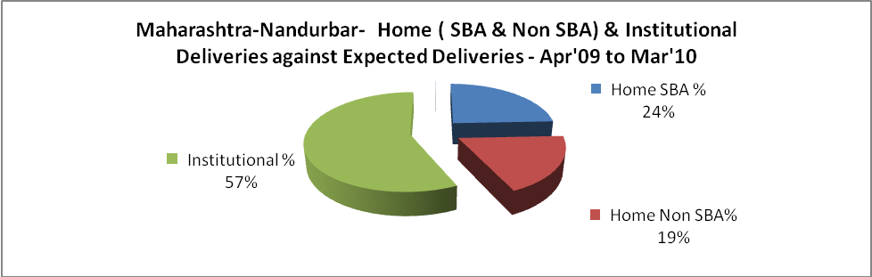

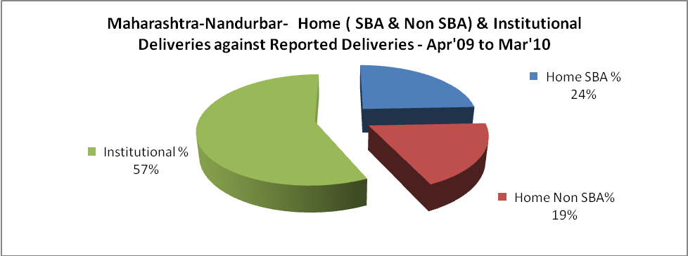

Maharashtra-Nandurbar- C sections & Complicated Deliveries Apr'09 to Mar'10
 | Institutional Deliveries (Public) | Institutional Deliveries (Pvt)
 | 10,902 | 5,037
C Section | 80 | 126
C Section% | 1% | 3%
Complicated Pregnancies attended | 656 | 297
Complicated Pregnancies attended % | 6% | 6%

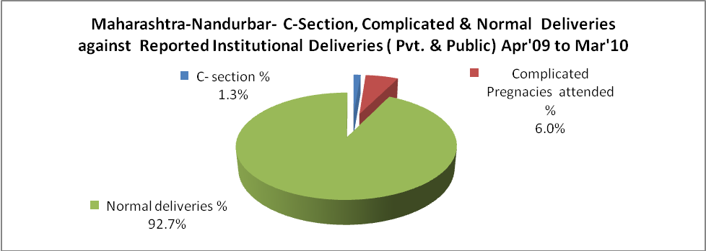

Maharashtra-Nandurbar- Complicated Pregnancies & Deliveries Treated - Apr'09 to Mar'10
Reported Deliveries |  |  | Reported ANC Registration
28,011 |  |  | 31,090
Complicated Pregnancies attended | Complicated Pregnancies Rate | C - Section Deliveries | PNC Maternal Complications | Abortions | Still Births
953 | 3% | 206 | - | 516 | 857
Complicated Deliveries Treated with |  |  |  | No Of Eclampsia cases Treated | No Of severe anemia cases treated
IV Antibiotics | IV antihypertensive/Magsulph injection | IV Oxytocis | Blood Transfusion | No Of Eclampsia cases Treated | No Of severe anemia cases treated
- | - | - | - | - | -

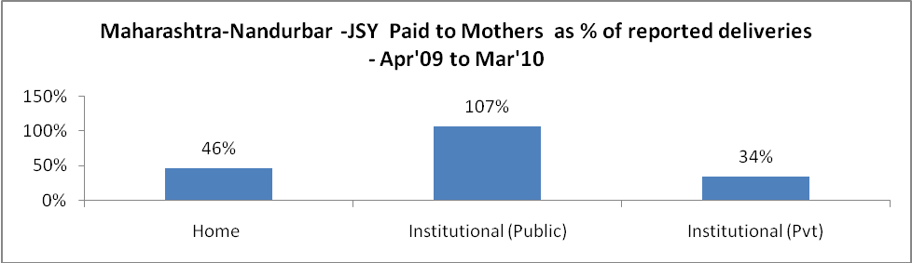

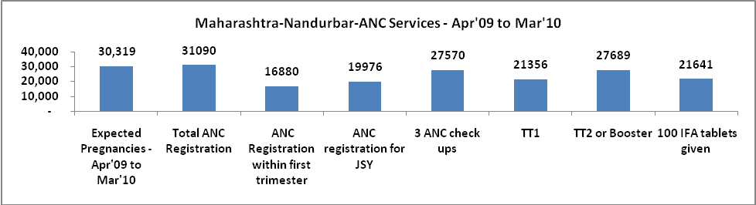

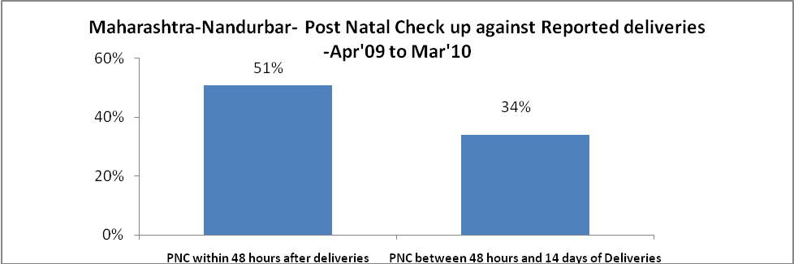

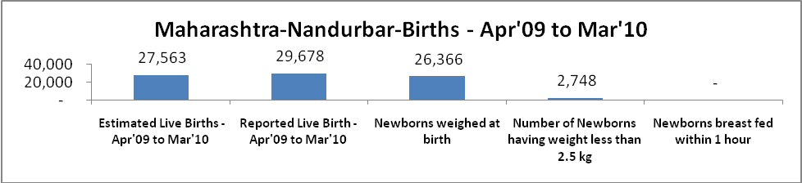

Maharashtra-Nandurbar - Births - Apr'09 to Mar'10
Live Birth - Males | Live Birth - females | Live Birth - Total | Sex Ratio at birth | Still Birth | Abortion( Induced/Spontaneous
15,532 | 14,146 | 29,678 | 911 | 857 | 516

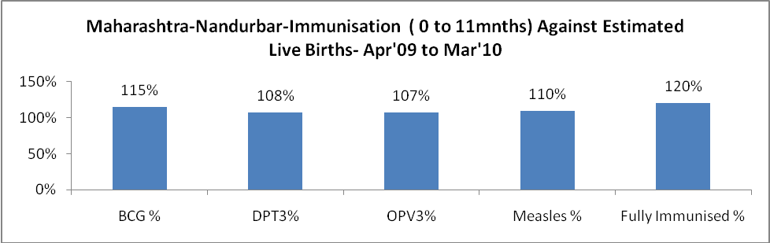

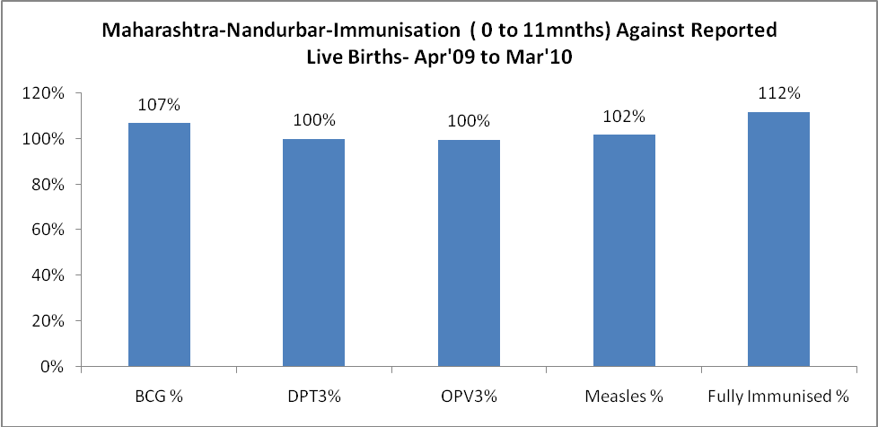

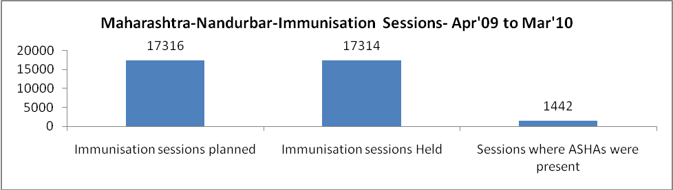

Maharashtra-Nandurbar- Apr'09 to Mar'10
Total Abortions | Abortion Rate
728 | 2.4%

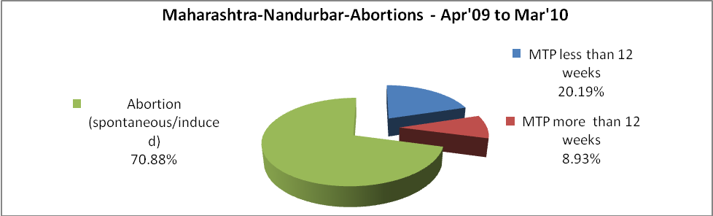

Maharashtra-Nandurbar- Apr'09 to Mar'10
Total OPD | Total RTI/STI cases
126,412 | 5,970

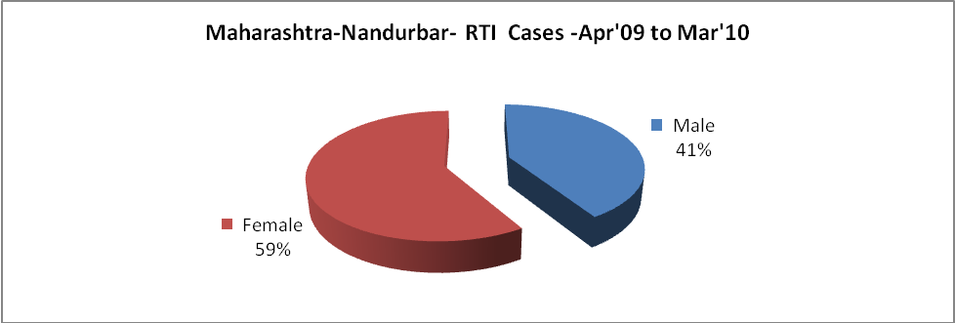

Maharashtra-Nandurbar-Sterilizations - Apr'09 to Mar'10
 | Reported | %age of Reported Sterilization
Total Sterilization | 7,316 | -
NSV | 1,238 | 17%
Laparoscopic | 2,951 | 40%
MiniLap | 2,619 | 36%
Post Partum | 508 | 7%
Male Sterilization | 1,238 | 17%
Female Sterilization | 6,078 | 83%

Maharashtra-Nandurbar-FP Methods - Apr'09 to Mar'10
 | Reported | %age of All Reported FP Methods
Total Reported FP Method (All types) Users | 19,242 | -
Sterilizations | 7,316 | 38%
IUD | 2,344 | 12%
Condom Users | 5,629 | 29%
OCP Users | 3,952 | 21%
Limiting Methods | 7,316 | 38%
Spacing Methods | 11,926 | 62%

Maharashtra-Nandurbar- Service Delivery - Apr'09 to Mar'10
Operation major (General and spinal anaesthesia) | Operation minor (No or local anaesthesia) | AYUSH | Dental Procedures | Adolescent counselling services | Total OPD | Total IPD
647 | 630 | - | - | - | 126,412 | -
Operation major (General and spinal anaesthesia) as %ge of OPD | Operation minor (No or local anaesthesia)as %ge of OPD | AYUSH as %ge of OPD | Dental Procedures as %ge of OPD | Adolescent counselling services as %ge of OPD | IPD as percentage of OPD
0.5% | 0.5% | 0.0% | 0.0% | 0.0% | 0%

Maharashtra-Nandurbar- Lab Services - Apr'09 to Mar'10
Total OPD | Total HB tested | Total HIV Tested | Total Population
126,412 | - | - | 1,539,838
HB test conducted as %age of OPD | HB<7gm as %age of HB tested | HIV test conducted as %age of OPD | HIV positive as %age of HIV tested | Blood Smear Examined as % of Population
0.0% | 0.0% | 0.0% | 0.0% | 0.0%

Maharashtra-Nandurbar- Childhood Disease - Vaccine Preventable -Apr'09 to Mar'10
Diphtheria | Pertussis | Tetanus Neonatorum | Tetanus others | Polio | Measles
3 | 0 | 0 | 2 | 0 | 5
Maharashtra-Nandurbar-Childhood Disease - Others - Apr'09 to Mar'10
Diarrhoea and dehydration | Malaria | Number admitted with Respiratory Infections
1,267 | 79 | 331

Maharashtra-Nandurbar- Infant & Child Deaths - Apr'09 to Mar'10
Infant Deaths within 24 hrs of birth | Infant Deaths between 24hrs & under 1 week | Infant Deaths between 1 week & under 1 month | Child Deaths between 1 month & under 1 year | Child Deaths between 1yr under 5years | Total Deaths
95 | 0 | 0 | 0 | 0 | 95

Maharashtra-Nandurbar- Causes of Infant & Child Deaths - Apr'09 to Mar'10
Sepsis |  |  | Asphyxia |  |  | LBW
Up to 1 Weeks of Birth | Between 1 week & 4 weeks of birth | Total | Up to 1 Weeks of Birth | Between 1 week & 4 weeks of birth | Total | Up to 1 Weeks of Birth | Between 1 week & 4 weeks of birth | Total
0 | 0 | 0 | 0 | 0 | 0 | 0 | 0 | 0
Pneumonia |  |  | Diarrhoea |  |  | Fever related
Between 1 month and 11 months | Between 1 year & 5 years | Total | Between 1 month and 11 months | Between 1 year & 5 years | Total | Between 1 month and 11 months | Between 1 year & 5 years | Total
0 | 0 | 0 | 0 | 0 | 0 | 0 | 0 | 0
Others |  |  | Measles |  |  | Others
Up to 1 Weeks of Birth | Between 1 week & 4 weeks of birth | Total | Between 1 month and 11 months | Between 1 year & 5 years | Total | Between 1 month and 11 months | Between 1 year & 5 years | Total
0 | 0 | 0 | 0 | 0 | 0 | 0 | 0 | 0

Maharashtra-Nandurbar- Maternal Deaths & Causes - Apr'09 to Mar'10
Abortion |  |  | Obstructed/prolonged labour |  |  | Severe hypertension/fits
6-14 yrs | 15-55 yrs. | Total | 6-14 yrs | 15-55 yrs. | Total | 6-14 yrs | 15-55 yrs. | Total
0 | 0 | 0 | 0 | 0 | 0 | 0 | 0 | 0
Bleeding |  |  | High Fever |  |  | Other Causes
6-14 yrs | 15-55 yrs. | Total | 6-14 yrs | 15-55 yrs. | Total | 6-14 yrs | 15-55 yrs. | Total
0 | 0 | 0 | 0 | 0 | 0 | 0 | 0 | 0

Maharashtra-Nandurbar-Causes of Deaths in 6 to 55yrs age group - Apr'09 to Mar'10
Diarrhoel Diseases |  |  |  | Tuberculosis |  |  |  | Respiratory Diseases( Other than TB)
6-14 yrs | 15-55 yrs. | Above 55yrs | Total | 6-14 yrs | 15-55 yrs. | Above 55yrs | Total | 6-14 yrs | 15-55 yrs. | Above 55yrs | Total
0 | 0 | 0 | 0 | 0 | 0 | 0 | 0 | 0 | 0 | 0 | 0
Malaria |  |  |  | Other fever Related |  |  |  | HIV/Aids
6-14 yrs | 15-55 yrs. | Above 55yrs | Total | 6-14 yrs | 15-55 yrs. | Above 55yrs | Total | 6-14 yrs | 15-55 yrs. | Above 55yrs | Total
0 | 0 | 0 | 0 | 0 | 0 | 0 | 0 | 0 | 0 | 0 | 0
Heart Disease/Hypertension related |  |  |  | Neurological Disease including strokes |  |  |  | Trauma/Accidents/ Burn Cases
6-14 yrs | 15-55 yrs. | Above 55yrs | Total | 6-14 yrs | 15-55 yrs. | Above 55yrs | Total | 6-14 yrs | 15-55 yrs. | Above 55yrs | Total
0 | 0 | 0 | 0 | 0 | 0 | 0 | 0 | 0 | 0 | 0 | 0
Suicide |  |  |  | Animal Bites & Stings
6-14 yrs | 15-55 yrs. | Above 55yrs | Total | 6-14 yrs | 15-55 yrs. | Above 55yrs | Total
0 | 0 | 0 | 0 | 0 | 0 | 0 | 0

