NHSRC
Maharashtra – Osmanabad
Analysis: Apr 2009 – Mar 2010

Maharashtra-Osmanabad- Summary-Apr'09 to Mar'10
ANC
ANC Registration against Expected Pregnancies | 78% | TT1 given to Pregnant women against ANC Registration | 54%
3 ANC Check ups against ANC Registrations | 80% | 100 IFA Tablets given to Pregnant women against ANC Registration | 82%
Deliveries
Unreported Deliveries against Estimated Deliveries | 21.1% | HOME Deliveries( SBA& Non SBA) against Estimated Deliveries | 10.4%
Institutional Deliveries against Estimated Deliveries | 68.5% | HOME Deliveries( SBA& Non SBA) against Reported Deliveries | 13.2%
Institutional Deliveries against Reported Deliveries | 86.8% | C Section Deliveries against Institutional Deliveries( Pvt & Pub) | 6%
Births & Neonates Care
Live Births Reported against Estimated Live Births | 76% | New borns weighed against Reported Live Births | 75%
Still Births (Reported) | 330 | New borns weighed less than 2.5 kgs against newborns weighed | 9%
Sex Ratio at Birth | 806 | New borns breastfed within one hr of Birth against Reported live Births | 0%
Child Immunization( 0 to 11 months)
BCG given against Expected Live Births | 91% | Measles given against Expected Live Births | 83%
OPV3 given against Expected Live Births | 88% | Fully Immunized Children against Expected Live Births | 79%
DPT3 given against Expected Live Births | 89%
Family Planning
Family Planning Methods Users ( Sterilizations(Male &Female)+IUD+ Condom pieces/72 + OCP Cycles/13) | 20,448 | IUD Insertions against reported FP Methods | 20%
Sterilization against reported FP Methods | 34% | Condom Users against reported FP Methods | 31%
 |  | OCP Users against reported FP Methods | 16%
Other Services
OPD | 169,830 | Major Operations | 1,349
IPD | - | Minor Operations | 374
`
Maharashtra-Osmanabad- Deliveries Apr'09 to Mar'10
Total Population | 1,747,055 | Expected Deliveries |  | 31,788
Home SBA | Home Non SBA | Institutional | Total Deliveries Reported | Unreported Deliveries
1,413 | 1,903 | 21,778 | 25,094 | 6,694
Home SBA % | Home Non SBA% | Institutional % | Total Deliveries Reported % | Unreported Deliveries %
4% | 6% | 69% | 79% | 21%

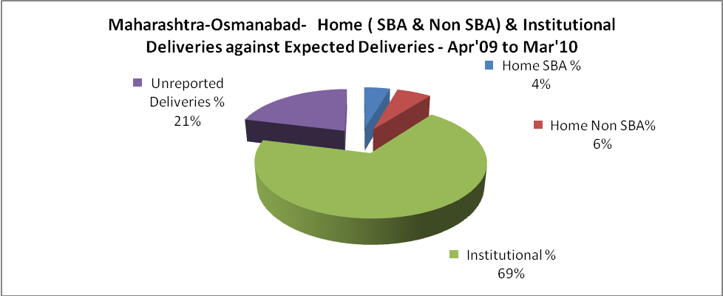

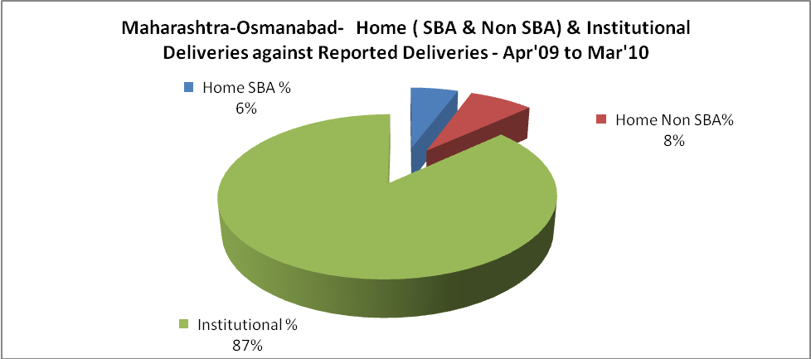

Maharashtra-Osmanabad- C sections & Complicated Deliveries Apr'09 to Mar'10
 | Institutional Deliveries (Public) | Institutional Deliveries (Pvt)
 | 10,445 | 11,333
C Section | 805 | 463
C Section% | 8% | 4%
Complicated Pregnancies attended | 1,317 | 100
Complicated Pregnancies attended % | 13% | 1%

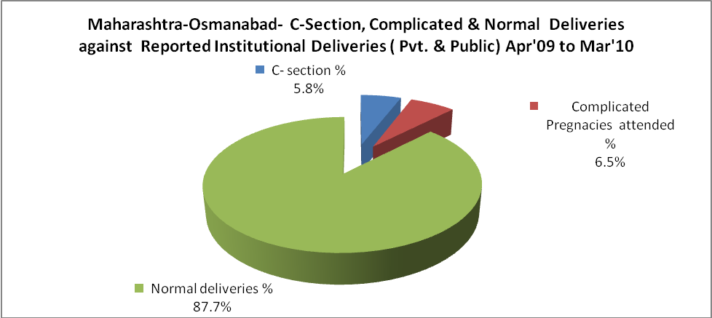

Maharashtra-Osmanabad- Complicated Pregnancies & Deliveries Treated - Apr'09 to Mar'10
Reported Deliveries |  |  | Reported ANC Registration
25,094 |  |  | 26,685
Complicated Pregnancies attended | Complicated Pregnancies Rate | C - Section Deliveries | PNC Maternal Complications | Abortions | Still Births
1,417 | 4% | 1,268 | - | 1,420 | 330
Complicated Deliveries Treated with |  |  |  | No Of Eclampsia cases Treated | No Of severe anemia cases treated
IV Antibiotics | IV antihypertensive/Magsulph injection | IV Oxytocis | Blood Transfusion | No Of Eclampsia cases Treated | No Of severe anemia cases treated
- | - | - | - | - | -

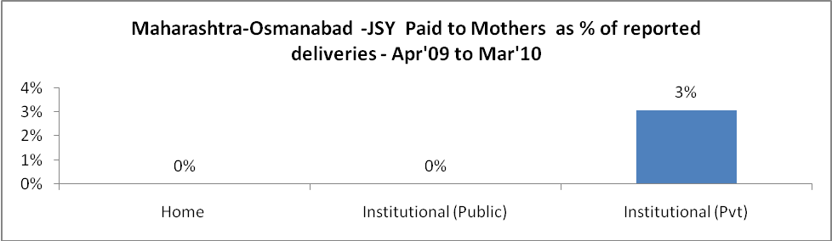

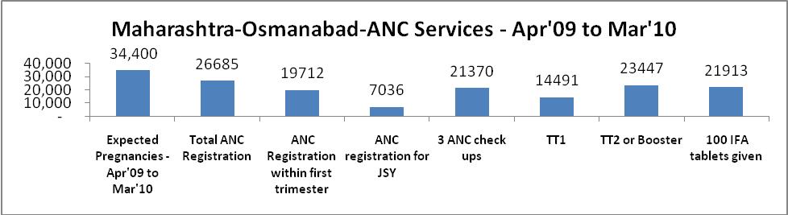

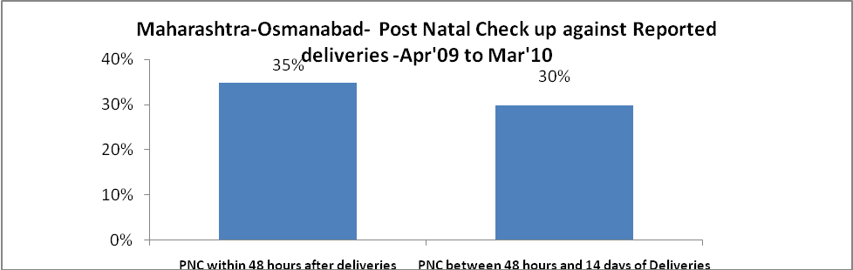

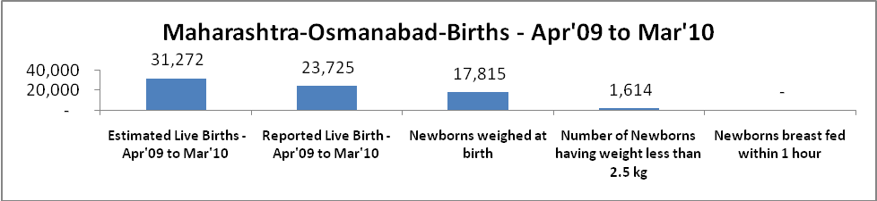

Maharashtra-Osmanabad - Births - Apr'09 to Mar'10
Live Birth - Males | Live Birth - females | Live Birth - Total | Sex Ratio at birth | Still Birth | Abortion( Induced/Spontaneous
13,139 | 10,586 | 23,725 | 806 | 330 | 1,420

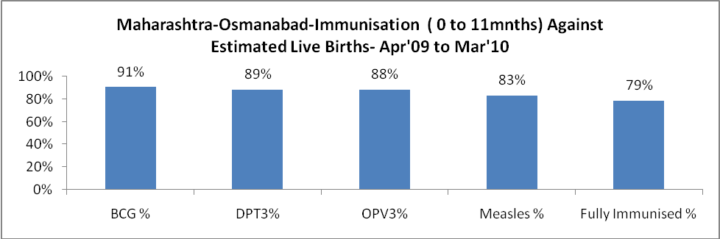

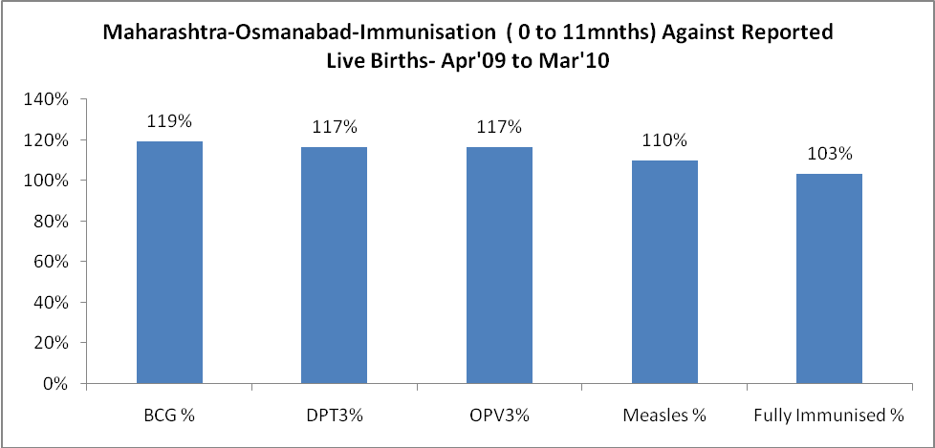

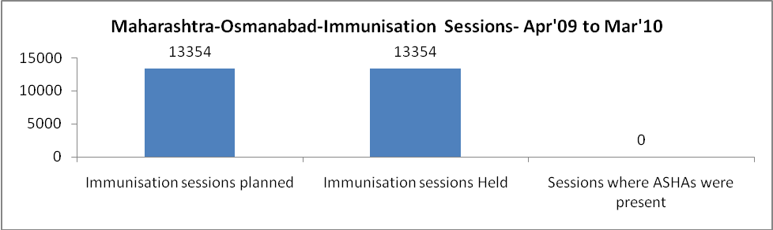

Maharashtra-Osmanabad- Apr'09 to Mar'10
Total Abortions | Abortion Rate
2,132 | 6.2%

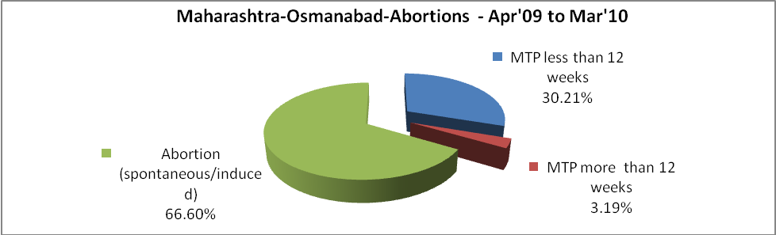

Maharashtra-Osmanabad- Apr'09 to Mar'10
Total OPD | Total RTI/STI cases
169,830 | 2,809

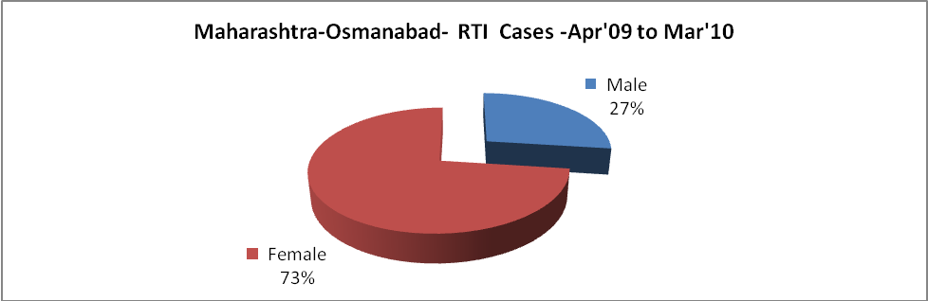

Maharashtra-Osmanabad-Sterilizations - Apr'09 to Mar'10
 | Reported | %age of Reported Sterilization
Total Sterilization | 6,902 | -
NSV | 16 | 0%
Laparoscopic | 2,455 | 36%
MiniLap | 3,458 | 50%
Post Partum | 973 | 14%
Male Sterilization | 16 | 0%
Female Sterilization | 6,886 | 100%

Maharashtra-Osmanabad-FP Methods - Apr'09 to Mar'10
 | Reported | %age of All Reported FP Methods
Total Reported FP Method (All types) Users | 20,448 | -
Sterilizations | 6,902 | 34%
IUD | 4,053 | 20%
Condom Users | 6,312 | 31%
OCP Users | 3,182 | 16%
Limiting Methods | 6,902 | 34%
Spacing Methods | 13,546 | 66%

Maharashtra-Osmanabad- Service Delivery - Apr'09 to Mar'10
Operation major (General and spinal anaesthesia) | Operation minor (No or local anaesthesia) | AYUSH | Dental Procedures | Adolescent counselling services | Total OPD | Total IPD
1,349 | 374 | - | - | - | 169,830 | -
Operation major (General and spinal anaesthesia) as %ge of OPD | Operation minor (No or local anaesthesia)as %ge of OPD | AYUSH as %ge of OPD | Dental Procedures as %ge of OPD | Adolescent counselling services as %ge of OPD | IPD as percentage of OPD
0.8% | 0.2% | 0.0% | 0.0% | 0.0% | 0%

Maharashtra-Osmanabad- Lab Services - Apr'09 to Mar'10
Total OPD | Total HB tested | Total HIV Tested | Total Population
169,830 | - | - | 1,747,055
HB test conducted as %age of OPD | HB<7gm as %age of HB tested | HIV test conducted as %age of OPD | HIV positive as %age of HIV tested | Blood Smear Examined as % of Population
0.0% | 0.0% | 0.0% | 0.0% | 7.2%

Maharashtra-Osmanabad- Childhood Disease - Vaccine Preventable -Apr'09 to Mar'10
Diphtheria | Pertussis | Tetanus Neonatorum | Tetanus others | Polio | Measles
0 | 0 | 0 | 0 | 6 | 3
Maharashtra-Osmanabad-Childhood Disease - Others - Apr'09 to Mar'10
Diarrhoea and dehydration | Malaria | Number admitted with Respiratory Infections
4,624 | - | 1,366

Maharashtra-Osmanabad- Infant & Child Deaths - Apr'09 to Mar'10
Infant Deaths within 24 hrs of birth | Infant Deaths between 24hrs & under 1 week | Infant Deaths between 1 week & under 1 month | Child Deaths between 1 month & under 1 year | Child Deaths between 1yr under 5years | Total Deaths
148 | 50 | 10 | 15 | 13 | 236

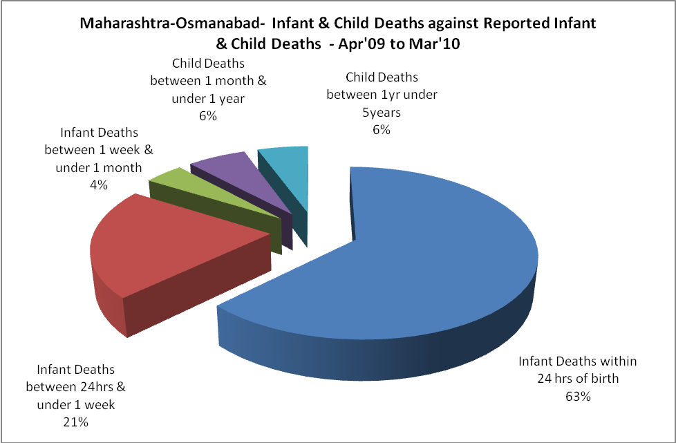

Maharashtra-Osmanabad- Causes of Infant & Child Deaths - Apr'09 to Mar'10
Sepsis |  |  | Asphyxia |  |  | LBW
Up to 1 Weeks of Birth | Between 1 week & 4 weeks of birth | Total | Up to 1 Weeks of Birth | Between 1 week & 4 weeks of birth | Total | Up to 1 Weeks of Birth | Between 1 week & 4 weeks of birth | Total
0 | 0 | 0 | 0 | 0 | 0 | 0 | 0 | 0
Pneumonia |  |  | Diarrhoea |  |  | Fever related
Between 1 month and 11 months | Between 1 year & 5 years | Total | Between 1 month and 11 months | Between 1 year & 5 years | Total | Between 1 month and 11 months | Between 1 year & 5 years | Total
0 | 0 | 0 | 0 | 0 | 0 | 0 | 0 | 0
Others |  |  | Measles |  |  | Others
Up to 1 Weeks of Birth | Between 1 week & 4 weeks of birth | Total | Between 1 month and 11 months | Between 1 year & 5 years | Total | Between 1 month and 11 months | Between 1 year & 5 years | Total
50 | 10 | 60 | 0 | 0 | 0 | 15 | 13 | 28

Maharashtra-Osmanabad- Maternal Deaths & Causes - Apr'09 to Mar'10
Abortion |  |  | Obstructed/prolonged labour |  |  | Severe hypertension/fits
6-14 yrs | 15-55 yrs. | Total | 6-14 yrs | 15-55 yrs. | Total | 6-14 yrs | 15-55 yrs. | Total
0 | 0 | 0 | 0 | 0 | 0 | 0 | 0 | 0
Bleeding |  |  | High Fever |  |  | Other Causes
6-14 yrs | 15-55 yrs. | Total | 6-14 yrs | 15-55 yrs. | Total | 6-14 yrs | 15-55 yrs. | Total
0 | 0 | 0 | 0 | 0 | 0 | 0 | 0 | 0

Maharashtra-Osmanabad-Causes of Deaths in 6 to 55yrs age group - Apr'09 to Mar'10
Diarrhoel Diseases |  |  |  | Tuberculosis |  |  |  | Respiratory Diseases( Other than TB)
6-14 yrs | 15-55 yrs. | Above 55yrs | Total | 6-14 yrs | 15-55 yrs. | Above 55yrs | Total | 6-14 yrs | 15-55 yrs. | Above 55yrs | Total
0 | 0 | 0 | 0 | 0 | 0 | 0 | 0 | 0 | 0 | 0 | 0
Malaria |  |  |  | Other fever Related |  |  |  | HIV/Aids
6-14 yrs | 15-55 yrs. | Above 55yrs | Total | 6-14 yrs | 15-55 yrs. | Above 55yrs | Total | 6-14 yrs | 15-55 yrs. | Above 55yrs | Total
0 | 0 | 0 | 0 | 0 | 0 | 0 | 0 | 0 | 0 | 0 | 0
Heart Disease/Hypertension related |  |  |  | Neurological Disease including strokes |  |  |  | Trauma/Accidents/ Burn Cases
6-14 yrs | 15-55 yrs. | Above 55yrs | Total | 6-14 yrs | 15-55 yrs. | Above 55yrs | Total | 6-14 yrs | 15-55 yrs. | Above 55yrs | Total
0 | 0 | 0 | 0 | 0 | 0 | 0 | 0 | 0 | 0 | 0 | 0
Suicide |  |  |  | Animal Bites & Stings
6-14 yrs | 15-55 yrs. | Above 55yrs | Total | 6-14 yrs | 15-55 yrs. | Above 55yrs | Total
0 | 0 | 0 | 0 | 0 | 0 | 0 | 0

