NHSRC
Maharashtra – Pune
Analysis: Apr 2009 – Mar 2010

Maharashtra-Pune- Summary-Apr'09 to Mar'10
ANC
ANC Registration against Expected Pregnancies | 86% | TT1 given to Pregnant women against ANC Registration | 67%
3 ANC Check ups against ANC Registrations | 63% | 100 IFA Tablets given to Pregnant women against ANC Registration | 56%
Deliveries
Unreported Deliveries against Estimated Deliveries | 28.7% | HOME Deliveries( SBA& Non SBA) against Estimated Deliveries | 2.8%
Institutional Deliveries against Estimated Deliveries | 68.5% | HOME Deliveries( SBA& Non SBA) against Reported Deliveries | 3.9%
Institutional Deliveries against Reported Deliveries | 96.1% | C Section Deliveries against Institutional Deliveries( Pvt & Pub) | 12%
Births & Neonates Care
Live Births Reported against Estimated Live Births | 67% | New borns weighed against Reported Live Births | 93%
Still Births (Reported) | 1,465 | New borns weighed less than 2.5 kgs against newborns weighed | 44%
Sex Ratio at Birth | 860 | New borns breastfed within one hr of Birth against Reported live Births | 21%
Child Immunization( 0 to 11 months)
BCG given against Expected Live Births | 96% | Measles given against Expected Live Births | 96%
OPV3 given against Expected Live Births | 96% | Fully Immunized Children against Expected Live Births | 70%
DPT3 given against Expected Live Births | 97%
Family Planning
Family Planning Methods Users ( Sterilizations(Male &Female)+IUD+ Condom pieces/72 + OCP Cycles/13) | 97,947 | IUD Insertions against reported FP Methods | 24%
Sterilization against reported FP Methods | 44% | Condom Users against reported FP Methods | 19%
 |  | OCP Users against reported FP Methods | 13%
Other Services
OPD | 1,228,192 | Major Operations | 1,872
IPD | - | Minor Operations | 1,213
`

Maharashtra-Pune- Deliveries Apr'09 to Mar'10
Total Population | 8,489,438 | Expected Deliveries |  | 154,468
Home SBA | Home Non SBA | Institutional | Total Deliveries Reported | Unreported Deliveries
2,169 | 2,176 | 105,786 | 110,131 | 44,337
Home SBA % | Home Non SBA% | Institutional % | Total Deliveries Reported % | Unreported Deliveries %
1% | 1% | 68% | 71% | 29%

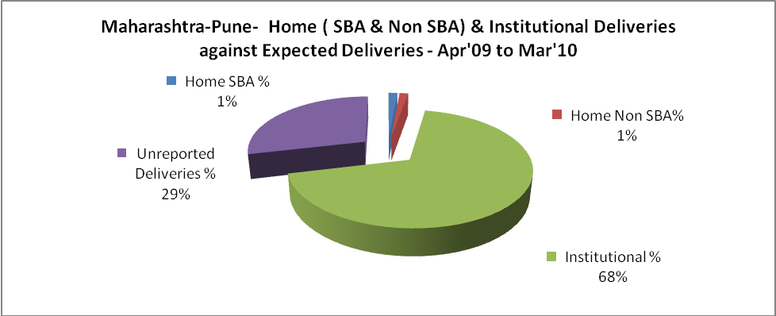

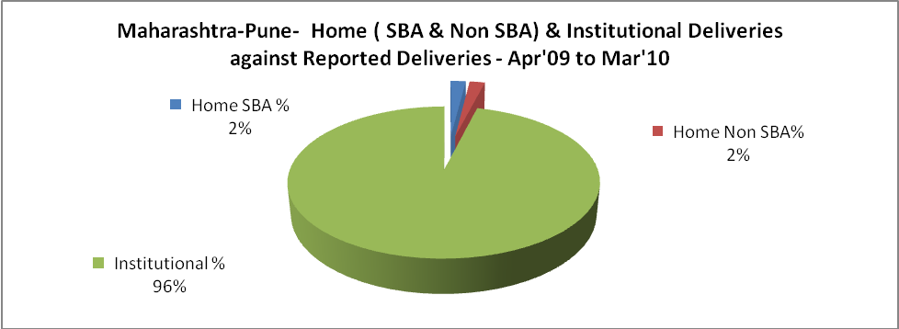

Maharashtra-Pune- C sections & Complicated Deliveries Apr'09 to Mar'10
 | Institutional Deliveries (Public) | Institutional Deliveries (Pvt)
 | 61,860 | 43,926
C Section | 5,753 | 6,559
C Section% | 9% | 15%
Complicated Pregnancies attended | 2,891 | 722
Complicated Pregnancies attended % | 5% | 2%

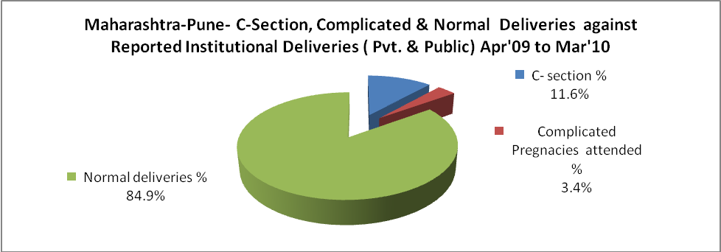

Maharashtra-Pune- Complicated Pregnancies & Deliveries Treated - Apr'09 to Mar'10
Reported Deliveries |  |  | Reported ANC Registration
110,131 |  |  | 144,236
Complicated Pregnancies attended | Complicated Pregnancies Rate | C - Section Deliveries | PNC Maternal Complications | Abortions | Still Births
3,613 | 2% | 12,312 | 456 | 7,610 | 1,465
Complicated Deliveries Treated with |  |  |  | No Of Eclampsia cases Treated | No Of severe anemia cases treated
IV Antibiotics | IV antihypertensive/Magsulph injection | IV Oxytocis | Blood Transfusion | No Of Eclampsia cases Treated | No Of severe anemia cases treated
- | - | - | - | - | 672

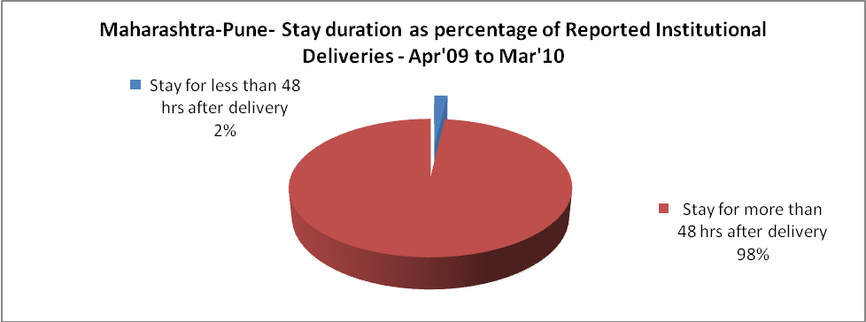

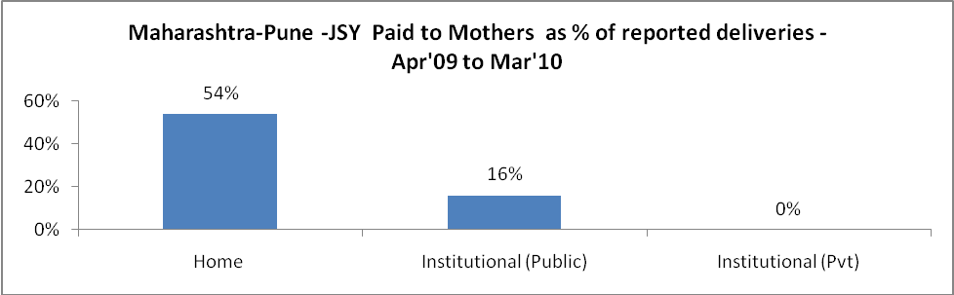

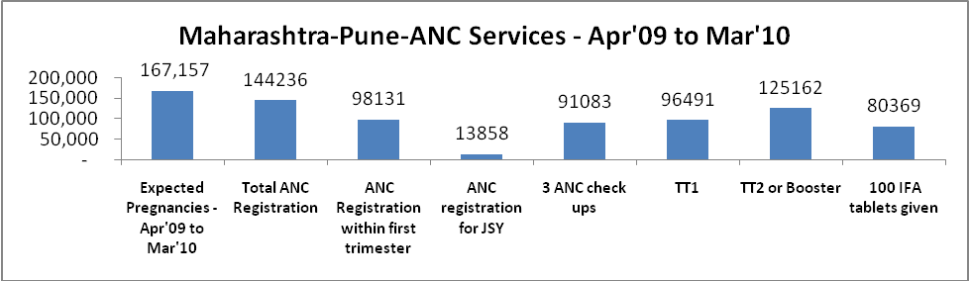

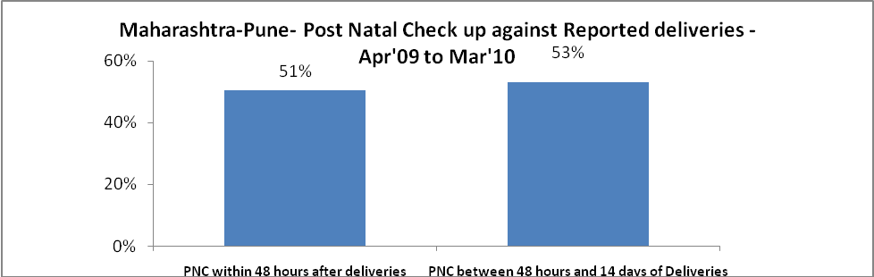

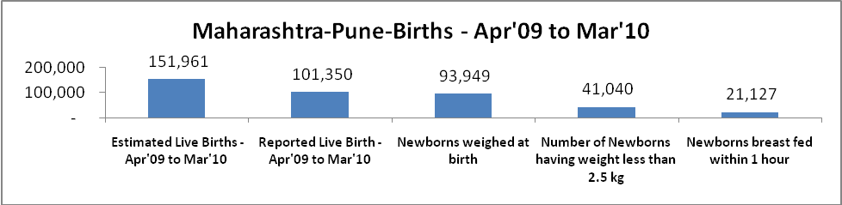

Maharashtra-Pune - Births - Apr'09 to Mar'10
Live Birth - Males | Live Birth - females | Live Birth - Total | Sex Ratio at birth | Still Birth | Abortion( Induced/Spontaneous
54,484 | 46,866 | 101,350 | 860 | 1,465 | 7,610

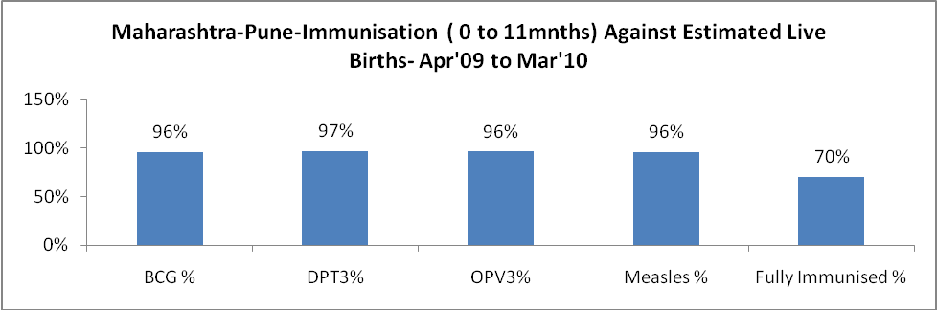

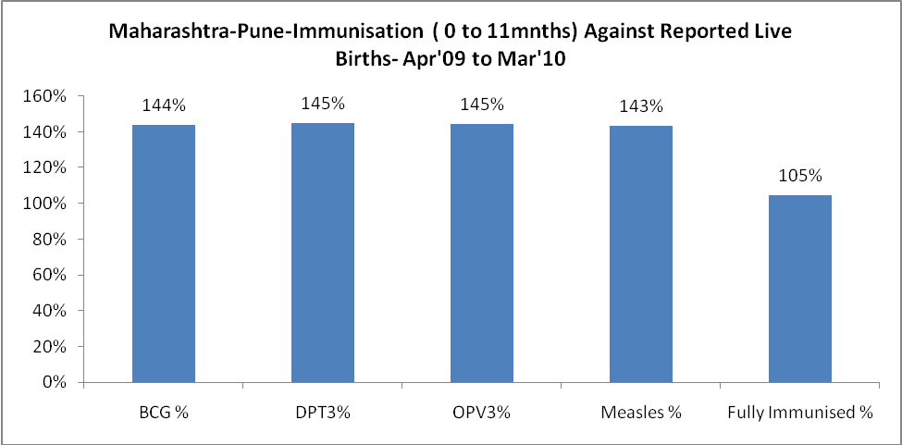

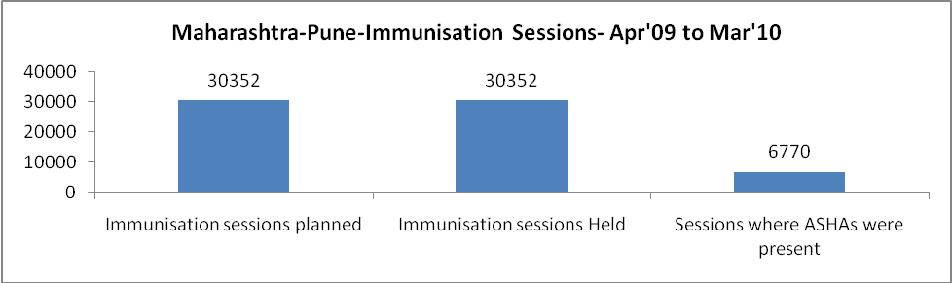

Maharashtra-Pune- Apr'09 to Mar'10
Total Abortions | Abortion Rate
19,845 | 11.9%

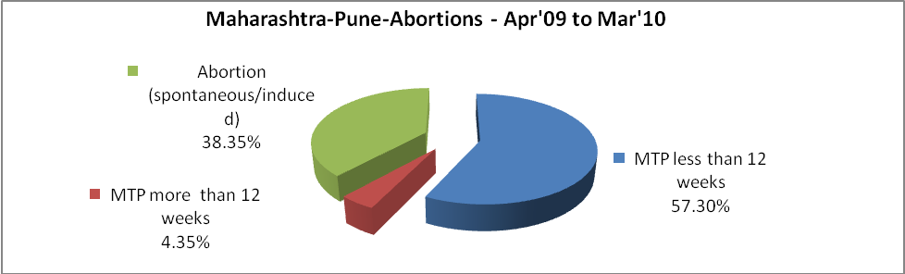

Maharashtra-Pune- Apr'09 to Mar'10
Total OPD | Total RTI/STI cases
1,228,192 | 24,901



Maharashtra-Pune-Sterilizations - Apr'09 to Mar'10
 | Reported | %age of Reported Sterilization
Total Sterilization | 43,439 | -
NSV | 2,928 | 7%
Laparoscopic | 19,547 | 45%
MiniLap | 15,766 | 36%
Post Partum | 5,198 | 12%
Male Sterilization | 2,928 | 7%
Female Sterilization | 40,511 | 93%

Maharashtra-Pune-FP Methods - Apr'09 to Mar'10
 | Reported | %age of All Reported FP Methods
Total Reported FP Method (All types) Users | 97,947 | -
Sterilizations | 43,439 | 44%
IUD | 23,135 | 24%
Condom Users | 18,792 | 19%
OCP Users | 12,581 | 13%
Limiting Methods | 43,439 | 44%
Spacing Methods | 54,508 | 56%

Maharashtra-Pune- Service Delivery - Apr'09 to Mar'10
Operation major (General and spinal anaesthesia) | Operation minor (No or local anaesthesia) | AYUSH | Dental Procedures | Adolescent counselling services | Total OPD | Total IPD
1,872 | 1,213 | 11,621 | 1,725 | 7,596 | 1,228,192 | -
Operation major (General and spinal anaesthesia) as %ge of OPD | Operation minor (No or local anaesthesia)as %ge of OPD | AYUSH as %ge of OPD | Dental Procedures as %ge of OPD | Adolescent counselling services as %ge of OPD | IPD as percentage of OPD
0.2% | 0.1% | 0.9% | 0.1% | 0.6% | 0%

Maharashtra-Pune- Lab Services - Apr'09 to Mar'10
Total OPD | Total HB tested | Total HIV Tested | Total Population
1,228,192 | - | - | 8,489,438
HB test conducted as %age of OPD | HB<7gm as %age of HB tested | HIV test conducted as %age of OPD | HIV positive as %age of HIV tested | Blood Smear Examined as % of Population
0.0% | 0.0% | 0.0% | 0.0% | 6.4%

Maharashtra-Pune- Childhood Disease - Vaccine Preventable -Apr'09 to Mar'10
Diphtheria | Pertussis | Tetanus Neonatorum | Tetanus others | Polio | Measles
0 | 0 | 0 | 0 | 0 | 40
Maharashtra-Pune-Childhood Disease - Others - Apr'09 to Mar'10
Diarrhoea and dehydration | Malaria | Number admitted with Respiratory Infections
3,803 | - | 786

Maharashtra-Pune- Infant & Child Deaths - Apr'09 to Mar'10
Infant Deaths within 24 hrs of birth | Infant Deaths between 24hrs & under 1 week | Infant Deaths between 1 week & under 1 month | Child Deaths between 1 month & under 1 year | Child Deaths between 1yr under 5years | Total Deaths
179 | 268 | 130 | 269 | 175 | 1021

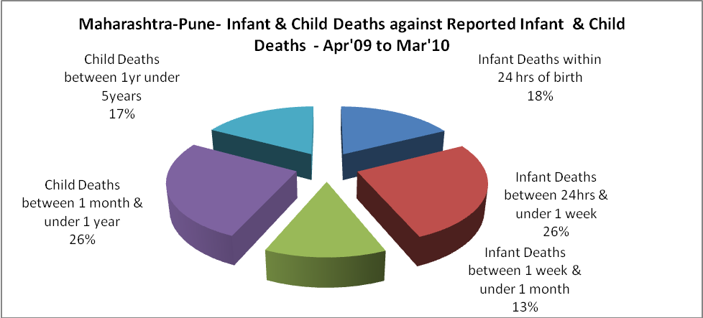

Maharashtra-Pune- Causes of Infant & Child Deaths - Apr'09 to Mar'10
Sepsis |  |  | Asphyxia |  |  | LBW
Up to 1 Weeks of Birth | Between 1 week & 4 weeks of birth | Total | Up to 1 Weeks of Birth | Between 1 week & 4 weeks of birth | Total | Up to 1 Weeks of Birth | Between 1 week & 4 weeks of birth | Total
49 | 27 | 76 | 69 | 37 | 106 | 69 | 39 | 108
Pneumonia |  |  | Diarrhoea |  |  | Fever related
Between 1 month and 11 months | Between 1 year & 5 years | Total | Between 1 month and 11 months | Between 1 year & 5 years | Total | Between 1 month and 11 months | Between 1 year & 5 years | Total
76 | 54 | 130 | 48 | 27 | 75 | 93 | 65 | 158
Others |  |  | Measles |  |  | Others
Up to 1 Weeks of Birth | Between 1 week & 4 weeks of birth | Total | Between 1 month and 11 months | Between 1 year & 5 years | Total | Between 1 month and 11 months | Between 1 year & 5 years | Total
81 | 27 | 108 | 13 | 7 | 20 | 39 | 22 | 61

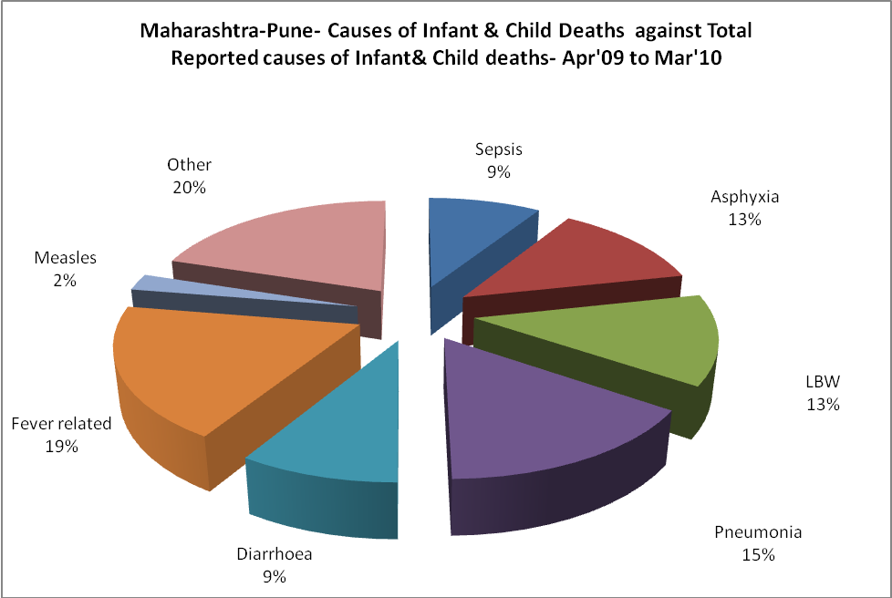

Maharashtra-Pune- Maternal Deaths & Causes - Apr'09 to Mar'10
Abortion |  |  | Obstructed/prolonged labour |  |  | Severe hypertension/fits
6-14 yrs | 15-55 yrs. | Total | 6-14 yrs | 15-55 yrs. | Total | 6-14 yrs | 15-55 yrs. | Total
0 | 0 | 0 | 0 | 0 | 0 | 0 | 5 | 5
Bleeding |  |  | High Fever |  |  | Other Causes
6-14 yrs | 15-55 yrs. | Total | 6-14 yrs | 15-55 yrs. | Total | 6-14 yrs | 15-55 yrs. | Total
0 | 15 | 15 | 0 | 0 | 0 | 0 | 4 | 4

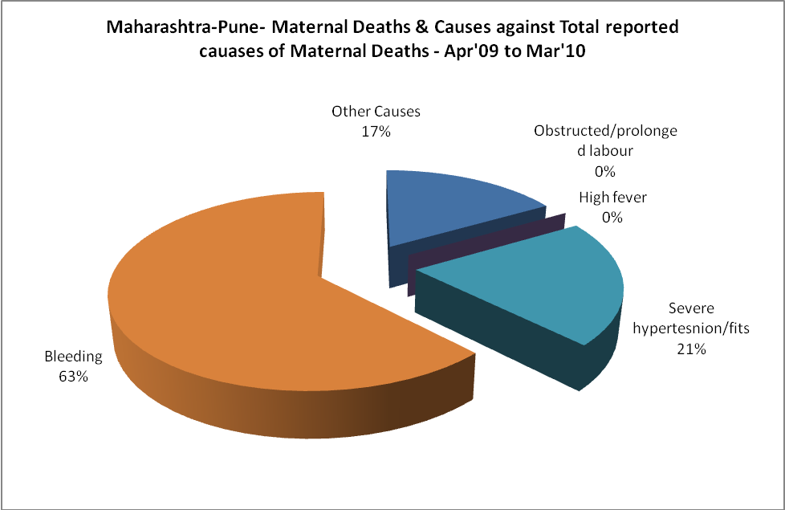

Maharashtra-Pune-Causes of Deaths in 6 to 55yrs age group - Apr'09 to Mar'10
Diarrhoel Diseases |  |  |  | Tuberculosis |  |  |  | Respiratory Diseases( Other than TB)
6-14 yrs | 15-55 yrs. | Above 55yrs | Total | 6-14 yrs | 15-55 yrs. | Above 55yrs | Total | 6-14 yrs | 15-55 yrs. | Above 55yrs | Total
0 | 0 | 0 | 0 | 0 | 0 | 0 | 0 | 0 | 0 | 0 | 0
Malaria |  |  |  | Other fever Related |  |  |  | HIV/Aids
6-14 yrs | 15-55 yrs. | Above 55yrs | Total | 6-14 yrs | 15-55 yrs. | Above 55yrs | Total | 6-14 yrs | 15-55 yrs. | Above 55yrs | Total
0 | 0 | 0 | 0 | 0 | 0 | 0 | 0 | 0 | 0 | 0 | 0
Heart Disease/Hypertension related |  |  |  | Neurological Disease including strokes |  |  |  | Trauma/Accidents/ Burn Cases
6-14 yrs | 15-55 yrs. | Above 55yrs | Total | 6-14 yrs | 15-55 yrs. | Above 55yrs | Total | 6-14 yrs | 15-55 yrs. | Above 55yrs | Total
0 | 0 | 0 | 0 | 0 | 0 | 0 | 0 | 0 | 0 | 0 | 0
Suicide |  |  |  | Animal Bites & Stings
6-14 yrs | 15-55 yrs. | Above 55yrs | Total | 6-14 yrs | 15-55 yrs. | Above 55yrs | Total
0 | 0 | 0 | 0 | 0 | 0 | 0 | 0

