NHSRC
Maharashtra – Raigarh
Analysis: Apr 2009 – Mar 2010

Maharashtra-Raigarh- Summary-Apr'09 to Mar'10
ANC
ANC Registration against Expected Pregnancies | 93% | TT1 given to Pregnant women against ANC Registration | 69%
3 ANC Check ups against ANC Registrations | 76% | 100 IFA Tablets given to Pregnant women against ANC Registration | 73%
Deliveries
Unreported Deliveries against Estimated Deliveries | 22.9% | HOME Deliveries( SBA& Non SBA) against Estimated Deliveries | 15.2%
Institutional Deliveries against Estimated Deliveries | 62.0% | HOME Deliveries( SBA& Non SBA) against Reported Deliveries | 19.6%
Institutional Deliveries against Reported Deliveries | 80.4% | C Section Deliveries against Institutional Deliveries( Pvt & Pub) | 16%
Births & Neonates Care
Live Births Reported against Estimated Live Births | 68% | New borns weighed against Reported Live Births | 95%
Still Births (Reported) | 565 | New borns weighed less than 2.5 kgs against newborns weighed | 13%
Sex Ratio at Birth | 898 | New borns breastfed within one hr of Birth against Reported live Births | 0%
Child Immunization( 0 to 11 months)
BCG given against Expected Live Births | 87% | Measles given against Expected Live Births | 87%
OPV3 given against Expected Live Births | 88% | Fully Immunized Children against Expected Live Births | 84%
DPT3 given against Expected Live Births | 88%
Family Planning
Family Plannig Methods Users ( Sterilizations(Male &Female)+IUD+ Condom pieces/72 + OCP Cycles/13) | 27,051 | IUD Insertions against reported FP Methods | 29%
Sterilization against reported FP Methods | 23% | Condom Users against reported FP Methods | 24%
 |  | OCP Users against reported FP Methods | 24%
Other Services
OPD | - | Major Operations | -
IPD | - | Minor Operations | -

`
Maharashtra-Raigarh- Deliveries Apr'09 to Mar'10
Total Population | 2,591,527 | Expected Deliveries |  | 47,154
Home SBA | Home Non SBA | Institutional | Total Deliveries Reported | Unreported Deliveries
4,911 | 2,235 | 29,226 | 36,372 | 10,782
Home SBA % | Home Non SBA% | Institutional % | Total Deliveries Reported % | Unreported Deliveries %
10% | 5% | 62% | 77% | 23%

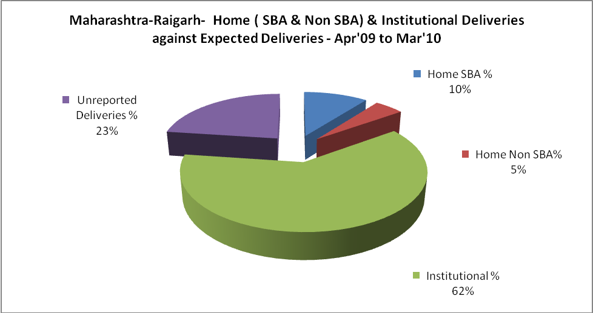

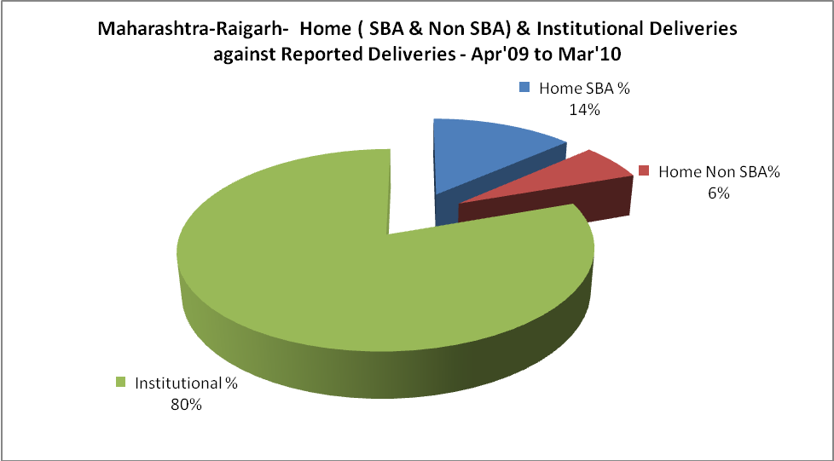

Maharashtra-Raigarh- C sections & Complicated Deliveries Apr'09 to Mar'10
 | Institutional Deliveries (Public) | Institutional Deliveries (Pvt)
 | 8,784 | 20,442
C Section | 1,336 | 3,323
C Section% | 15% | 16%
Complicated Pregnancies attended | 903 | 789
Complicated Pregnancies attended % | 10% | 4%

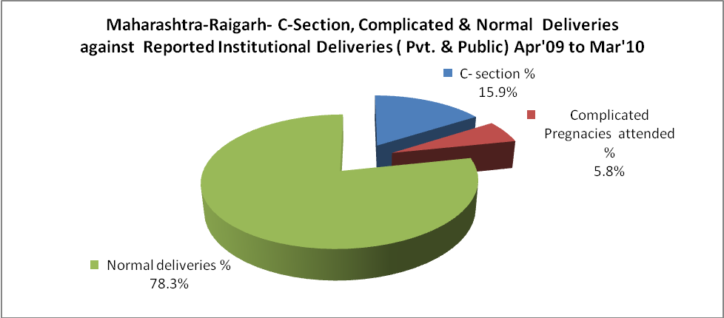

Maharashtra-Raigarh- Complicated Pregnancies & Deliveries Treated - Apr'09 to Mar'10
Reported Deliveries |  |  | Reported ANC Registration
36,372 |  |  | 47,287
Complicated Pregnancies attended | Complicated Pregnancies Rate | C - Section Deliveries | PNC Maternal Complications | Abortions | Still Births
1,692 | 3% | 4,659 | - | 1,934 | 565
Complicated Deliveries Treated with |  |  |  | No Of Eclampsia cases Treated | No Of severe anemia cases treated
IV Antibiotics | IV antihypertensive/Magsulph injection | IV Oxytocis | Blood Transfusion | No Of Eclampsia cases Treated | No Of severe anemia cases treated
- | - | - | - | - | -

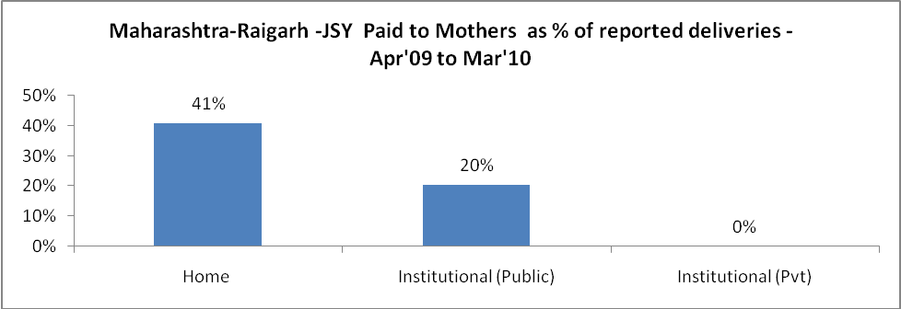

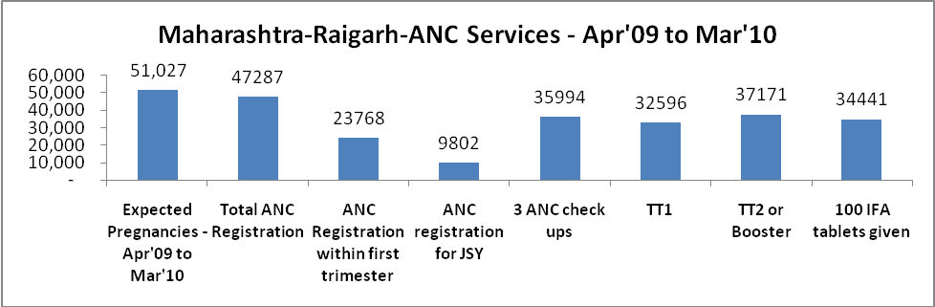

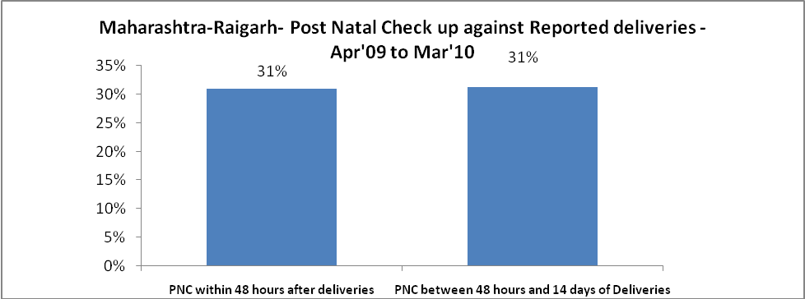

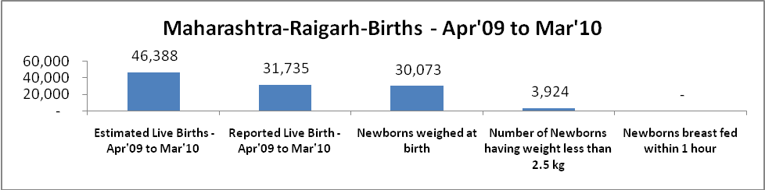

Maharashtra-Raigarh - Births - Apr'09 to Mar'10
Live Birth - Males | Live Birth - females | Live Birth - Total | Sex Ratio at birth | Still Birth | Abortion( Induced/Spontaneous
16,716 | 15,019 | 31,735 | 898 | 565 | 1,934

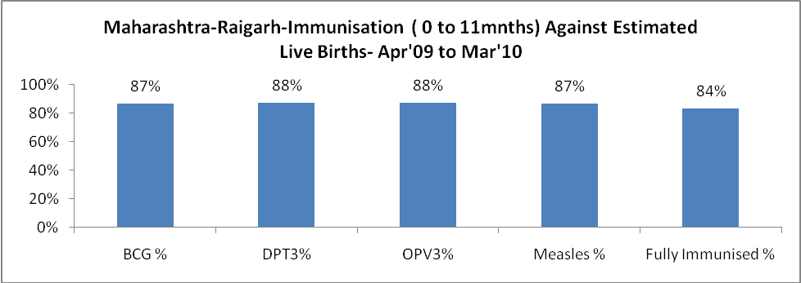

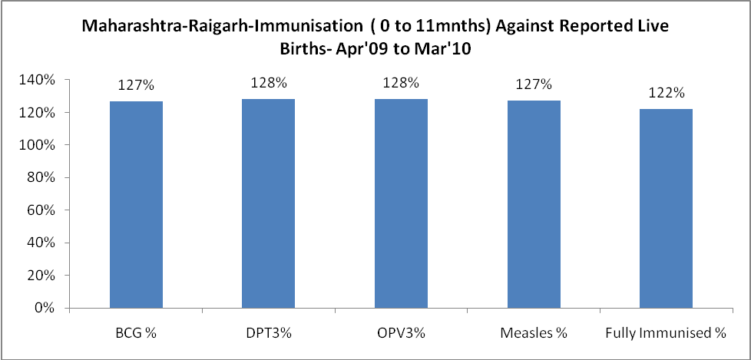

Maharashtra-Raigarh- Apr'09 to Mar'10
Total Abortions | Abortion Rate
6,065 | 11.9%

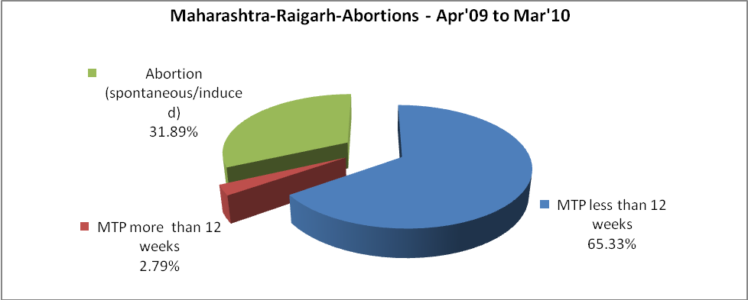

Maharashtra-Raigarh- Apr'09 to Mar'10
Total OPD | Total RTI/STI cases
- | 6,111

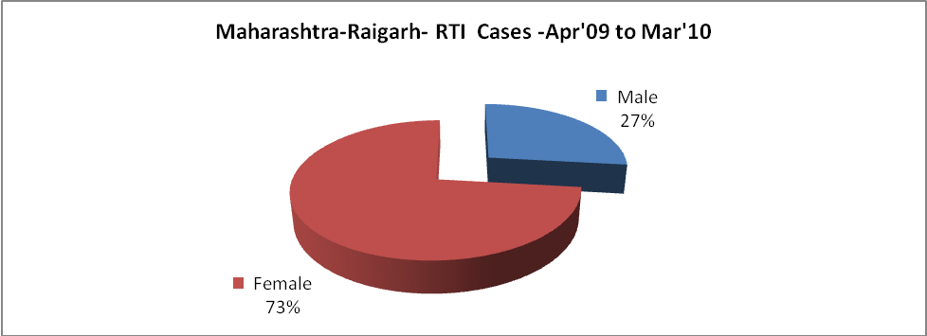

Maharashtra-Raigarh-Sterilizations - Apr'09 to Mar'10
 | Reported | %age of Reported Sterilization
Total Sterilization | 6,254 | -
NSV | 50 | 1%
Laparoscopic | 2,396 | 38%
Mini Lap | 2,873 | 46%
Post Partum | 935 | 15%
Male Sterilization | 50 | 1%
Female Sterilization | 6,204 | 99%

Maharashtra-Raigarh-FP Methods - Apr'09 to Mar'10
 | Reported | %age of All Reported FP Methods
Total Reported FP Method (All types) Users | 27,051 | -
Sterilizations | 6,254 | 23%
IUD | 7,847 | 29%
Condom Users | 6,365 | 24%
OCP Users | 6,584 | 24%
Limiting Methods | 6,254 | 23%
Spacing Methods | 20,797 | 77%

Maharashtra-Raigarh- Lab Services - Apr'09 to Mar'10
Total OPD | Total HB tested | Total HIV Tested | Total Population
- | - | - | 2,591,527
HB test conducted as %age of OPD | HB<7gm as %age of HB tested | HIV test conducted as %age of OPD | HIV positive as %age of HIV tested | Blood Smear Examined as % of Population
0.0% | 0.0% | 0.0% | 0.0% | 0.0%

Maharashtra-Raigarh- Childhood Disease - Vaccine Preventable -Apr'09 to Mar'10
Diphtheria | Pertussis | Tetanus Neonatorum | Tetanus others | Polio | Measles
0 | 0 | 0 | 0 | 0 | 0
Maharashtra-Raigarh-Childhood Disease - Others - Apr'09 to Mar'10
Diarrhoea and dehydration | Malaria | Number admitted with Respiratory Infections
1,225 | 28 | 131

Maharashtra-Raigarh- Infant & Child Deaths - Apr'09 to Mar'10
Infant Deaths within 24 hrs of birth | Infant Deaths between 24hrs & under 1 week | Infant Deaths between 1 week & under 1 month | Child Deaths between 1 month & under 1 year | Child Deaths between 1yr under 5years | Total Deaths
0 | 0 | 0 | 0 | 0 | 0

Maharashtra-Raigarh- Causes of Infant & Child Deaths - Apr'09 to Mar'10
Sepsis |  |  | Asphyxia |  |  | LBW
Up to 1 Weeks of Birth | Between 1 week & 4 weeks of birth | Total | Up to 1 Weeks of Birth | Between 1 week & 4 weeks of birth | Total | Up to 1 Weeks of Birth | Between 1 week & 4 weeks of birth | Total
0 | 0 | 0 | 0 | 0 | 0 | 0 | 0 | 0
Pneumonia |  |  | Diarrhoea |  |  | Fever related
Between 1 month and 11 months | Between 1 year & 5 years | Total | Between 1 month and 11 months | Between 1 year & 5 years | Total | Between 1 month and 11 months | Between 1 year & 5 years | Total
0 | 0 | 0 | 0 | 0 | 0 | 0 | 0 | 0
Others |  |  | Measles |  |  | Others
Up to 1 Weeks of Birth | Between 1 week & 4 weeks of birth | Total | Between 1 month and 11 months | Between 1 year & 5 years | Total | Between 1 month and 11 months | Between 1 year & 5 years | Total
0 | 0 | 0 | 0 | 0 | 0 | 0 | 0 | 0

Maharashtra-Raigarh- Maternal Deaths & Causes - Apr'09 to Mar'10
Abortion |  |  | Obstructed/prolonged labour |  |  | Severe hypertension/fits
6-14 yrs | 15-55 yrs. | Total | 6-14 yrs | 15-55 yrs. | Total | 6-14 yrs | 15-55 yrs. | Total
0 | 0 | 0 | 0 | 0 | 0 | 0 | 0 | 0
Bleeding |  |  | High Fever |  |  | Other Causes
6-14 yrs | 15-55 yrs. | Total | 6-14 yrs | 15-55 yrs. | Total | 6-14 yrs | 15-55 yrs. | Total
0 | 0 | 0 | 0 | 0 | 0 | 0 | 0 | 0

Maharashtra-Raigarh-Causes of Deaths in 6 to 55yrs age group - Apr'09 to Mar'10
Diarrhoel Diseases |  |  |  | Tuberculosis |  |  |  | Respiratory Diseases( Other than TB)
6-14 yrs | 15-55 yrs. | Above 55yrs | Total | 6-14 yrs | 15-55 yrs. | Above 55yrs | Total | 6-14 yrs | 15-55 yrs. | Above 55yrs | Total
0 | 0 | 0 | 0 | 0 | 0 | 0 | 0 | 0 | 0 | 0 | 0
Malaria |  |  |  | Other fever Related |  |  |  | HIV/Aids
6-14 yrs | 15-55 yrs. | Above 55yrs | Total | 6-14 yrs | 15-55 yrs. | Above 55yrs | Total | 6-14 yrs | 15-55 yrs. | Above 55yrs | Total
0 | 0 | 0 | 0 | 0 | 0 | 0 | 0 | 0 | 0 | 0 | 0
Heart Disease/Hypertension related |  |  |  | Neurological Disease including strokes |  |  |  | Trauma/Accidents/ Burn Cases
6-14 yrs | 15-55 yrs. | Above 55yrs | Total | 6-14 yrs | 15-55 yrs. | Above 55yrs | Total | 6-14 yrs | 15-55 yrs. | Above 55yrs | Total
0 | 0 | 0 | 0 | 0 | 0 | 0 | 0 | 0 | 0 | 0 | 0
Suicide |  |  |  | Animal Bites & Stings
6-14 yrs | 15-55 yrs. | Above 55yrs | Total | 6-14 yrs | 15-55 yrs. | Above 55yrs | Total
0 | 0 | 0 | 0 | 0 | 0 | 0 | 0

