NHSRC
Rajasthan
Analysis: Apr 2009 – Mar 2010

Rajasthan- Summary-Apr'09 to Mar'10
ANC
ANC Registration against Expected Pregnancies | 98% | TT1 given to Pregnant women against ANC Registraion | 66%
3 ANC Check ups against ANC Reigtrations | 66% | 100 IFA Tablets given to Pregnant women against ANC Registraion | 80%
Deliveries
Unreported Deliveries against Estimated Deliveries | 27.4% | HOME Deliveries( SBA& Non SBA) against Estimated Deliveries | 10.0%
Institutional Deliveries against Estimated Deliveries | 62.7% | HOME Deliveries( SBA& Non SBA) against Reported Deliveries | 13.8%
Institutional Deliveries against Reported Deliveries | 86.2% | C Section Deliveries against Institutional Deliveries( Pvt & Pub) | 4%
Births & Neonates Care
Live Births Reported against Estimated Live Births | 72% | New borns weighed against Reported Live Births | 85%
Still Births (Reported) | 21,740 | New borns weighed less than 2.5 kgs against newborns weighed | 16%
Sex Ratio at Birh | 900 | New borns breastfed within one hr of Birth against Reported live Births | 77%
Child Immunisation( 0 to 11 months)
BCG given against Expected Live Births | 94% | Measles given against Expected Live Births | 87%
OPV3 given against Expected Live Births | 89% | Fully Immunised Children against Expected Live Births | 83%
DPT3 given against Expected Live Births | 89%
Family Planning
Family Plannig Methods Users ( Sterilisations(Male &Female)+IUD+ Condom pieces/72 + OCP Cycles/13) | 3,262,433 | IUD Insertions against reported FP Methods | 13%
Sterilisation against reported FP Methods | 9% | Condom Users against reported FP Methods | 51%
 |  | OCP Users against reported FP Methods | 27%
Other Services
OPD | 30,121,134 | Major Operations | 61,425
IPD | 1,759,834 | Minor Operations | 137,204

Rajasthan- Deliveries Apr'09 to Mar'10
Total Population | 67,664,000 | Expected Deliveries |  | 1,919,374
Home SBA | Home Non SBA | Institutional | Total Deliveries Reported | Unreported Deliveries
106,266 | 85,519 | 1,202,596 | 1,394,381 | 524,993
Home SBA % | Home Non SBA% | Institutional % | Total Deliveries Reported % | Unreported Deliveries %
6% | 4% | 63% | 73% | 27%
`

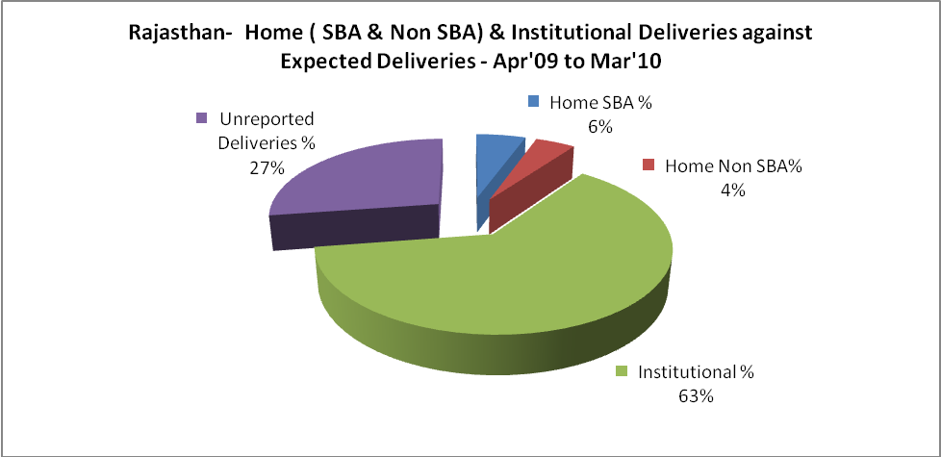

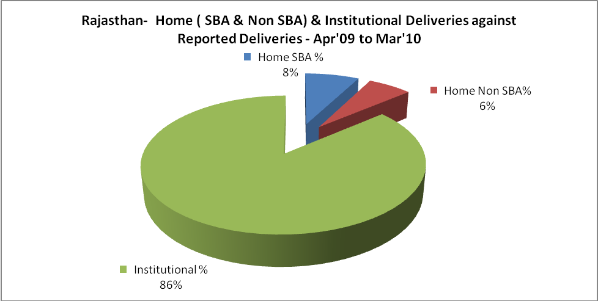

Rajasthan- C sections & Complicated Deliveries Apr'09 to Mar'10
 | Institutional Deliveries (Public) | Institutional Deliveries (Pvt)
 | 940,492 | 262,104
C Section | 37,302 | 12,865
C Section% | 4% | 5%
Complicated Pregnacies attended | 37,262 | 6,855
Complicated Pregnacies attended % | 4% | 3%

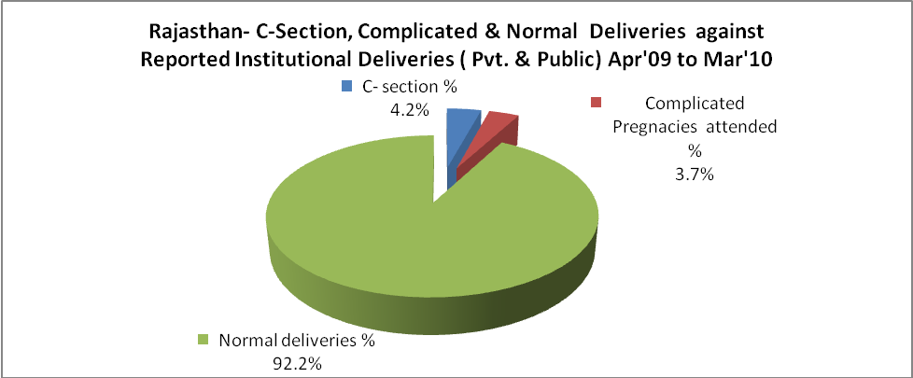

Rajasthan- Complicated Pregnancies & Deliveries Treated - Apr'09 to Mar'10
Reported Deliveries |  |  | Reported ANC Reigtration
1,394,381 |  |  | 2,012,114
Complicated Pregnancies attended | Complicated Pregnancies Rate | C - Section Deliveries | PNC Maternal Complications | Abortions | Still Births
44,117 | 2% | 50,167 | 16,502 | 21,908 | 21,740
Complicated Deliveries Treated with |  |  |  | No Of Eclampsia cases Treated | No Of severe anemia cases treated
IV Antibiotics | IV antihypertensive/Magsulph injection | IV Oxytocis | Blood Transfusion | No Of Eclampsia cases Treated | No Of severe anemia cases treated
75,647 | 11,074 | 69,412 | 10,532 | 8,416 | 54,812

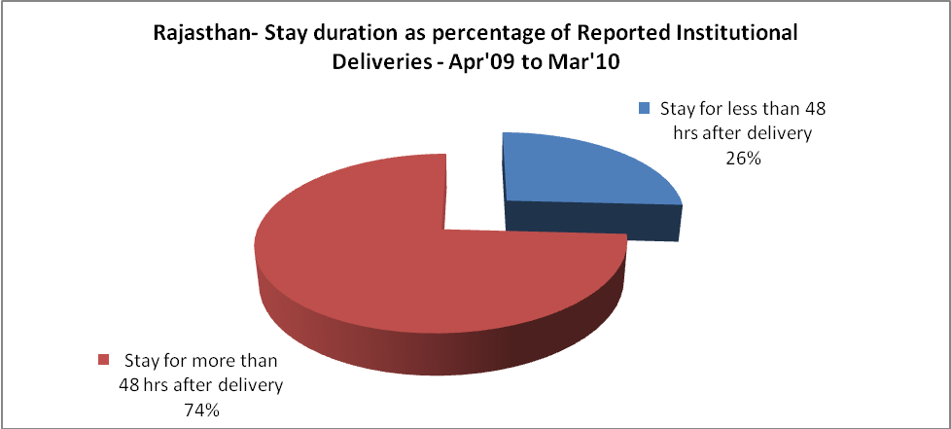

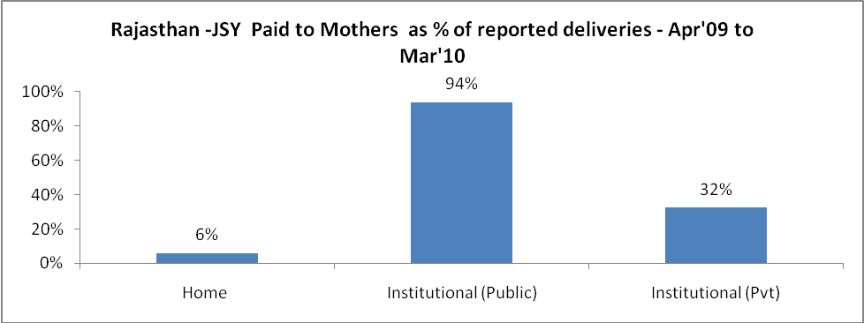

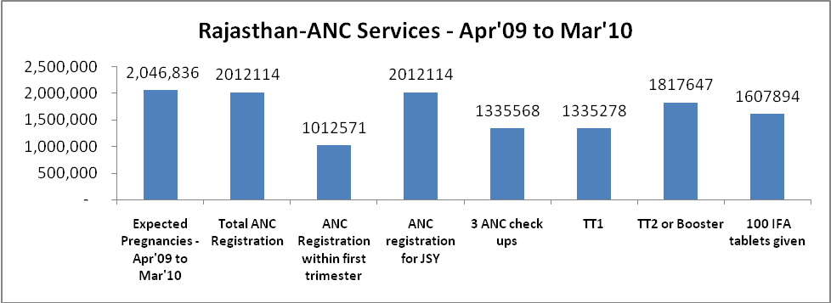

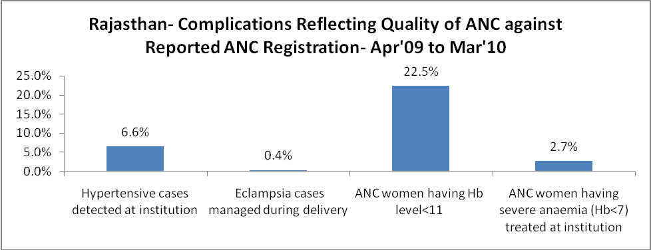

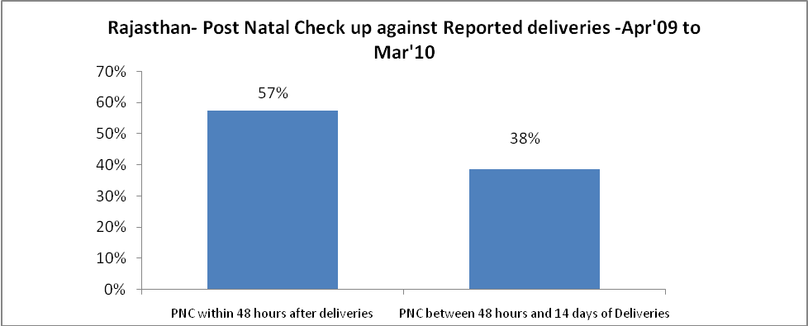

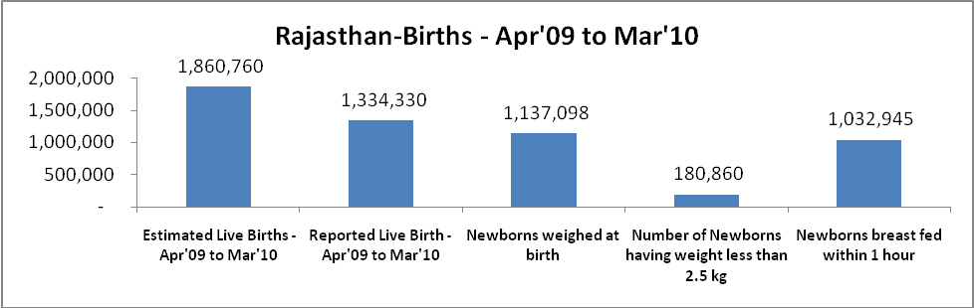

Rajasthan - Births - Apr'09 to Mar'10
Live Birth - Males | Live Birth - females | Live Birth - Total | Sex Ratio at birth | Still Birth | Abortion( Induced/Spontaneous
702,134 | 632,196 | 1,334,330 | 900 | 21,740 | 21,908

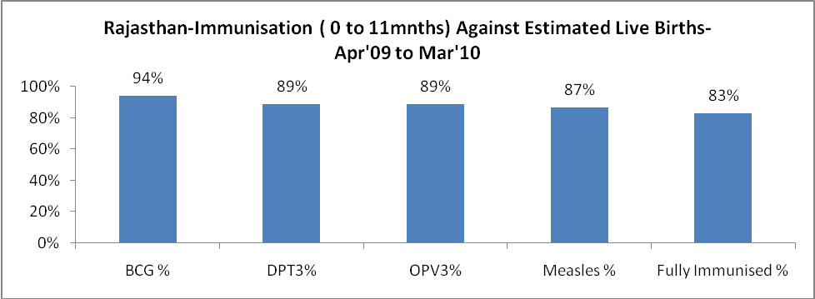

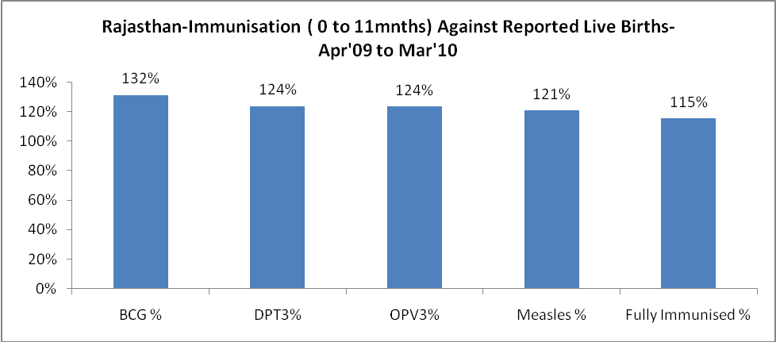

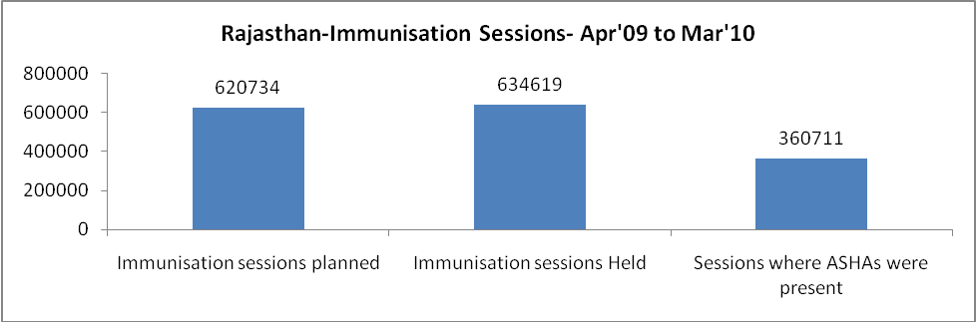

Rajasthan- Apr'09 to Mar'10
Total Abortions | Abortion Rate
45,288 | 2.2%

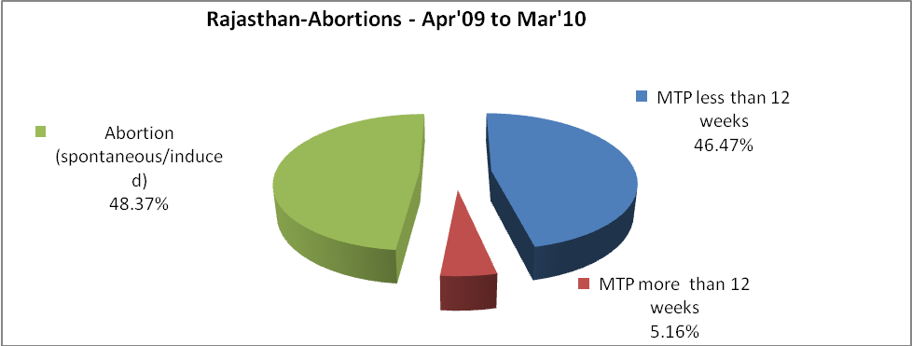

Rajasthan- Apr'09 to Mar'10
Total OPD | Total RTI/STI cases
30,121,134 | 153,508

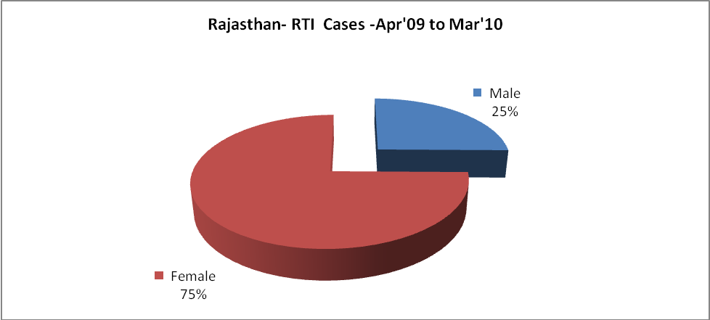

Rajasthan-Sterilisations - Apr'09 to Mar'10
 | Reported | %age of Reported Sterilisation
Total Sterilisation | 304,003 | -
NSV | 9,314 | 3%
Laproscopic | 256,909 | 85%
MiniLap | 4,149 | 1%
Post Partum | 33,631 | 11%
Male Sterilisation | 9,314 | 3%
Female Sterilisation | 294,689 | 97%

Rajasthan-FP Methods - Apr'09 to Mar'10
 | Reported | %age of All Reported FP Methods
Total Reported FP Methodd (All types) Users | 3,262,433 | -
Sterilisations | 304,003 | 9%
IUD | 409,560 | 13%
Condom Users | 1,679,601 | 51%
OCP Users | 869,268 | 27%
Limiting Methods | 304,003 | 9%
Spacing Methods | 2,958,430 | 91%

Rajasthan- Service Delivery - Apr'09 to Mar'10
Operation major (General and spinal anaesthesia) | Operation minor (No or local anaesthesia) | AYUSH | Dental Procedures | Adolescent counselling services | Total OPD | Total IPD
61,425 | 137,204 | 1,334,765 | 75,977 | 62,862 | 30,121,134 | 1,759,834
Operation major (General and spinal anaesthesia) as %ge of OPD | Operation minor (No or local anaesthesia)as %ge of OPD | AYUSH as %ge of OPD | Dental Procedures as %ge of OPD | Adolescent counselling services as %ge of OPD | IPD as percentage of OPD
0.2% | 0.5% | 4.4% | 0.3% | 0.2% | 6%

Rajasthan- Lab Services - Apr'09 to Mar'10
Total OPD | Total HB tested | Total HIV Tested | Total Population
30,121,134 | 853,783 | 214,830 | 67,664,000
HB test conducted as %age of OPD | HB<7gm as %age of HB tested | HIV test conducted as %age of OPD | HIV positive as %age of HIV tested | Blood Smear Examined as % of Population
2.8% | 7.8% | 0.7% | 0.7% | 6.2%

Rajasthan- Childhood Disease - Vaccine Preventable -Apr'09 to Mar'10
Diphtheria | Pertussis | Tetanus Neonatorum | Tetanus others | Polio | Measles
76 | 116 | 24 | 113 | 1 | 1809
Rajasthan-Childhood Disease - Others - Apr'09 to Mar'10
Diarrhoea and dehydration | Malaria | Number admitted with Respiratory Infections
104,183 | 9,970 | 67,263

Rajasthan- Infant & Child Deaths - Apr'09 to Mar'10
Infant Deaths within 24 hrs of birth | Infant Deaths between 24hrs & under 1 week | Infant Deaths between 1 week & under 1 month | Child Deaths between 1 month & under 1 year | Child Deaths between 1yr under 5years | Total Deaths
1695 | 3529 | 1545 | 2999 | 3099 | 12867

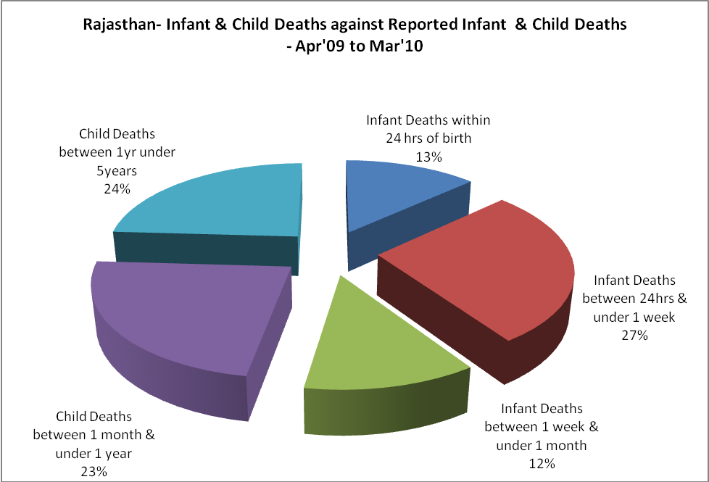

Rajasthan- Causes of Infant & Child Deaths - Apr'09 to Mar'10
Sepsis |  |  | Asphyxia |  |  | LBW
Up to 1 Weeks of Birth | Between 1 week & 4 weeks of birth | Total | Up to 1 Weeks of Birth | Between 1 week & 4 weeks of birth | Total | Up to 1 Weeks of Birth | Between 1 week & 4 weeks of birth | Total
339 | 206 | 545 | 683 | 262 | 945 | 986 | 395 | 1381
Pneumonia |  |  | Diarrhoea |  |  | Fever related
Between 1 month and 11 months | Between 1 year & 5 years | Total | Between 1 month and 11 months | Between 1 year & 5 years | Total | Between 1 month and 11 months | Between 1 year & 5 years | Total
551 | 401 | 952 | 432 | 505 | 937 | 611 | 764 | 1375
Others |  |  | Measles |  |  | Others
Up to 1 Weeks of Birth | Between 1 week & 4 weeks of birth | Total | Between 1 month and 11 months | Between 1 year & 5 years | Total | Between 1 month and 11 months | Between 1 year & 5 years | Total
1521 | 682 | 2203 | 8 | 8 | 16 | 1397 | 1421 | 2818

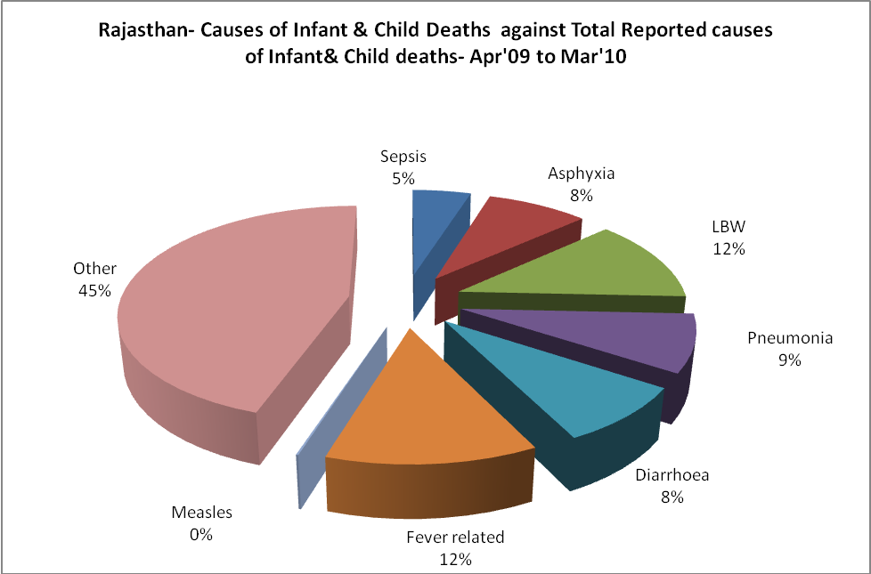

Rajasthan- Maternal Deaths & Causes - Apr'09 to Mar'10
Abortion |  |  | Obstructed/prolonged labour |  |  | Severe hypertesnion/fits
6-14 yrs | 15-55 yrs. | Total | 6-14 yrs | 15-55 yrs. | Total | 6-14 yrs | 15-55 yrs. | Total
6 | 86 | 92 | 2 | 41 | 43 | 9 | 24 | 33
Bleeding |  |  | High Fever |  |  | Other Causes
6-14 yrs | 15-55 yrs. | Total | 6-14 yrs | 15-55 yrs. | Total | 6-14 yrs | 15-55 yrs. | Total
8 | 85 | 93 | 7 | 34 | 41 | 62 | 319 | 381

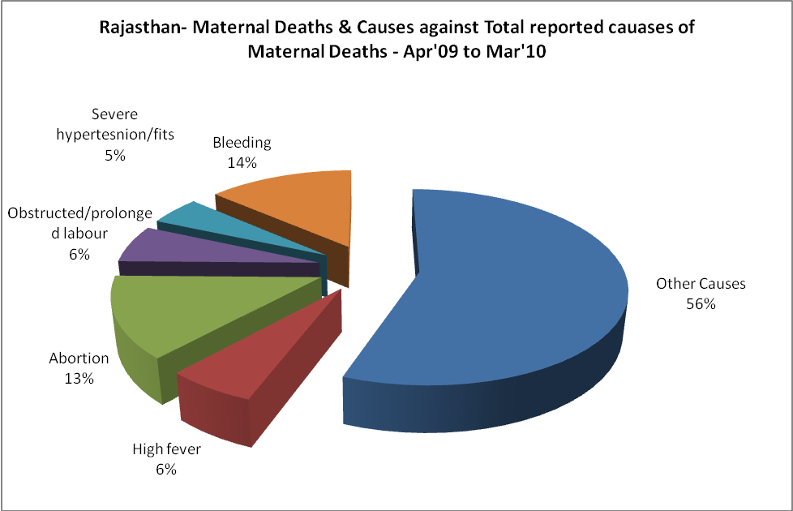

Rajasthan-Causes of Deaths in 6 to 55yrs age group - Apr'09 to Mar'10
Diarrhoel Diseases |  |  |  | Tuberculosis |  |  |  | Respiratory Diseases( Other than TB)
6-14 yrs | 15-55 yrs. | Above 55yrs | Total | 6-14 yrs | 15-55 yrs. | Above 55yrs | Total | 6-14 yrs | 15-55 yrs. | Above 55yrs | Total
666 | 429 | 269 | 1364 | 110 | 783 | 423 | 1316 | 288 | 1173 | 1439 | 2900
Malaria |  |  |  | Other fever Related |  |  |  | HIV/Aids
6-14 yrs | 15-55 yrs. | Above 55yrs | Total | 6-14 yrs | 15-55 yrs. | Above 55yrs | Total | 6-14 yrs | 15-55 yrs. | Above 55yrs | Total
79 | 286 | 80 | 445 | 538 | 592 | 446 | 1576 | 7 | 42 | 35 | 84
Heart Disease/Hypertenion related |  |  |  | Neurological Disease including strokes |  |  |  | Trauma/Accidents/ Burn Cases
6-14 yrs | 15-55 yrs. | Above 55yrs | Total | 6-14 yrs | 15-55 yrs. | Above 55yrs | Total | 6-14 yrs | 15-55 yrs. | Above 55yrs | Total
105 | 1081 | 1186 | 2372 | 1115 | 389 | 384 | 1888 | 254 | 1006 | 355 | 1615
Suicide |  |  |  | Animal Bites & Stings
6-14 yrs | 15-55 yrs. | Above 55yrs | Total | 6-14 yrs | 15-55 yrs. | Above 55yrs | Total
52 | 499 | 96 | 647 | 97 | 236 | 134 | 467

