NHSRC
Rajasthan-Rajasmand
Analysis: Apr 2009 – Mar 2010

Rajasthan- Rajsamand- Summary-Apr'09 to Mar'10
ANC
ANC Registration against Expected Pregnancies | 105% | TT1 given to Pregnant women against ANC Registration | 71%
3 ANC Checkups against ANC Registrations | 64% | 100 IFA Tablets given to Pregnant women against ANC Registration | 98%
Deliveries
Unreported Deliveries against Estimated Deliveries | 29.3% | HOME Deliveries( SBA& Non SBA) against Estimated Deliveries | 13.3%
Institutional Deliveries against Estimated Deliveries | 57.4% | HOME Deliveries( SBA& Non SBA) against Reported Deliveries | 18.8%
Institutional Deliveries against Reported Deliveries | 81.2% | C Section Deliveries against Institutional Deliveries( Pvt & Pub) | 2%
Births & Neonates Care
Live Births Reported against Estimated Live Births | 71% | New borns weighed against Reported Live Births | 79%
Still Births (Reported) | 332 | New borns weighed less than 2.5 kgs against newborns weighed | 35%
Sex Ratio at Birh | 953 | New borns breastfed within one hr of Birth against Reported live Births | 75%
Child Immunisation( 0 to 11 months)
BCG given against Expected Live Births | 92% | Measles given against Expected Live Births | 86%
OPV3 given against Expected Live Births | 86% | Fully Immunised Children against Expected Live Births | 83%
DPT3 given against Expected Live Births | 87%
Family Planning
Family Plannig Methods Users ( Sterilisations(Male &Female)+IUD+ Condom pieces/72 + OCP Cycles/13) | 70,933 | IUD Insertions against reported FP Methods | 12%
Sterilisation against reported FP Methods | 7% | Condom Users against reported FP Methods | 49%
 |  | OCP Users against reported FP Methods | 32%
Other Services
OPD | 671,622 | Major Operations | 2,826
IPD | 45,919 | Minor Operations | 2,534

Rajasthan- Rajsamand- Deliveries Apr'09 to Mar'10
Total Population | 1,173,200 | Expected Deliveries |  | 33,279
Home SBA | Home Non SBA | Institutional | Total Deliveries Reported | Unreported Deliveries
2,305 | 2,112 | 19,112 | 23,529 | 9,750
Home SBA % | Home Non SBA% | Institutional % | Total Deliveries Reported % | Unreported Deliveries %
7% | 6% | 57% | 71% | 29%
`

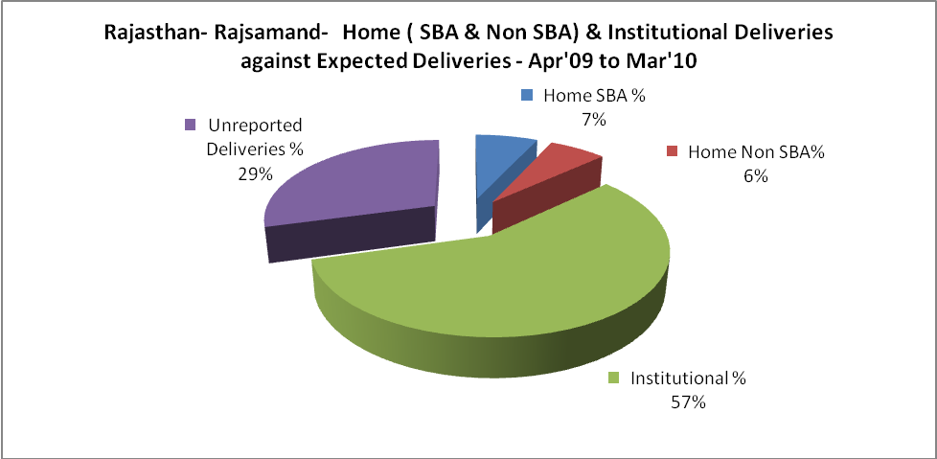

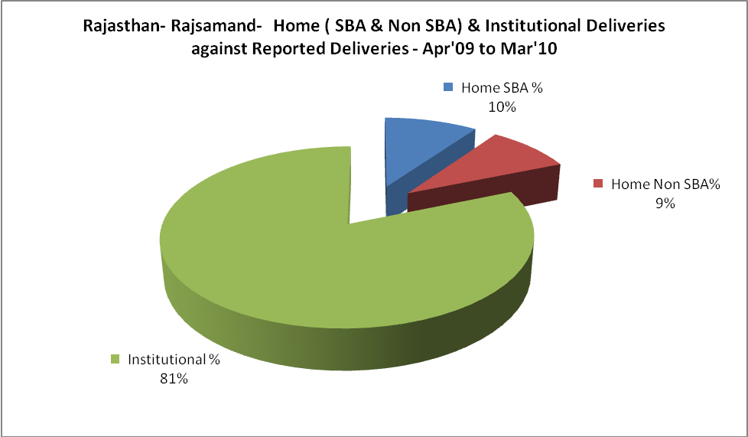

Rajasthan- Rajsamand- C sections & Complicated Deliveries Apr'09 to Mar'10
 | Institutional Deliveries (Public) | Institutional Deliveries (Pvt)
 | 17,489 | 1,623
C Section | 133 | 295
C Section% | 1% | 18%
Complicated Pregnacies attended | 394 | 124
Complicated Pregnacies attended % | 2% | 8%

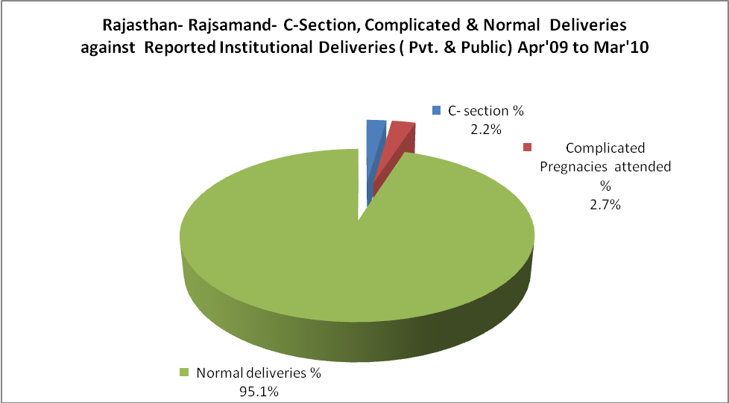

Rajasthan- Rajsamand- Complicated Pregnancies & Deliveries Treated - Apr'09 to Mar'10
Reported Deliveries |  |  | Reported ANC Reigtration
23,529 |  |  | 37,197
Complicated Pregnancies attended | Complicated Pregnancies Rate | C - Section Deliveries | PNC Maternal Complications | Abortions | Still Births
518 | 1% | 428 | 241 | 598 | 332
Complicated Deliveries Treated with |  |  |  | No Of Eclampsia cases Treated | No Of severe anemia cases treated
IV Antibiotics | IV antihypertensive/Magsulph injection | IV Oxytocis | Blood Transfusion | No Of Eclampsia cases Treated | No Of severe anemia cases treated
833 | 264 | 1,301 | 61 | 45 | 438

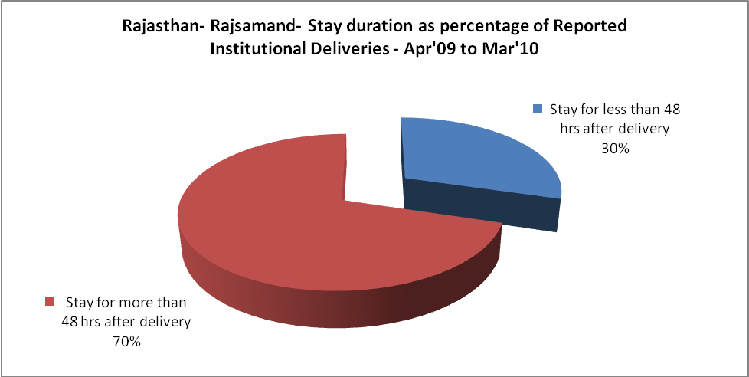

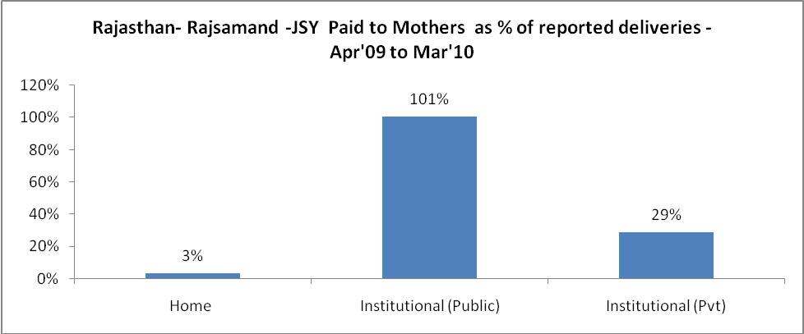

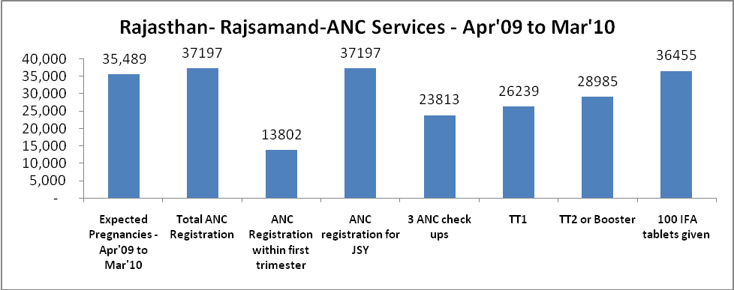

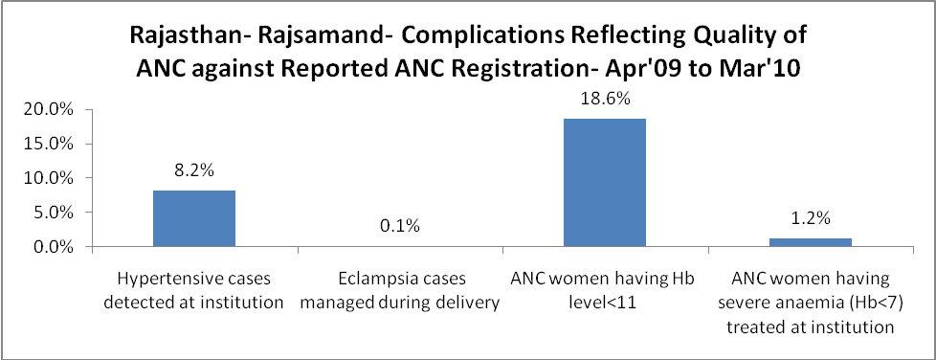

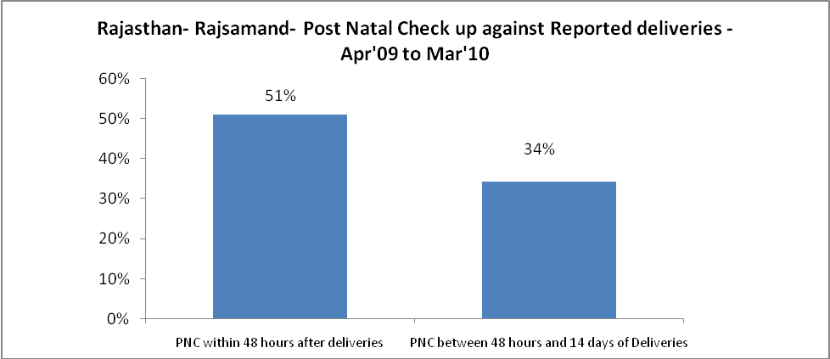

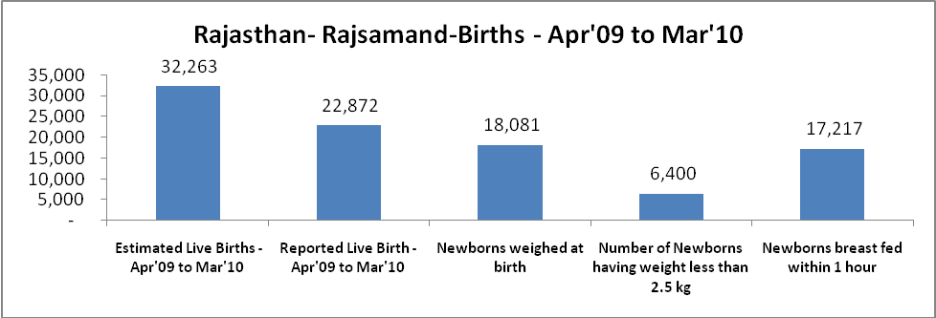

Rajasthan- Rajsamand - Births - Apr'09 to Mar'10
Live Birth - Males | Live Birth - females | Live Birth - Total | Sex Ratio at birth | Still Birth | Abortion( Induced/Spontaneous
11,712 | 11,160 | 22,872 | 953 | 332 | 598

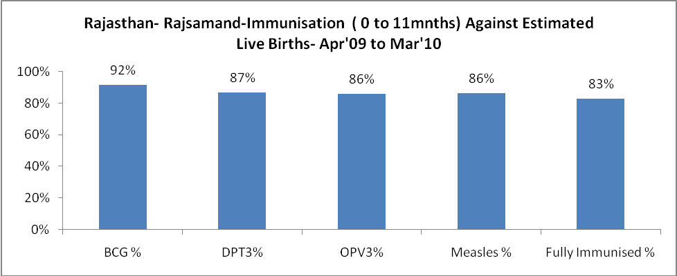

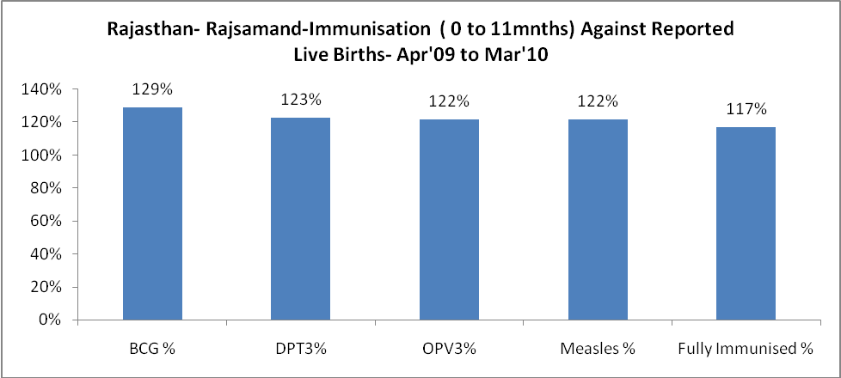

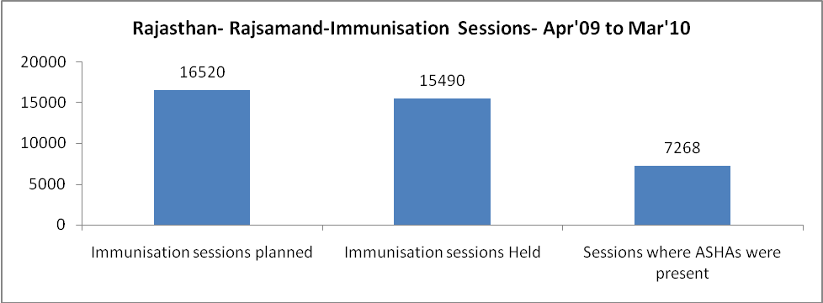

Rajasthan- Rajsamand- Apr'09 to Mar'10
Total Abortions | Abortion Rate
958 | 2.7%

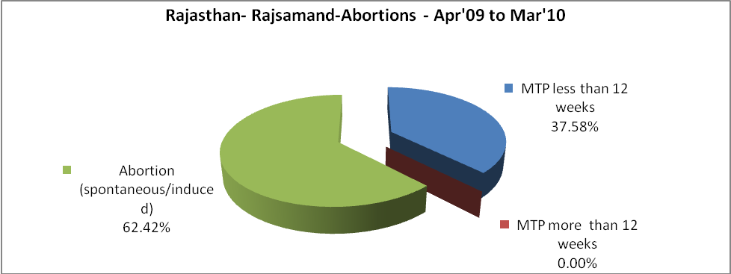

Rajasthan- Rajsamand- Apr'09 to Mar'10
Total OPD | Total RTI/STI cases
671,622 | 3,000

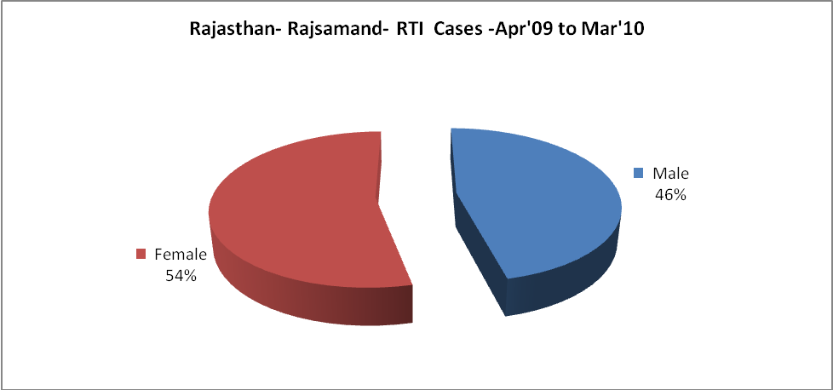

Rajasthan- Rajsamand-Sterilisations - Apr'09 to Mar'10
 | Reported | %age of Reported Sterilisation
Total Sterilisation | 5,011 | -
NSV | 526 | 10%
Laproscopic | - | 0%
MiniLap | - | 0%
Post Partum | 4,485 | 90%
Male Sterilisation | 526 | 10%
Female Sterilisation | 4,485 | 90%

Rajasthan- Rajsamand-FP Methods - Apr'09 to Mar'10
 | Reported | %age of All Reported FP Methods
Total Reported FP Methodd (All types) Users | 70,933 | -
Sterilisations | 5,011 | 7%
IUD | 8,467 | 12%
Condom Users | 34,940 | 49%
OCP Users | 22,515 | 32%
Limiting Methods | 5,011 | 7%
Spacing Methods | 65,922 | 93%

Rajasthan- Rajsamand- Service Delivery - Apr'09 to Mar'10
Operation major (General and spinal anaesthesia) | Operation minor (No or local anaesthesia) | AYUSH | Dental Procedures | Adolescent counselling services | Total OPD | Total IPD
2,826 | 2,534 | 18,499 | 613 | 722 | 671,622 | 45,919
Operation major (General and spinal anaesthesia) as %ge of OPD | Operation minor (No or local anaesthesia)as %ge of OPD | AYUSH as %ge of OPD | Dental Procedures as %ge of OPD | Adolescent counselling services as %ge of OPD | IPD as percentage of OPD
0.4% | 0.4% | 2.8% | 0.1% | 0.1% | 7%

Rajasthan- Rajsamand- Lab Services - Apr'09 to Mar'10
Total OPD | Total HB tested | Total HIV Tested | Total Population
671,622 | 15,166 | 5,656 | 1,173,200
HB test conducted as %age of OPD | HB<7gm as %age of HB tested | HIV test conducted as %age of OPD | HIV positive as %age of HIV tested | Blood Smear Examined as % of Population
2.3% | 11.8% | 0.8% | 1.1% | 4.4%

Rajasthan- Rajsamand- Childhood Disease - Vaccine Preventable -Apr'09 to Mar'10
Diphtheria | Pertussis | Tetanus Neonatorum | Tetanus others | Polio | Measles
0 | 0 | 0 | 0 | 0 | 5
Rajasthan- Rajsamand-Childhood Disease - Others - Apr'09 to Mar'10
Diarrhoea and dehydration | Malaria | Number admitted with Respiratory Infections
2,515 | 168 | 759

Rajasthan- Rajsamand- Infant & Child Deaths - Apr'09 to Mar'10
Infant Deaths within 24 hrs of birth | Infant Deaths between 24hrs & under 1 week | Infant Deaths between 1 week & under 1 month | Child Deaths between 1 month & under 1 year | Child Deaths between 1yr under 5years | Total Deaths
28 | 93 | 52 | 127 | 105 | 405

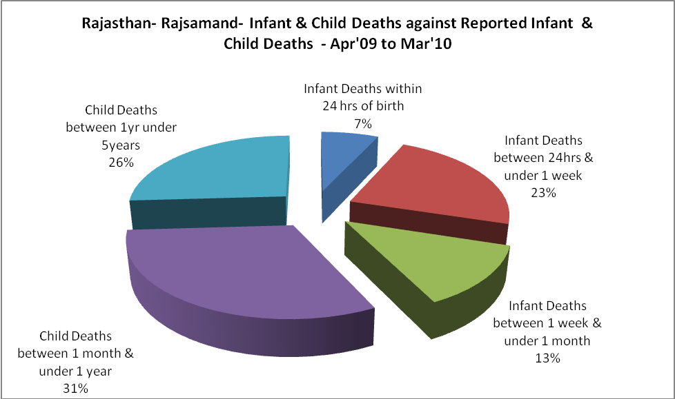

Rajasthan- Rajsamand- Causes of Infant & Child Deaths - Apr'09 to Mar'10
Sepsis |  |  | Asphyxia |  |  | LBW
Up to 1 Weeks of Birth | Between 1 week & 4 weeks of birth | Total | Up to 1 Weeks of Birth | Between 1 week & 4 weeks of birth | Total | Up to 1 Weeks of Birth | Between 1 week & 4 weeks of birth | Total
7 | 2 | 9 | 9 | 7 | 16 | 21 | 17 | 38
Pneumonia |  |  | Diarrhoea |  |  | Fever related
Between 1 month and 11 months | Between 1 year & 5 years | Total | Between 1 month and 11 months | Between 1 year & 5 years | Total | Between 1 month and 11 months | Between 1 year & 5 years | Total
17 | 9 | 26 | 10 | 12 | 22 | 12 | 21 | 33
Others |  |  | Measles |  |  | Others
Up to 1 Weeks of Birth | Between 1 week & 4 weeks of birth | Total | Between 1 month and 11 months | Between 1 year & 5 years | Total | Between 1 month and 11 months | Between 1 year & 5 years | Total
56 | 26 | 82 | 0 | 0 | 0 | 88 | 63 | 151

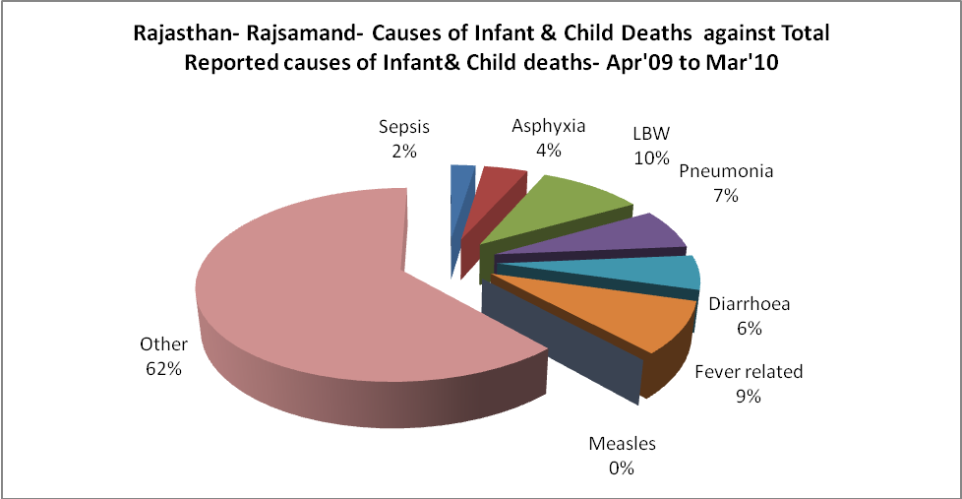

Rajasthan- Rajsamand- Maternal Deaths & Causes - Apr'09 to Mar'10
Abortion |  |  | Obstructed/prolonged labour |  |  | Severe hypertesnion/fits
6-14 yrs | 15-55 yrs. | Total | 6-14 yrs | 15-55 yrs. | Total | 6-14 yrs | 15-55 yrs. | Total
0 | 2 | 2 | 0 | 1 | 1 | 0 | 1 | 1
Bleeding |  |  | High Fever |  |  | Other Causes
6-14 yrs | 15-55 yrs. | Total | 6-14 yrs | 15-55 yrs. | Total | 6-14 yrs | 15-55 yrs. | Total
0 | 1 | 1 | 0 | 2 | 2 | 0 | 20 | 20

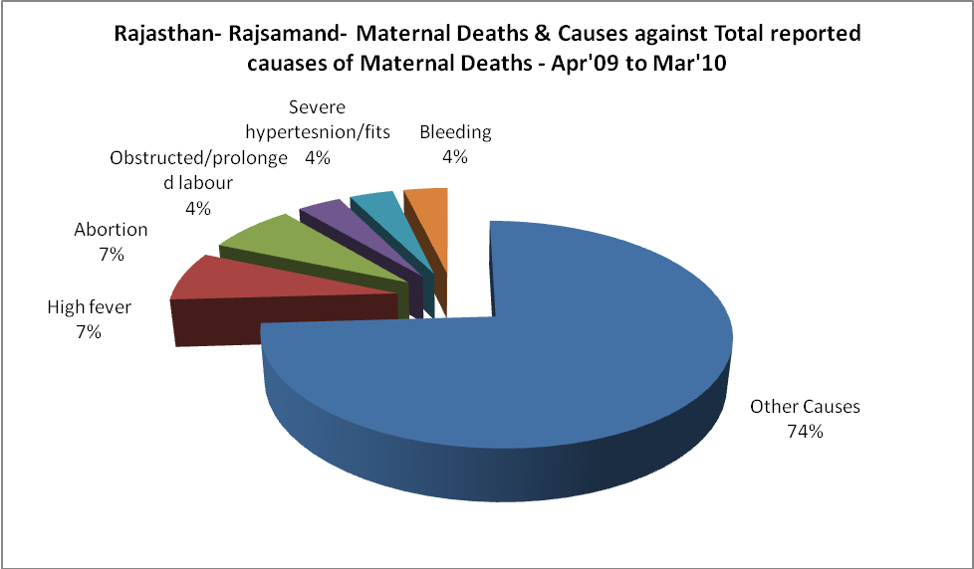

Rajasthan- Rajsamand-Causes of Deaths in 6 to 55yrs age group - Apr'09 to Mar'10
Diarrhoel Diseases |  |  |  | Tuberculosis |  |  |  | Respiratory Diseases( Other than TB)
6-14 yrs | 15-55 yrs. | Above 55yrs | Total | 6-14 yrs | 15-55 yrs. | Above 55yrs | Total | 6-14 yrs | 15-55 yrs. | Above 55yrs | Total
19 | 20 | 29 | 68 | 4 | 16 | 4 | 24 | 24 | 46 | 64 | 134
Malaria |  |  |  | Other fever Related |  |  |  | HIV/Aids
6-14 yrs | 15-55 yrs. | Above 55yrs | Total | 6-14 yrs | 15-55 yrs. | Above 55yrs | Total | 6-14 yrs | 15-55 yrs. | Above 55yrs | Total
1 | 0 | 5 | 6 | 73 | 27 | 22 | 122 | 0 | 1 | 0 | 1
Heart Disease/Hypertenion related |  |  |  | Neurological Disease including strokes |  |  |  | Trauma/Accidents/ Burn Cases
6-14 yrs | 15-55 yrs. | Above 55yrs | Total | 6-14 yrs | 15-55 yrs. | Above 55yrs | Total | 6-14 yrs | 15-55 yrs. | Above 55yrs | Total
5 | 40 | 24 | 69 | 20 | 23 | 54 | 97 | 10 | 101 | 4 | 115
Suicide |  |  |  | Animal Bites & Stings
6-14 yrs | 15-55 yrs. | Above 55yrs | Total | 6-14 yrs | 15-55 yrs. | Above 55yrs | Total
0 | 13 | 0 | 13 | 0 | 25 | 0 | 25

