NHSRC
Maharashtra – Ratnagiri
Analysis: Apr 2009 – Mar 2010

`
Maharashtra-Ratnagiri- Summary-Apr'09 to Mar'10
ANC
ANC Registration against Expected Pregnancies | 69% | TT1 given to Pregnant women against ANC Registration | 66%
3 ANC Check ups against ANC Registrations | 81% | 100 IFA Tablets given to Pregnant women against ANC Registration | 72%
Deliveries
Unreported Deliveries against Estimated Deliveries | 42.1% | HOME Deliveries( SBA& Non SBA) against Estimated Deliveries | 5.6%
Institutional Deliveries against Estimated Deliveries | 52.4% | HOME Deliveries( SBA& Non SBA) against Reported Deliveries | 9.6%
Institutional Deliveries against Reported Deliveries | 90.4% | C Section Deliveries against Institutional Deliveries( Pvt & Pub) | 15%
Births & Neonates Care
Live Births Reported against Estimated Live Births | 58% | New borns weighed against Reported Live Births | 99%
Still Births (Reported) | 268 | New borns weighed less than 2.5 kgs against newborns weighed | 16%
Sex Ratio at Birth | 881 | New borns breastfed within one hr of Birth against Reported live Births | 0%
Child Immunization( 0 to 11 months)
BCG given against Expected Live Births | 69% | Measles given against Expected Live Births | 63%
OPV3 given against Expected Live Births | 65% | Fully Immunized Children against Expected Live Births | 63%
DPT3 given against Expected Live Births | 65%
Family Planning
Family Planning Methods Users ( Sterilizations(Male &Female)+IUD+ Condom pieces/72 + OCP Cycles/13) | 34,798 | IUD Insertions against reported FP Methods | 22%
Sterilization against reported FP Methods | 21% | Condom Users against reported FP Methods | 35%
 |  | OCP Users against reported FP Methods | 23%
Other Services
OPD | 229,881 | Major Operations | 1,187
IPD | - | Minor Operations | 1,419

Maharashtra-Ratnagiri- Deliveries Apr'09 to Mar'10
Total Population | 1,991,367 | Expected Deliveries |  | 36,234
Home SBA | Home Non SBA | Institutional | Total Deliveries Reported | Unreported Deliveries
1,933 | 86 | 18,969 | 20,988 | 15,246
Home SBA % | Home Non SBA% | Institutional % | Total Deliveries Reported % | Unreported Deliveries %
5% | 0% | 52% | 58% | 42%

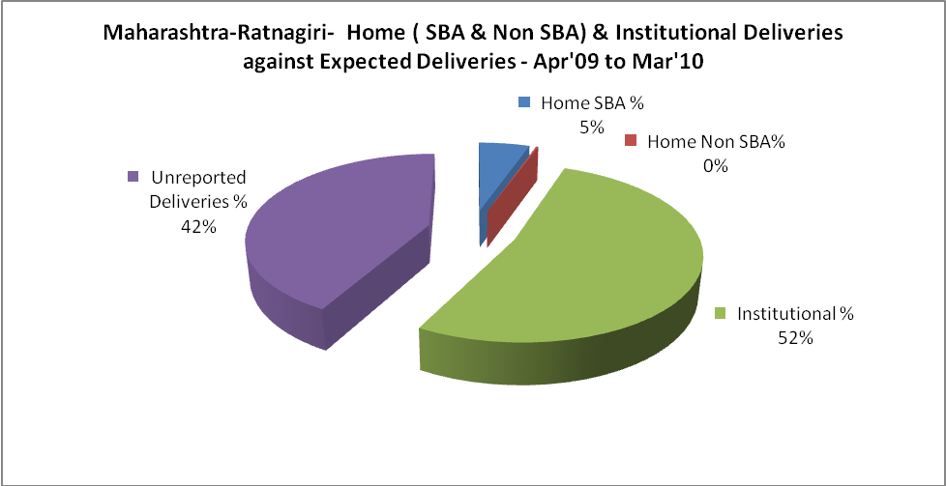

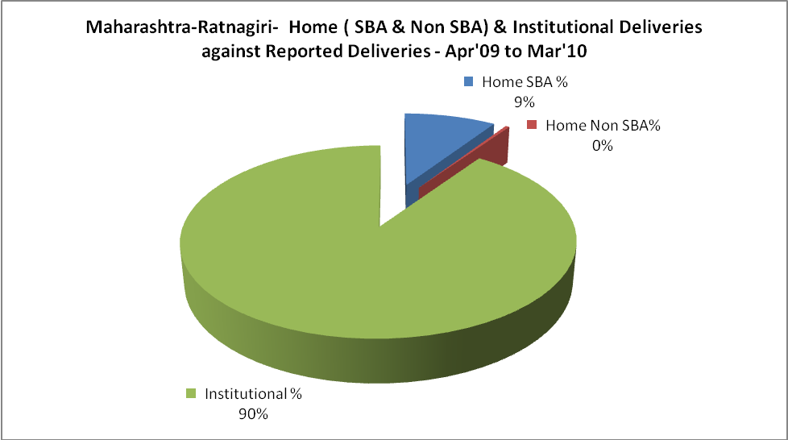

Maharashtra-Ratnagiri- C sections & Complicated Deliveries Apr'09 to Mar'10
 | Institutional Deliveries (Public) | Institutional Deliveries (Pvt)
 | 6,265 | 12,704
C Section | 680 | 2,228
C Section% | 11% | 18%
Complicated Pregnancies attended | 1,023 | 1,116
Complicated Pregnancies attended % | 16% | 9%

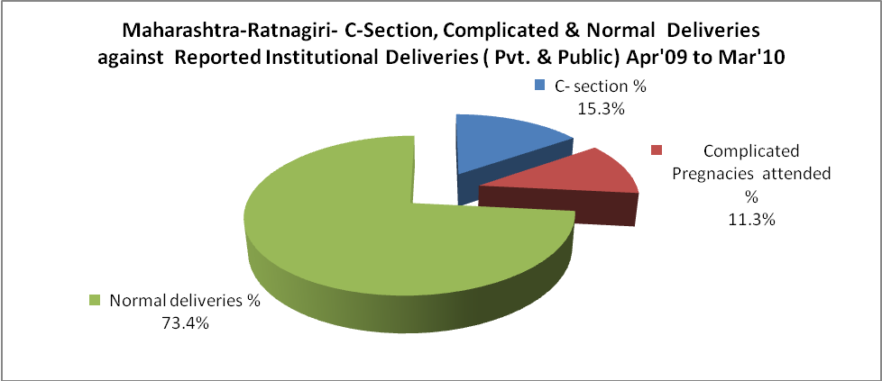

Maharashtra-Ratnagiri- Complicated Pregnancies & Deliveries Treated - Apr'09 to Mar'10
Reported Deliveries |  |  | Reported ANC Registration
20,988 |  |  | 27,161
Complicated Pregnancies attended | Complicated Pregnancies Rate | C - Section Deliveries | PNC Maternal Complications | Abortions | Still Births
2,139 | 5% | 2,908 | - | 1,487 | 268
Complicated Deliveries Treated with |  |  |  | No Of Eclampsia cases Treated | No Of severe anemia cases treated
IV Antibiotics | IV antihypertensive/Magsulph injection | IV Oxytocis | Blood Transfusion | No Of Eclampsia cases Treated | No Of severe anemia cases treated
- | - | - | - | - | -

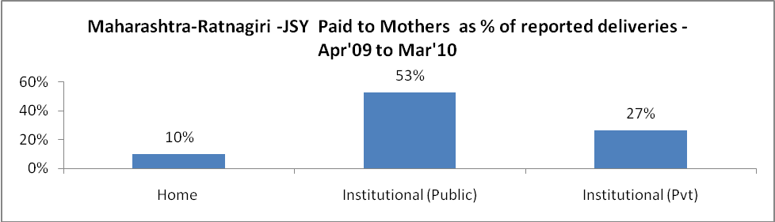

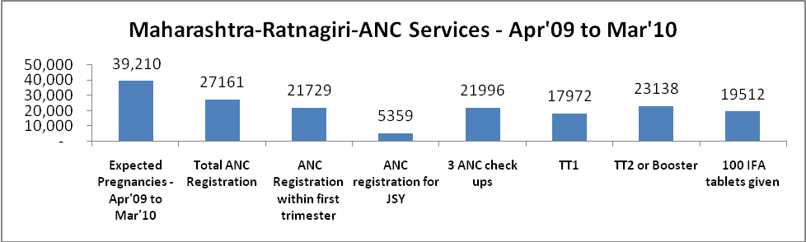

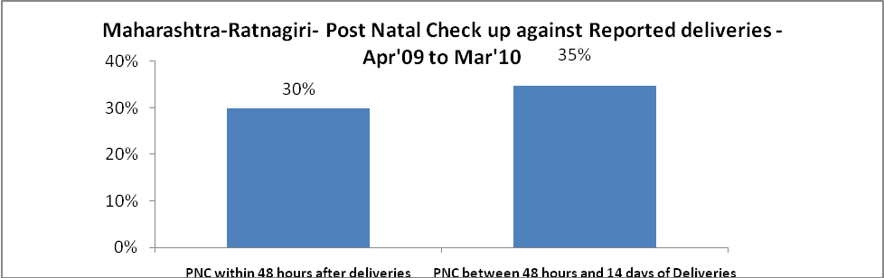

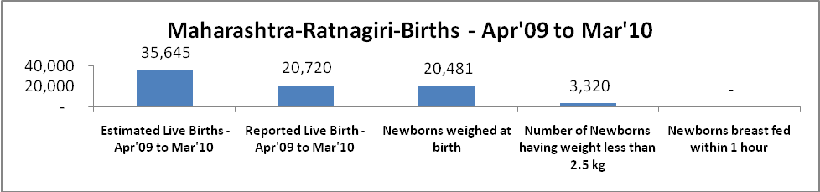

Maharashtra-Ratnagiri - Births - Apr'09 to Mar'10
Live Birth - Males | Live Birth - females | Live Birth - Total | Sex Ratio at birth | Still Birth | Abortion( Induced/Spontaneous
11,013 | 9,707 | 20,720 | 881 | 268 | 1,487

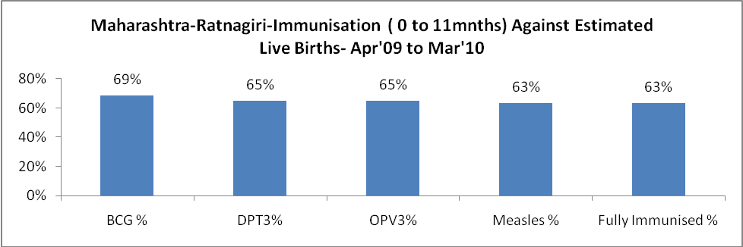

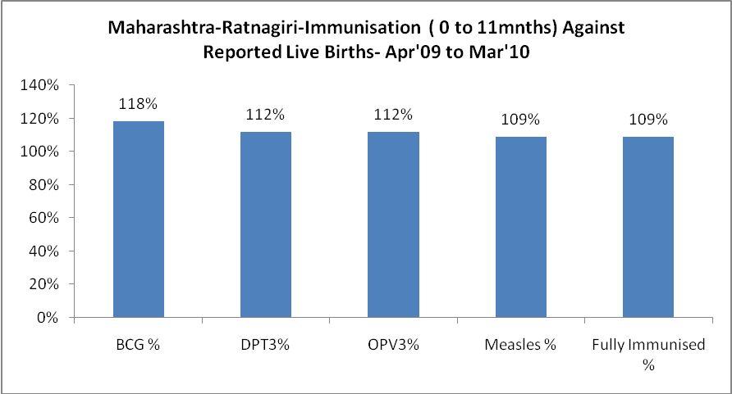

Maharashtra-Ratnagiri- Apr'09 to Mar'10
Total Abortions | Abortion Rate
3,294 | 8.4%

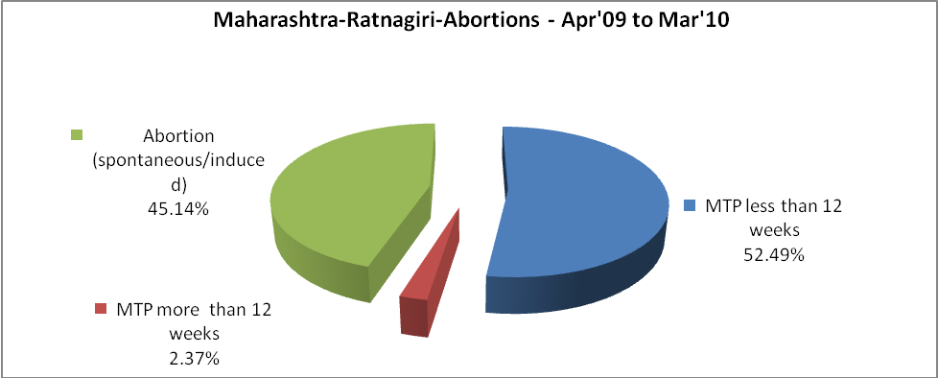

Maharashtra-Ratnagiri- Apr'09 to Mar'10
Total OPD | Total RTI/STI cases
229,881 | 2,397

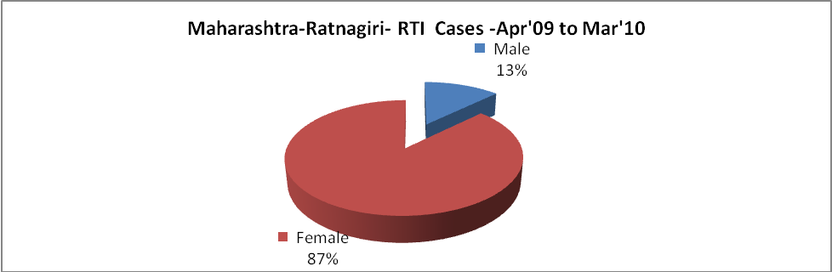

Maharashtra-Ratnagiri-Sterilizations - Apr'09 to Mar'10
 | Reported | %age of Reported Sterilization
Total Sterilization | 7,292 | -
NSV | 200 | 3%
Laparoscopic | 4,520 | 62%
MiniLap | 1,720 | 24%
Post Partum | 852 | 12%
Male Sterilization | 200 | 3%
Female Sterilization | 7,092 | 97%

Maharashtra-Ratnagiri-FP Methods - Apr'09 to Mar'10
 | Reported | %age of All Reported FP Methods
Total Reported FP Method (All types) Users | 34,798 | -
Sterilizations | 7,292 | 21%
IUD | 7,615 | 22%
Condom Users | 12,008 | 35%
OCP Users | 7,883 | 23%
Limiting Methods | 7,292 | 21%
Spacing Methods | 27,506 | 79%

Maharashtra-Ratnagiri- Service Delivery - Apr'09 to Mar'10
Operation major (General and spinal anaesthesia) | Operation minor (No or local anaesthesia) | AYUSH | Dental Procedures | Adolescent counselling services | Total OPD | Total IPD
1,187 | 1,419 | - | - | - | 229,881 | -
Operation major (General and spinal anaesthesia) as %ge of OPD | Operation minor (No or local anaesthesia)as %ge of OPD | AYUSH as %ge of OPD | Dental Procedures as %ge of OPD | Adolescent counselling services as %ge of OPD | IPD as percentage of OPD
0.5% | 0.6% | 0.0% | 0.0% | 0.0% | 0%

Maharashtra-Ratnagiri- Lab Services - Apr'09 to Mar'10
Total OPD | Total HB tested | Total HIV Tested | Total Population
229,881 | - | - | 1,991,367
HB test conducted as %age of OPD | HB<7gm as %age of HB tested | HIV test conducted as %age of OPD | HIV positive as %age of HIV tested | Blood Smear Examined as % of Population
0.0% | 0.0% | 0.0% | 0.0% | 8.6%

Maharashtra-Ratnagiri- Childhood Disease - Vaccine Preventable -Apr'09 to Mar'10
Diphtheria | Pertussis | Tetanus Neonatorum | Tetanus others | Polio | Measles
0 | 0 | 0 | 0 | 0 | 3
Maharashtra-Ratnagiri-Childhood Disease - Others - Apr'09 to Mar'10
Diarrhoea and dehydration | Malaria | Number admitted with Respiratory Infections
1,361 | 27 | 757

Maharashtra-Ratnagiri- Infant & Child Deaths - Apr'09 to Mar'10
Infant Deaths within 24 hrs of birth | Infant Deaths between 24hrs & under 1 week | Infant Deaths between 1 week & under 1 month | Child Deaths between 1 month & under 1 year | Child Deaths between 1yr under 5years | Total Deaths
62 | 0 | 0 | 0 | 0 | 62

Maharashtra-Ratnagiri- Causes of Infant & Child Deaths - Apr'09 to Mar'10
Sepsis |  |  | Asphyxia |  |  | LBW
Up to 1 Weeks of Birth | Between 1 week & 4 weeks of birth | Total | Up to 1 Weeks of Birth | Between 1 week & 4 weeks of birth | Total | Up to 1 Weeks of Birth | Between 1 week & 4 weeks of birth | Total
0 | 0 | 0 | 0 | 0 | 0 | 0 | 0 | 0
Pneumonia |  |  | Diarrhoea |  |  | Fever related
Between 1 month and 11 months | Between 1 year & 5 years | Total | Between 1 month and 11 months | Between 1 year & 5 years | Total | Between 1 month and 11 months | Between 1 year & 5 years | Total
0 | 0 | 0 | 0 | 0 | 0 | 0 | 0 | 0
Others |  |  | Measles |  |  | Others
Up to 1 Weeks of Birth | Between 1 week & 4 weeks of birth | Total | Between 1 month and 11 months | Between 1 year & 5 years | Total | Between 1 month and 11 months | Between 1 year & 5 years | Total
0 | 0 | 0 | 0 | 0 | 0 | 0 | 0 | 0

Maharashtra-Ratnagiri- Maternal Deaths & Causes - Apr'09 to Mar'10
Abortion |  |  | Obstructed/prolonged labour |  |  | Severe hypertension/fits
6-14 yrs | 15-55 yrs. | Total | 6-14 yrs | 15-55 yrs. | Total | 6-14 yrs | 15-55 yrs. | Total
0 | 0 | 0 | 0 | 0 | 0 | 0 | 0 | 0
Bleeding |  |  | High Fever |  |  | Other Causes
6-14 yrs | 15-55 yrs. | Total | 6-14 yrs | 15-55 yrs. | Total | 6-14 yrs | 15-55 yrs. | Total
0 | 0 | 0 | 0 | 0 | 0 | 0 | 0 | 0

Maharashtra-Ratnagiri-Causes of Deaths in 6 to 55yrs age group - Apr'09 to Mar'10
Diarrhoel Diseases |  |  |  | Tuberculosis |  |  |  | Respiratory Diseases( Other than TB)
6-14 yrs | 15-55 yrs. | Above 55yrs | Total | 6-14 yrs | 15-55 yrs. | Above 55yrs | Total | 6-14 yrs | 15-55 yrs. | Above 55yrs | Total
0 | 0 | 0 | 0 | 0 | 0 | 0 | 0 | 0 | 0 | 0 | 0
Malaria |  |  |  | Other fever Related |  |  |  | HIV/Aids
6-14 yrs | 15-55 yrs. | Above 55yrs | Total | 6-14 yrs | 15-55 yrs. | Above 55yrs | Total | 6-14 yrs | 15-55 yrs. | Above 55yrs | Total
0 | 0 | 0 | 0 | 0 | 0 | 0 | 0 | 0 | 0 | 0 | 0
Heart Disease/Hypertension related |  |  |  | Neurological Disease including strokes |  |  |  | Trauma/Accidents/ Burn Cases
6-14 yrs | 15-55 yrs. | Above 55yrs | Total | 6-14 yrs | 15-55 yrs. | Above 55yrs | Total | 6-14 yrs | 15-55 yrs. | Above 55yrs | Total
0 | 0 | 0 | 0 | 0 | 0 | 0 | 0 | 0 | 0 | 0 | 0
Suicide |  |  |  | Animal Bites & Stings
6-14 yrs | 15-55 yrs. | Above 55yrs | Total | 6-14 yrs | 15-55 yrs. | Above 55yrs | Total
0 | 0 | 0 | 0 | 0 | 0 | 0 | 0

