NHSRC
Maharashtra – Sangil
Analysis: Apr 2009 – Mar 2010

Maharashtra-Sangli- Summary-Apr'09 to Mar'10
ANC
ANC Registration against Expected Pregnancies | 90% | TT1 given to Pregnant women against ANC Registration | 77%
3 ANC Check ups against ANC Registrations | 85% | 100 IFA Tablets given to Pregnant women against ANC Registration | 124%
Deliveries
Unreported Deliveries against Estimated Deliveries | 50.9% | HOME Deliveries( SBA& Non SBA) against Estimated Deliveries | 2.9%
Institutional Deliveries against Estimated Deliveries | 46.2% | HOME Deliveries( SBA& Non SBA) against Reported Deliveries | 6.0%
Institutional Deliveries against Reported Deliveries | 94.0% | C Section Deliveries against Institutional Deliveries( Pvt & Pub) | 13%
Births & Neonates Care
Live Births Reported against Estimated Live Births | 73% | New borns weighed against Reported Live Births | 99%
Still Births (Reported) | 370 | New borns weighed less than 2.5 kgs against newborns weighed | 21%
Sex Ratio at Birth | 849 | New borns breastfed within one hr of Birth against Reported live Births | 2%
Child Immunization( 0 to 11 months)
BCG given against Expected Live Births | 86% | Measles given against Expected Live Births | 79%
OPV3 given against Expected Live Births | 80% | Fully Immunized Children against Expected Live Births | 112%
DPT3 given against Expected Live Births | 80%
Family Planning
Family Planning Methods Users ( Sterilizations(Male &Female)+IUD+ Condom pieces/72 + OCP Cycles/13) | 36,158 | IUD Insertions against reported FP Methods | 37%
Sterilization against reported FP Methods | 36% | Condom Users against reported FP Methods | 13%
 |  | OCP Users against reported FP Methods | 14%
Other Services
OPD | 212,627 | Major Operations | 323
IPD | 334 | Minor Operations | 563

`
Maharashtra-Sangli- Deliveries Apr'09 to Mar'10
Total Population | 3,032,276 | Expected Deliveries |  | 55,173
Home SBA | Home Non SBA | Institutional | Total Deliveries Reported | Unreported Deliveries
1,503 | 118 | 25,466 | 27,087 | 28,086
Home SBA % | Home Non SBA% | Institutional % | Total Deliveries Reported % | Unreported Deliveries %
3% | 0% | 46% | 49% | 51%

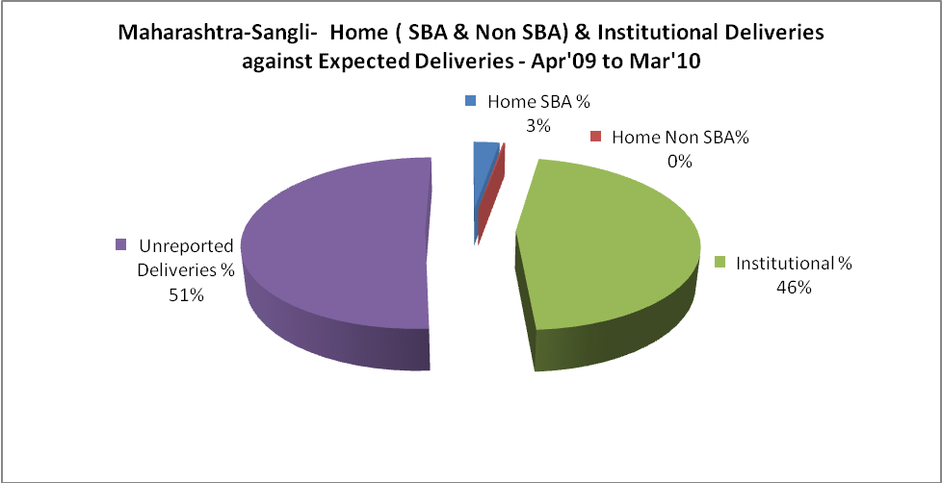

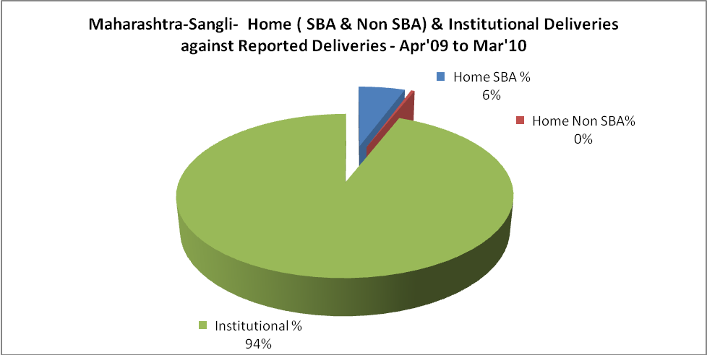

Maharashtra-Sangli- C sections & Complicated Deliveries Apr'09 to Mar'10
 | Institutional Deliveries (Public) | Institutional Deliveries (Pvt)
 | 10,705 | 14,761
C Section | 549 | 2,721
C Section% | 5% | 18%
Complicated Pregnancies attended | 997 | 1,179
Complicated Pregnancies attended % | 9% | 8%

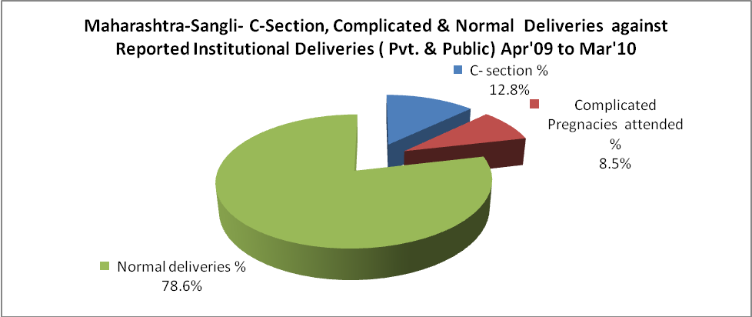

Maharashtra-Sangli- Complicated Pregnancies & Deliveries Treated - Apr'09 to Mar'10
Reported Deliveries |  |  | Reported ANC Registration
27,087 |  |  | 53,437
Complicated Pregnancies attended | Complicated Pregnancies Rate | C - Section Deliveries | PNC Maternal Complications | Abortions | Still Births
2,176 | 4% | 3,270 | - | 1,979 | 370
Complicated Deliveries Treated with |  |  |  | No Of Eclampsia cases Treated | No Of severe anemia cases treated
IV Antibiotics | IV antihypertensive/Magsulph injection | IV Oxytocis | Blood Transfusion | No Of Eclampsia cases Treated | No Of severe anemia cases treated
- | - | - | - | - | -

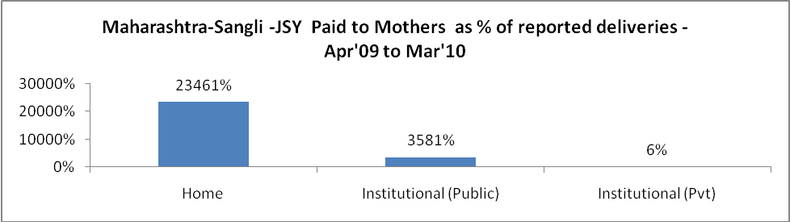

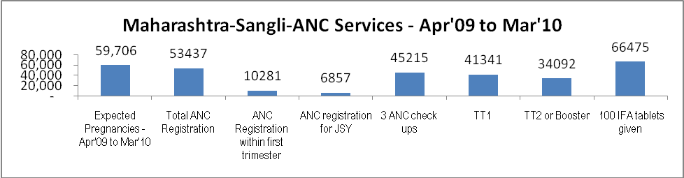

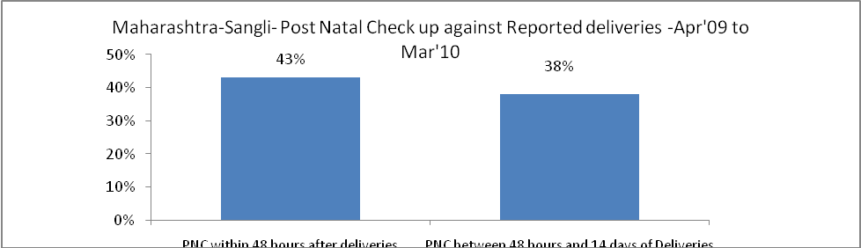

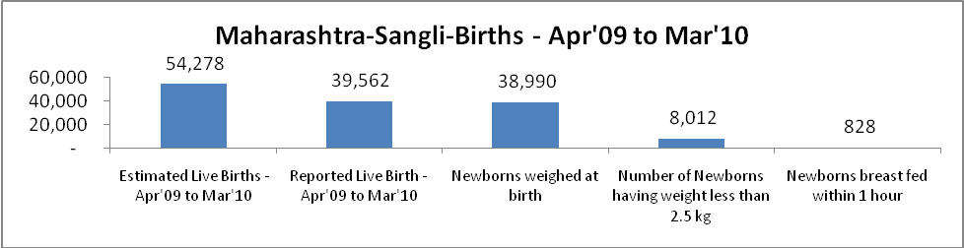

Maharashtra-Sangli - Births - Apr'09 to Mar'10
Live Birth - Males | Live Birth - females | Live Birth - Total | Sex Ratio at birth | Still Birth | Abortion( Induced/Spontaneous
21,402 | 18,160 | 39,562 | 849 | 370 | 1,979

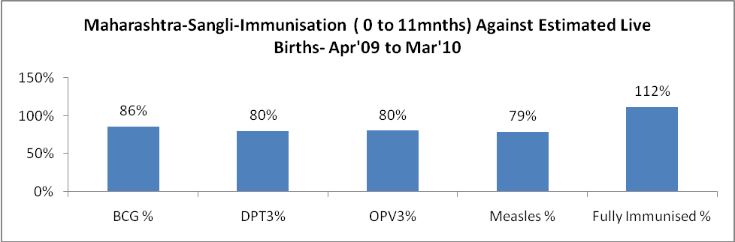

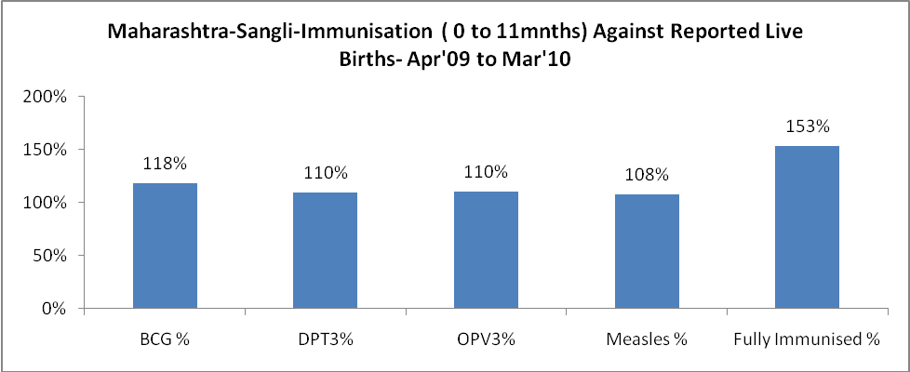

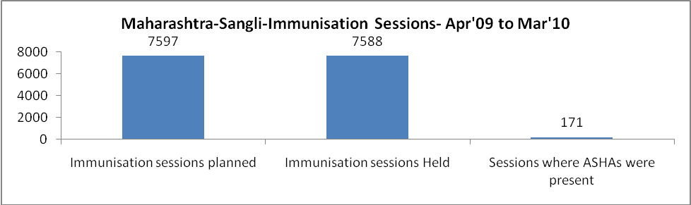

Maharashtra-Sangli- Apr'09 to Mar'10
Total Abortions | Abortion Rate
3,465 | 5.8%

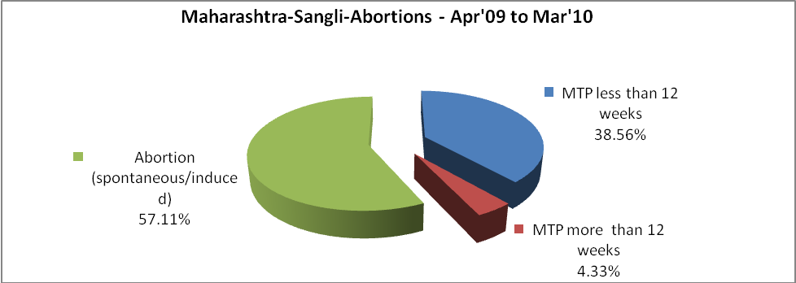

Maharashtra-Sangli- Apr'09 to Mar'10
Total OPD | Total RTI/STI cases
212,627 | 11,033

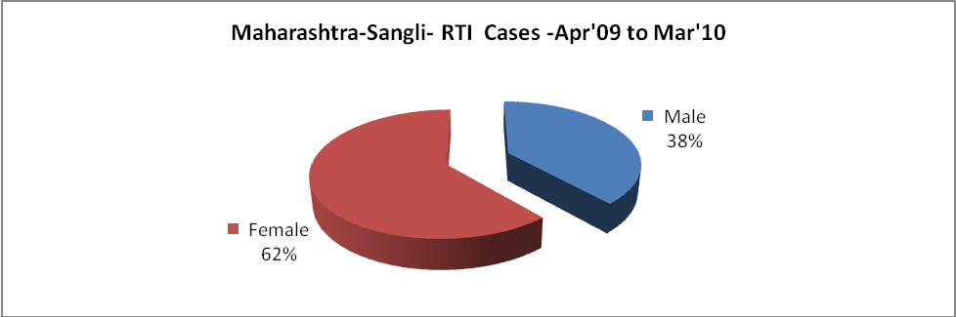

Maharashtra-Sangli-Sterilizations - Apr'09 to Mar'10
 | Reported | %age of Reported Sterilization
Total Sterilization | 13,099 | -
NSV | 206 | 2%
Laparoscopic | 2,405 | 18%
Minilap | 6,395 | 49%
Post Partum | 4,093 | 31%
Male Sterilization | 206 | 2%
Female Sterilization | 12,893 | 98%

Maharashtra-Sangli-FP Methods - Apr'09 to Mar'10
 | Reported | %age of All Reported FP Methods
Total Reported FP Method (All types) Users | 36,158 | -
Sterilizations | 13,099 | 36%
IUD | 13,472 | 37%
Condom Users | 4,601 | 13%
OCP Users | 4,986 | 14%
Limiting Methods | 13,099 | 36%
Spacing Methods | 23,059 | 64%

Maharashtra-Sangli- Service Delivery - Apr'09 to Mar'10
Operation major (General and spinal anaesthesia) | Operation minor (No or local anaesthesia) | AYUSH | Dental Procedures | Adolescent counselling services | Total OPD | Total IPD
323 | 563 | - | - | - | 212,627 | 334
Operation major (General and spinal anaesthesia) as %ge of OPD | Operation minor (No or local anaesthesia)as %ge of OPD | AYUSH as %ge of OPD | Dental Procedures as %ge of OPD | Adolescent counselling services as %ge of OPD | IPD as percentage of OPD
0.2% | 0.3% | 0.0% | 0.0% | 0.0% | 0%

Maharashtra-Sangli- Lab Services - Apr'09 to Mar'10
Total OPD | Total HB tested | Total HIV Tested | Total Population
212,627 | 3,352 | - | 3,032,276
HB test conducted as %age of OPD | HB<7gm as %age of HB tested | HIV test conducted as %age of OPD | HIV positive as %age of HIV tested | Blood Smear Examined as % of Population
1.6% | 0.0% | 0.0% | 0.0% | 7.2%

Maharashtra-Sangli- Childhood Disease - Vaccine Preventable -Apr'09 to Mar'10
Diphtheria | Pertussis | Tetanus Neonatorum | Tetanus others | Polio | Measles
16 | 0 | 0 | 0 | 0 | 0
Maharashtra-Sangli-Childhood Disease - Others - Apr'09 to Mar'10
Diarrhoea and dehydration | Malaria | Number admitted with Respiratory Infections
1,948 | 1 | 1,455

Maharashtra-Sangli- Infant & Child Deaths - Apr'09 to Mar'10
Infant Deaths within 24 hrs of birth | Infant Deaths between 24hrs & under 1 week | Infant Deaths between 1 week & under 1 month | Child Deaths between 1 month & under 1 year | Child Deaths between 1yr under 5years | Total Deaths
57 | 373 | 88 | 145 | 32 | 695

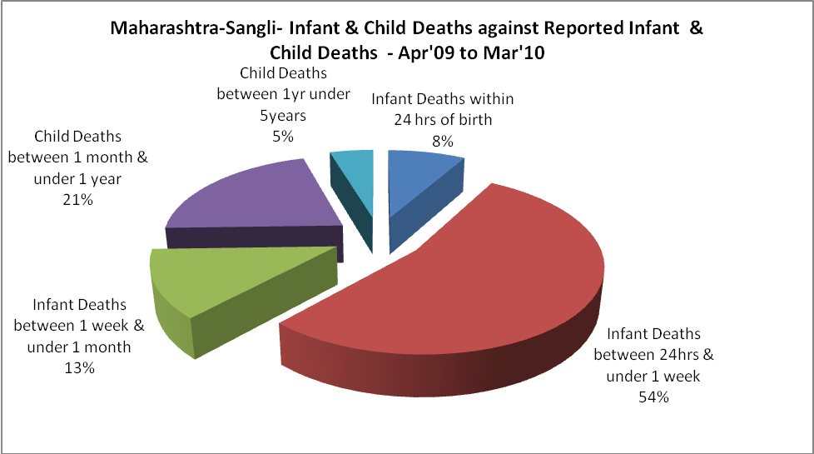

Maharashtra-Sangli- Causes of Infant & Child Deaths - Apr'09 to Mar'10
Sepsis |  |  | Asphyxia |  |  | LBW
Up to 1 Weeks of Birth | Between 1 week & 4 weeks of birth | Total | Up to 1 Weeks of Birth | Between 1 week & 4 weeks of birth | Total | Up to 1 Weeks of Birth | Between 1 week & 4 weeks of birth | Total
1 | 1 | 2 | 114 | 27 | 141 | 46 | 4 | 50
Pneumonia |  |  | Diarrhoea |  |  | Fever related
Between 1 month and 11 months | Between 1 year & 5 years | Total | Between 1 month and 11 months | Between 1 year & 5 years | Total | Between 1 month and 11 months | Between 1 year & 5 years | Total
13 | 3 | 16 | 12 | 3 | 15 | 25 | 4 | 29
Others |  |  | Measles |  |  | Others
Up to 1 Weeks of Birth | Between 1 week & 4 weeks of birth | Total | Between 1 month and 11 months | Between 1 year & 5 years | Total | Between 1 month and 11 months | Between 1 year & 5 years | Total
212 | 56 | 268 | 0 | 0 | 0 | 95 | 22 | 117

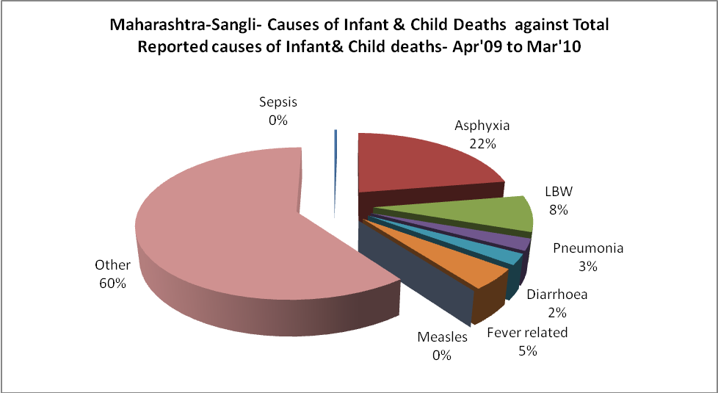

Maharashtra-Sangli- Maternal Deaths & Causes - Apr'09 to Mar'10
Abortion |  |  | Obstructed/prolonged labour |  |  | Severe hypertension/fits
6-14 yrs | 15-55 yrs. | Total | 6-14 yrs | 15-55 yrs. | Total | 6-14 yrs | 15-55 yrs. | Total
0 | 0 | 0 | 0 | 1 | 1 | 0 | 0 | 0
Bleeding |  |  | High Fever |  |  | Other Causes
6-14 yrs | 15-55 yrs. | Total | 6-14 yrs | 15-55 yrs. | Total | 6-14 yrs | 15-55 yrs. | Total
0 | 0 | 0 | 0 | 0 | 0 | 0 | 3 | 3

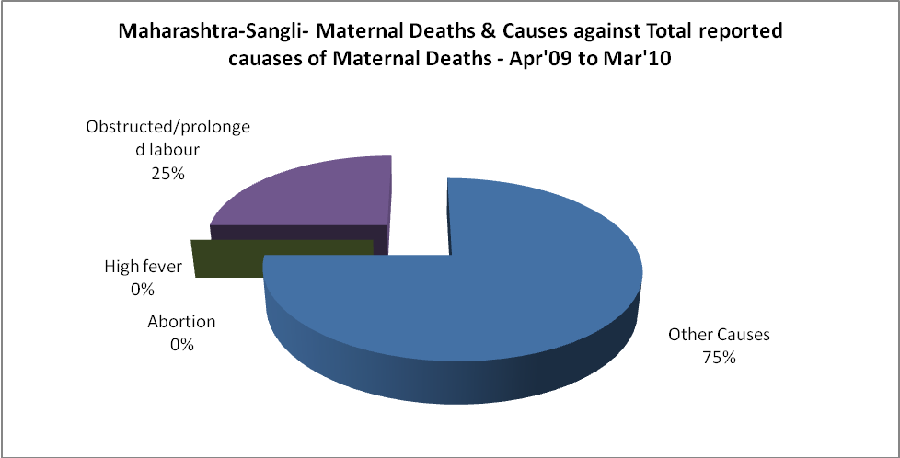

Maharashtra-Sangli-Causes of Deaths in 6 to 55yrs age group - Apr'09 to Mar'10
Diarrhoel Diseases |  |  |  | Tuberculosis |  |  |  | Respiratory Diseases( Other than TB)
6-14 yrs | 15-55 yrs. | Above 55yrs | Total | 6-14 yrs | 15-55 yrs. | Above 55yrs | Total | 6-14 yrs | 15-55 yrs. | Above 55yrs | Total
0 | 0 | 0 | 0 | 0 | 0 | 0 | 0 | 0 | 0 | 0 | 0
Malaria |  |  |  | Other fever Related |  |  |  | HIV/Aids
6-14 yrs | 15-55 yrs. | Above 55yrs | Total | 6-14 yrs | 15-55 yrs. | Above 55yrs | Total | 6-14 yrs | 15-55 yrs. | Above 55yrs | Total
0 | 0 | 0 | 0 | 0 | 0 | 0 | 0 | 0 | 0 | 0 | 0
Heart Disease/Hypertension related |  |  |  | Neurological Disease including strokes |  |  |  | Trauma/Accidents/ Burn Cases
6-14 yrs | 15-55 yrs. | Above 55yrs | Total | 6-14 yrs | 15-55 yrs. | Above 55yrs | Total | 6-14 yrs | 15-55 yrs. | Above 55yrs | Total
0 | 0 | 0 | 0 | 0 | 0 | 0 | 0 | 0 | 0 | 0 | 0
Suicide |  |  |  | Animal Bites & Stings
6-14 yrs | 15-55 yrs. | Above 55yrs | Total | 6-14 yrs | 15-55 yrs. | Above 55yrs | Total
0 | 0 | 0 | 0 | 0 | 0 | 0 | 0

