NHSRC
Maharashtra – Satara
Analysis: Apr 2009 – Mar 2010

`
Maharashtra-Satara- Summary-Apr'09 to Mar'10
ANC
ANC Registration against Expected Pregnancies | 80% | TT1 given to Pregnant women against ANC Registration | 73%
3 ANC Check ups against ANC Registrations | 88% | 100 IFA Tablets given to Pregnant women against ANC Registration | 87%
Deliveries
Unreported Deliveries against Estimated Deliveries | 11.9% | HOME Deliveries( SBA& Non SBA) against Estimated Deliveries | 4.6%
Institutional Deliveries against Estimated Deliveries | 83.5% | HOME Deliveries( SBA& Non SBA) against Reported Deliveries | 5.2%
Institutional Deliveries against Reported Deliveries | 94.8% | C Section Deliveries against Institutional Deliveries( Pvt & Pub) | 16%
Births & Neonates Care
Live Births Reported against Estimated Live Births | 79% | New borns weighed against Reported Live Births | 88%
Still Births (Reported) | 562 | New borns weighed less than 2.5 kgs against newborns weighed | 11%
Sex Ratio at Birth | 922 | New borns breastfed within one hr of Birth against Reported live Births | 84%
Child Immunization( 0 to 11 months)
BCG given against Expected Live Births | 92% | Measles given against Expected Live Births | 81%
OPV3 given against Expected Live Births | 82% | Fully Immunized Children against Expected Live Births | 78%
DPT3 given against Expected Live Births | 82%
Family Planning
Family Planning Methods Users ( Sterilizations(Male &Female)+IUD+ Condom pieces/72 + OCP Cycles/13) | 53,334 | IUD Insertions against reported FP Methods | 19%
Sterilization against reported FP Methods | 28% | Condom Users against reported FP Methods | 32%
 |  | OCP Users against reported FP Methods | 20%
Other Services
OPD | 276,102 | Major Operations | 1,606
IPD | - | Minor Operations | 1,234

Maharashtra-Satara- Deliveries Apr'09 to Mar'10
Total Population | 3,298,634 | Expected Deliveries |  | 60,020
Home SBA | Home Non SBA | Institutional | Total Deliveries Reported | Unreported Deliveries
1,364 | 1,402 | 50,121 | 52,887 | 7,133
Home SBA % | Home Non SBA% | Institutional % | Total Deliveries Reported % | Unreported Deliveries %
2% | 2% | 84% | 88% | 12%

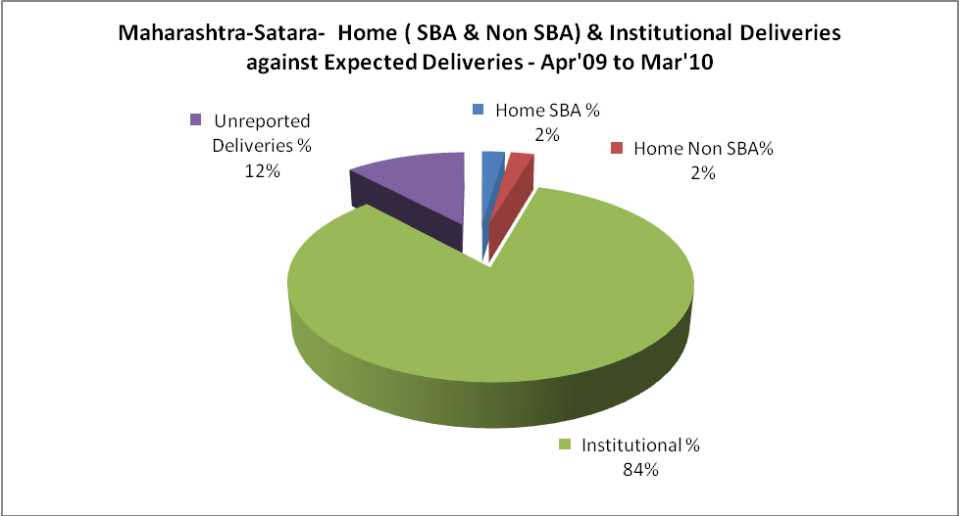

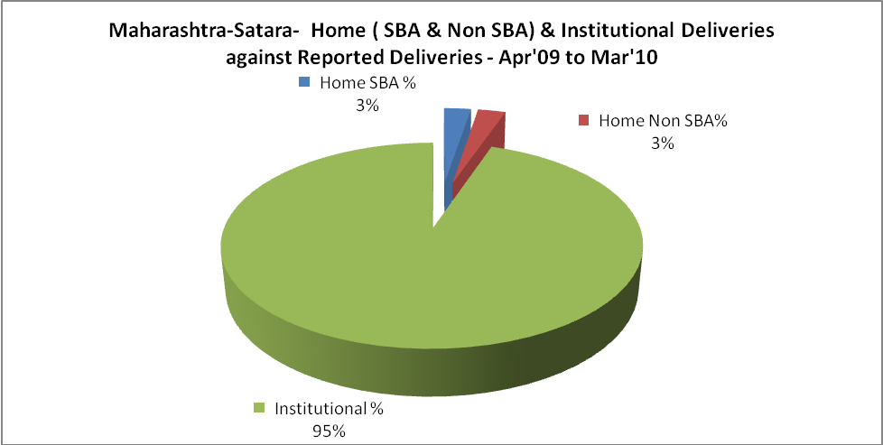

Maharashtra-Satara- C sections & Complicated Deliveries Apr'09 to Mar'10
 | Institutional Deliveries (Public) | Institutional Deliveries (Pvt)
 | 20,000 | 30,121
C Section | 843 | 7,104
C Section% | 4% | 24%
Complicated Pregnancies attended | 2,023 | 1,934
Complicated Pregnancies attended % | 10% | 6%

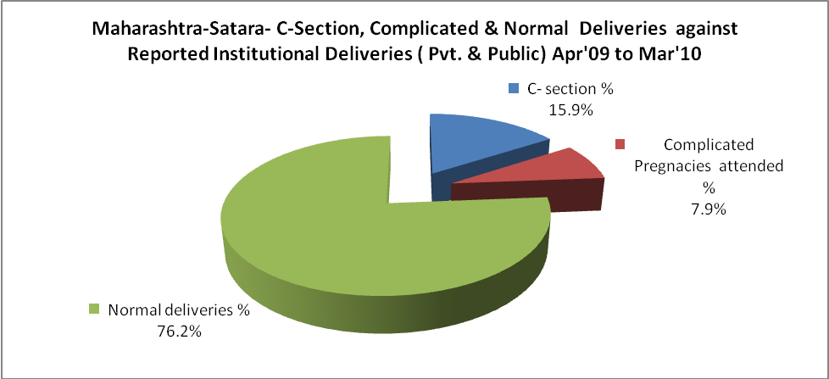

Maharashtra-Satara- Complicated Pregnancies & Deliveries Treated - Apr'09 to Mar'10
Reported Deliveries |  |  | Reported ANC Registration
52,887 |  |  | 51,640
Complicated Pregnancies attended | Complicated Pregnancies Rate | C - Section Deliveries | PNC Maternal Complications | Abortions | Still Births
3,957 | 6% | 7,947 | - | 4,693 | 562
Complicated Deliveries Treated with |  |  |  | No Of Eclampsia cases Treated | No Of severe anemia cases treated
IV Antibiotics | IV antihypertensive/Magsulph injection | IV Oxytocis | Blood Transfusion | No Of Eclampsia cases Treated | No Of severe anemia cases treated
- | - | - | - | - | -

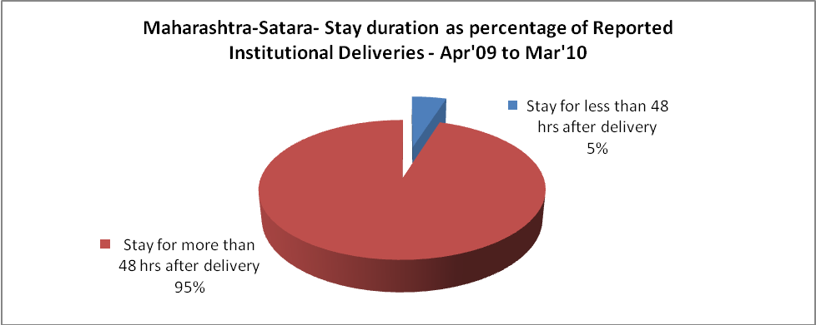

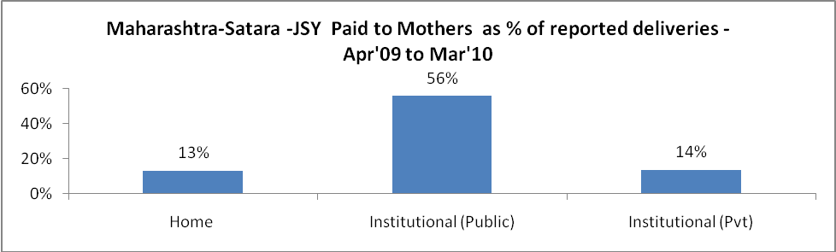

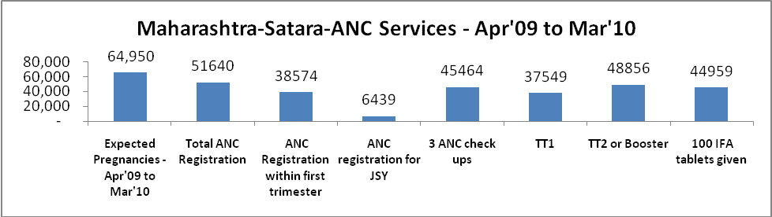

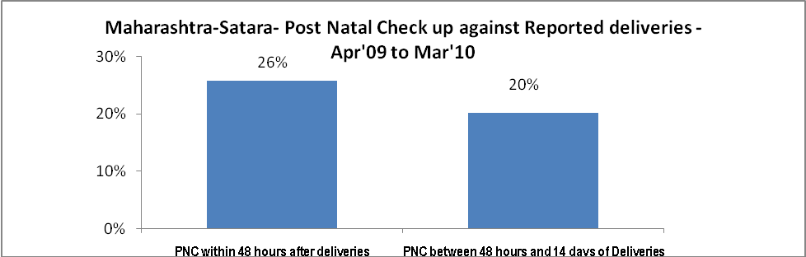

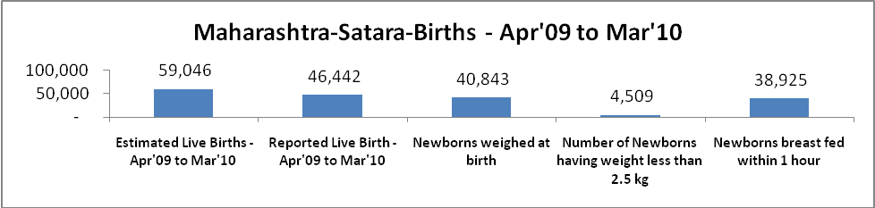

Maharashtra-Satara - Births - Apr'09 to Mar'10
Live Birth - Males | Live Birth - females | Live Birth - Total | Sex Ratio at birth | Still Birth | Abortion( Induced/Spontaneous
24,166 | 22,276 | 46,442 | 922 | 562 | 4,693

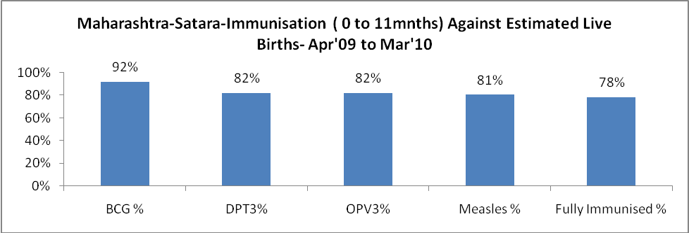

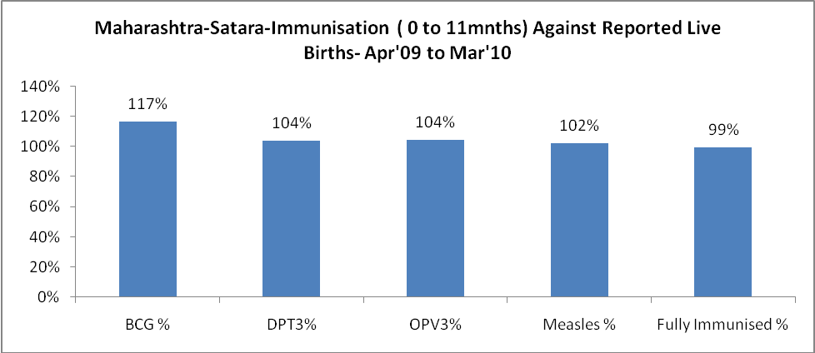

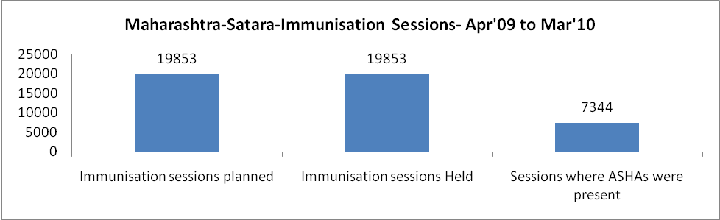

Maharashtra-Satara- Apr'09 to Mar'10
Total Abortions | Abortion Rate
8,436 | 13.0%

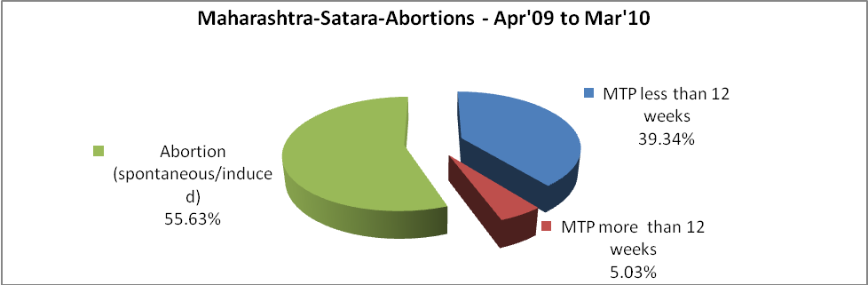

Maharashtra-Satara- Apr'09 to Mar'10
Total OPD | Total RTI/STI cases
276,102 | 8,244

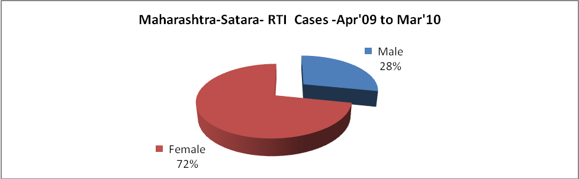

Maharashtra-Satara-Sterilizations - Apr'09 to Mar'10
 | Reported | %age of Reported Sterilization
Total Sterilization | 15,192 | -
NSV | 672 | 4%
Laparoscopic | 6,890 | 45%
Mini Lap | 4,567 | 30%
Post Partum | 3,063 | 20%
Male Sterilization | 672 | 4%
Female Sterilization | 14,520 | 96%

Maharashtra-Satara-FP Methods - Apr'09 to Mar'10
 | Reported | %age of All Reported FP Methods
Total Reported FP Method (All types) Users | 53,334 | -
Sterilizations | 15,192 | 28%
IUD | 9,932 | 19%
Condom Users | 17,283 | 32%
OCP Users | 10,927 | 20%
Limiting Methods | 15,192 | 28%
Spacing Methods | 38,142 | 72%

Maharashtra-Satara- Service Delivery - Apr'09 to Mar'10
Operation major (General and spinal anaesthesia) | Operation minor (No or local anaesthesia) | AYUSH | Dental Procedures | Adolescent counselling services | Total OPD | Total IPD
1,606 | 1,234 | - | - | - | 276,102 | -
Operation major (General and spinal anaesthesia) as %ge of OPD | Operation minor (No or local anaesthesia)as %ge of OPD | AYUSH as %ge of OPD | Dental Procedures as %ge of OPD | Adolescent counselling services as %ge of OPD | IPD as percentage of OPD
0.6% | 0.4% | 0.0% | 0.0% | 0.0% | 0%

Maharashtra-Satara- Lab Services - Apr'09 to Mar'10
Total OPD | Total HB tested | Total HIV Tested | Total Population
276,102 | - | - | 3,298,634
HB test conducted as %age of OPD | HB<7gm as %age of HB tested | HIV test conducted as %age of OPD | HIV positive as %age of HIV tested | Blood Smear Examined as % of Population
0.0% | 0.0% | 0.0% | 0.0% | 5.5%

Maharashtra-Satara- Childhood Disease - Vaccine Preventable -Apr'09 to Mar'10
Diphtheria | Pertussis | Tetanus Neonatorum | Tetanus others | Polio | Measles
0 | 0 | 0 | 0 | 0 | 0
Maharashtra-Satara-Childhood Disease - Others - Apr'09 to Mar'10
Diarrhoea and dehydration | Malaria | Number admitted with Respiratory Infections
1,851 | - | 84

Maharashtra-Satara- Infant & Child Deaths - Apr'09 to Mar'10
Infant Deaths within 24 hrs of birth | Infant Deaths between 24hrs & under 1 week | Infant Deaths between 1 week & under 1 month | Child Deaths between 1 month & under 1 year | Child Deaths between 1yr under 5years | Total Deaths
249 | 355 | 102 | 65 | 147 | 918

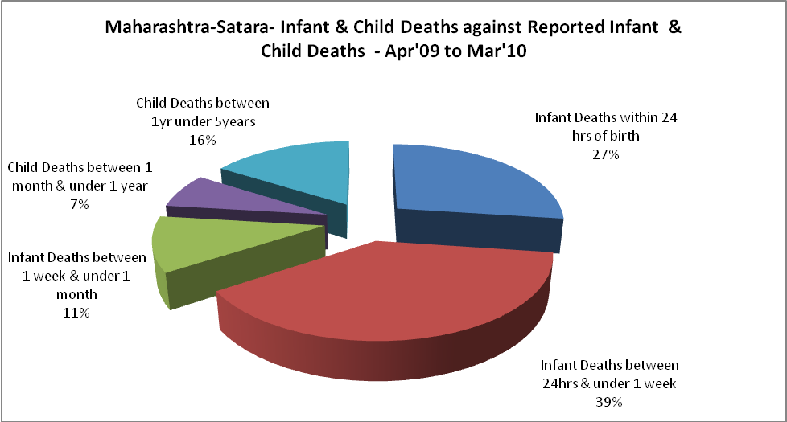

Maharashtra-Satara- Causes of Infant & Child Deaths - Apr'09 to Mar'10
Sepsis |  |  | Asphyxia |  |  | LBW
Up to 1 Weeks of Birth | Between 1 week & 4 weeks of birth | Total | Up to 1 Weeks of Birth | Between 1 week & 4 weeks of birth | Total | Up to 1 Weeks of Birth | Between 1 week & 4 weeks of birth | Total
7 | 8 | 15 | 65 | 15 | 80 | 77 | 29 | 106
Pneumonia |  |  | Diarrhoea |  |  | Fever related
Between 1 month and 11 months | Between 1 year & 5 years | Total | Between 1 month and 11 months | Between 1 year & 5 years | Total | Between 1 month and 11 months | Between 1 year & 5 years | Total
4 | 19 | 23 | 0 | 0 | 0 | 6 | 18 | 24
Others |  |  | Measles |  |  | Others
Up to 1 Weeks of Birth | Between 1 week & 4 weeks of birth | Total | Between 1 month and 11 months | Between 1 year & 5 years | Total | Between 1 month and 11 months | Between 1 year & 5 years | Total
206 | 50 | 256 | 0 | 0 | 0 | 55 | 110 | 165

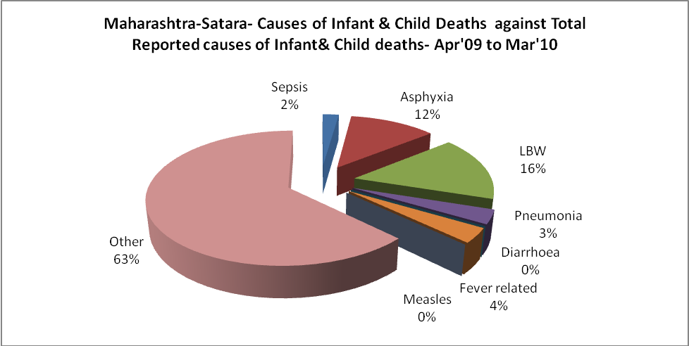

Maharashtra-Satara- Maternal Deaths & Causes - Apr'09 to Mar'10
Abortion |  |  | Obstructed/prolonged labour |  |  | Severe hypertension/fits
6-14 yrs | 15-55 yrs. | Total | 6-14 yrs | 15-55 yrs. | Total | 6-14 yrs | 15-55 yrs. | Total
0 | 0 | 0 | 0 | 0 | 0 | 0 | 4 | 4
Bleeding |  |  | High Fever |  |  | Other Causes
6-14 yrs | 15-55 yrs. | Total | 6-14 yrs | 15-55 yrs. | Total | 6-14 yrs | 15-55 yrs. | Total
0 | 7 | 7 | 0 | 1 | 1 | 0 | 4 | 4

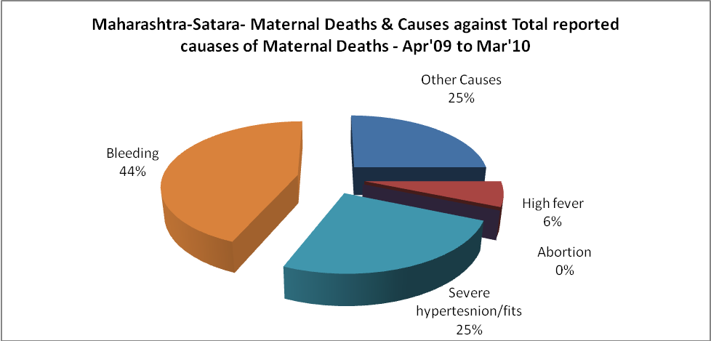

Maharashtra-Satara-Causes of Deaths in 6 to 55yrs age group - Apr'09 to Mar'10
Diarrheal Diseases |  |  |  | Tuberculosis |  |  |  | Respiratory Diseases( Other than TB)
6-14 yrs | 15-55 yrs. | Above 55yrs | Total | 6-14 yrs | 15-55 yrs. | Above 55yrs | Total | 6-14 yrs | 15-55 yrs. | Above 55yrs | Total
0 | 0 | 0 | 0 | 0 | 0 | 0 | 0 | 0 | 0 | 0 | 0
Malaria |  |  |  | Other fever Related |  |  |  | HIV/Aids
6-14 yrs | 15-55 yrs. | Above 55yrs | Total | 6-14 yrs | 15-55 yrs. | Above 55yrs | Total | 6-14 yrs | 15-55 yrs. | Above 55yrs | Total
0 | 0 | 0 | 0 | 0 | 0 | 0 | 0 | 0 | 0 | 0 | 0
Heart Disease/Hypertension related |  |  |  | Neurological Disease including strokes |  |  |  | Trauma/Accidents/ Burn Cases
6-14 yrs | 15-55 yrs. | Above 55yrs | Total | 6-14 yrs | 15-55 yrs. | Above 55yrs | Total | 6-14 yrs | 15-55 yrs. | Above 55yrs | Total
0 | 0 | 0 | 0 | 0 | 0 | 0 | 0 | 0 | 0 | 0 | 0
Suicide |  |  |  | Animal Bites & Stings
6-14 yrs | 15-55 yrs. | Above 55yrs | Total | 6-14 yrs | 15-55 yrs. | Above 55yrs | Total
0 | 0 | 0 | 0 | 0 | 0 | 0 | 0

