NHSRC
Rajasthan-Sawai Madhopur
Analysis: Apr 2009 – Mar 2010

Rajasthan- Sawai Madhopur- Summary-Apr'09 to Mar'10
ANC
ANC Registration against Expected Pregnancies | 97% | TT1 given to Pregnant women against ANC Registration | 66%
3 ANC Checkups against ANC Registrations | 71% | 100 IFA Tablets given to Pregnant women against ANC Registration | 93%
Deliveries
Unreported Deliveries against Estimated Deliveries | 27.9% | HOME Deliveries( SBA& Non SBA) against Estimated Deliveries | 6.6%
Institutional Deliveries against Estimated Deliveries | 65.5% | HOME Deliveries( SBA& Non SBA) against Reported Deliveries | 9.2%
Institutional Deliveries against Reported Deliveries | 90.8% | C Section Deliveries against Institutional Deliveries( Pvt & Pub) | 2%
Births & Neonates Care
Live Births Reported against Estimated Live Births | 73% | New borns weighed against Reported Live Births | 96%
Still Births (Reported) | 670 | New borns weighed less than 2.5 kgs against newborns weighed | 13%
Sex Ratio at Birh | 921 | New borns breastfed within one hr of Birth against Reported live Births | 85%
Child Immunisation( 0 to 11 months)
BCG given against Expected Live Births | 99% | Measles given against Expected Live Births | 94%
OPV3 given against Expected Live Births | 90% | Fully Immunised Children against Expected Live Births | 88%
DPT3 given against Expected Live Births | 90%
Family Planning
Family Plannig Methods Users ( Sterilisations(Male &Female)+IUD+ Condom pieces/72 + OCP Cycles/13) | 98,671 | IUD Insertions against reported FP Methods | 11%
Sterilisation against reported FP Methods | 7% | Condom Users against reported FP Methods | 57%
 |  | OCP Users against reported FP Methods | 25%
Other Services
OPD | 371,559 | Major Operations | 775
IPD | 51,859 | Minor Operations | 1,428

Rajasthan- Sawai Madhopur- Deliveries Apr'09 to Mar'10
Total Population | 1,330,800 | Expected Deliveries |  | 37,750
Home SBA | Home Non SBA | Institutional | Total Deliveries Reported | Unreported Deliveries
1,529 | 979 | 24,724 | 27,232 | 10,518
Home SBA % | Home Non SBA% | Institutional % | Total Deliveries Reported % | Unreported Deliveries %
4% | 3% | 65% | 72% | 28%
`

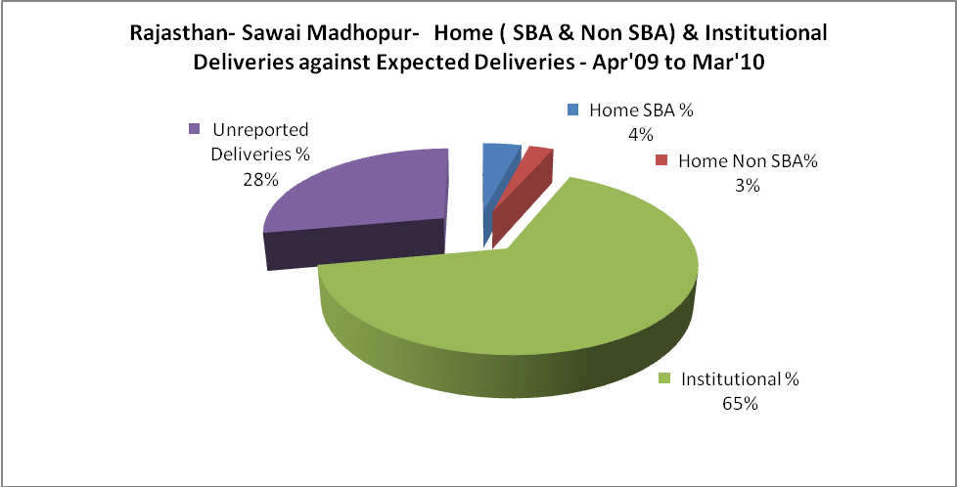

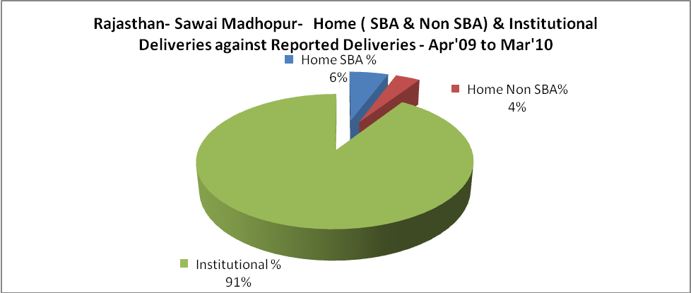

Rajasthan- Sawai Madhopur- C sections & Complicated Deliveries Apr'09 to Mar'10
 | Institutional Deliveries (Public) | Institutional Deliveries (Pvt)
 | 22,881 | 1,843
C Section | 495 | -
C Section% | 2% | 0%
Complicated Pregnacies attended | 439 | -
Complicated Pregnacies attended % | 2% | 0%

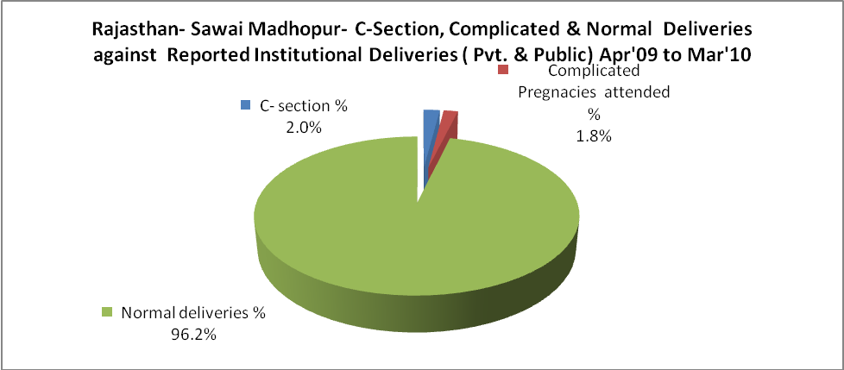

Rajasthan- Sawai Madhopur- Complicated Pregnancies & Deliveries Treated - Apr'09 to Mar'10
Reported Deliveries |  |  | Reported ANC Reigtration
27,232 |  |  | 39,159
Complicated Pregnancies attended | Complicated Pregnancies Rate | C - Section Deliveries | PNC Maternal Complications | Abortions | Still Births
439 | 1% | 495 | 79 | 748 | 670
Complicated Deliveries Treated with |  |  |  | No Of Eclampsia cases Treated | No Of severe anemia cases treated
IV Antibiotics | IV antihypertensive/Magsulph injection | IV Oxytocis | Blood Transfusion | No Of Eclampsia cases Treated | No Of severe anemia cases treated
899 | 237 | 611 | 54 | 141 | 435

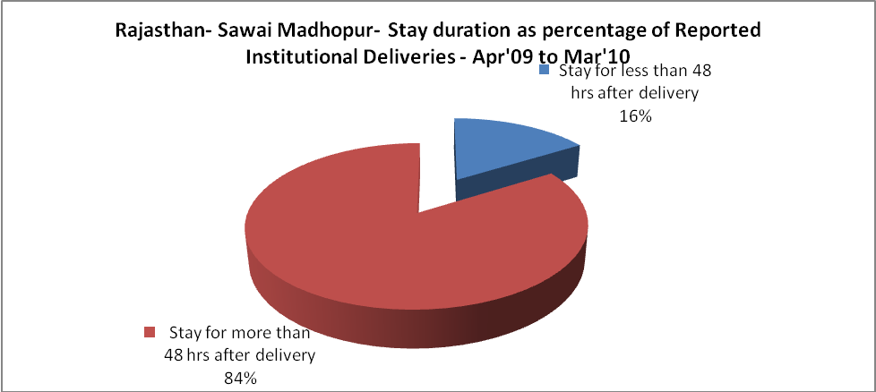

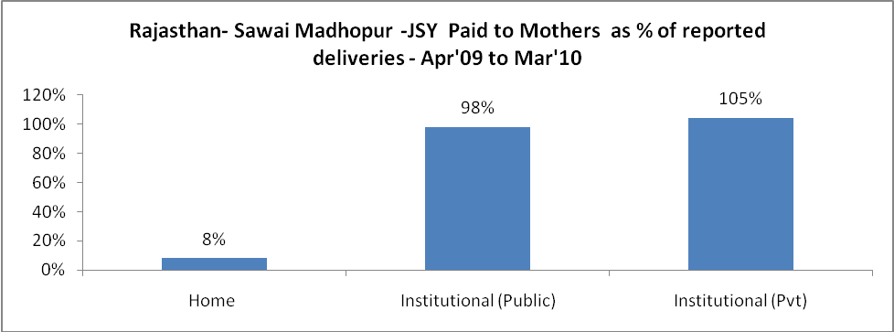

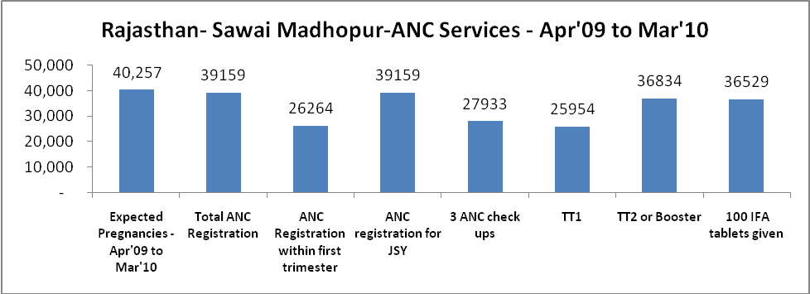

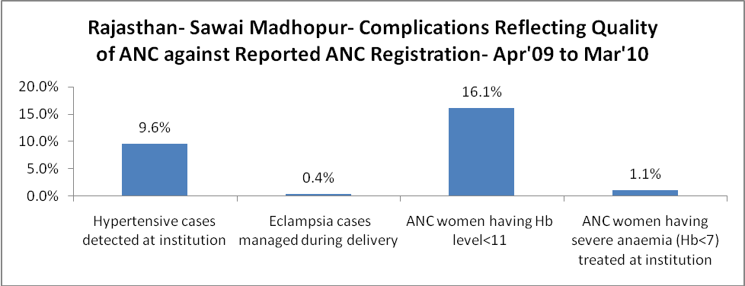

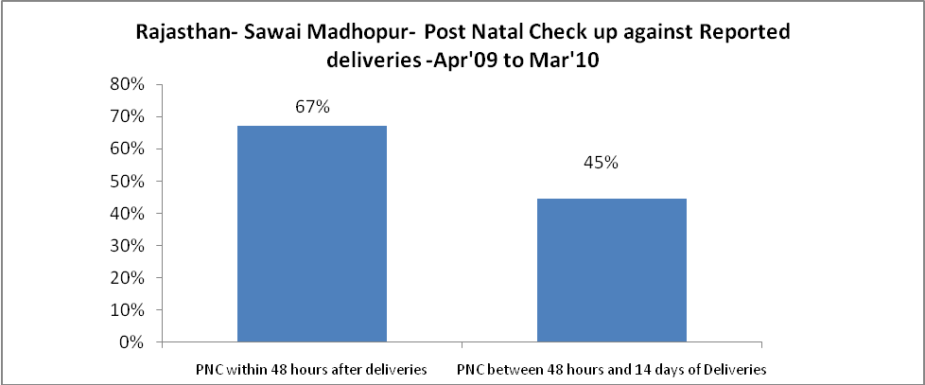

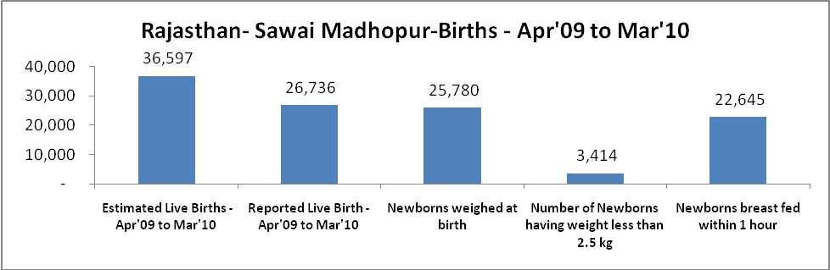

Rajasthan- Sawai Madhopur - Births - Apr'09 to Mar'10
Live Birth - Males | Live Birth - females | Live Birth - Total | Sex Ratio at birth | Still Birth | Abortion( Induced/Spontaneous
13,917 | 12,819 | 26,736 | 921 | 670 | 748

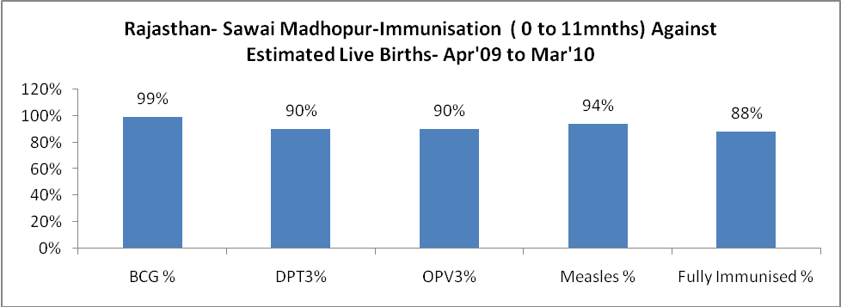

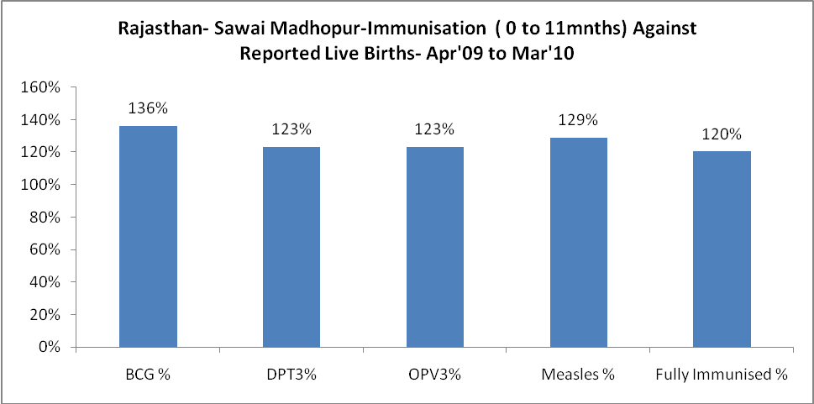

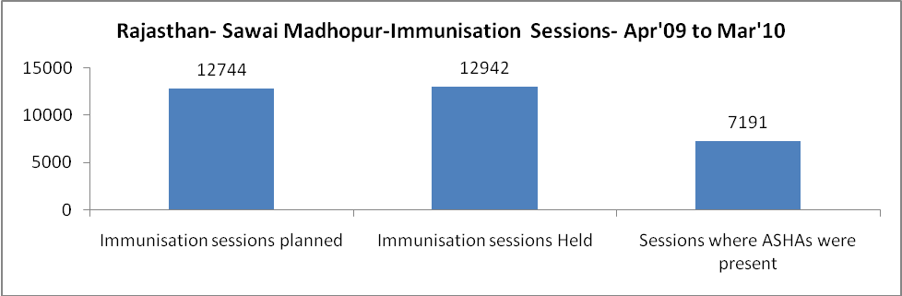

Rajasthan- Sawai Madhopur- Apr'09 to Mar'10
Total Abortions | Abortion Rate
1,040 | 2.6%

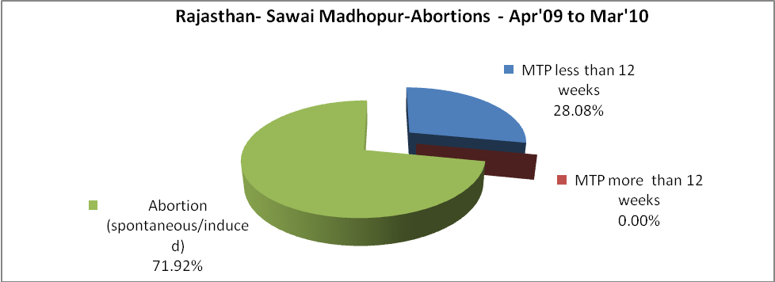

Rajasthan- Sawai Madhopur- Apr'09 to Mar'10
Total OPD | Total RTI/STI cases
371,559 | 2,285

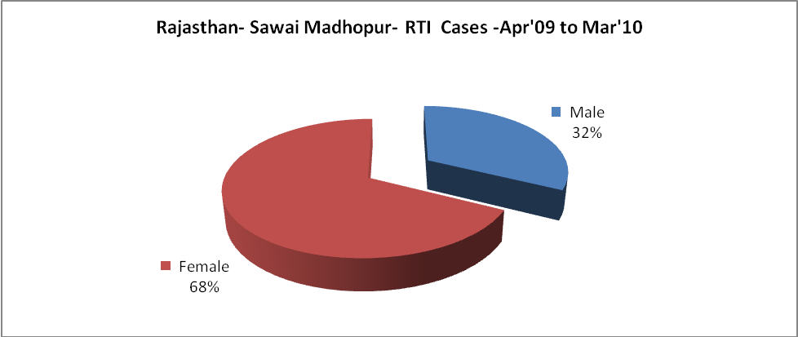

Rajasthan- Sawai Madhopur-Sterilisations - Apr'09 to Mar'10
 | Reported | %age of Reported Sterilisation
Total Sterilisation | 6,427 | -
NSV | 76 | 1%
Laproscopic | 6,186 | 96%
MiniLap | 24 | 0%
Post Partum | 141 | 2%
Male Sterilisation | 76 | 1%
Female Sterilisation | 6,351 | 99%

Rajasthan- Sawai Madhopur-FP Methods - Apr'09 to Mar'10
 | Reported | %age of All Reported FP Methods
Total Reported FP Methodd (All types) Users | 98,671 | -
Sterilisations | 6,427 | 7%
IUD | 11,170 | 11%
Condom Users | 56,445 | 57%
OCP Users | 24,629 | 25%
Limiting Methods | 6,427 | 7%
Spacing Methods | 92,244 | 93%

Rajasthan- Sawai Madhopur- Lab Services - Apr'09 to Mar'10
Total OPD | Total HB tested | Total HIV Tested | Total Population
371,559 | 10,393 | 3,171 | 1,330,800
HB test conducted as %age of OPD | HB<7gm as %age of HB tested | HIV test conducted as %age of OPD | HIV positive as %age of HIV tested | Blood Smear Examined as % of Population
2.8% | 8.1% | 0.9% | 0.1% | 2.7%

Rajasthan- Sawai Madhopur- Childhood Disease - Vaccine Preventable -Apr'09 to Mar'10
Diphtheria | Pertussis | Tetanus Neonatorum | Tetanus others | Polio | Measles
0 | 0 | 0 | 0 | 0 | 84
Rajasthan- Sawai Madhopur-Childhood Disease - Others - Apr'09 to Mar'10
Diarrhoea and dehydration | Malaria | Number admitted with Respiratory Infections
452 | 206 | -

Rajasthan- Sawai Madhopur- Infant & Child Deaths - Apr'09 to Mar'10
Infant Deaths within 24 hrs of birth | Infant Deaths between 24hrs & under 1 week | Infant Deaths between 1 week & under 1 month | Child Deaths between 1 month & under 1 year | Child Deaths between 1yr under 5years | Total Deaths
9 | 20 | 3 | 38 | 3 | 73

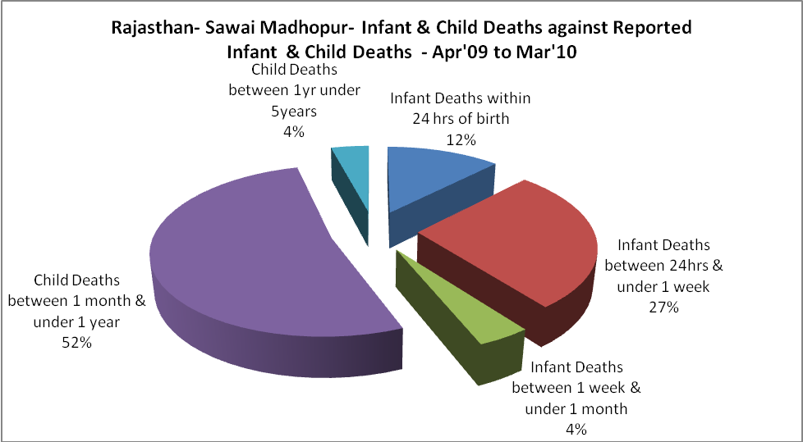

Rajasthan- Sawai Madhopur- Causes of Infant & Child Deaths - Apr'09 to Mar'10
Sepsis |  |  | Asphyxia |  |  | LBW
Up to 1 Weeks of Birth | Between 1 week & 4 weeks of birth | Total | Up to 1 Weeks of Birth | Between 1 week & 4 weeks of birth | Total | Up to 1 Weeks of Birth | Between 1 week & 4 weeks of birth | Total
4 | 1 | 5 | 8 | 0 | 8 | 8 | 2 | 10
Pneumonia |  |  | Diarrhoea |  |  | Fever related
Between 1 month and 11 months | Between 1 year & 5 years | Total | Between 1 month and 11 months | Between 1 year & 5 years | Total | Between 1 month and 11 months | Between 1 year & 5 years | Total
5 | 0 | 5 | 28 | 0 | 28 | 0 | 1 | 1
Others |  |  | Measles |  |  | Others
Up to 1 Weeks of Birth | Between 1 week & 4 weeks of birth | Total | Between 1 month and 11 months | Between 1 year & 5 years | Total | Between 1 month and 11 months | Between 1 year & 5 years | Total
0 | 0 | 0 | 0 | 0 | 0 | 5 | 2 | 7

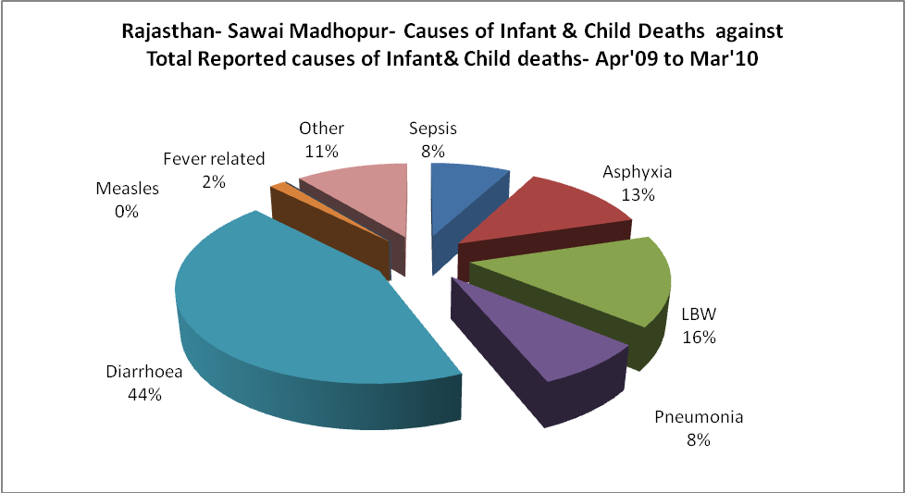

Rajasthan- Sawai Madhopur- Maternal Deaths & Causes - Apr'09 to Mar'10
Abortion |  |  | Obstructed/prolonged labour |  |  | Severe hypertesnion/fits
6-14 yrs | 15-55 yrs. | Total | 6-14 yrs | 15-55 yrs. | Total | 6-14 yrs | 15-55 yrs. | Total
0 | 0 | 0 | 0 | 0 | 0 | 0 | 0 | 0
Bleeding |  |  | High Fever |  |  | Other Causes
6-14 yrs | 15-55 yrs. | Total | 6-14 yrs | 15-55 yrs. | Total | 6-14 yrs | 15-55 yrs. | Total
0 | 0 | 0 | 0 | 0 | 0 | 0 | 0 | 0

Rajasthan- Sawai Madhopur-Causes of Deaths in 6 to 55yrs age group - Apr'09 to Mar'10
Diarrhoel Diseases |  |  |  | Tuberculosis |  |  |  | Respiratory Diseases( Other than TB)
6-14 yrs | 15-55 yrs. | Above 55yrs | Total | 6-14 yrs | 15-55 yrs. | Above 55yrs | Total | 6-14 yrs | 15-55 yrs. | Above 55yrs | Total
2 | 1 | 1 | 4 | 2 | 6 | 1 | 9 | 0 | 0 | 0 | 0
Malaria |  |  |  | Other fever Related |  |  |  | HIV/Aids
6-14 yrs | 15-55 yrs. | Above 55yrs | Total | 6-14 yrs | 15-55 yrs. | Above 55yrs | Total | 6-14 yrs | 15-55 yrs. | Above 55yrs | Total
1 | 0 | 1 | 2 | 1 | 0 | 0 | 1 | 0 | 0 | 0 | 0
Heart Disease/Hypertenion related |  |  |  | Neurological Disease including strokes |  |  |  | Trauma/Accidents/ Burn Cases
6-14 yrs | 15-55 yrs. | Above 55yrs | Total | 6-14 yrs | 15-55 yrs. | Above 55yrs | Total | 6-14 yrs | 15-55 yrs. | Above 55yrs | Total
1 | 0 | 0 | 1 | 1 | 1 | 0 | 2 | 0 | 0 | 0 | 0
Suicide |  |  |  | Animal Bites & Stings
6-14 yrs | 15-55 yrs. | Above 55yrs | Total | 6-14 yrs | 15-55 yrs. | Above 55yrs | Total
0 | 0 | 0 | 0 | 0 | 0 | 0 | 0

