NHSRC
Rajasthan-Sikar
Analysis: Apr 2009 – Mar 2010

Rajasthan- Sikar- Summary-Apr'09 to Mar'10
ANC
ANC Registration against Expected Pregnancies | 88% | TT1 given to Pregnant women against ANC Registration | 57%
3 ANC Checkups against ANC Registrations | 59% | 100 IFA Tablets given to Pregnant women against ANC Registration | 86%
Deliveries
Unreported Deliveries against Estimated Deliveries | 27.2% | HOME Deliveries( SBA& Non SBA) against Estimated Deliveries | 1.5%
Institutional Deliveries against Estimated Deliveries | 71.3% | HOME Deliveries( SBA& Non SBA) against Reported Deliveries | 2.1%
Institutional Deliveries against Reported Deliveries | 97.9% | C Section Deliveries against Institutional Deliveries( Pvt & Pub) | 1%
Births & Neonates Care
Live Births Reported against Estimated Live Births | 74% | New borns weighed against Reported Live Births | 96%
Still Births (Reported) | 375 | New borns weighed less than 2.5 kgs against newborns weighed | 14%
Sex Ratio at Birh | 953 | New borns breastfed within one hr of Birth against Reported live Births | 98%
Child Immunisation( 0 to 11 months)
BCG given against Expected Live Births | 96% | Measles given against Expected Live Births | 90%
OPV3 given against Expected Live Births | 95% | Fully Immunised Children against Expected Live Births | 85%
DPT3 given against Expected Live Births | 95%
Family Planning
Family Plannig Methods Users ( Sterilisations(Male &Female)+IUD+ Condom pieces/72 + OCP Cycles/13) | 108,849 | IUD Insertions against reported FP Methods | 11%
Sterilisation against reported FP Methods | 11% | Condom Users against reported FP Methods | 54%
 |  | OCP Users against reported FP Methods | 24%
Other Services
OPD | 1,305,549 | Major Operations | 593
IPD | 76,032 | Minor Operations | 4,016

`

Rajasthan- Sikar- Deliveries Apr'09 to Mar'10
Total Population | 2,746,700 | Expected Deliveries |  | 77,914
Home SBA | Home Non SBA | Institutional | Total Deliveries Reported | Unreported Deliveries
716 | 451 | 55,566 | 56,733 | 21,181
Home SBA % | Home Non SBA% | Institutional % | Total Deliveries Reported % | Unreported Deliveries %
1% | 1% | 71% | 73% | 27%

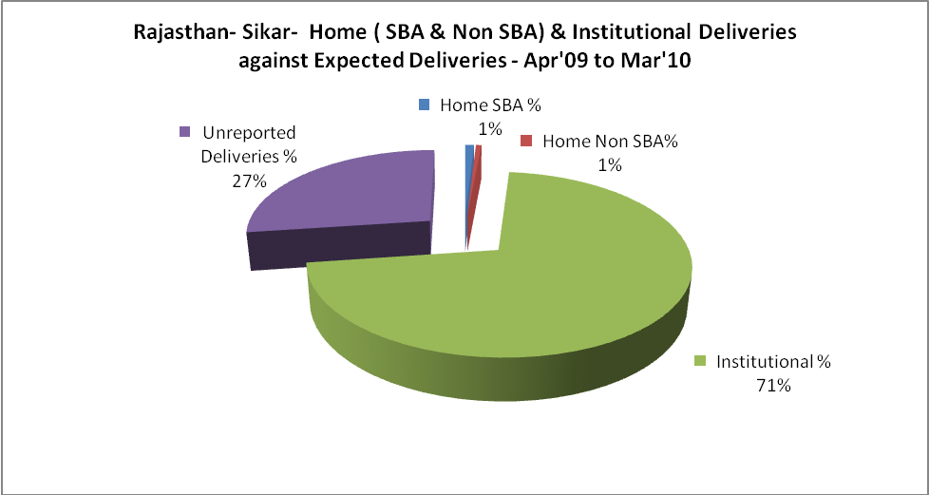

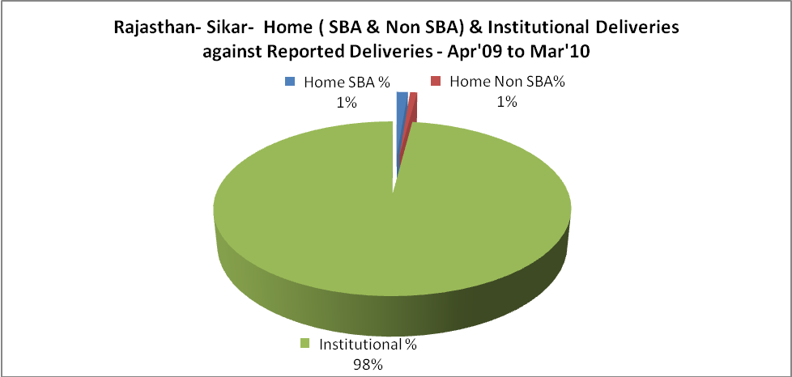

Rajasthan- Sikar- C sections & Complicated Deliveries Apr'09 to Mar'10
 | Institutional Deliveries (Public) | Institutional Deliveries (Pvt)
 | 30,456 | 25,110
C Section | 252 | 115
C Section% | 1% | 0%
Complicated Pregnacies attended | 362 | 24
Complicated Pregnacies attended % | 1% | 0%

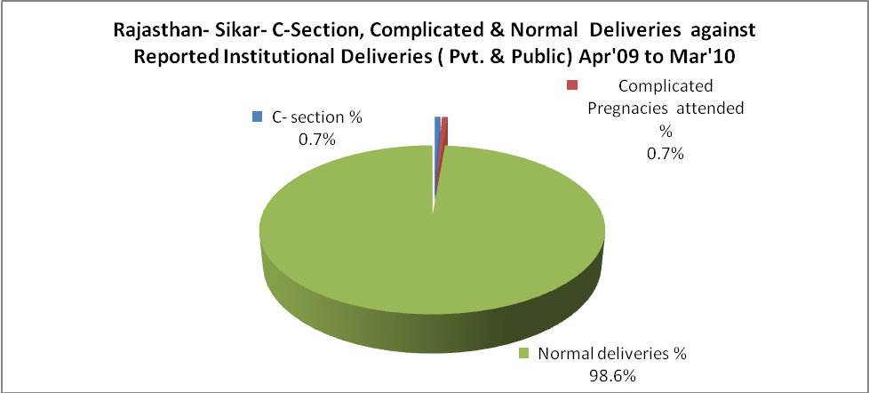

Rajasthan- Sikar- Complicated Pregnancies & Deliveries Treated - Apr'09 to Mar'10
Reported Deliveries |  |  | Reported ANC Reigtration
56,733 |  |  | 72,899
Complicated Pregnancies attended | Complicated Pregnancies Rate | C - Section Deliveries | PNC Maternal Complications | Abortions | Still Births
386 | 0% | 367 | 539 | 210 | 375
Complicated Deliveries Treated with |  |  |  | No Of Eclampsia cases Treated | No Of severe anemia cases treated
IV Antibiotics | IV antihypertensive/Magsulph injection | IV Oxytocis | Blood Transfusion | No Of Eclampsia cases Treated | No Of severe anemia cases treated
2,046 | 498 | 2,053 | 11 | 200 | 1,274

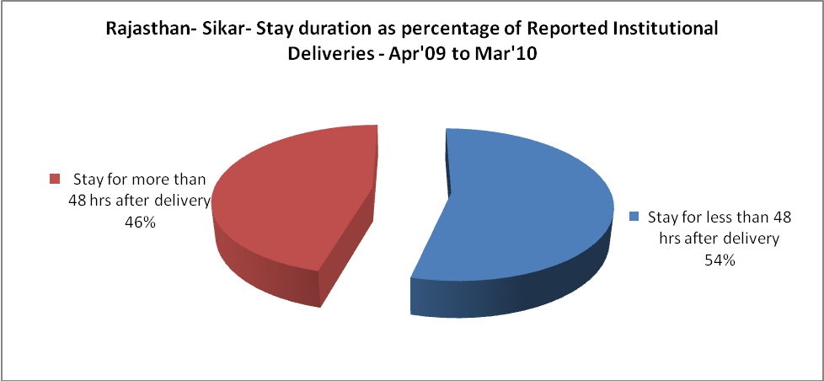

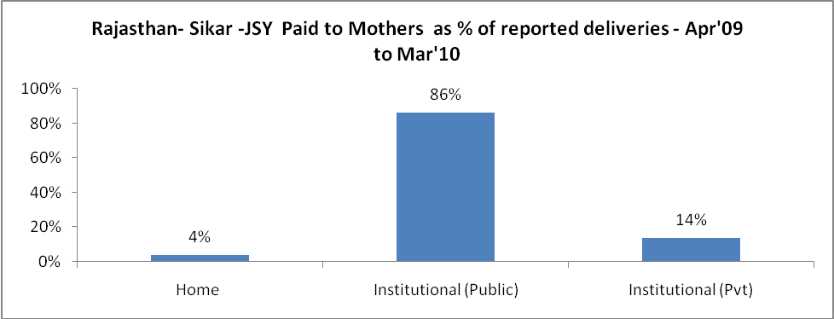

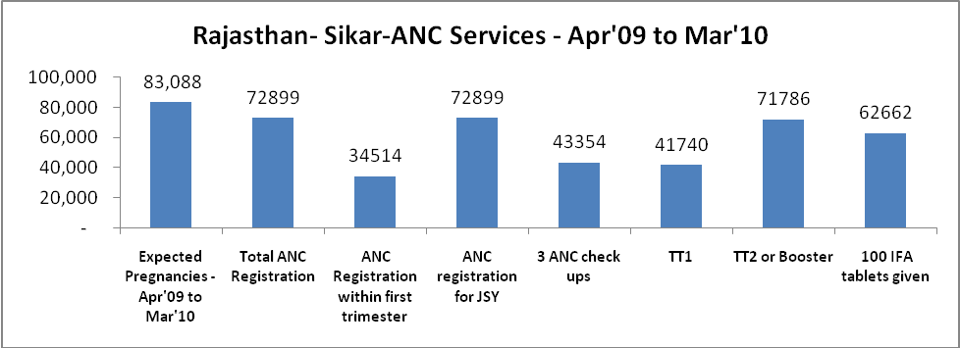

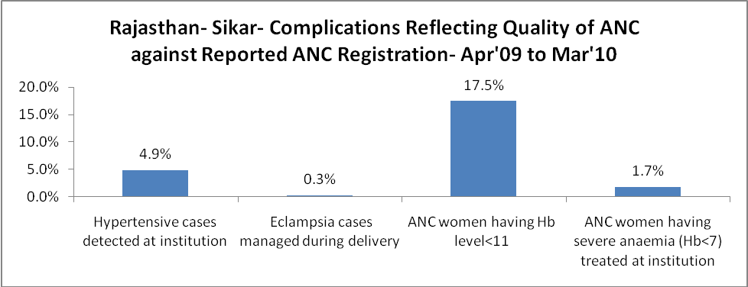

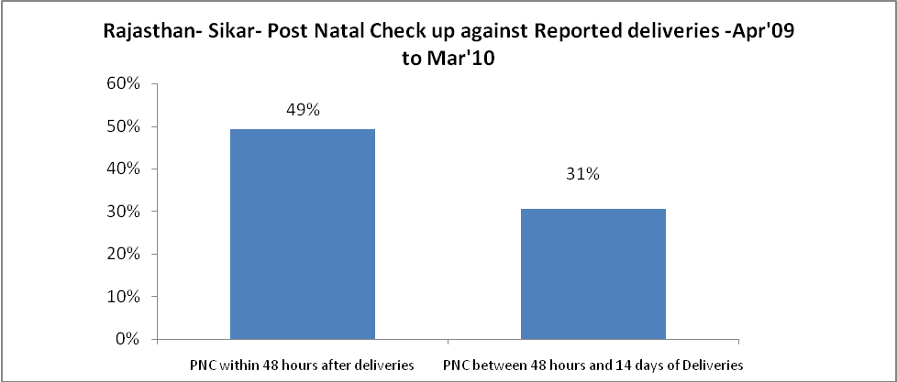

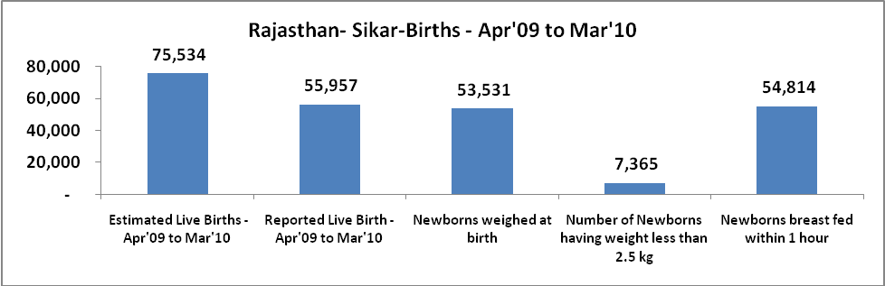

Rajasthan- Sikar - Births - Apr'09 to Mar'10
Live Birth - Males | Live Birth - females | Live Birth - Total | Sex Ratio at birth | Still Birth | Abortion( Induced/Spontaneous
28,649 | 27,308 | 55,957 | 953 | 375 | 210

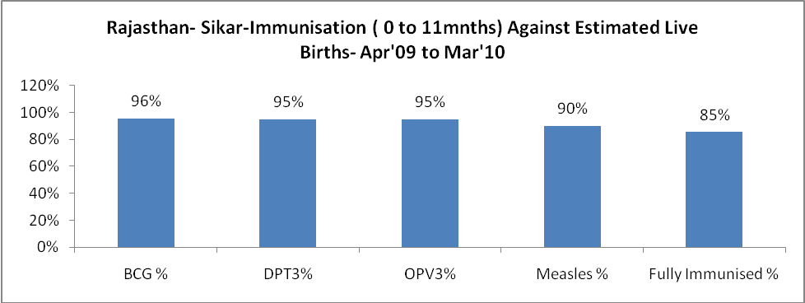

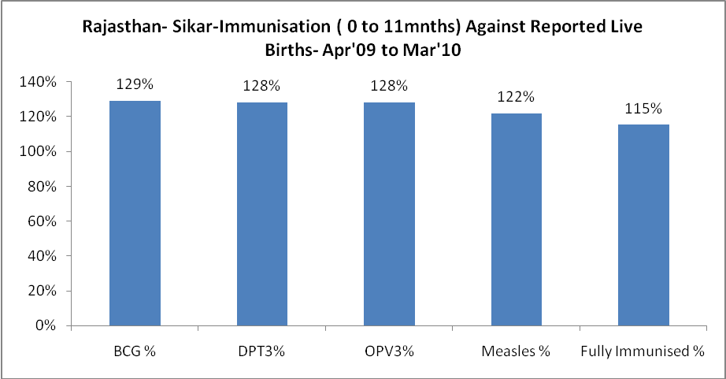

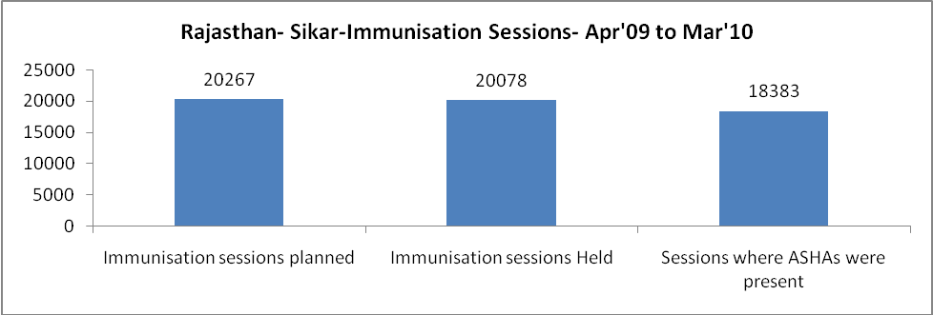

Rajasthan- Sikar- Apr'09 to Mar'10
Total Abortions | Abortion Rate
485 | 0.6%

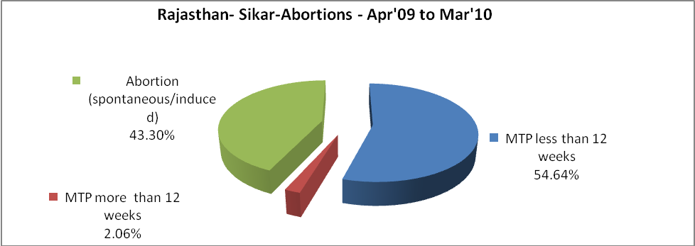

Rajasthan- Sikar- Apr'09 to Mar'10
Total OPD | Total RTI/STI cases
1,305,549 | 4,659

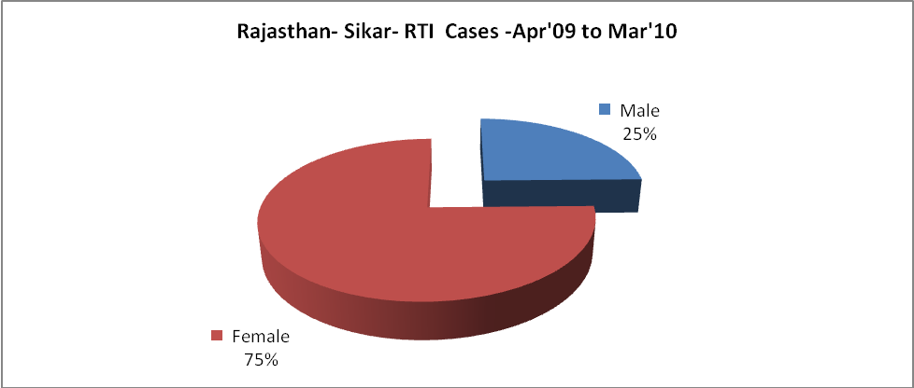

Rajasthan- Sikar-Sterilisations - Apr'09 to Mar'10
 | Reported | %age of Reported Sterilisation
Total Sterilisation | 12,232 | -
NSV | 156 | 1%
Laproscopic | 12,052 | 99%
MiniLap | 2 | 0%
Post Partum | 22 | 0%
Male Sterilisation | 156 | 1%
Female Sterilisation | 12,076 | 99%

Rajasthan- Sikar-FP Methods - Apr'09 to Mar'10
 | Reported | %age of All Reported FP Methods
Total Reported FP Methodd (All types) Users | 108,849 | -
Sterilisations | 12,232 | 11%
IUD | 12,097 | 11%
Condom Users | 58,597 | 54%
OCP Users | 25,923 | 24%
Limiting Methods | 12,232 | 11%
Spacing Methods | 96,617 | 89%

Rajasthan- Sikar- Lab Services - Apr'09 to Mar'10
Total OPD | Total HB tested | Total HIV Tested | Total Population
1,305,549 | 28,135 | 61 | 2,746,700
HB test conducted as %age of OPD | HB<7gm as %age of HB tested | HIV test conducted as %age of OPD | HIV positive as %age of HIV tested | Blood Smear Examined as % of Population
2.2% | 4.2% | 0.0% | 1.6% | 12.6%

Rajasthan- Sikar- Childhood Disease - Vaccine Preventable -Apr'09 to Mar'10
Diphtheria | Pertussis | Tetanus Neonatorum | Tetanus others | Polio | Measles
0 | 0 | 0 | 0 | 0 | 1
Rajasthan- Sikar-Childhood Disease - Others - Apr'09 to Mar'10
Diarrhoea and dehydration | Malaria | Number admitted with Respiratory Infections
2,472 | 225 | 1,723

Rajasthan- Sikar- Infant & Child Deaths - Apr'09 to Mar'10
Infant Deaths within 24 hrs of birth | Infant Deaths between 24hrs & under 1 week | Infant Deaths between 1 week & under 1 month | Child Deaths between 1 month & under 1 year | Child Deaths between 1yr under 5years | Total Deaths
7 | 19 | 17 | 17 | 23 | 83

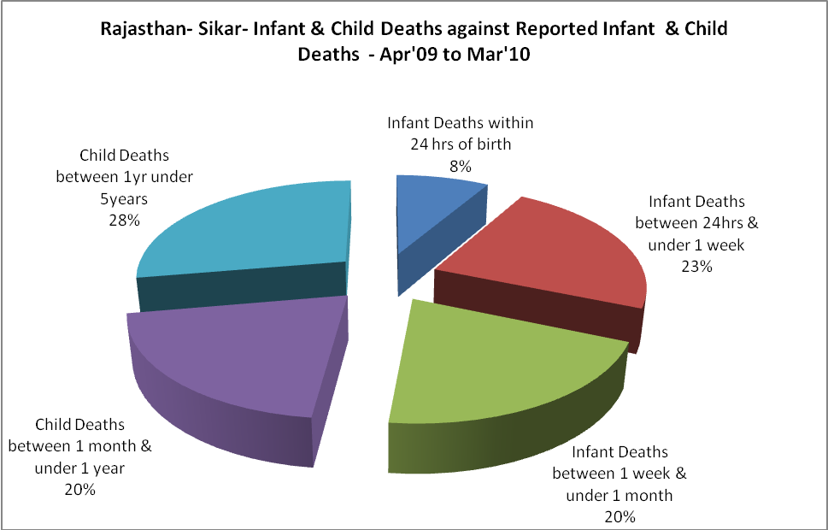

Rajasthan- Sikar- Causes of Infant & Child Deaths - Apr'09 to Mar'10
Sepsis |  |  | Asphyxia |  |  | LBW
Up to 1 Weeks of Birth | Between 1 week & 4 weeks of birth | Total | Up to 1 Weeks of Birth | Between 1 week & 4 weeks of birth | Total | Up to 1 Weeks of Birth | Between 1 week & 4 weeks of birth | Total
5 | 2 | 7 | 2 | 3 | 5 | 7 | 2 | 9
Pneumonia |  |  | Diarrhoea |  |  | Fever related
Between 1 month and 11 months | Between 1 year & 5 years | Total | Between 1 month and 11 months | Between 1 year & 5 years | Total | Between 1 month and 11 months | Between 1 year & 5 years | Total
3 | 3 | 6 | 4 | 5 | 9 | 4 | 9 | 13
Others |  |  | Measles |  |  | Others
Up to 1 Weeks of Birth | Between 1 week & 4 weeks of birth | Total | Between 1 month and 11 months | Between 1 year & 5 years | Total | Between 1 month and 11 months | Between 1 year & 5 years | Total
5 | 10 | 15 | 0 | 0 | 0 | 6 | 6 | 12
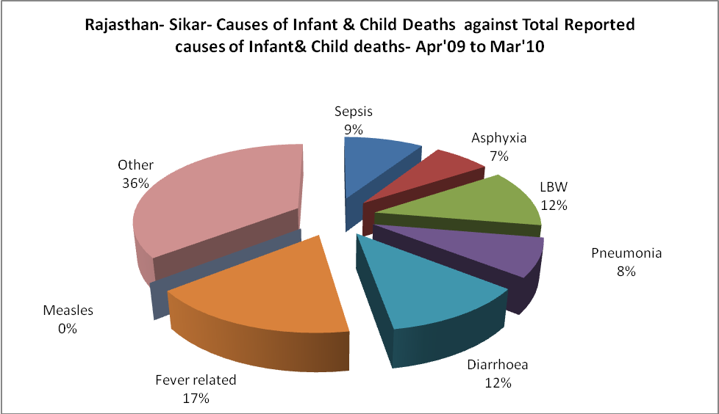

Rajasthan- Sikar- Maternal Deaths & Causes - Apr'09 to Mar'10
Abortion |  |  | Obstructed/prolonged labour |  |  | Severe hypertesnion/fits
6-14 yrs | 15-55 yrs. | Total | 6-14 yrs | 15-55 yrs. | Total | 6-14 yrs | 15-55 yrs. | Total
0 | 0 | 0 | 0 | 0 | 0 | 0 | 0 | 0
Bleeding |  |  | High Fever |  |  | Other Causes
6-14 yrs | 15-55 yrs. | Total | 6-14 yrs | 15-55 yrs. | Total | 6-14 yrs | 15-55 yrs. | Total
0 | 1 | 1 | 0 | 0 | 0 | 0 | 1 | 1

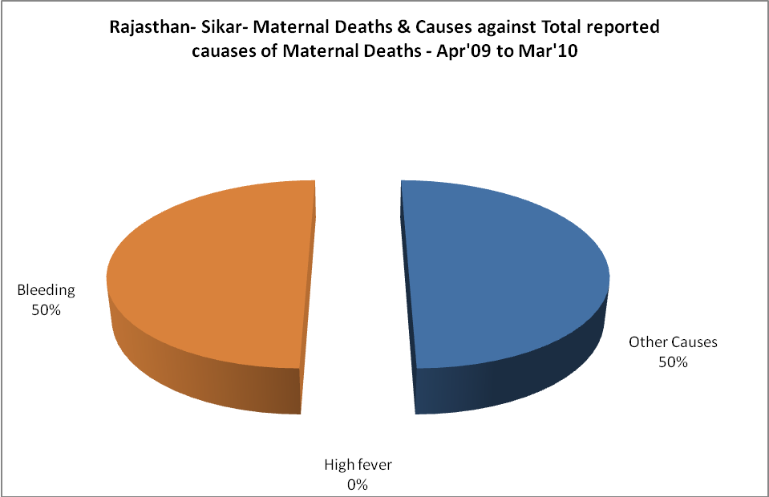

Rajasthan- Sikar-Causes of Deaths in 6 to 55yrs age group - Apr'09 to Mar'10
Diarrhoel Diseases |  |  |  | Tuberculosis |  |  |  | Respiratory Diseases( Other than TB)
6-14 yrs | 15-55 yrs. | Above 55yrs | Total | 6-14 yrs | 15-55 yrs. | Above 55yrs | Total | 6-14 yrs | 15-55 yrs. | Above 55yrs | Total
0 | 4 | 0 | 4 | 0 | 11 | 3 | 14 | 0 | 1 | 16 | 17
Malaria |  |  |  | Other fever Related |  |  |  | HIV/Aids
6-14 yrs | 15-55 yrs. | Above 55yrs | Total | 6-14 yrs | 15-55 yrs. | Above 55yrs | Total | 6-14 yrs | 15-55 yrs. | Above 55yrs | Total
0 | 0 | 0 | 0 | 0 | 0 | 0 | 0 | 0 | 0 | 0 | 0
Heart Disease/Hypertenion related |  |  |  | Neurological Disease including strokes |  |  |  | Trauma/Accidents/ Burn Cases
6-14 yrs | 15-55 yrs. | Above 55yrs | Total | 6-14 yrs | 15-55 yrs. | Above 55yrs | Total | 6-14 yrs | 15-55 yrs. | Above 55yrs | Total
0 | 8 | 10 | 18 | 0 | 0 | 2 | 2 | 0 | 12 | 0 | 12
Suicide |  |  |  | Animal Bites & Stings
6-14 yrs | 15-55 yrs. | Above 55yrs | Total | 6-14 yrs | 15-55 yrs. | Above 55yrs | Total
0 | 2 | 1 | 3 | 0 | 3 | 0 | 3

