NHSRC
Maharashtra – Sindhudurg
Analysis: Apr 2009 – Mar 2010

Maharashtra-Sindhudurg- Summary-Apr'09 to Mar'10
ANC
ANC Registration against Expected Pregnancies | 55% | TT1 given to Pregnant women against ANC Registration | 68%
3 ANC Check ups against ANC Registrations | 96% | 100 IFA Tablets given to Pregnant women against ANC Registration | 94%
Deliveries
Unreported Deliveries against Estimated Deliveries | 47.0% | HOME Deliveries( SBA& Non SBA) against Estimated Deliveries | 0.5%
Institutional Deliveries against Estimated Deliveries | 52.4% | HOME Deliveries( SBA& Non SBA) against Reported Deliveries | 1.0%
Institutional Deliveries against Reported Deliveries | 99.0% | C Section Deliveries against Institutional Deliveries( Pvt & Pub) | 16%
Births & Neonates Care
Live Births Reported against Estimated Live Births | 54% | New borns weighed against Reported Live Births | 97%
Still Births (Reported) | 146 | New borns weighed less than 2.5 kgs against newborns weighed | 27%
Sex Ratio at Birth | 877 | New borns breastfed within one hr of Birth against Reported live Births | 0%
Child Immunization( 0 to 11 months)
BCG given against Expected Live Births | 56% | Measles given against Expected Live Births | 56%
OPV3 given against Expected Live Births | 56% | Fully Immunized Children against Expected Live Births | 55%
DPT3 given against Expected Live Births | 56%
Family Planning
Family Planning Methods Users ( Sterilizations(Male &Female)+IUD+ Condom pieces/72 + OCP Cycles/13) | 21,222 | IUD Insertions against reported FP Methods | 23%
Sterilization against reported FP Methods | 11% | Condom Users against reported FP Methods | 42%
 |  | OCP Users against reported FP Methods | 24%
Other Services
OPD | 75,268 | Major Operations | 714
IPD | - | Minor Operations | 1,390
`
Maharashtra-Sindhudurg- Deliveries Apr'09 to Mar'10
Total Population | 1,020,848 | Expected Deliveries |  | 18,575
Home SBA | Home Non SBA | Institutional | Total Deliveries Reported | Unreported Deliveries
83 | 15 | 9,739 | 9,837 | 8,738
Home SBA % | Home Non SBA% | Institutional % | Total Deliveries Reported % | Unreported Deliveries %
0% | 0% | 52% | 53% | 47%

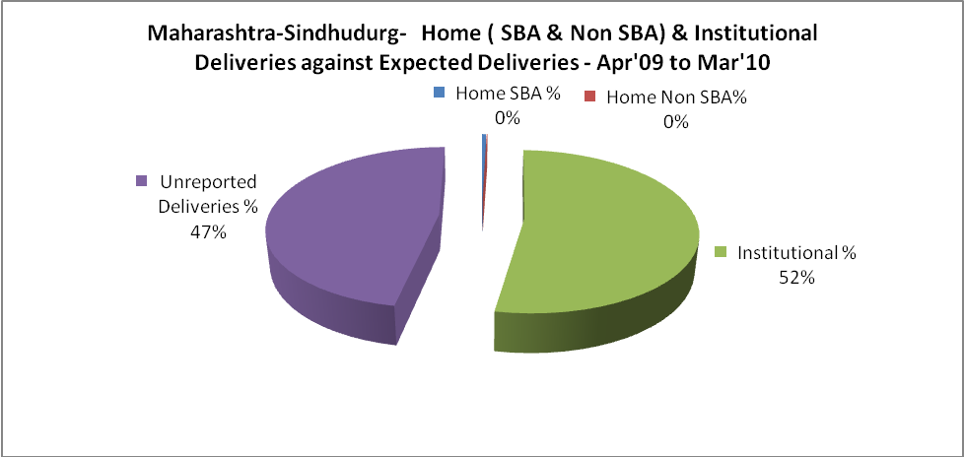

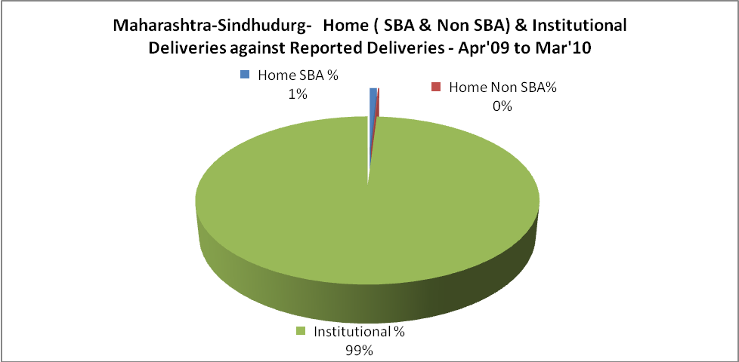

Maharashtra-Sindhudurg- C sections & Complicated Deliveries Apr'09 to Mar'10
 | Institutional Deliveries (Public) | Institutional Deliveries (Pvt)
 | 6,884 | 2,855
C Section | 889 | 700
C Section% | 13% | 25%
Complicated Pregnancies attended | 1,589 | 105
Complicated Pregnancies attended % | 23% | 4%

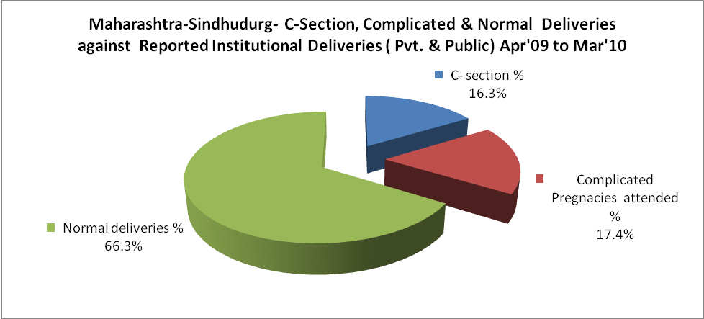

Maharashtra-Sindhudurg- Complicated Pregnancies & Deliveries Treated - Apr'09 to Mar'10
Reported Deliveries |  |  | Reported ANC Reigtration
9,837 |  |  | 11,144
Complicated Pregnancies attended | Complicated Pregnancies Rate | C - Section Deliveries | PNC Maternal Complications | Abortions | Still Births
1,694 | 8% | 1,589 | - | 1,400 | 146
Complicated Deliveries Treated with |  |  |  | No Of Eclampsia cases Treated | No Of severe anemia cases treated
IV Antibiotics | IV antihypertensive/Magsulph injection | IV Oxytocis | Blood Transfusion | No Of Eclampsia cases Treated | No Of severe anemia cases treated
- | - | - | - | - | -

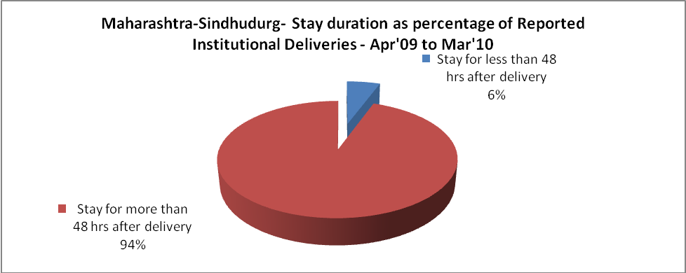

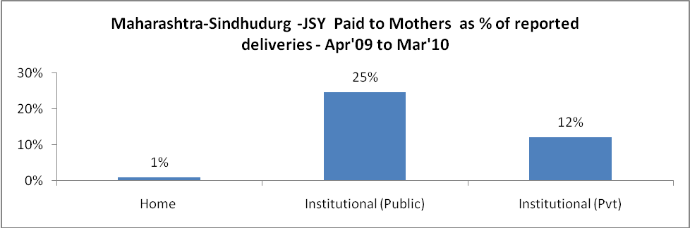

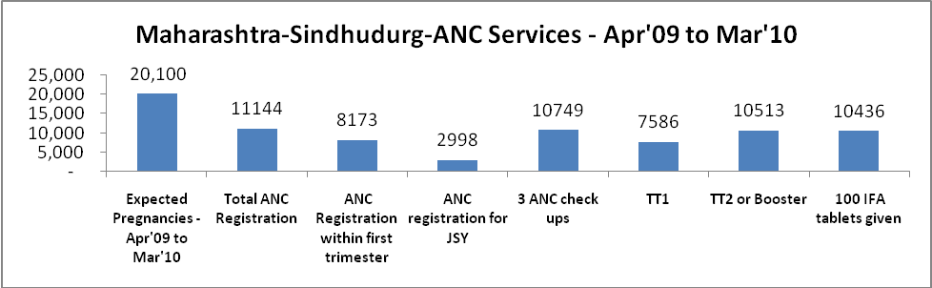

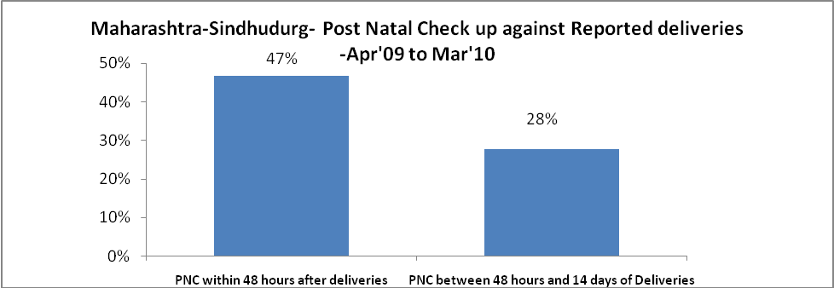

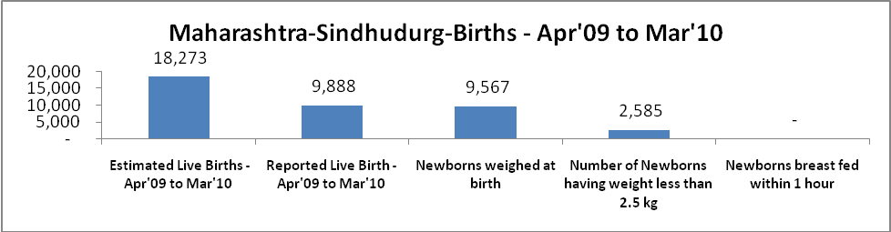

Maharashtra-Sindhudurg - Births - Apr'09 to Mar'10
Live Birth - females | Live Birth - Total | Sex Ratio at birth | Still Birth | Abortion( Induced/Spontaneous
4,619 | 9,888 | 877 | 146 | 1,400

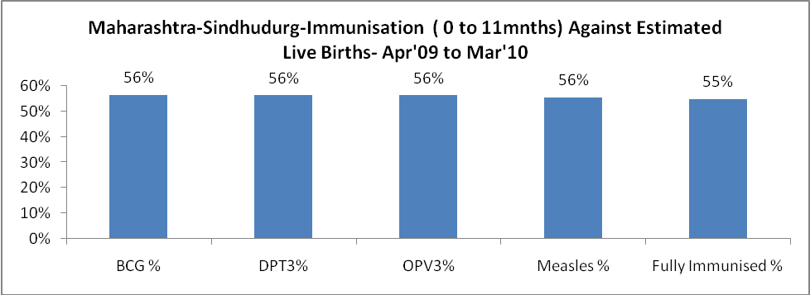

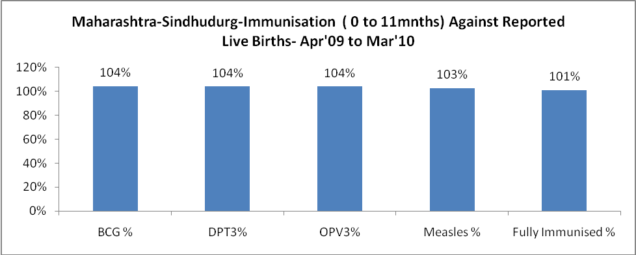

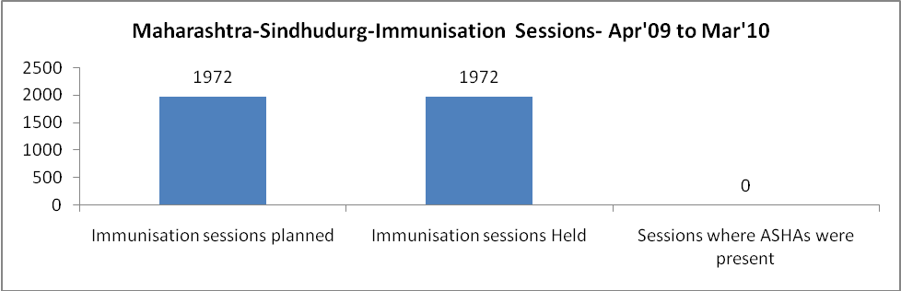

Maharashtra-Sindhudurg- Apr'09 to Mar'10
Total Abortions | Abortion Rate
2,615 | 13.0%

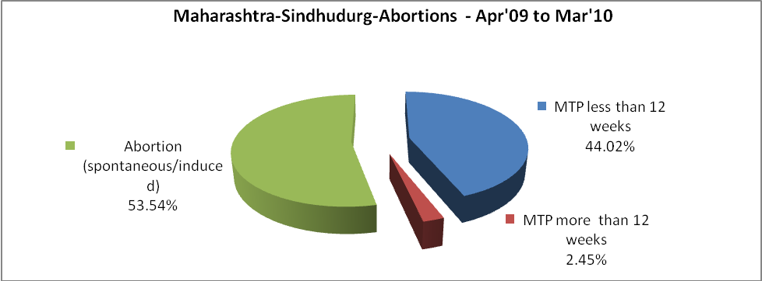

Maharashtra-Sindhudurg- Apr'09 to Mar'10
Total OPD | Total RTI/STI cases
75,268 | 1,855

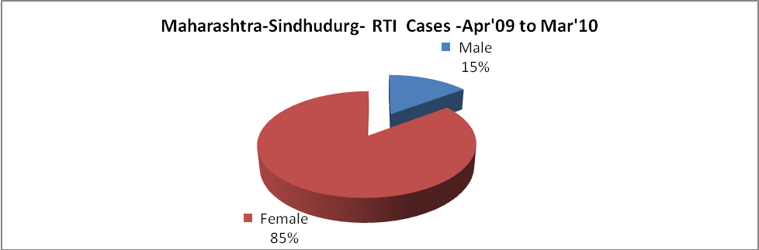

Maharashtra-Sindhudurg-Sterilizations - Apr'09 to Mar'10
 | Reported | %age of Reported Sterilization
Total Sterilization | 2,338 | -
NSV | 40 | 2%
Laparoscopic | 738 | 32%
Minilap | 1,442 | 62%
Post Partum | 118 | 5%
Male Sterilization | 40 | 2%
Female Sterilization | 2,298 | 98%

Maharashtra-Sindhudurg-FP Methods - Apr'09 to Mar'10
 | Reported | %age of All Reported FP Methods
Total Reported FP Method (All types) Users | 21,222 | -
Sterilizations | 2,338 | 11%
IUD | 4,889 | 23%
Condom Users | 8,935 | 42%
OCP Users | 5,060 | 24%
Limiting Methods | 2,338 | 11%
Spacing Methods | 18,884 | 89%

Maharashtra-Sindhudurg- Service Delivery - Apr'09 to Mar'10
Operation major (General and spinal anaesthesia) | Operation minor (No or local anaesthesia) | AYUSH | Dental Procedures | Adolescent counselling services | Total OPD | Total IPD
714 | 1,390 | - | - | - | 75,268 | -
Operation major (General and spinal anaesthesia) as %ge of OPD | Operation minor (No or local anaesthesia)as %ge of OPD | AYUSH as %ge of OPD | Dental Procedures as %ge of OPD | Adolescent counselling services as %ge of OPD | IPD as percentage of OPD
0.9% | 1.8% | 0.0% | 0.0% | 0.0% | 0%

Maharashtra-Sindhudurg- Lab Services - Apr'09 to Mar'10
Total OPD | Total HB tested | Total HIV Tested | Total Population
75,268 | - | - | 1,020,848
HB test conducted as %age of OPD | HB<7gm as %age of HB tested | HIV test conducted as %age of OPD | HIV positive as %age of HIV tested | Blood Smear Examined as % of Population
0.0% | 0.0% | 0.0% | 0.0% | 0.0%

Maharashtra-Sindhudurg- Childhood Disease - Vaccine Preventable -Apr'09 to Mar'10
Diphtheria | Pertussis | Tetanus Neonatorum | Tetanus others | Polio | Measles
0 | 0 | 0 | 0 | 0 | 2
Maharashtra-Sindhudurg-Childhood Disease - Others - Apr'09 to Mar'10
Diarrhoea and dehydration | Malaria | Number admitted with Respiratory Infections
130 | 1 | 4

Maharashtra-Sindhudurg- Infant & Child Deaths - Apr'09 to Mar'10
Infant Deaths within 24 hrs of birth | Infant Deaths between 24hrs & under 1 week | Infant Deaths between 1 week & under 1 month | Child Deaths between 1 month & under 1 year | Child Deaths between 1yr under 5years | Total Deaths
39 | 42 | 16 | 23 | 18 | 138

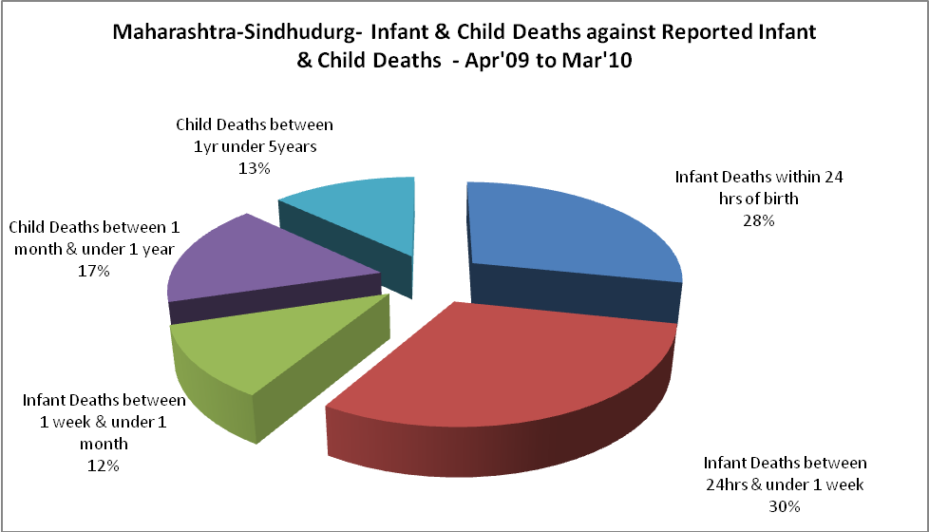

Maharashtra-Sindhudurg- Causes of Infant & Child Deaths - Apr'09 to Mar'10
Sepsis |  |  | Asphyxia |  |  | LBW
Up to 1 Weeks of Birth | Between 1 week & 4 weeks of birth | Total | Up to 1 Weeks of Birth | Between 1 week & 4 weeks of birth | Total | Up to 1 Weeks of Birth | Between 1 week & 4 weeks of birth | Total
0 | 1 | 1 | 12 | 4 | 16 | 24 | 7 | 31
Pneumonia |  |  | Diarrhoea |  |  | Fever related
Between 1 month and 11 months | Between 1 year & 5 years | Total | Between 1 month and 11 months | Between 1 year & 5 years | Total | Between 1 month and 11 months | Between 1 year & 5 years | Total
2 | 3 | 5 | 0 | 0 | 0 | 0 | 3 | 3
Others |  |  | Measles |  |  | Others
Up to 1 Weeks of Birth | Between 1 week & 4 weeks of birth | Total | Between 1 month and 11 months | Between 1 year & 5 years | Total | Between 1 month and 11 months | Between 1 year & 5 years | Total
6 | 4 | 10 | 0 | 0 | 0 | 21 | 12 | 33

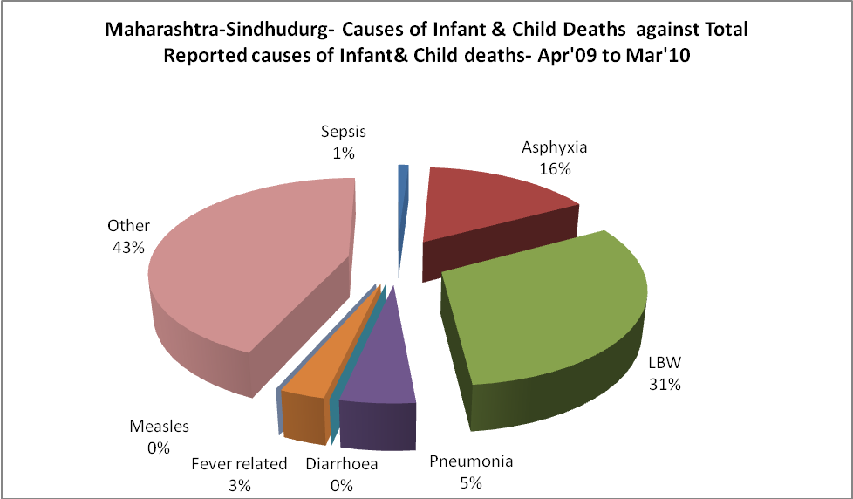

Maharashtra-Sindhudurg- Maternal Deaths & Causes - Apr'09 to Mar'10
Abortion |  |  | Obstructed/prolonged labour |  |  | Severe hypertension/fits
6-14 yrs | 15-55 yrs. | Total | 6-14 yrs | 15-55 yrs. | Total | 6-14 yrs | 15-55 yrs. | Total
0 | 0 | 0 | 0 | 0 | 0 | 0 | 0 | 0
Bleeding |  |  | High Fever |  |  | Other Causes
6-14 yrs | 15-55 yrs. | Total | 6-14 yrs | 15-55 yrs. | Total | 6-14 yrs | 15-55 yrs. | Total
0 | 0 | 0 | 0 | 0 | 0 | 0 | 0 | 0

Maharashtra-Sindhudurg-Causes of Deaths in 6 to 55yrs age group - Apr'09 to Mar'10
Diarrhoel Diseases |  |  |  | Tuberculosis |  |  |  | Respiratory Diseases( Other than TB)
6-14 yrs | 15-55 yrs. | Above 55yrs | Total | 6-14 yrs | 15-55 yrs. | Above 55yrs | Total | 6-14 yrs | 15-55 yrs. | Above 55yrs | Total
0 | 0 | 0 | 0 | 0 | 0 | 0 | 0 | 0 | 0 | 0 | 0
Malaria |  |  |  | Other fever Related |  |  |  | HIV/Aids
6-14 yrs | 15-55 yrs. | Above 55yrs | Total | 6-14 yrs | 15-55 yrs. | Above 55yrs | Total | 6-14 yrs | 15-55 yrs. | Above 55yrs | Total
0 | 0 | 0 | 0 | 0 | 0 | 0 | 0 | 0 | 0 | 0 | 0
Heart Disease/Hypertension related |  |  |  | Neurological Disease including strokes |  |  |  | Trauma/Accidents/ Burn Cases
6-14 yrs | 15-55 yrs. | Above 55yrs | Total | 6-14 yrs | 15-55 yrs. | Above 55yrs | Total | 6-14 yrs | 15-55 yrs. | Above 55yrs | Total
0 | 0 | 0 | 0 | 0 | 0 | 0 | 0 | 0 | 0 | 0 | 0
Suicide |  |  |  | Animal Bites & Stings
6-14 yrs | 15-55 yrs. | Above 55yrs | Total | 6-14 yrs | 15-55 yrs. | Above 55yrs | Total
0 | 0 | 0 | 0 | 0 | 0 | 0 | 0

