NHSRC
Maharashtra – Solapur
Analysis: Apr 2009 – Mar 2010

Maharashtra-Solapur- Summary-Apr'09 to Mar'10
ANC
ANC Registration against Expected Pregnancies | 99% | TT1 given to Pregnant women against ANC Registration | 73%
3 ANC Check ups against ANC Registrations | 78% | 100 IFA Tablets given to Pregnant women against ANC Registration | 67%
Deliveries
Unreported Deliveries against Estimated Deliveries | 20.8% | HOME Deliveries( SBA& Non SBA) against Estimated Deliveries | 2.5%
Institutional Deliveries against Estimated Deliveries | 76.7% | HOME Deliveries( SBA& Non SBA) against Reported Deliveries | 3.1%
Institutional Deliveries against Reported Deliveries | 96.9% | C Section Deliveries against Institutional Deliveries( Pvt & Pub) | 10%
Births & Neonates Care
Live Births Reported against Estimated Live Births | 81% | New borns weighed against Reported Live Births | 73%
Still Births (Reported) | 1,073 | New borns weighed less than 2.5 kgs against newborns weighed | 22%
Sex Ratio at Birth | 872 | New borns breastfed within one hr of Birth against Reported live Births | 44%
Child Immunization( 0 to 11 months)
BCG given against Expected Live Births | 94% | Measles given against Expected Live Births | 87%
OPV3 given against Expected Live Births | 147% | Fully Immunized Children against Expected Live Births | 83%
DPT3 given against Expected Live Births | 147%
Family Planning
Family Planning Methods Users ( Sterilizations(Male &Female)+IUD+ Condom pieces/72 + OCP Cycles/13) | 75,715 | IUD Insertions against reported FP Methods | 34%
Sterilization against reported FP Methods | 30% | Condom Users against reported FP Methods | 17%
 |  | OCP Users against reported FP Methods | 19%
Other Services
OPD | 666,817 | Major Operations | 680
IPD | 3,115 | Minor Operations | 1,278
`
Maharashtra-Solapur- Deliveries Apr'09 to Mar'10
Total Population | 4,516,800 | Expected Deliveries |  | 82,185
Home SBA | Home Non SBA | Institutional | Total Deliveries Reported | Unreported Deliveries
1,370 | 670 | 63,019 | 65,059 | 17,126
Home SBA % | Home Non SBA% | Institutional % | Total Deliveries Reported % | Unreported Deliveries %
2% | 1% | 77% | 79% | 21%

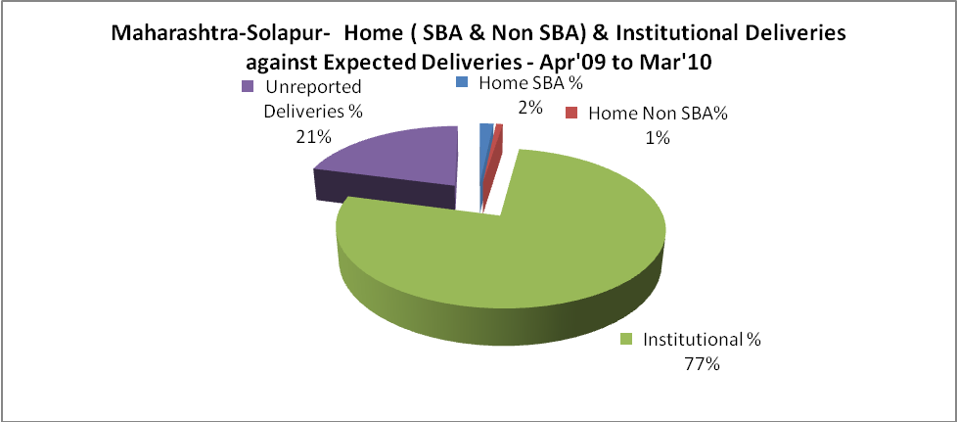

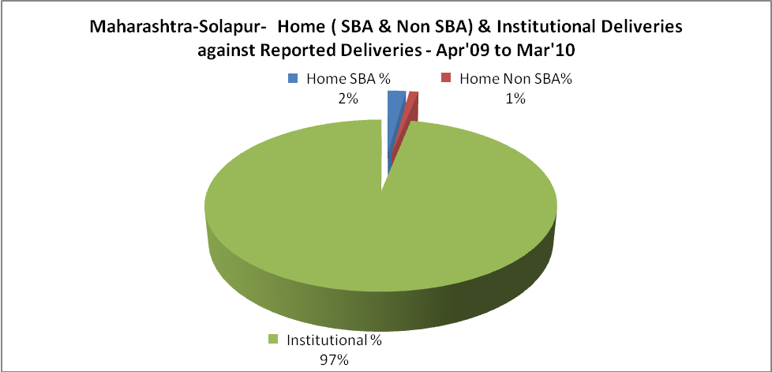

Maharashtra-Solapur- C sections & Complicated Deliveries Apr'09 to Mar'10
 | Institutional Deliveries (Public) | Institutional Deliveries (Pvt)
 | 33,624 | 29,395
C Section | 3,960 | 2,598
C Section% | 12% | 9%
Complicated Pregnancies attended | 1,507 | 224
Complicated Pregnancies attended % | 4% | 1%

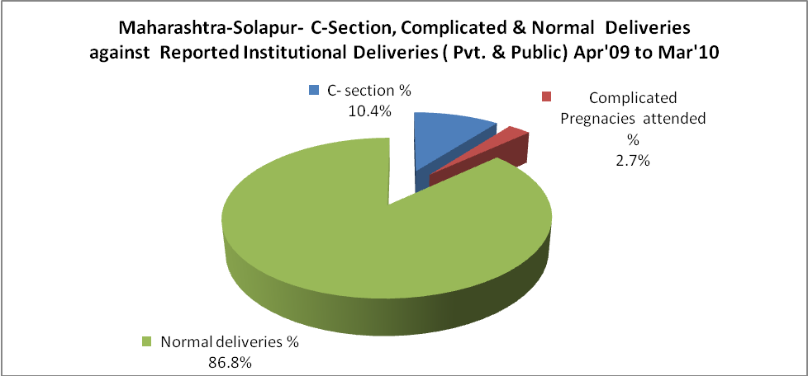

Maharashtra-Solapur- Complicated Pregnancies & Deliveries Treated - Apr'09 to Mar'10
Reported Deliveries |  |  | Reported ANC Registration
65,059 |  |  | 87,658
Complicated Pregnancies attended | Complicated Pregnancies Rate | C - Section Deliveries | PNC Maternal Complications | Abortions | Still Births
1,731 | 2% | 6,558 | 662 | 2,364 | 1,073
Complicated Deliveries Treated with |  |  |  | No Of Eclampsia cases Treated | No Of severe anemia cases treated
IV Antibiotics | IV antihypertensive/Magsulph injection | IV Oxytocis | Blood Transfusion | No Of Eclampsia cases Treated | No Of severe anemia cases treated
189 | 5 | 26 | 18 | 194 | 11,280

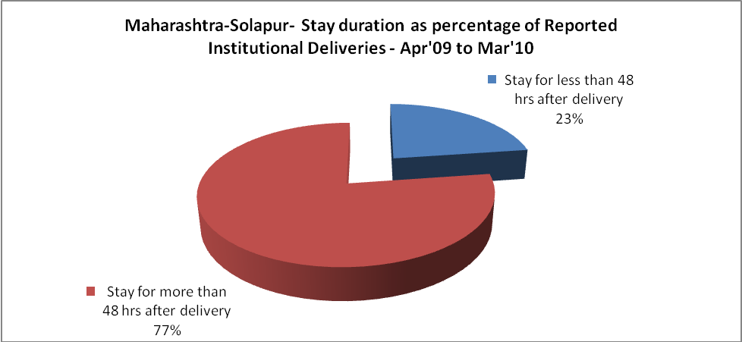

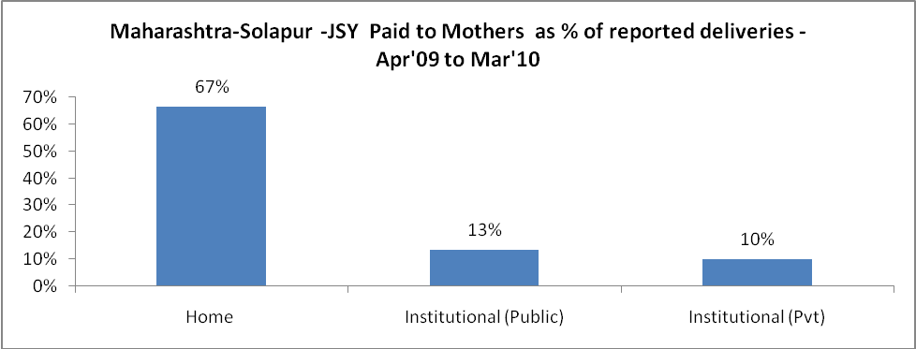

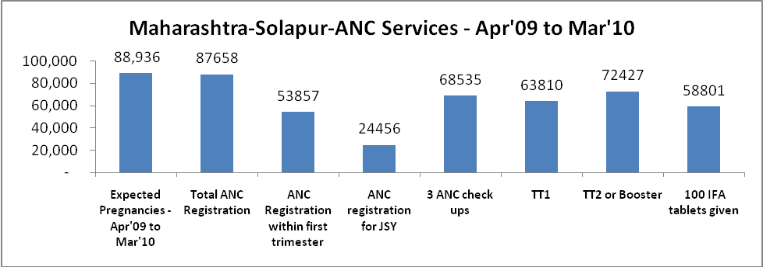

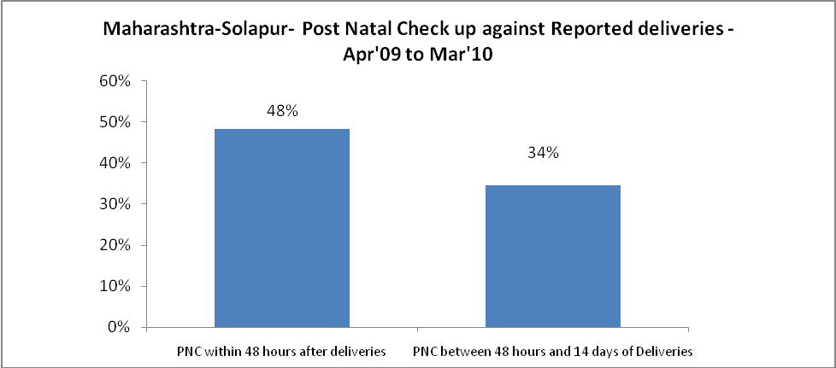

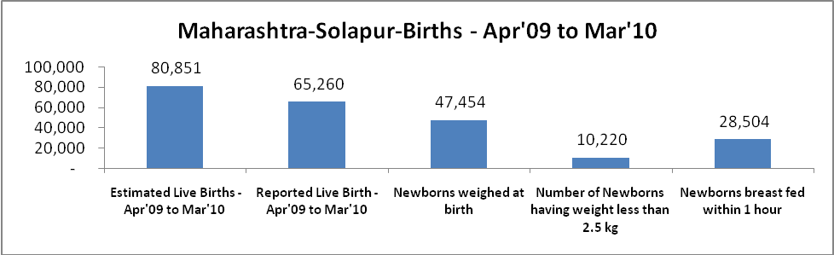

Maharashtra-Solapur - Births - Apr'09 to Mar'10
Live Birth - Males | Live Birth - females | Live Birth - Total | Sex Ratio at birth | Still Birth | Abortion( Induced/Spontaneous
34,857 | 30,403 | 65,260 | 872 | 1,073 | 2,364

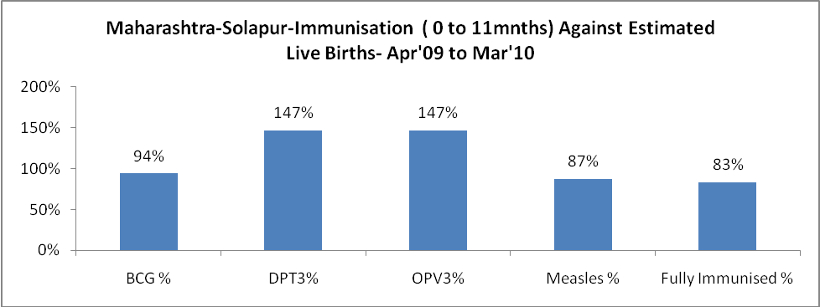

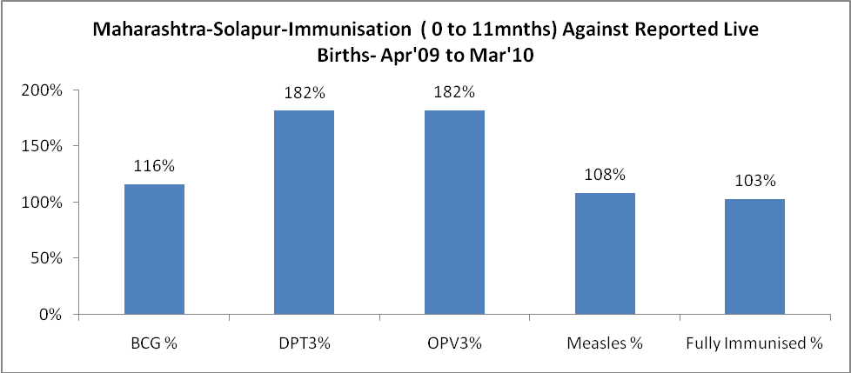

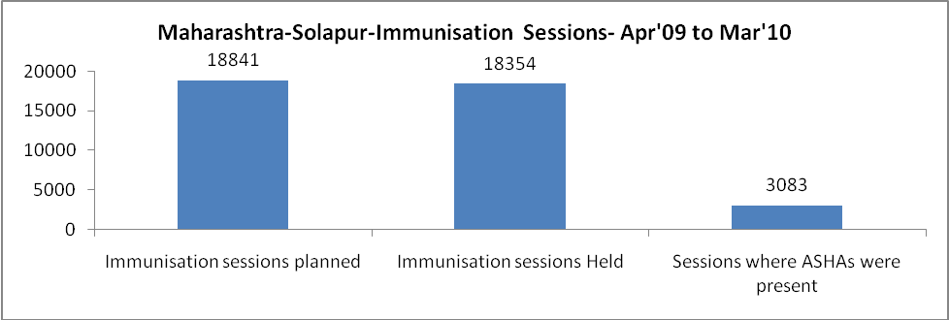

Maharashtra-Solapur- Apr'09 to Mar'10
Total Abortions | Abortion Rate
4,092 | 4.6%

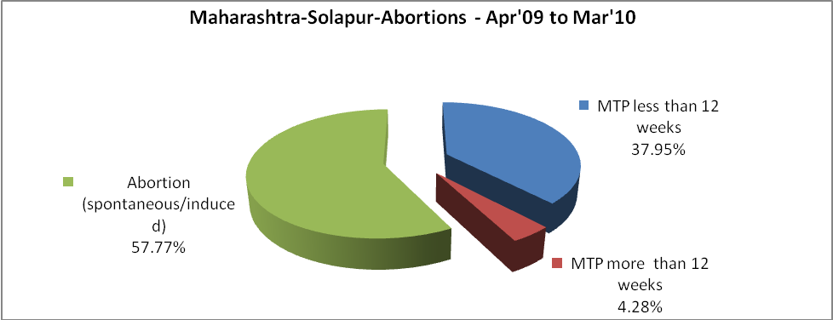

Maharashtra-Solapur- Apr'09 to Mar'10
Total OPD | Total RTI/STI cases
666,817 | 11,792

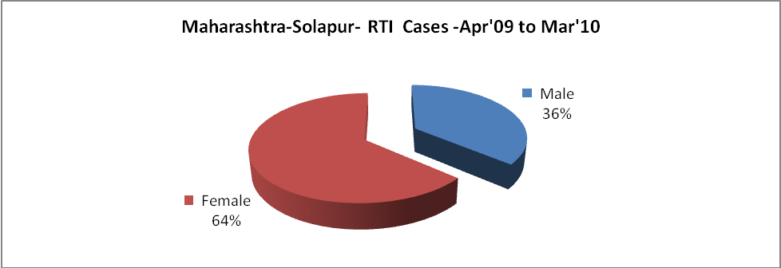

Maharashtra-Solapur-Sterilizations - Apr'09 to Mar'10
 | Reported | %age of Reported Sterilization
Total Sterilization | 22,784 | -
NSV | 1,428 | 6%
Laparoscopic | 8,830 | 39%
Mini Lap | 9,266 | 41%
Post Partum | 3,260 | 14%
Male Sterilization | 1,428 | 6%
Female Sterilization | 21,356 | 94%

Maharashtra-Solapur-FP Methods - Apr'09 to Mar'10
 | Reported | %age of All Reported FP Methods
Total Reported FP Method (All types) Users | 75,715 | -
Sterilisations | 22,784 | 30%
IUD | 25,901 | 34%
Condom Users | 12,703 | 17%
OCP Users | 14,327 | 19%
Limiting Methods | 22,784 | 30%
Spacing Methods | 52,931 | 70%

Maharashtra-Solapur- Service Delivery - Apr'09 to Mar'10
Operation major (General and spinal anaesthesia) | Operation minor (No or local anaesthesia) | AYUSH | Dental Procedures | Adolescent counseling services | Total OPD | Total IPD
680 | 1,278 | 2 | 8 | 456 | 666,817 | 3,115
Operation major (General and spinal anaesthesia) as %ge of OPD | Operation minor (No or local anaesthesia)as %ge of OPD | AYUSH as %ge of OPD | Dental Procedures as %ge of OPD | Adolescent counselling services as %ge of OPD | IPD as percentage of OPD
0.1% | 0.2% | 0.0% | 0.0% | 0.1% | 0%

Maharashtra-Solapur- Lab Services - Apr'09 to Mar'10
Total OPD | Total HB tested | Total HIV Tested | Total Population
666,817 | 11,562 | - | 4,516,800
HB test conducted as %age of OPD | HB<7gm as %age of HB tested | HIV test conducted as %age of OPD | HIV positive as %age of HIV tested | Blood Smear Examined as % of Population
1.7% | 2.5% | 0.0% | 0.0% | 5.3%

Maharashtra-Solapur- Childhood Disease - Vaccine Preventable -Apr'09 to Mar'10
Diphtheria | Pertussis | Tetanus Neonatorum | Tetanus others | Polio | Measles
5 | 3 | 5 | 8 | 8 | 20
Maharashtra-Solapur-Childhood Disease - Others - Apr'09 to Mar'10
Diarrhoea and dehydration | Malaria | Number admitted with Respiratory Infections
4,999 | 25 | 1,492

Maharashtra-Solapur- Infant & Child Deaths - Apr'09 to Mar'10
Infant Deaths within 24 hrs of birth | Infant Deaths between 24hrs & under 1 week | Infant Deaths between 1 week & under 1 month | Child Deaths between 1 month & under 1 year | Child Deaths between 1yr under 5years | Total Deaths
111 | 125 | 25 | 66 | 16 | 343

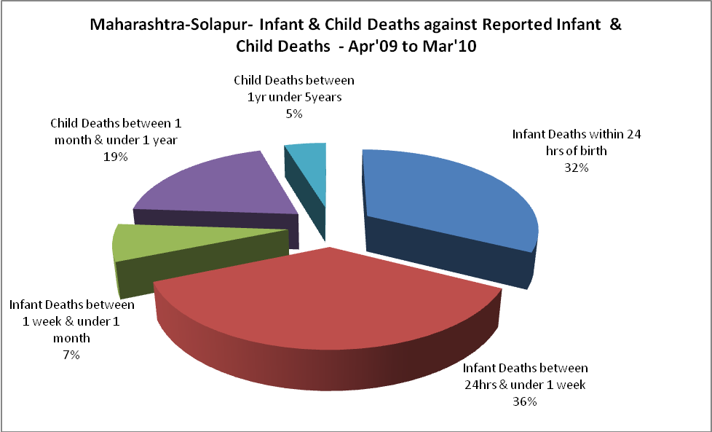

Maharashtra-Solapur- Causes of Infant & Child Deaths - Apr'09 to Mar'10
Sepsis |  |  | Asphyxia |  |  | LBW
Up to 1 Weeks of Birth | Between 1 week & 4 weeks of birth | Total | Up to 1 Weeks of Birth | Between 1 week & 4 weeks of birth | Total | Up to 1 Weeks of Birth | Between 1 week & 4 weeks of birth | Total
4 | 1 | 5 | 10 | 10 | 20 | 22 | 10 | 32
Pneumonia |  |  | Diarrhoea |  |  | Fever related
Between 1 month and 11 months | Between 1 year & 5 years | Total | Between 1 month and 11 months | Between 1 year & 5 years | Total | Between 1 month and 11 months | Between 1 year & 5 years | Total
1 | 3 | 4 | 12 | 3 | 15 | 16 | 0 | 16
Others |  |  | Measles |  |  | Others
Up to 1 Weeks of Birth | Between 1 week & 4 weeks of birth | Total | Between 1 month and 11 months | Between 1 year & 5 years | Total | Between 1 month and 11 months | Between 1 year & 5 years | Total
89 | 4 | 93 | 1 | 0 | 1 | 36 | 10 | 46

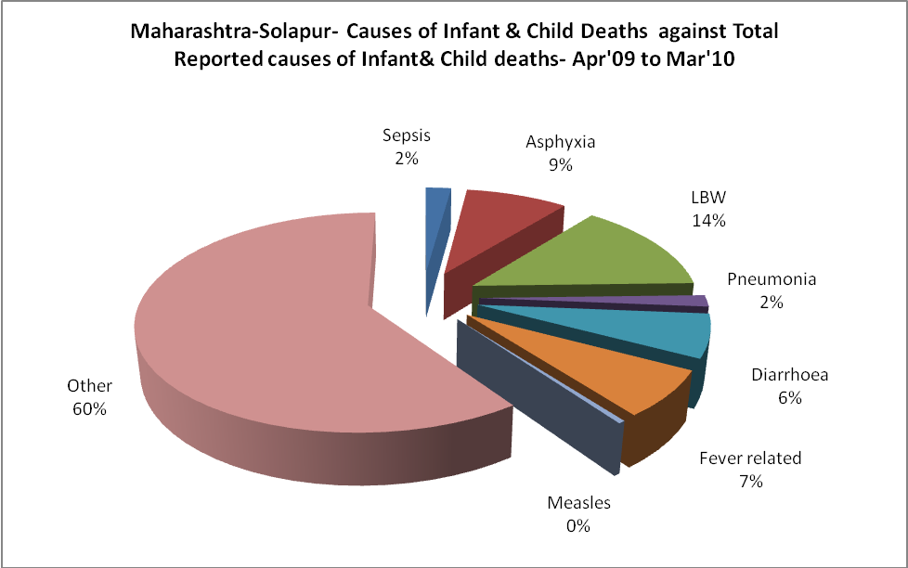

Maharashtra-Solapur- Maternal Deaths & Causes - Apr'09 to Mar'10
Abortion |  |  | Obstructed/prolonged labour |  |  | Severe hypertension/fits
6-14 yrs | 15-55 yrs. | Total | 6-14 yrs | 15-55 yrs. | Total | 6-14 yrs | 15-55 yrs. | Total
0 | 0 | 0 | 0 | 0 | 0 | 0 | 2 | 2
Bleeding |  |  | High Fever |  |  | Other Causes
6-14 yrs | 15-55 yrs. | Total | 6-14 yrs | 15-55 yrs. | Total | 6-14 yrs | 15-55 yrs. | Total
0 | 4 | 4 | 0 | 0 | 0 | 0 | 22 | 22

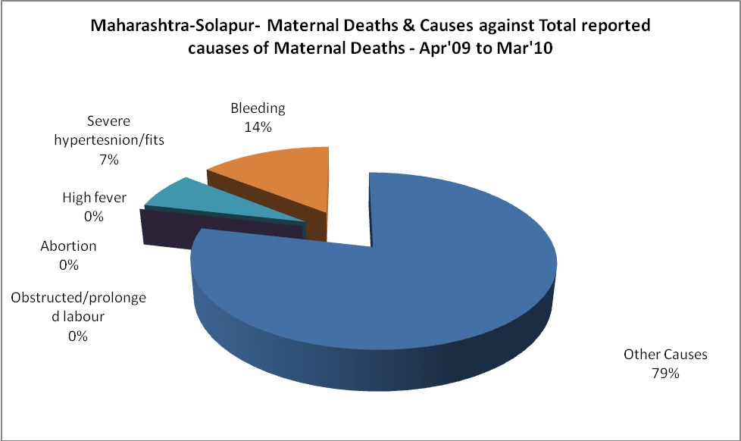

Maharashtra-Solapur-Causes of Deaths in 6 to 55yrs age group - Apr'09 to Mar'10
Diarrhoel Diseases |  |  |  | Tuberculosis |  |  |  | Respiratory Diseases( Other than TB)
6-14 yrs | 15-55 yrs. | Above 55yrs | Total | 6-14 yrs | 15-55 yrs. | Above 55yrs | Total | 6-14 yrs | 15-55 yrs. | Above 55yrs | Total
0 | 210 | 0 | 210 | 0 | 6 | 0 | 6 | 1 | 1 | 0 | 2
Malaria |  |  |  | Other fever Related |  |  |  | HIV/Aids
6-14 yrs | 15-55 yrs. | Above 55yrs | Total | 6-14 yrs | 15-55 yrs. | Above 55yrs | Total | 6-14 yrs | 15-55 yrs. | Above 55yrs | Total
1 | 1 | 0 | 2 | 0 | 2 | 0 | 2 | 0 | 0 | 0 | 0
Heart Disease/Hypertension related |  |  |  | Neurological Disease including strokes |  |  |  | Trauma/Accidents/ Burn Cases
6-14 yrs | 15-55 yrs. | Above 55yrs | Total | 6-14 yrs | 15-55 yrs. | Above 55yrs | Total | 6-14 yrs | 15-55 yrs. | Above 55yrs | Total
0 | 3 | 0 | 3 | 0 | 0 | 0 | 0 | 0 | 2 | 0 | 2
Suicide |  |  |  | Animal Bites & Stings
6-14 yrs | 15-55 yrs. | Above 55yrs | Total | 6-14 yrs | 15-55 yrs. | Above 55yrs | Total
0 | 4 | 0 | 4 | 0 | 0 | 0 | 0

