NHSRC
Meghalaya-South Garo Hills
Analysis: Apr 2009 – Mar 2010

MEGHALAYA- SOUTH GARO HILLS DIST.- Summary-Apr'09 to Mar'10
ANC
ANC Registration against Expected Pregnancies | 75% | TT1 given to Pregnant women against ANC Registraion | 80%
3 ANC Check ups against ANC Reigtrations | 26% | 100 IFA Tablets given to Pregnant women against ANC Registraion | 69%
Deliveries
Unreported Deliveries against Estimated Deliveries | 49.8% | HOME Deliveries( SBA& Non SBA) against Estimated Deliveries | 40.0%
Institutional Deliveries against Estimated Deliveries | 10.2% | HOME Deliveries( SBA& Non SBA) against Reported Deliveries | 79.6%
Institutional Deliveries against Reported Deliveries | 20.4% | C Section Deliveries against Institutional Deliveries( Pvt & Pub) | 0%
Births & Neonates Care
Live Births Reported against Estimated Live Births | 51% | New borns weighed against Reported Live Births | 27%
Still Births (Reported) | 10 | New borns weighed less than 2.5 kgs against newborns weighed | 20%
Sex Ratio at Birh | 1,047 | New borns breastfed within one hr of Birth against Reported live Births | 55%
Child Immunisation( 0 to 11 months)
BCG given against Expected Live Births | 113% | Measles given against Expected Live Births | 67%
OPV3 given against Expected Live Births | 87% | Fully Immunised Children against Expected Live Births | 80%
DPT3 given against Expected Live Births | 87%
Family Planning
Family Plannig Methods Users ( Sterilisations(Male &Female)+IUD+ Condom pieces/72 + OCP Cycles/13) | 295 | IUD Insertions against reported FP Methods | 31%
Sterilisation against reported FP Methods | 6% | Condom Users against reported FP Methods | 35%
 |  | OCP Users against reported FP Methods | 28%
Other Services
OPD | 33,702 | Major Operations | -
IPD | 2,043 | Minor Operations | 11

MEGHALAYA- SOUTH GARO HILLS DIST.- Deliveries Apr'09 to Mar'10
Total Population | 1,23,742 | Expected Deliveries |  | 3,209
Home SBA | Home Non SBA | Institutional | Total Deliveries Reported | Unreported Deliveries
208 | 1,074 | 328 | 1,610 | 1,599
Home SBA % | Home Non SBA% | Institutional % | Total Deliveries Reported % | Unreported Deliveries %
6% | 33% | 10% | 50% | 50%
`

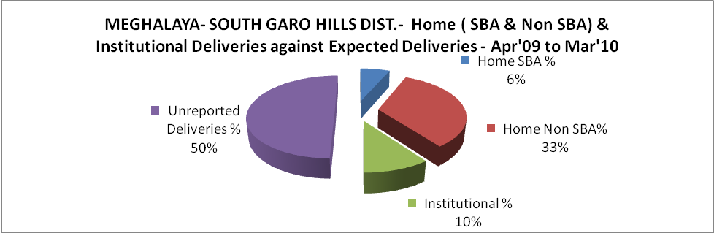

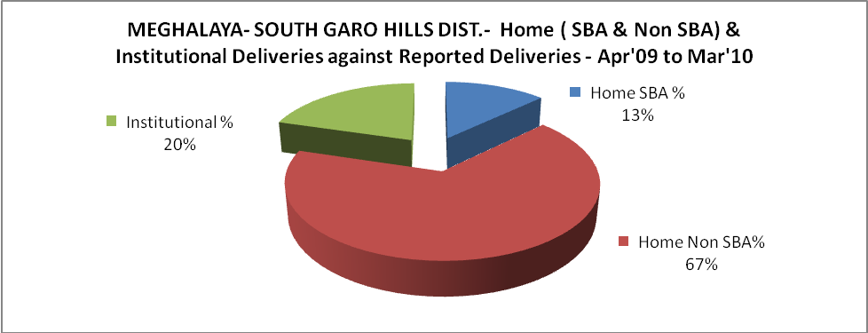

MEGHALAYA- SOUTH GARO HILLS DIST.- C sections & Complicated Deliveries Apr'09 to Mar'10
 | Institutional Deliveries (Public) | Institutional Deliveries (Pvt)
 | 328 | -
C Section | - | -
C Section% | 0% | 0%
Complicated Pregnacies attended | 2 | -
Complicated Pregnacies attended % | 1% | 0%

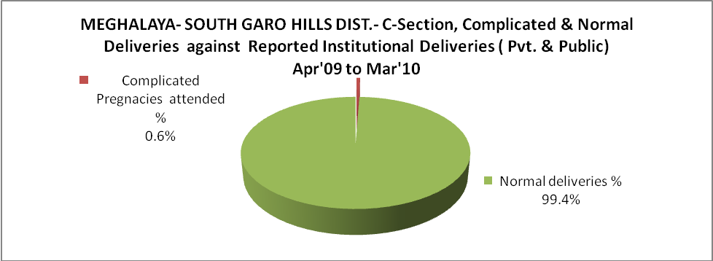

MEGHALAYA- SOUTH GARO HILLS DIST.- Complicated Pregnancies & Deliveries Treated - Apr'09 to Mar'10
Reported Deliveries |  |  | Reported ANC Reigtration
1,610 |  |  | 2,557
Complicated Pregnancies attended | Complicated Pregnancies Rate | C - Section Deliveries | PNC Maternal Complications | Abortions | Still Births
2 | 0% | - | 5 | 3 | 10
Complicated Deliveries Treated with |  |  |  | No Of Eclampsia cases Treated | No Of severe anemia cases treated
IV Antibiotics | IV antihypertensive/Magsulph injection | IV Oxytocis | Blood Transfusion | No Of Eclampsia cases Treated | No Of severe anemia cases treated
2 | 1 | 10 | - | 1 | 5

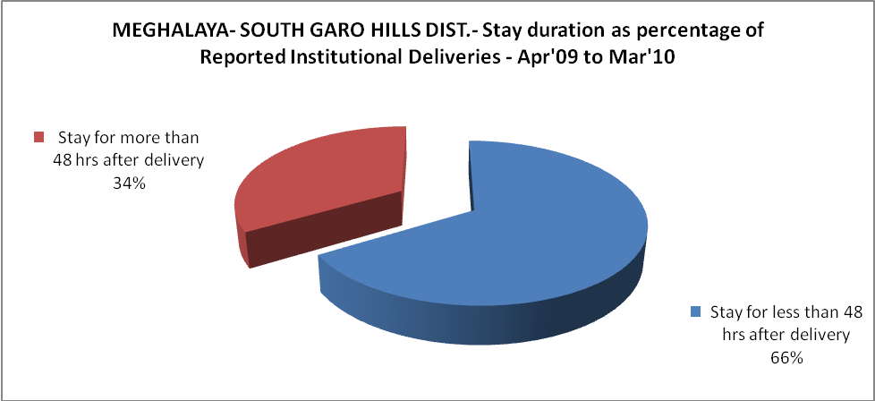

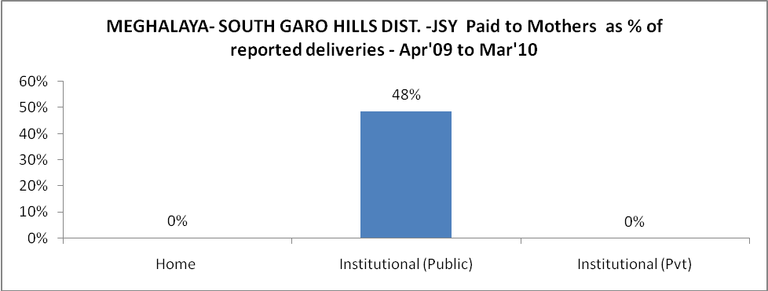

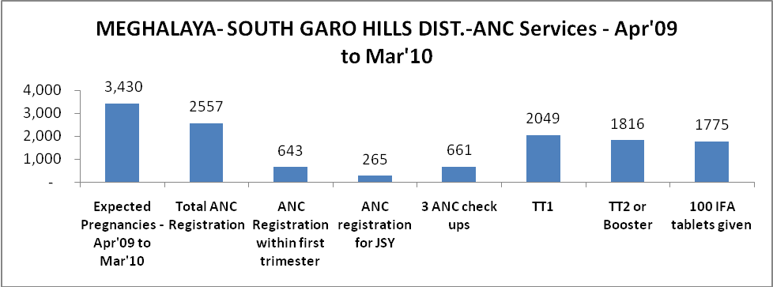

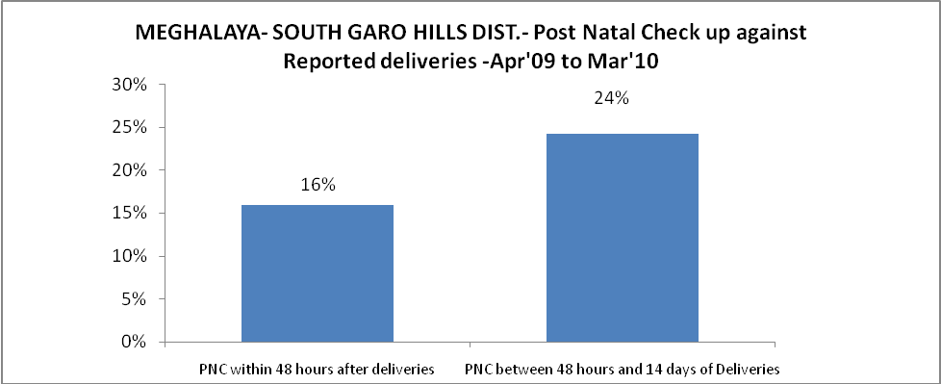

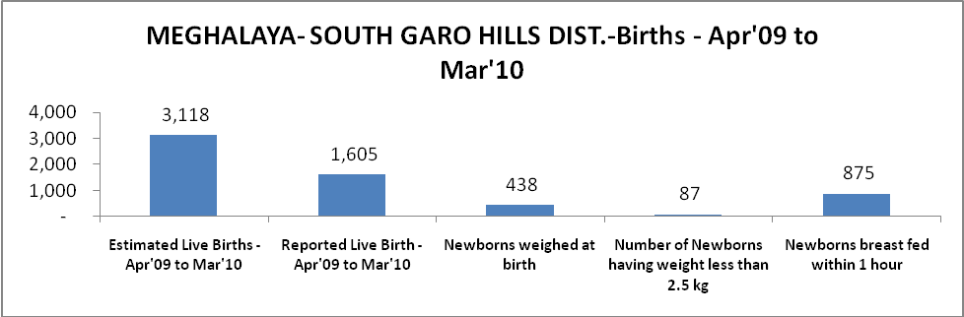

MEGHALAYA- SOUTH GARO HILLS DIST. - Births - Apr'09 to Mar'10
Live Birth - Males | Live Birth - females | Live Birth - Total | Sex Ratio at birth | Still Birth | Abortion( Induced/Spontaneous
784 | 821 | 1,605 | 1,047 | 10 | 3

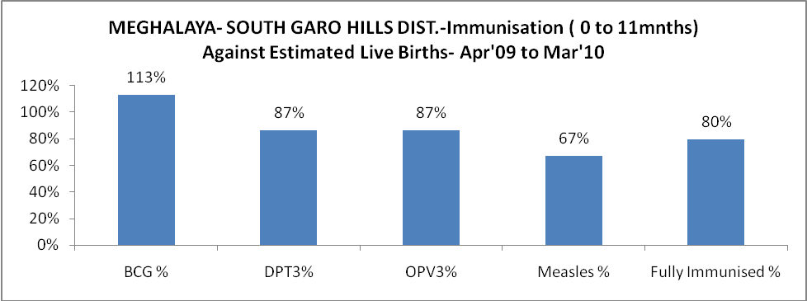

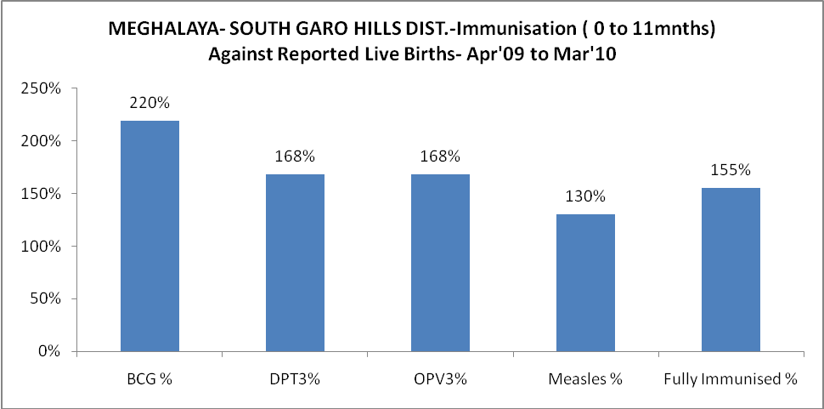

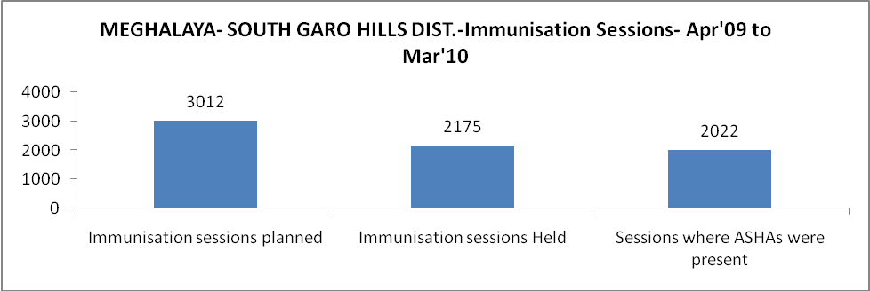

MEGHALAYA- SOUTH GARO HILLS DIST.- Apr'09 to Mar'10
Total Abortions | Abortion Rate
4 | 0.1%

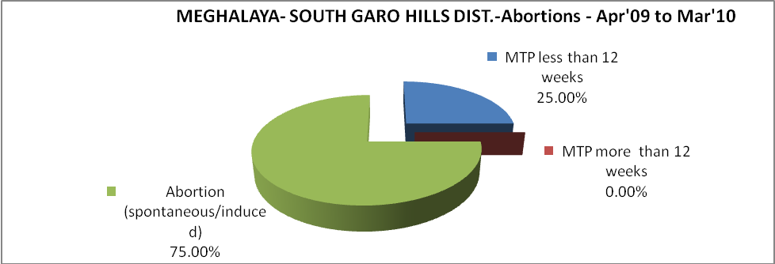

MEGHALAYA- SOUTH GARO HILLS DIST.- Apr'09 to Mar'10
Total OPD | Total RTI/STI cases
33,702 | 29

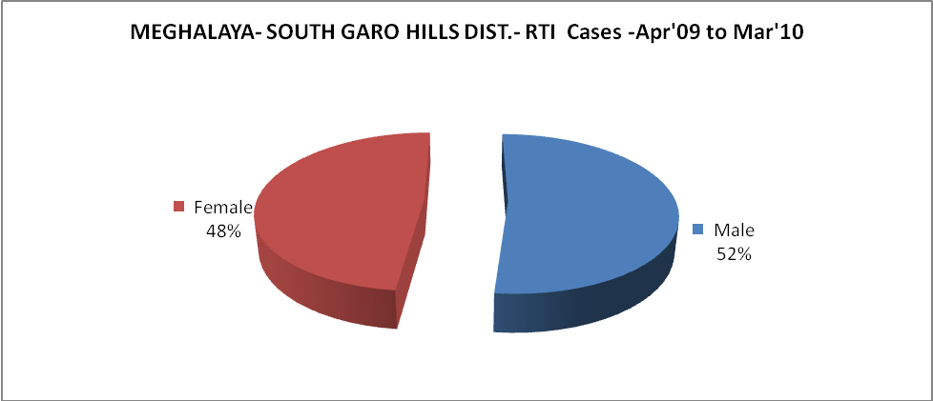

MEGHALAYA- SOUTH GARO HILLS DIST.-Sterilisations - Apr'09 to Mar'10
 | Reported | %age of Reported Sterilisation
Total Sterilisation | 17 | -
NSV | - | 0%
Laproscopic | - | 0%
MiniLap | 17 | 100%
Post Partum | - | 0%
Male Sterilisation | - | 0%
Female Sterilisation | 17 | 100%

MEGHALAYA- SOUTH GARO HILLS DIST.-FP Methods - Apr'09 to Mar'10
 | Reported | %age of All Reported FP Methods
Total Reported FP Methodd (All types) Users | 295 | -
Sterilisations | 17 | 6%
IUD | 93 | 31%
Condom Users | 102 | 35%
OCP Users | 83 | 28%
Limiting Methods | 17 | 6%
Spacing Methods | 278 | 94%

MEGHALAYA- SOUTH GARO HILLS DIST.- Service Delivery - Apr'09 to Mar'10
Operation major (General and spinal anaesthesia) | Operation minor (No or local anaesthesia) | AYUSH | Dental Procedures | Adolescent counselling services | Total OPD | Total IPD
- | 11 | 1,961 | - | - | 33,702 | 2,043
Operation major (General and spinal anaesthesia) as %ge of OPD | Operation minor (No or local anaesthesia)as %ge of OPD | AYUSH as %ge of OPD | Dental Procedures as %ge of OPD | Adolescent counselling services as %ge of OPD | IPD as percentage of OPD
0.0% | 0.0% | 5.8% | 0.0% | 0.0% | 6%

MEGHALAYA- SOUTH GARO HILLS DIST.- Lab Services - Apr'09 to Mar'10
Total OPD | Total HB tested | Total HIV Tested | Total Population
33,702 | 607 | 10 | 1,23,742
HB test conducted as %age of OPD | HB<7gm as %age of HB tested | HIV test conducted as %age of OPD | HIV positive as %age of HIV tested | Blood Smear Examined as % of Population
1.8% | 14.2% | 0.0% | 0.0% | 9.1%

MEGHALAYA- SOUTH GARO HILLS DIST.- Childhood Disease - Vaccine Preventable -Apr'09 to Mar'10
Diphtheria | Pertussis | Tetanus Neonatorum | Tetanus others | Polio | Measles
0 | 0 | 0 | 0 | 0 | 6
MEGHALAYA- SOUTH GARO HILLS DIST.-Childhood Disease - Others - Apr'09 to Mar'10
Diarrhoea and dehydration | Malaria | Number admitted with Respiratory Infections
2,239 | 2,832 | 300

MEGHALAYA- SOUTH GARO HILLS DIST.- Infant & Child Deaths - Apr'09 to Mar'10
Infant Deaths within 24 hrs of birth | Infant Deaths between 24hrs & under 1 week | Infant Deaths between 1 week & under 1 month | Child Deaths between 1 month & under 1 year | Child Deaths between 1yr under 5years | Total Deaths
5 | 1 | 0 | 28 | 10 | 44

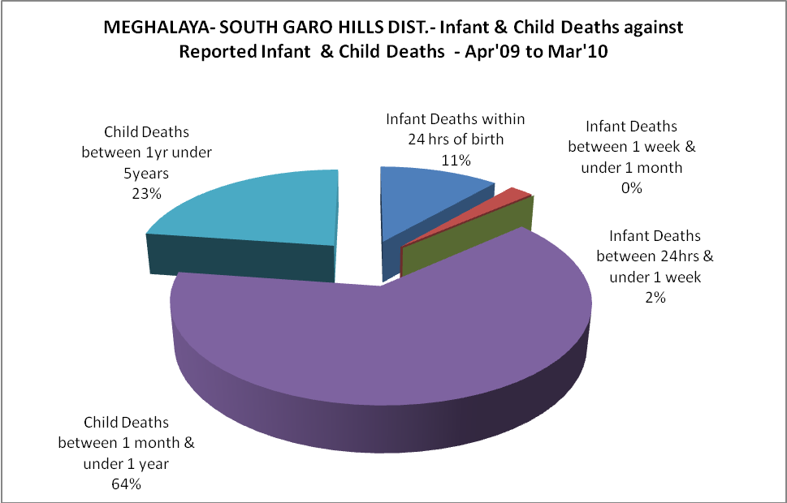

MEGHALAYA- SOUTH GARO HILLS DIST.- Causes of Infant & Child Deaths - Apr'09 to Mar'10
Sepsis |  |  | Asphyxia |  |  | LBW
Up to 1 Weeks of Birth | Between 1 week & 4 weeks of birth | Total | Up to 1 Weeks of Birth | Between 1 week & 4 weeks of birth | Total | Up to 1 Weeks of Birth | Between 1 week & 4 weeks of birth | Total
0 | 0 | 0 | 0 | 0 | 0 | 0 | 0 | 0
Pneumonia |  |  | Diarrhoea |  |  | Fever related
Between 1 month and 11 months | Between 1 year & 5 years | Total | Between 1 month and 11 months | Between 1 year & 5 years | Total | Between 1 month and 11 months | Between 1 year & 5 years | Total
0 | 0 | 0 | 4 | 1 | 5 | 20 | 9 | 29
Others |  |  | Measles |  |  | Others
Up to 1 Weeks of Birth | Between 1 week & 4 weeks of birth | Total | Between 1 month and 11 months | Between 1 year & 5 years | Total | Between 1 month and 11 months | Between 1 year & 5 years | Total
1 | 0 | 1 | 0 | 0 | 0 | 4 | 0 | 4

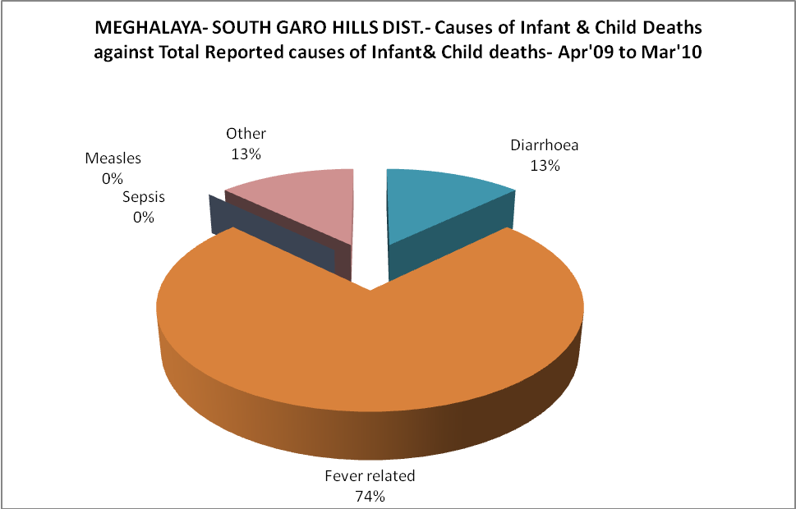

MEGHALAYA- SOUTH GARO HILLS DIST.- Maternal Deaths & Causes - Apr'09 to Mar'10
Abortion |  |  | Obstructed/prolonged labour |  |  | Severe hypertesnion/fits
6-14 yrs | 15-55 yrs. | Total | 6-14 yrs | 15-55 yrs. | Total | 6-14 yrs | 15-55 yrs. | Total
0 | 0 | 0 | 0 | 2 | 2 | 0 | 0 | 0
Bleeding |  |  | High Fever |  |  | Other Causes
6-14 yrs | 15-55 yrs. | Total | 6-14 yrs | 15-55 yrs. | Total | 6-14 yrs | 15-55 yrs. | Total
0 | 0 | 0 | 0 | 0 | 0 | 0 | 0 | 0

MEGHALAYA- SOUTH GARO HILLS DIST.-Causes of Deaths in 6 to 55yrs age group - Apr'09 to Mar'10
Diarrhoel Diseases |  |  |  | Tuberculosis |  |  |  | Respiratory Diseases( Other than TB)
6-14 yrs | 15-55 yrs. | Above 55yrs | Total | 6-14 yrs | 15-55 yrs. | Above 55yrs | Total | 6-14 yrs | 15-55 yrs. | Above 55yrs | Total
2 | 0 | 0 | 2 | 1 | 0 | 0 | 1 | 0 | 1 | 0 | 1
Malaria |  |  |  | Other fever Related |  |  |  | HIV/Aids
6-14 yrs | 15-55 yrs. | Above 55yrs | Total | 6-14 yrs | 15-55 yrs. | Above 55yrs | Total | 6-14 yrs | 15-55 yrs. | Above 55yrs | Total
12 | 3 | 0 | 15 | 6 | 2 | 1 | 9 | 0 | 0 | 0 | 0
Heart Disease/Hypertenion related |  |  |  | Neurological Disease including strokes |  |  |  | Trauma/Accidents/ Burn Cases
6-14 yrs | 15-55 yrs. | Above 55yrs | Total | 6-14 yrs | 15-55 yrs. | Above 55yrs | Total | 6-14 yrs | 15-55 yrs. | Above 55yrs | Total
0 | 0 | 2 | 2 | 0 | 0 | 0 | 0 | 0 | 0 | 0 | 0
Suicide |  |  |  | Animal Bites & Stings
6-14 yrs | 15-55 yrs. | Above 55yrs | Total | 6-14 yrs | 15-55 yrs. | Above 55yrs | Total
0 | 0 | 0 | 0 | 1 | 1 | 0 | 2

