NHSRC
Maharashtra – Thane
Analysis: Apr 2009 – Mar 2010

Maharashtra-Thane- Summary-Apr'09 to Mar'10
ANC
ANC Registration against Expected Pregnancies | 98% | TT1 given to Pregnant women against ANC Registration | 63%
3 ANC Check ups against ANC Registrations | 75% | 100 IFA Tablets given to Pregnant women against ANC Registration | 71%
Deliveries
Unreported Deliveries against Estimated Deliveries | 49.6% | HOME Deliveries( SBA& Non SBA) against Estimated Deliveries | 5.6%
Institutional Deliveries against Estimated Deliveries | 44.8% | HOME Deliveries( SBA& Non SBA) against Reported Deliveries | 11.1%
Institutional Deliveries against Reported Deliveries | 88.9% | C Section Deliveries against Institutional Deliveries( Pvt & Pub) | 13%
Births & Neonates Care
Live Births Reported against Estimated Live Births | 54% | New borns weighed against Reported Live Births | 110%
Still Births (Reported) | 1,786 | New borns weighed less than 2.5 kgs against newborns weighed | 19%
Sex Ratio at Birth | 943 | New borns breastfed within one hr of Birth against Reported live Births | 12%
Child Immunization( 0 to 11 months)
BCG given against Expected Live Births | 132% | Measles given against Expected Live Births | 91%
OPV3 given against Expected Live Births | 92% | Fully Immunized Children against Expected Live Births | 63%
DPT3 given against Expected Live Births | 93%
Family Planning
Family Planning Methods Users ( Sterilizations(Male &Female)+IUD+ Condom pieces/72 + OCP Cycles/13) | 66,884 | IUD Insertions against reported FP Methods | 30%
Sterilization against reported FP Methods | 38% | Condom Users against reported FP Methods | 15%
 |  | OCP Users against reported FP Methods | 17%
Other Services
OPD | 617,217 | Major Operations | 828
IPD | - | Minor Operations | 6,597
`
Maharashtra-Thane- Deliveries Apr'09 to Mar'10
Total Population | 9,543,947 | Expected Deliveries |  | 173,655
Home SBA | Home Non SBA | Institutional | Total Deliveries Reported | Unreported Deliveries
3,380 | 6,291 | 77,838 | 87,509 | 86,146
Home SBA % | Home Non SBA% | Institutional % | Total Deliveries Reported % | Unreported Deliveries %
2% | 4% | 45% | 50% | 50%

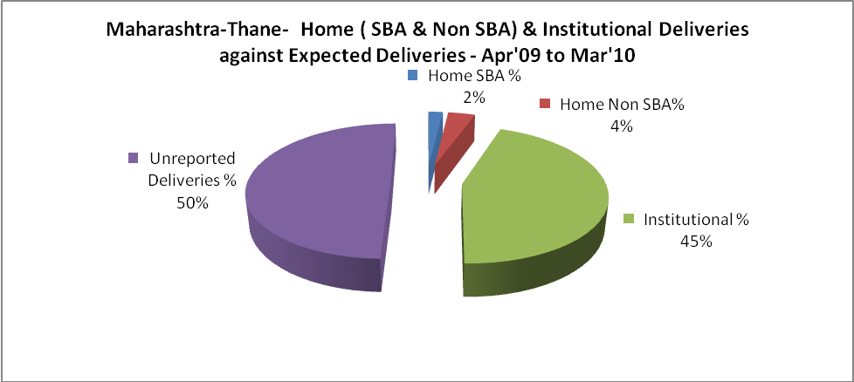

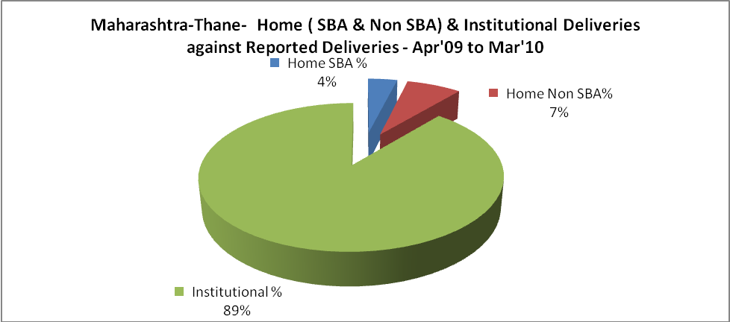

Maharashtra-Thane- C sections & Complicated Deliveries Apr'09 to Mar'10
 | Institutional Deliveries (Public) | Institutional Deliveries (Pvt)
 | 53,833 | 24,005
C Section | 2,463 | 7,921
C Section% | 5% | 33%
Complicated Pregnancies attended | 519 | 131
Complicated Pregnancies attended % | 1% | 1%

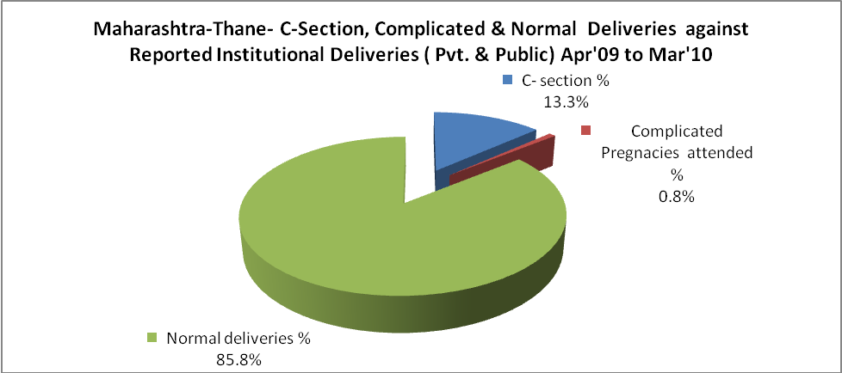

Maharashtra-Thane- Complicated Pregnancies & Deliveries Treated - Apr'09 to Mar'10
Reported Deliveries |  |  | Reported ANC Reigtration
87,509 |  |  | 184,214
Complicated Pregnancies attended | Complicated Pregnancies Rate | C - Section Deliveries | PNC Maternal Complications | Abortions | Still Births
650 | 0% | 10,384 | 911 | 5,015 | 1,786
Complicated Deliveries Treated with |  |  |  | No Of Eclampsia cases Treated | No Of severe anemia cases treated
IV Antibiotics | IV antihypertensive/Magsulph injection | IV Oxytocis | Blood Transfusion | No Of Eclampsia cases Treated | No Of severe anemia cases treated
- | - | - | - | - | -

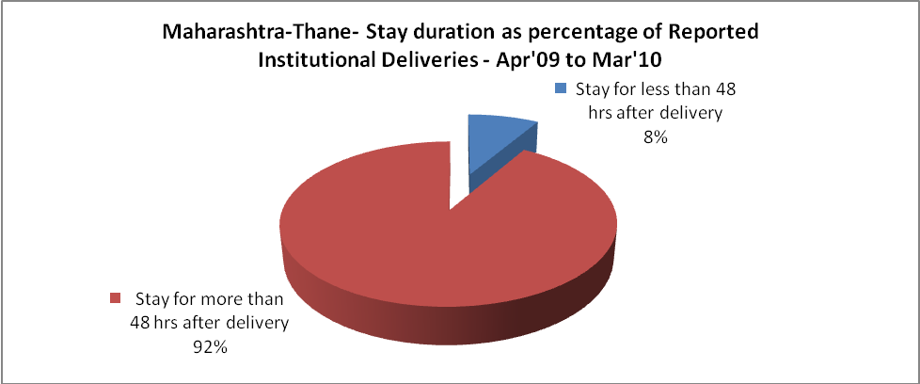

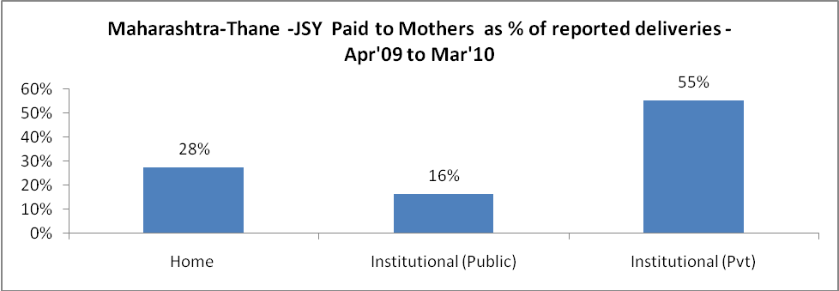

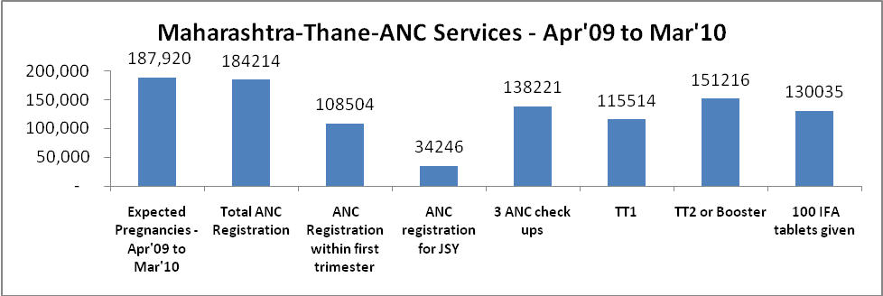

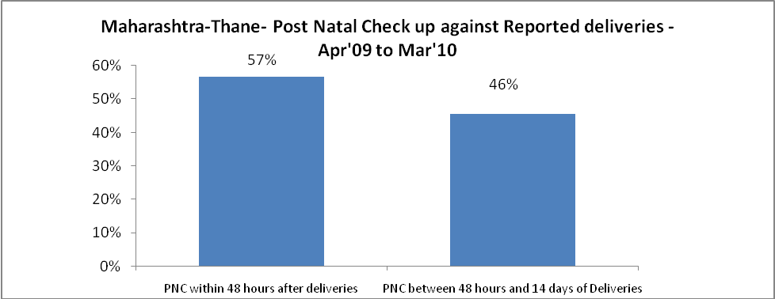

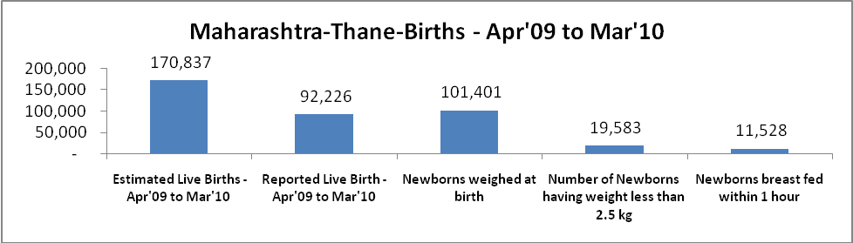

Maharashtra-Thane - Births - Apr'09 to Mar'10
Live Birth - Males | Live Birth - females | Live Birth - Total | Sex Ratio at birth | Still Birth | Abortion( Induced/Spontaneous
47,477 | 44,749 | 92,226 | 943 | 1,786 | 5,015

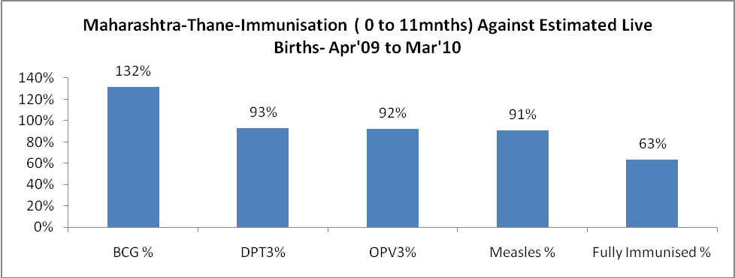

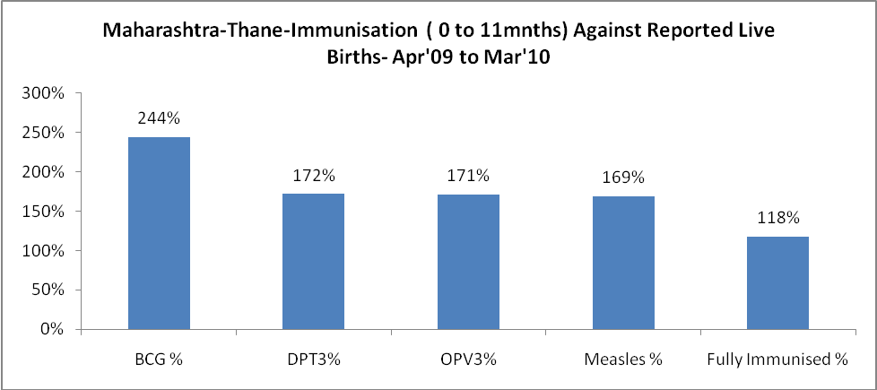

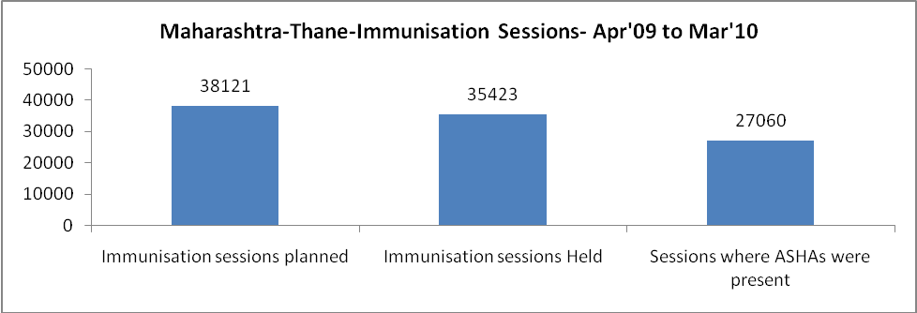

Maharashtra-Thane- Apr'09 to Mar'10
Total Abortions | Abortion Rate
10,032 | 5.3%

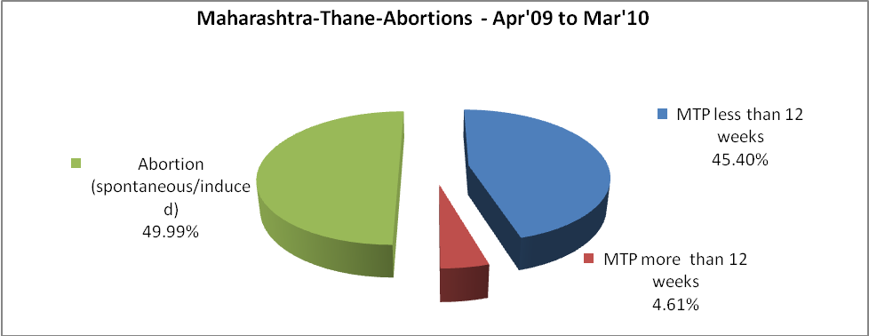

Maharashtra-Thane- Apr'09 to Mar'10
Total OPD | Total RTI/STI cases
617,217 | 5,562

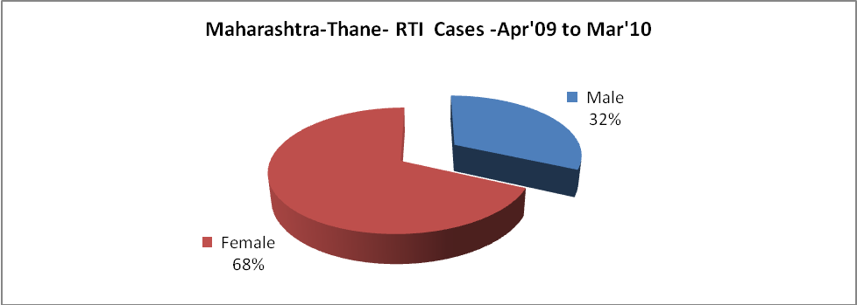

Maharashtra-Thane-Sterilizations - Apr'09 to Mar'10
 | Reported | %age of Reported Sterilization
Total Sterilization | 25,409 | -
NSV | 890 | 4%
Laparoscopic | 17,761 | 70%
Minilab | 3,559 | 14%
Post Partum | 3,199 | 13%
Male Sterilization | 890 | 4%
Female Sterilization | 24,519 | 96%

Maharashtra-Thane-FP Methods - Apr'09 to Mar'10
 | Reported | %age of All Reported FP Methods
Total Reported FP Method (All types) Users | 66,884 | -
Sterilizations | 25,409 | 38%
IUD | 20,080 | 30%
Condom Users | 9,777 | 15%
OCP Users | 11,619 | 17%
Limiting Methods | 25,409 | 38%
Spacing Methods | 41,475 | 62%

Maharashtra-Thane- Lab Services - Apr'09 to Mar'10
Total OPD | Total HB tested | Total HIV Tested | Total Population
617,217 | - | - | 9,543,947
HB test conducted as %age of OPD | HB<7gm as %age of HB tested | HIV test conducted as %age of OPD | HIV positive as %age of HIV tested | Blood Smear Examined as % of Population
0.0% | 0.0% | 0.0% | 0.0% | 7.5%

Maharashtra-Thane- Childhood Disease - Vaccine Preventable -Apr'09 to Mar'10
Diphtheria | Pertussis | Tetanus Neonatorum | Tetanus others | Polio | Measles
20 | 0 | 0 | 0 | 59 | 14
Maharashtra-Thane-Childhood Disease - Others - Apr'09 to Mar'10
Diarrhoea and dehydration | Malaria | Number admitted with Respiratory Infections
415 | 61 | 63

Maharashtra-Thane- Infant & Child Deaths - Apr'09 to Mar'10
Infant Deaths within 24 hrs of birth | Infant Deaths between 24hrs & under 1 week | Infant Deaths between 1 week & under 1 month | Child Deaths between 1 month & under 1 year | Child Deaths between 1yr under 5years | Total Deaths
125 | 126 | 34 | 49 | 30 | 364

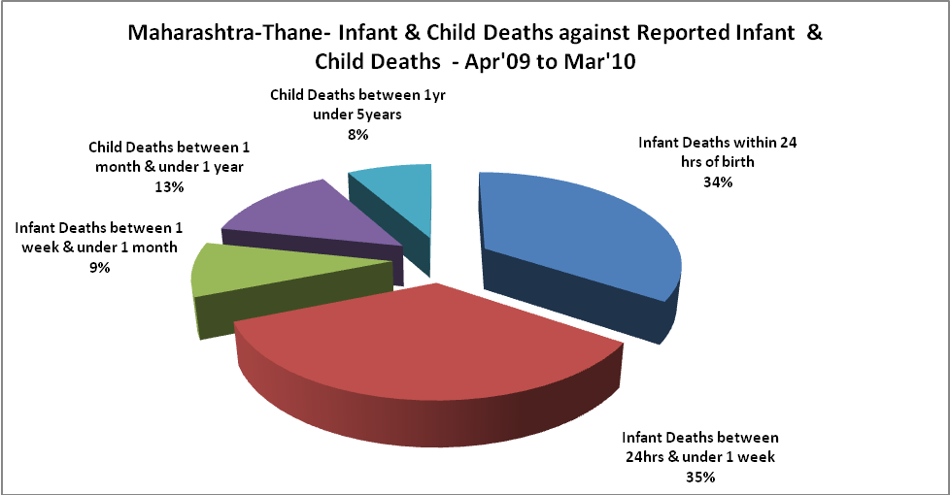

Maharashtra-Thane- Causes of Infant & Child Deaths - Apr'09 to Mar'10
Sepsis |  |  | Asphyxia |  |  | LBW
Up to 1 Weeks of Birth | Between 1 week & 4 weeks of birth | Total | Up to 1 Weeks of Birth | Between 1 week & 4 weeks of birth | Total | Up to 1 Weeks of Birth | Between 1 week & 4 weeks of birth | Total
8 | 4 | 12 | 22 | 3 | 25 | 58 | 14 | 72
Pneumonia |  |  | Diarrhoea |  |  | Fever related
Between 1 month and 11 months | Between 1 year & 5 years | Total | Between 1 month and 11 months | Between 1 year & 5 years | Total | Between 1 month and 11 months | Between 1 year & 5 years | Total
13 | 0 | 13 | 3 | 1 | 4 | 0 | 0 | 0
Others |  |  | Measles |  |  | Others
Up to 1 Weeks of Birth | Between 1 week & 4 weeks of birth | Total | Between 1 month and 11 months | Between 1 year & 5 years | Total | Between 1 month and 11 months | Between 1 year & 5 years | Total
38 | 13 | 51 | 0 | 0 | 0 | 33 | 29 | 62

Maharashtra-Thane- Maternal Deaths & Causes - Apr'09 to Mar'10
Abortion |  |  | Obstructed/prolonged labour |  |  | Severe hypertension/fits
6-14 yrs | 15-55 yrs. | Total | 6-14 yrs | 15-55 yrs. | Total | 6-14 yrs | 15-55 yrs. | Total
0 | 0 | 0 | 0 | 0 | 0 | 0 | 0 | 0
Bleeding |  |  | High Fever |  |  | Other Causes
6-14 yrs | 15-55 yrs. | Total | 6-14 yrs | 15-55 yrs. | Total | 6-14 yrs | 15-55 yrs. | Total
0 | 0 | 0 | 0 | 0 | 0 | 0 | 3 | 3

Maharashtra-Thane-Causes of Deaths in 6 to 55yrs age group - Apr'09 to Mar'10
Diarrheal Diseases |  |  |  | Tuberculosis |  |  |  | Respiratory Diseases( Other than TB)
6-14 yrs | 15-55 yrs. | Above 55yrs | Total | 6-14 yrs | 15-55 yrs. | Above 55yrs | Total | 6-14 yrs | 15-55 yrs. | Above 55yrs | Total
0 | 0 | 0 | 0 | 0 | 0 | 0 | 0 | 0 | 0 | 0 | 0
Malaria |  |  |  | Other fever Related |  |  |  | HIV/Aids
6-14 yrs | 15-55 yrs. | Above 55yrs | Total | 6-14 yrs | 15-55 yrs. | Above 55yrs | Total | 6-14 yrs | 15-55 yrs. | Above 55yrs | Total
0 | 0 | 0 | 0 | 0 | 0 | 0 | 0 | 0 | 0 | 0 | 0
Heart Disease/Hypertension related |  |  |  | Neurological Disease including strokes |  |  |  | Trauma/Accidents/ Burn Cases
6-14 yrs | 15-55 yrs. | Above 55yrs | Total | 6-14 yrs | 15-55 yrs. | Above 55yrs | Total | 6-14 yrs | 15-55 yrs. | Above 55yrs | Total
0 | 0 | 0 | 0 | 0 | 0 | 0 | 0 | 0 | 0 | 0 | 0
Suicide |  |  |  | Animal Bites & Stings
6-14 yrs | 15-55 yrs. | Above 55yrs | Total | 6-14 yrs | 15-55 yrs. | Above 55yrs | Total
0 | 0 | 0 | 0 | 0 | 0 | 0 | 0

