NHSRC
Rajasthan-Tonk
Analysis: Apr 2009 – Mar 2010

Rajasthan- Tonk- Summary-Apr'09 to Mar'10
ANC
ANC Registration against Expected Pregnancies | 85% | TT1 given to Pregnant women against ANC Registration | 63%
3 ANC Checkups against ANC Registrations | 69% | 100 IFA Tablets given to Pregnant women against ANC Registration | 85%
Deliveries
Unreported Deliveries against Estimated Deliveries | 35.3% | HOME Deliveries( SBA& Non SBA) against Estimated Deliveries | 3.3%
Institutional Deliveries against Estimated Deliveries | 61.3% | HOME Deliveries( SBA& Non SBA) against Reported Deliveries | 5.2%
Institutional Deliveries against Reported Deliveries | 94.8% | C Section Deliveries against Institutional Deliveries( Pvt & Pub) | 4%
Births & Neonates Care
Live Births Reported against Estimated Live Births | 65% | New borns weighed against Reported Live Births | 88%
Still Births (Reported) | 417 | New borns weighed less than 2.5 kgs against newborns weighed | 17%
Sex Ratio at Birth | 908 | New borns breastfed within one hr of Birth against Reported live Births | 87%
Child Immunisation( 0 to 11 months)
BCG given against Expected Live Births | 90% | Measles given against Expected Live Births | 80%
OPV3 given against Expected Live Births | 87% | Fully Immunised Children against Expected Live Births | 76%
DPT3 given against Expected Live Births | 88%
Family Planning
Family Plannig Methods Users ( Sterilisations(Male &Female)+IUD+ Condom pieces/72 + OCP Cycles/13) | 82,884 | IUD Insertions against reported FP Methods | 10%
Sterilisation against reported FP Methods | 8% | Condom Users against reported FP Methods | 57%
 |  | OCP Users against reported FP Methods | 24%
Other Services
OPD | 842,707 | Major Operations | 1,232
IPD | 64,079 | Minor Operations | 2,090

`
Rajasthan- Tonk- Deliveries Apr'09 to Mar'10
Total Population | 1,442,300 | Expected Deliveries |  | 40,913
Home SBA | Home Non SBA | Institutional | Total Deliveries Reported | Unreported Deliveries
982 | 383 | 25,092 | 26,457 | 14,456
Home SBA % | Home Non SBA% | Institutional % | Total Deliveries Reported % | Unreported Deliveries %
2% | 1% | 61% | 65% | 35%

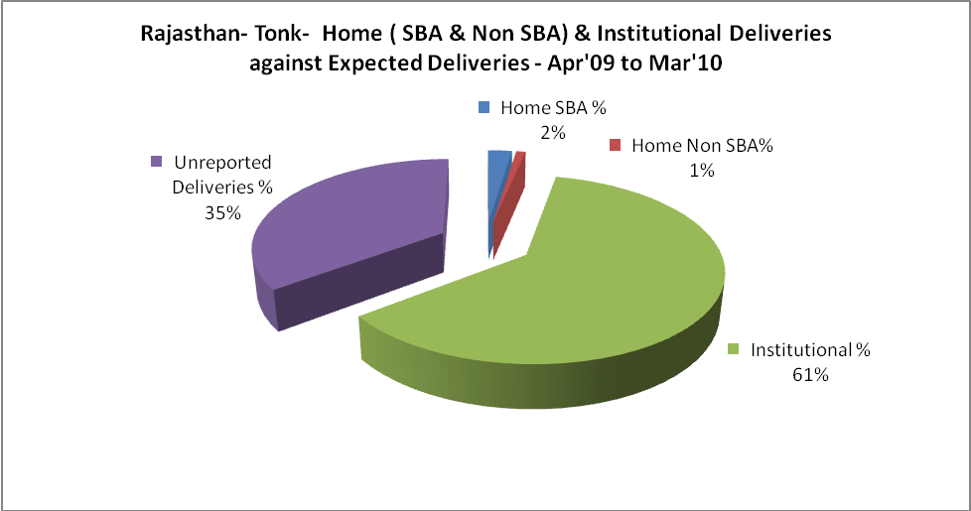

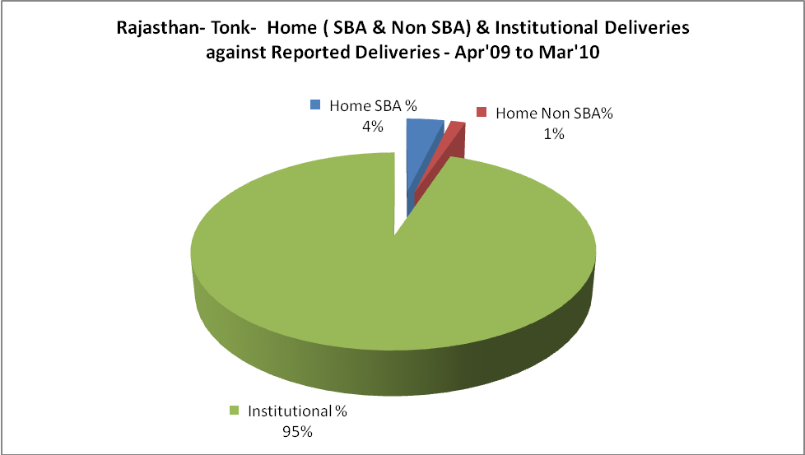

Rajasthan- Tonk- C sections & Complicated Deliveries Apr'09 to Mar'10
 | Institutional Deliveries (Public) | Institutional Deliveries (Pvt)
 | 20,124 | 4,968
C Section | 711 | 184
C Section% | 4% | 4%
Complicated Pregnacies attended | 821 | 203
Complicated Pregnacies attended % | 4% | 4%

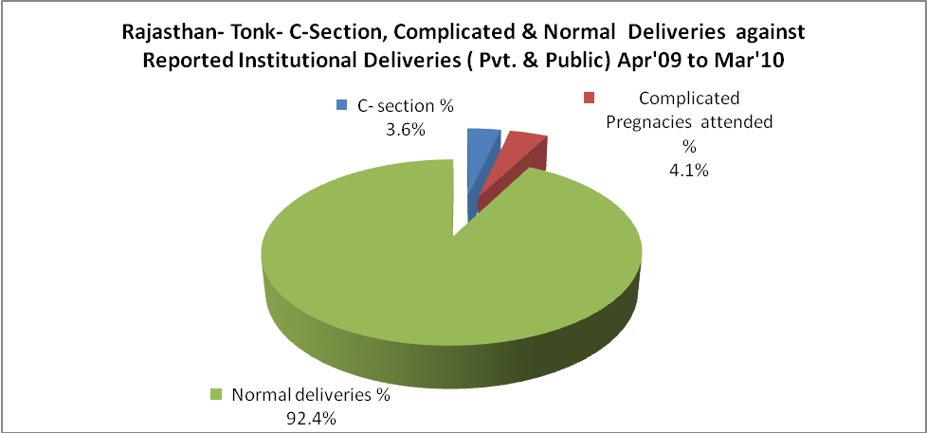

Rajasthan- Tonk- Complicated Pregnancies & Deliveries Treated - Apr'09 to Mar'10
Reported Deliveries |  |  | Reported ANC Reigtration
26,457 |  |  | 36,897
Complicated Pregnancies attended | Complicated Pregnancies Rate | C - Section Deliveries | PNC Maternal Complications | Abortions | Still Births
1,024 | 2% | 895 | 81 | 654 | 417
Complicated Deliveries Treated with |  |  |  | No Of Eclampsia cases Treated | No Of severe anemia cases treated
IV Antibiotics | IV antihypertensive/Magsulph injection | IV Oxytocis | Blood Transfusion | No Of Eclampsia cases Treated | No Of severe anemia cases treated
967 | 170 | 3,172 | 134 | 37 | 373

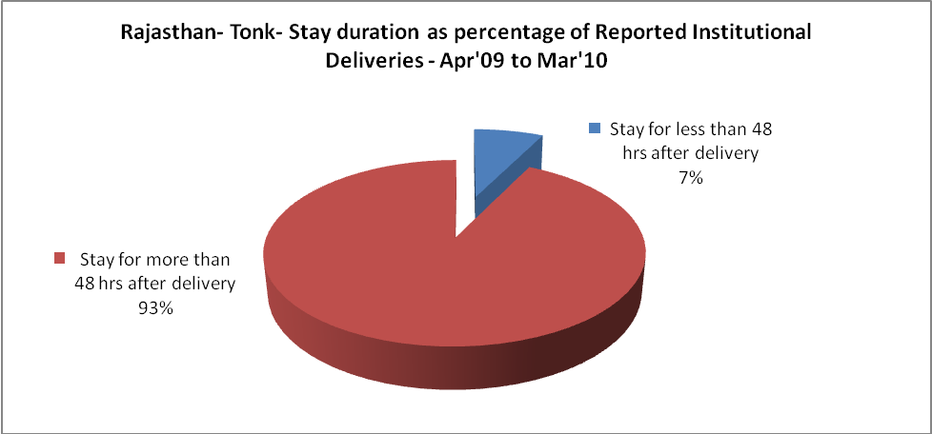

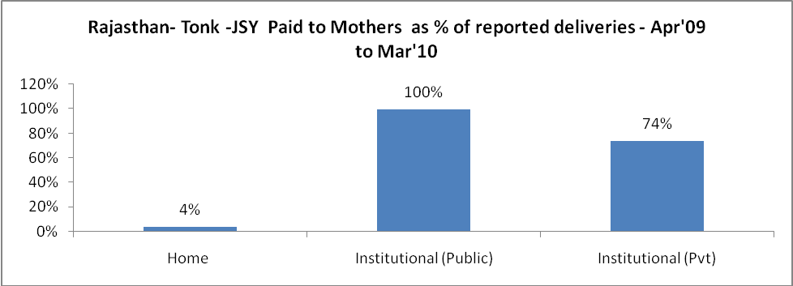

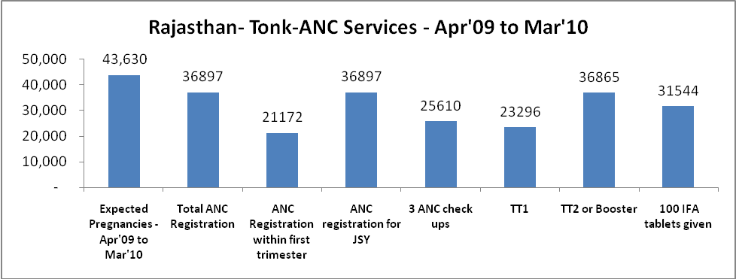

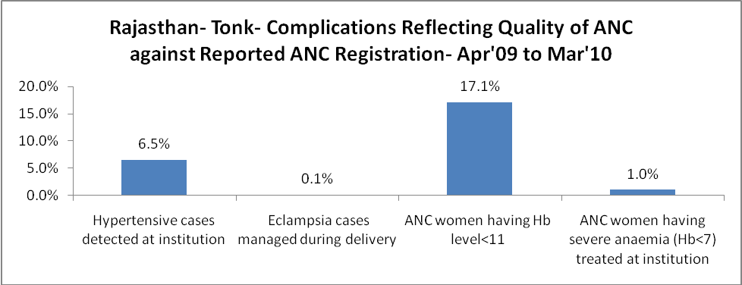

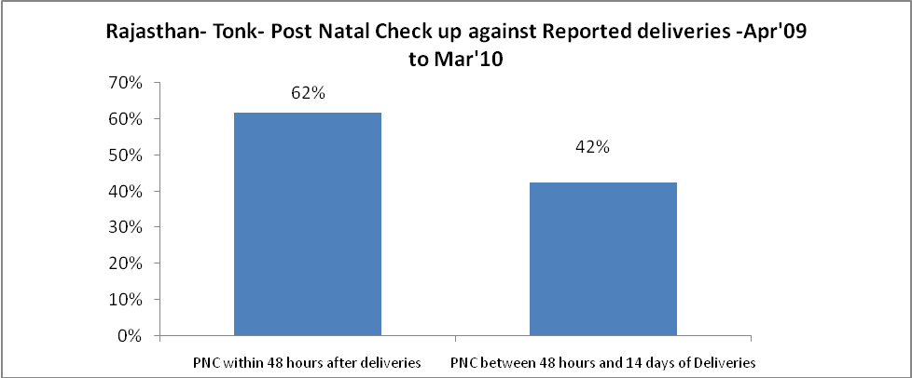

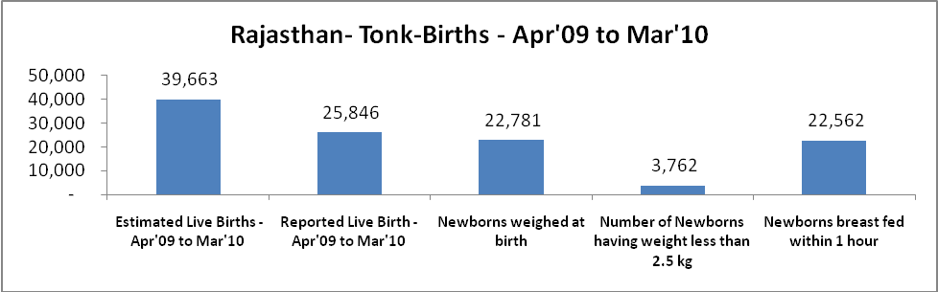

Rajasthan- Tonk - Births - Apr'09 to Mar'10
Live Birth - Males | Live Birth - females | Live Birth - Total | Sex Ratio at birth | Still Birth | Abortion( Induced/Spontaneous
13,549 | 12,297 | 25,846 | 908 | 417 | 654

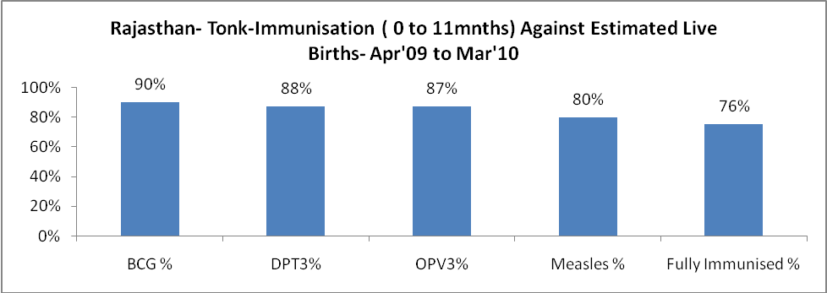

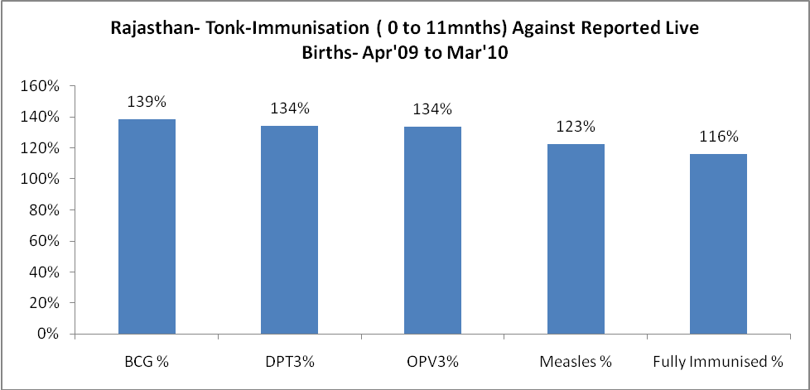

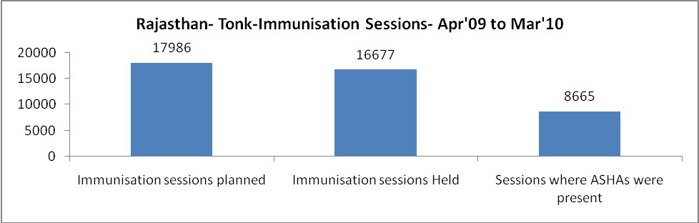

Rajasthan- Tonk- Apr'09 to Mar'10
Total Abortions | Abortion Rate
1,286 | 2.9%

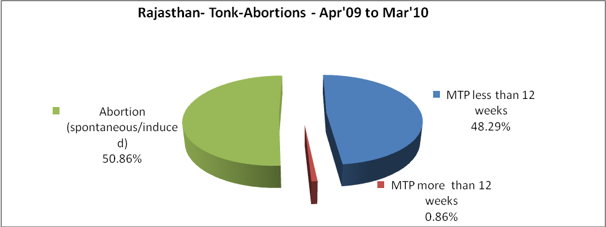

Rajasthan- Tonk- Apr'09 to Mar'10
Total OPD | Total RTI/STI cases
842,707 | 2,437

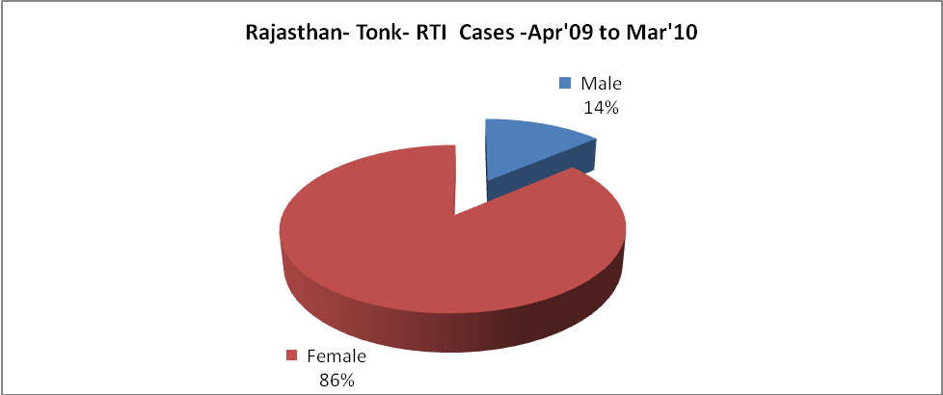
Rajasthan- Tonk-Sterilisations - Apr'09 to Mar'10
 | Reported | %age of Reported Sterilisation
Total Sterilisation | 6,891 | -
NSV | 48 | 1%
Laproscopic | 6,760 | 98%
MiniLap | - | 0%
Post Partum | 83 | 1%
Male Sterilisation | 48 | 1%
Female Sterilisation | 6,843 | 99%

Rajasthan- Tonk-FP Methods - Apr'09 to Mar'10
 | Reported | %age of All Reported FP Methods
Total Reported FP Methodd (All types) Users | 82,884 | -
Sterilisations | 6,891 | 8%
IUD | 8,700 | 10%
Condom Users | 47,002 | 57%
OCP Users | 20,291 | 24%
Limiting Methods | 6,891 | 8%
Spacing Methods | 75,993 | 92%

Rajasthan- Tonk- Service Delivery - Apr'09 to Mar'10
Operation major (General and spinal anaesthesia) | Operation minor (No or local anaesthesia) | AYUSH | Dental Procedures | Adolescent counselling services | Total OPD | Total IPD
1,232 | 2,090 | 26,573 | 250 | 1,024 | 842,707 | 64,079
Operation major (General and spinal anaesthesia) as %ge of OPD | Operation minor (No or local anaesthesia)as %ge of OPD | AYUSH as %ge of OPD | Dental Procedures as %ge of OPD | Adolescent counselling services as %ge of OPD | IPD as percentage of OPD
0.1% | 0.2% | 3.2% | 0.0% | 0.1% | 8%

Rajasthan- Tonk- Lab Services - Apr'09 to Mar'10
Total OPD | Total HB tested | Total HIV Tested | Total Population
842,707 | 22,607 | 9,780 | 1,442,300
HB test conducted as %age of OPD | HB<7gm as %age of HB tested | HIV test conducted as %age of OPD | HIV positive as %age of HIV tested | Blood Smear Examined as % of Population
2.7% | 12.0% | 1.2% | 0.4% | 10.2%

Rajasthan- Tonk- Childhood Disease - Vaccine Preventable -Apr'09 to Mar'10
Diphtheria | Pertussis | Tetanus Neonatorum | Tetanus others | Polio | Measles
0 | 0 | 0 | 5 | 0 | 73
Rajasthan- Tonk-Childhood Disease - Others - Apr'09 to Mar'10
Diarrhoea and dehydration | Malaria | Number admitted with Respiratory Infections
1,798 | 42 | 2,364

Rajasthan- Tonk- Infant & Child Deaths - Apr'09 to Mar'10
Infant Deaths within 24 hrs of birth | Infant Deaths between 24hrs & under 1 week | Infant Deaths between 1 week & under 1 month | Child Deaths between 1 month & under 1 year | Child Deaths between 1yr under 5years | Total Deaths
43 | 131 | 47 | 83 | 77 | 381

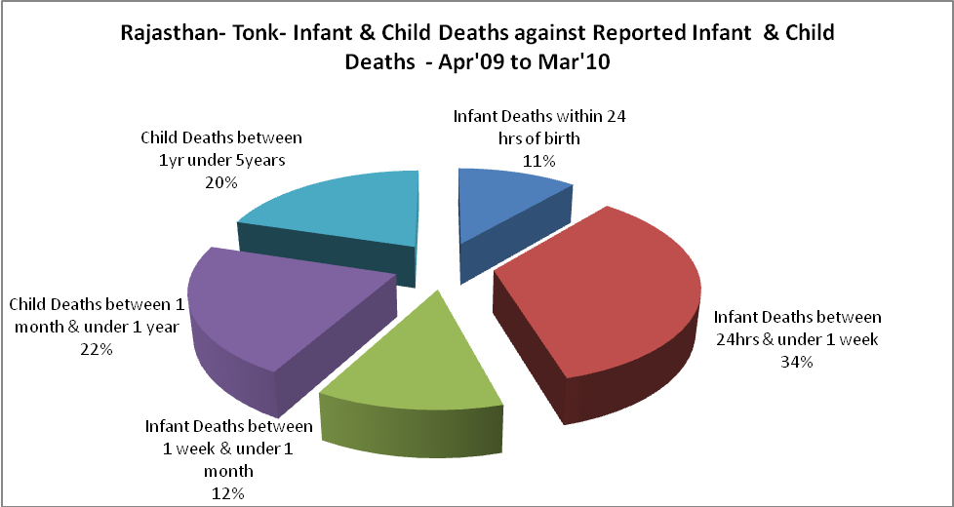

Rajasthan- Tonk- Causes of Infant & Child Deaths - Apr'09 to Mar'10
Sepsis |  |  | Asphyxia |  |  | LBW
Up to 1 Weeks of Birth | Between 1 week & 4 weeks of birth | Total | Up to 1 Weeks of Birth | Between 1 week & 4 weeks of birth | Total | Up to 1 Weeks of Birth | Between 1 week & 4 weeks of birth | Total
5 | 2 | 7 | 23 | 4 | 27 | 29 | 8 | 37
Pneumonia |  |  | Diarrhoea |  |  | Fever related
Between 1 month and 11 months | Between 1 year & 5 years | Total | Between 1 month and 11 months | Between 1 year & 5 years | Total | Between 1 month and 11 months | Between 1 year & 5 years | Total
15 | 7 | 22 | 12 | 18 | 30 | 0 | 9 | 9
Others |  |  | Measles |  |  | Others
Up to 1 Weeks of Birth | Between 1 week & 4 weeks of birth | Total | Between 1 month and 11 months | Between 1 year & 5 years | Total | Between 1 month and 11 months | Between 1 year & 5 years | Total
74 | 33 | 107 | 0 | 0 | 0 | 56 | 43 | 99

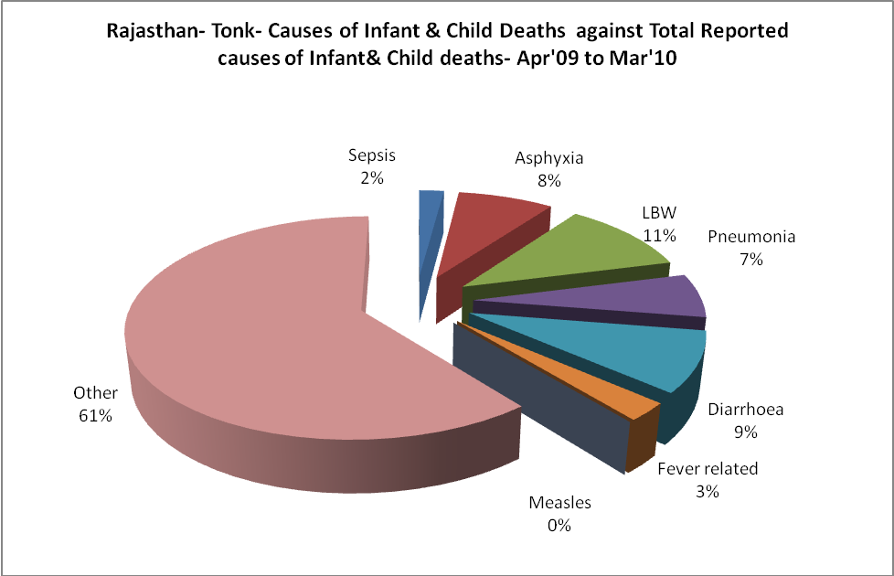

Rajasthan- Tonk- Maternal Deaths & Causes - Apr'09 to Mar'10
Abortion |  |  | Obstructed/prolonged labour |  |  | Severe hypertesnion/fits
6-14 yrs | 15-55 yrs. | Total | 6-14 yrs | 15-55 yrs. | Total | 6-14 yrs | 15-55 yrs. | Total
0 | 0 | 0 | 0 | 0 | 0 | 0 | 1 | 1
Bleeding |  |  | High Fever |  |  | Other Causes
6-14 yrs | 15-55 yrs. | Total | 6-14 yrs | 15-55 yrs. | Total | 6-14 yrs | 15-55 yrs. | Total
0 | 0 | 0 | 0 | 0 | 0 | 6 | 11 | 17

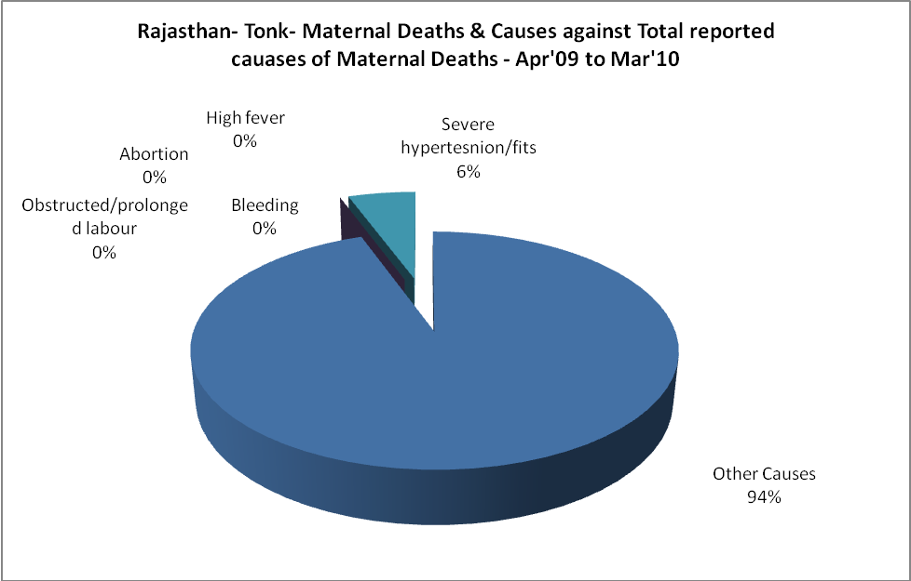

Rajasthan- Tonk-Causes of Deaths in 6 to 55yrs age group - Apr'09 to Mar'10
Diarrhoel Diseases |  |  |  | Tuberculosis |  |  |  | Respiratory Diseases( Other than TB)
6-14 yrs | 15-55 yrs. | Above 55yrs | Total | 6-14 yrs | 15-55 yrs. | Above 55yrs | Total | 6-14 yrs | 15-55 yrs. | Above 55yrs | Total
15 | 12 | 8 | 35 | 0 | 22 | 20 | 42 | 2 | 20 | 77 | 99
Malaria |  |  |  | Other fever Related |  |  |  | HIV/Aids
6-14 yrs | 15-55 yrs. | Above 55yrs | Total | 6-14 yrs | 15-55 yrs. | Above 55yrs | Total | 6-14 yrs | 15-55 yrs. | Above 55yrs | Total
0 | 1 | 0 | 1 | 10 | 8 | 5 | 23 | 0 | 1 | 0 | 1
Heart Disease/Hypertenion related |  |  |  | Neurological Disease including strokes |  |  |  | Trauma/Accidents/ Burn Cases
6-14 yrs | 15-55 yrs. | Above 55yrs | Total | 6-14 yrs | 15-55 yrs. | Above 55yrs | Total | 6-14 yrs | 15-55 yrs. | Above 55yrs | Total
5 | 31 | 39 | 75 | 55 | 14 | 11 | 80 | 15 | 22 | 6 | 43
Suicide |  |  |  | Animal Bites & Stings
6-14 yrs | 15-55 yrs. | Above 55yrs | Total | 6-14 yrs | 15-55 yrs. | Above 55yrs | Total
3 | 5 | 2 | 10 | 5 | 9 | 7 | 21

