NHSRC
Rajasthan-Udaipur
Analysis: Apr 2009 – Mar 2010

Rajasthan- Udaipur- Summary-Apr'09 to Mar'10
ANC
ANC Registration against Expected Pregnancies | 109% | TT1 given to Pregnant women against ANC Registration | 71%
3 ANC Checkups against ANC Registrations | 57% | 100 IFA Tablets given to Pregnant women against ANC Registration | 86%
Deliveries
Unreported Deliveries against Estimated Deliveries | 28.0% | HOME Deliveries( SBA& Non SBA) against Estimated Deliveries | 10.0%
Institutional Deliveries against Estimated Deliveries | 62.0% | HOME Deliveries( SBA& Non SBA) against Reported Deliveries | 13.9%
Institutional Deliveries against Reported Deliveries | 86.1% | C Section Deliveries against Institutional Deliveries( Pvt & Pub) | 5%
Births & Neonates Care
Live Births Reported against Estimated Live Births | 73% | New borns weighed against Reported Live Births | 83%
Still Births (Reported) | 1,407 | New borns weighed less than 2.5 kgs against newborns weighed | 11%
Sex Ratio at Birth | 923 | New borns breastfed within one hr of Birth against Reported live Births | 74%
Child Immunisation( 0 to 11 months)
BCG given against Expected Live Births | 108% | Measles given against Expected Live Births | 89%
OPV3 given against Expected Live Births | 94% | Fully Immunised Children against Expected Live Births | 80%
DPT3 given against Expected Live Births | 94%
Family Planning
Family Plannig Methods Users ( Sterilisations(Male &Female)+IUD+ Condom pieces/72 + OCP Cycles/13) | 168,397 | IUD Insertions against reported FP Methods | 12%
Sterilisation against reported FP Methods | 8% | Condom Users against reported FP Methods | 52%
 |  | OCP Users against reported FP Methods | 28%
Other Services
OPD | 1,051,769 | Major Operations | 451
IPD | 54,553 | Minor Operations | 1,255

`
Rajasthan- Udaipur- Deliveries Apr'09 to Mar'10
Total Population | 2,976,100 | Expected Deliveries |  | 84,421
Home SBA | Home Non SBA | Institutional | Total Deliveries Reported | Unreported Deliveries
5,596 | 2,862 | 52,313 | 60,771 | 23,650
Home SBA % | Home Non SBA% | Institutional % | Total Deliveries Reported % | Unreported Deliveries %
7% | 3% | 62% | 72% | 28%

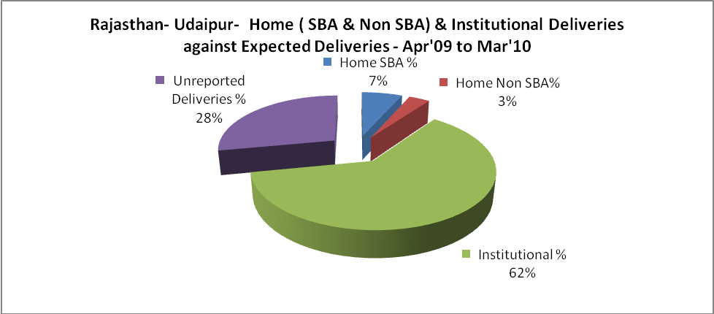

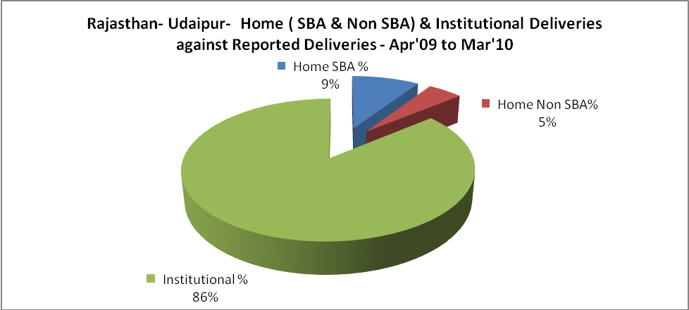

Rajasthan- Udaipur- C sections & Complicated Deliveries Apr'09 to Mar'10
 | Institutional Deliveries (Public) | Institutional Deliveries (Pvt)
 | 49,314 | 2,999
C Section | 2,720 | 128
C Section% | 6% | 4%
Complicated Pregnacies attended | 937 | 50
Complicated Pregnacies attended % | 2% | 2%

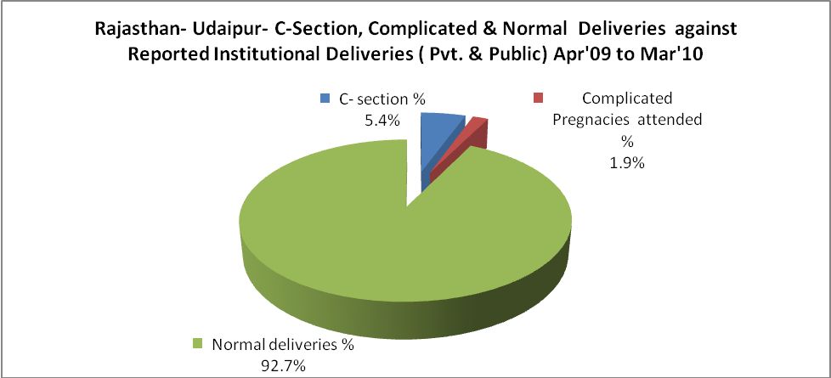

Rajasthan- Udaipur- Complicated Pregnancies & Deliveries Treated - Apr'09 to Mar'10
Reported Deliveries |  |  | Reported ANC Reigtration
60,771 |  |  | 98,322
Complicated Pregnancies attended | Complicated Pregnancies Rate | C - Section Deliveries | PNC Maternal Complications | Abortions | Still Births
987 | 1% | 2,848 | 341 | 1,137 | 1,407
Complicated Deliveries Treated with |  |  |  | No Of Eclampsia cases Treated | No Of severe anemia cases treated
IV Antibiotics | IV antihypertensive/Magsulph injection | IV Oxytocis | Blood Transfusion | No Of Eclampsia cases Treated | No Of severe anemia cases treated
5,977 | 500 | 1,869 | 2 | 311 | 954

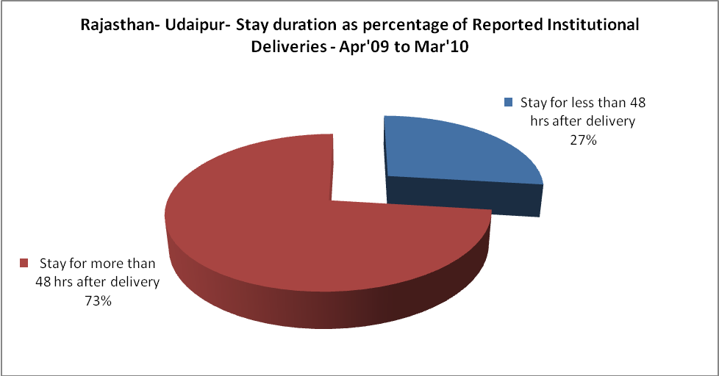

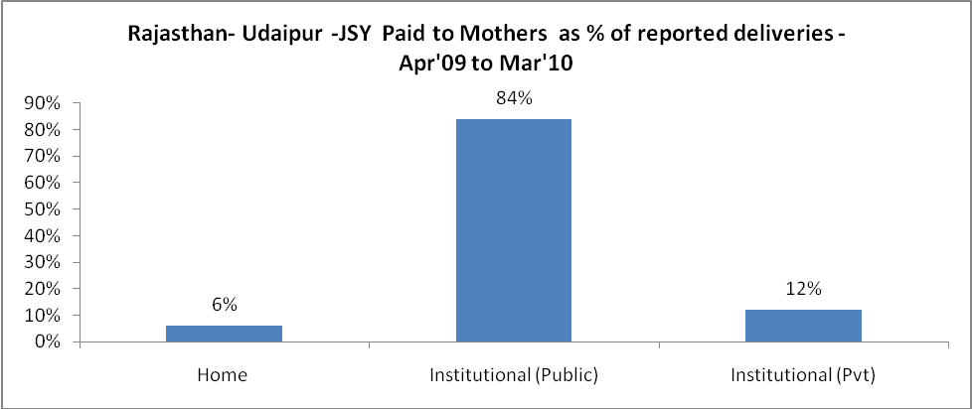

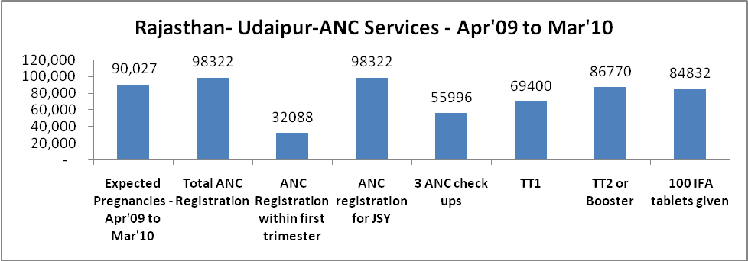
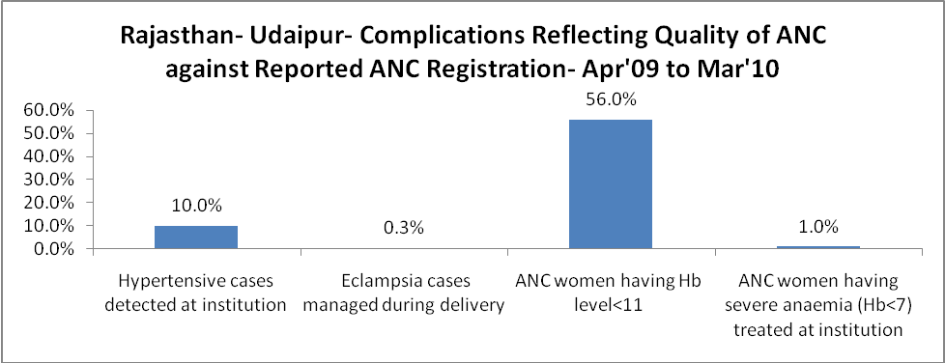

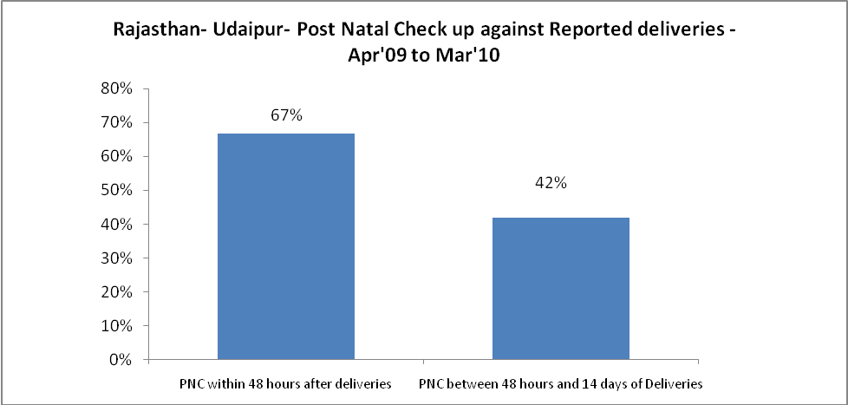

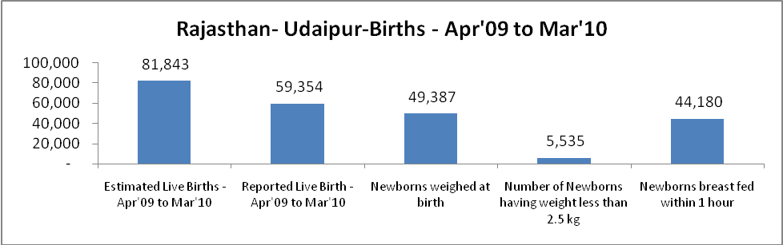

Rajasthan- Udaipur - Births - Apr'09 to Mar'10
Live Birth - Males | Live Birth - females | Live Birth - Total | Sex Ratio at birth | Still Birth | Abortion( Induced/Spontaneous
30,862 | 28,492 | 59,354 | 923 | 1,407 | 1,137

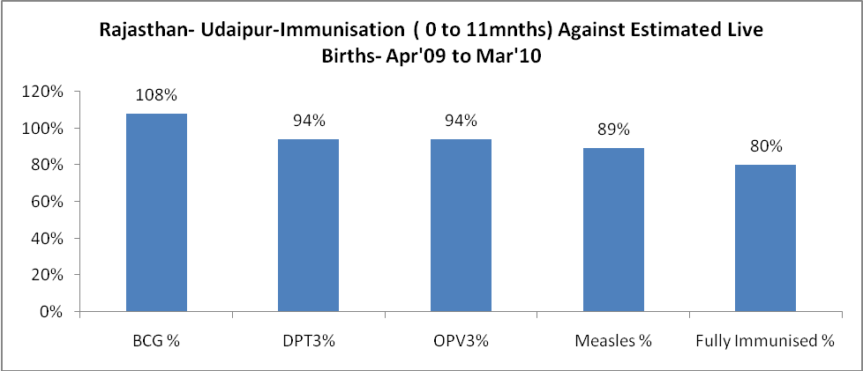

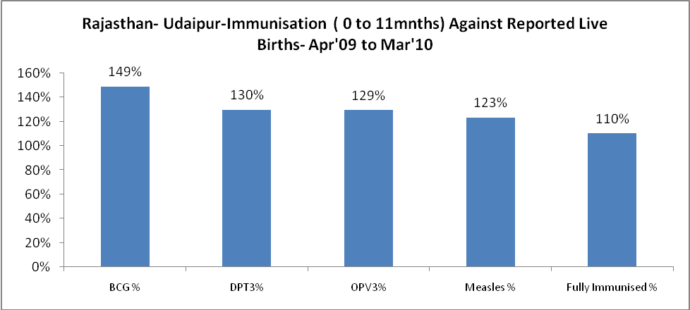

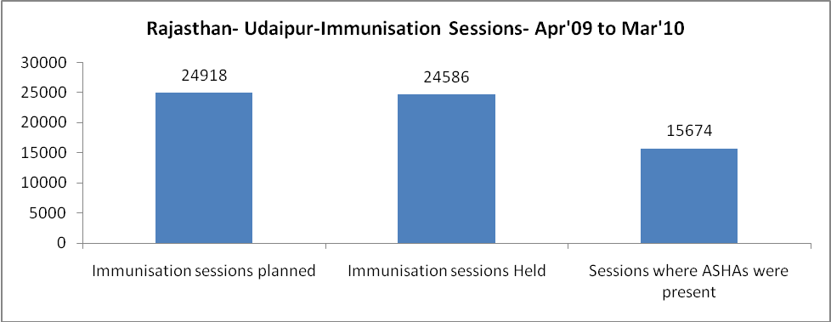

Rajasthan- Udaipur- Apr'09 to Mar'10
Total Abortions | Abortion Rate
2,303 | 2.6%

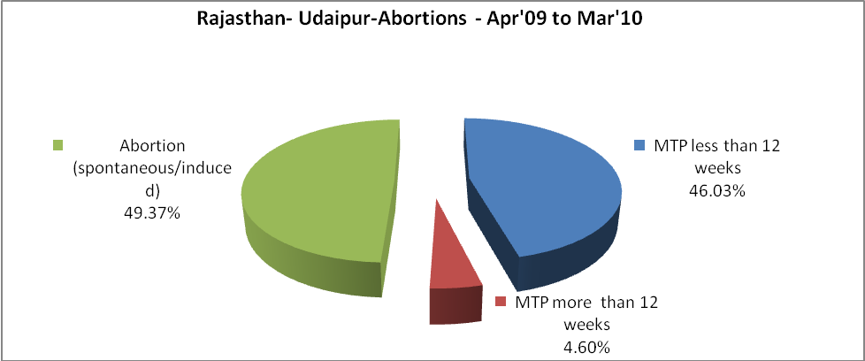

Rajasthan- Udaipur- Apr'09 to Mar'10
Total OPD | Total RTI/STI cases
1,051,769 | 6,910

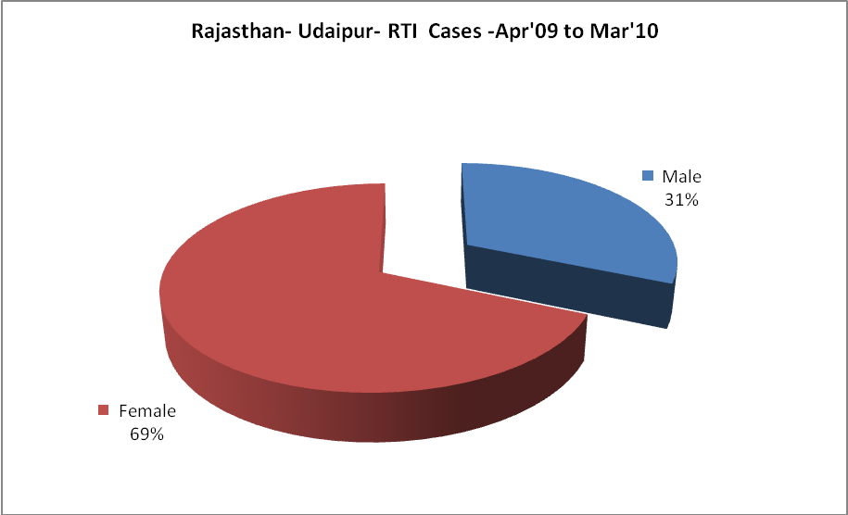

Rajasthan- Udaipur-Sterilisations - Apr'09 to Mar'10
 | Reported | %age of Reported Sterilisation
Total Sterilisation | 12,658 | -
NSV | 251 | 2%
Laproscopic | 8,047 | 64%
MiniLap | 11 | 0%
Post Partum | 4,349 | 34%
Male Sterilisation | 251 | 2%
Female Sterilisation | 12,407 | 98%

Rajasthan- Udaipur-FP Methods - Apr'09 to Mar'10
 | Reported | %age of All Reported FP Methods
Total Reported FP Methodd (All types) Users | 168,397 | -
Sterilisations | 12,658 | 8%
IUD | 20,273 | 12%
Condom Users | 88,134 | 52%
OCP Users | 47,332 | 28%
Limiting Methods | 12,658 | 8%
Spacing Methods | 155,739 | 92%

Rajasthan- Udaipur- Service Delivery - Apr'09 to Mar'10
Operation major (General and spinal anaesthesia) | Operation minor (No or local anaesthesia) | AYUSH | Dental Procedures | Adolescent counselling services | Total OPD | Total IPD
451 | 1,255 | 40,966 | 513 | 825 | 1,051,769 | 54,553
Operation major (General and spinal anaesthesia) as %ge of OPD | Operation minor (No or local anaesthesia)as %ge of OPD | AYUSH as %ge of OPD | Dental Procedures as %ge of OPD | Adolescent counselling services as %ge of OPD | IPD as percentage of OPD
0.0% | 0.1% | 3.9% | 0.0% | 0.1% | 5%

Rajasthan- Udaipur- Lab Services - Apr'09 to Mar'10
Total OPD | Total HB tested | Total HIV Tested | Total Population
1,051,769 | 43,820 | 18,247 | 2,976,100
HB test conducted as %age of OPD | HB<7gm as %age of HB tested | HIV test conducted as %age of OPD | HIV positive as %age of HIV tested | Blood Smear Examined as % of Population
4.2% | 3.3% | 1.7% | 0.3% | 3.9%

Rajasthan- Udaipur- Childhood Disease - Vaccine Preventable -Apr'09 to Mar'10
Diphtheria | Pertussis | Tetanus Neonatorum | Tetanus others | Polio | Measles
2 | 0 | 0 | 6 | 0 | 112
Rajasthan- Udaipur-Childhood Disease - Others - Apr'09 to Mar'10
Diarrhoea and dehydration | Malaria | Number admitted with Respiratory Infections
2,542 | 1,242 | 890

Rajasthan- Udaipur- Infant & Child Deaths - Apr'09 to Mar'10
Infant Deaths within 24 hrs of birth | Infant Deaths between 24hrs & under 1 week | Infant Deaths between 1 week & under 1 month | Child Deaths between 1 month & under 1 year | Child Deaths between 1yr under 5years | Total Deaths
55 | 552 | 241 | 196 | 249 | 1293

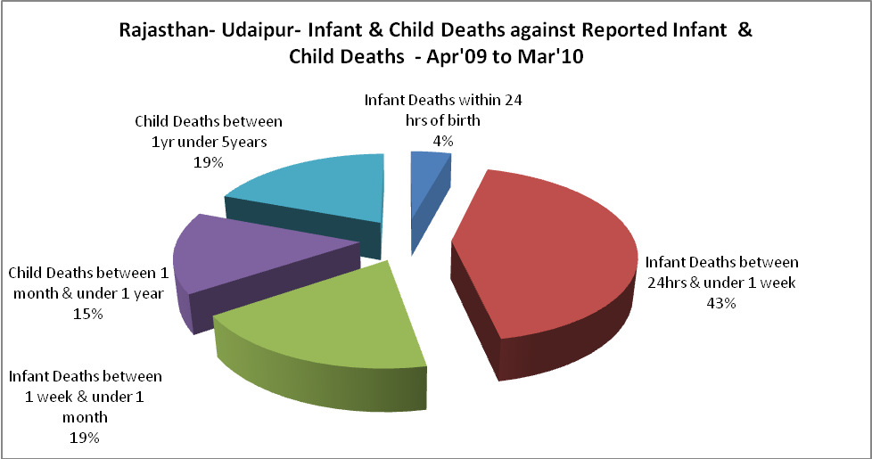

Rajasthan- Udaipur- Causes of Infant & Child Deaths - Apr'09 to Mar'10
Sepsis |  |  | Asphyxia |  |  | LBW
Up to 1 Weeks of Birth | Between 1 week & 4 weeks of birth | Total | Up to 1 Weeks of Birth | Between 1 week & 4 weeks of birth | Total | Up to 1 Weeks of Birth | Between 1 week & 4 weeks of birth | Total
45 | 34 | 79 | 176 | 76 | 252 | 208 | 71 | 279
Pneumonia |  |  | Diarrhoea |  |  | Fever related
Between 1 month and 11 months | Between 1 year & 5 years | Total | Between 1 month and 11 months | Between 1 year & 5 years | Total | Between 1 month and 11 months | Between 1 year & 5 years | Total
28 | 14 | 42 | 15 | 8 | 23 | 32 | 44 | 76
Others |  |  | Measles |  |  | Others
Up to 1 Weeks of Birth | Between 1 week & 4 weeks of birth | Total | Between 1 month and 11 months | Between 1 year & 5 years | Total | Between 1 month and 11 months | Between 1 year & 5 years | Total
123 | 60 | 183 | 0 | 0 | 0 | 121 | 183 | 304

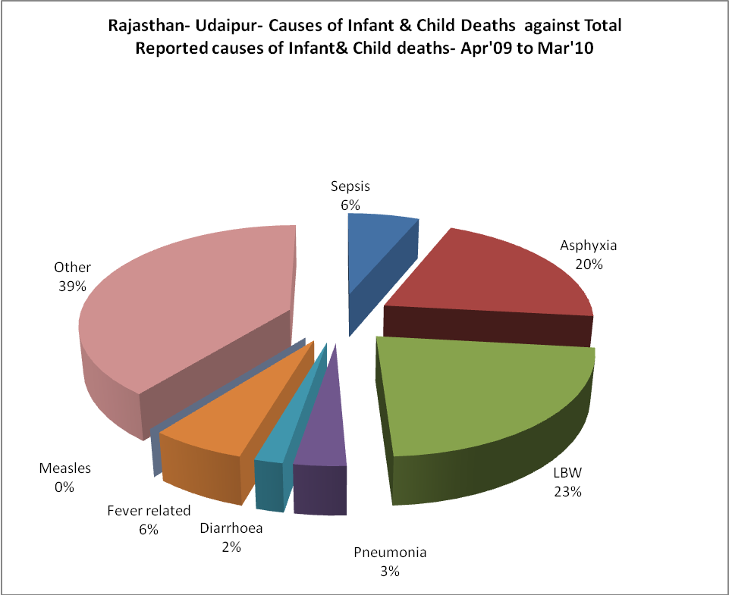

Rajasthan- Udaipur- Maternal Deaths & Causes - Apr'09 to Mar'10
Abortion |  |  | Obstructed/prolonged labour |  |  | Severe hypertesnion/fits
6-14 yrs | 15-55 yrs. | Total | 6-14 yrs | 15-55 yrs. | Total | 6-14 yrs | 15-55 yrs. | Total
1 | 4 | 5 | 0 | 1 | 1 | 0 | 0 | 0
Bleeding |  |  | High Fever |  |  | Other Causes
6-14 yrs | 15-55 yrs. | Total | 6-14 yrs | 15-55 yrs. | Total | 6-14 yrs | 15-55 yrs. | Total
1 | 3 | 4 | 0 | 0 | 0 | 2 | 11 | 13

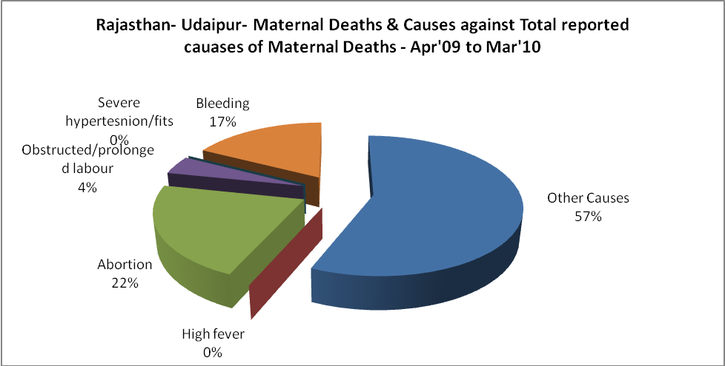

Rajasthan- Udaipur-Causes of Deaths in 6 to 55yrs age group - Apr'09 to Mar'10
Diarrhoel Diseases |  |  |  | Tuberculosis |  |  |  | Respiratory Diseases( Other than TB)
6-14 yrs | 15-55 yrs. | Above 55yrs | Total | 6-14 yrs | 15-55 yrs. | Above 55yrs | Total | 6-14 yrs | 15-55 yrs. | Above 55yrs | Total
4 | 8 | 2 | 14 | 6 | 31 | 18 | 55 | 1 | 17 | 51 | 69
Malaria |  |  |  | Other fever Related |  |  |  | HIV/Aids
6-14 yrs | 15-55 yrs. | Above 55yrs | Total | 6-14 yrs | 15-55 yrs. | Above 55yrs | Total | 6-14 yrs | 15-55 yrs. | Above 55yrs | Total
11 | 42 | 30 | 83 | 22 | 55 | 38 | 115 | 0 | 1 | 3 | 4
Heart Disease/Hypertenion related |  |  |  | Neurological Disease including strokes |  |  |  | Trauma/Accidents/ Burn Cases
6-14 yrs | 15-55 yrs. | Above 55yrs | Total | 6-14 yrs | 15-55 yrs. | Above 55yrs | Total | 6-14 yrs | 15-55 yrs. | Above 55yrs | Total
4 | 15 | 17 | 36 | 24 | 3 | 2 | 29 | 11 | 44 | 4 | 59
Suicide |  |  |  | Animal Bites & Stings
6-14 yrs | 15-55 yrs. | Above 55yrs | Total | 6-14 yrs | 15-55 yrs. | Above 55yrs | Total
0 | 22 | 4 | 26 | 1 | 1 | 5 | 7

