NHSRC
Maharashtra – Wardha
Analysis: Apr 2009 – Mar 2010

Maharashtra-Wardha- Summary-Apr'09 to Mar'10
ANC
ANC Registration against Expected Pregnancies | 89% | TT1 given to Pregnant women against ANC Registration | 63%
3 ANC Check ups against ANC Registrations | 68% | 100 IFA Tablets given to Pregnant women against ANC Registration | 70%
Deliveries
Unreported Deliveries against Estimated Deliveries | 21.1% | HOME Deliveries( SBA& Non SBA) against Estimated Deliveries | 2.7%
Institutional Deliveries against Estimated Deliveries | 76.2% | HOME Deliveries( SBA& Non SBA) against Reported Deliveries | 3.4%
Institutional Deliveries against Reported Deliveries | 96.6% | C Section Deliveries against Institutional Deliveries( Pvt & Pub) | 9%
Births & Neonates Care
Live Births Reported against Estimated Live Births | 79% | New borns weighed against Reported Live Births | 80%
Still Births (Reported) | 291 | New borns weighed less than 2.5 kgs against newborns weighed | 14%
Sex Ratio at Birth | 892 | New borns breastfed within one hr of Birth against Reported live Births | 0%
Child Immunization( 0 to 11 months)
BCG given against Expected Live Births | 84% | Measles given against Expected Live Births | 83%
OPV3 given against Expected Live Births | 83% | Fully Immunized Children against Expected Live Births | 66%
DPT3 given against Expected Live Births | 83%
Family Planning
Family Planning Methods Users ( Sterilizations(Male &Female)+IUD+ Condom pieces/72 + OCP Cycles/13) | 31,273 | IUD Insertions against reported FP Methods | 18%
Sterilization against reported FP Methods | 17% | Condom Users against reported FP Methods | 49%
 |  | OCP Users against reported FP Methods | 16%
Other Services
OPD | 169,047 | Major Operations | 881
IPD | - | Minor Operations | 1,810

Maharashtra-Wardha- Deliveries Apr'09 to Mar'10
Total Population | 1,452,444 | Expected Deliveries |  | 26,428
Home SBA | Home Non SBA | Institutional | Total Deliveries Reported | Unreported Deliveries
285 | 418 | 20,142 | 20,845 | 5,583
Home SBA % | Home Non SBA% | Institutional % | Total Deliveries Reported % | Unreported Deliveries %
1% | 2% | 76% | 79% | 21%
`

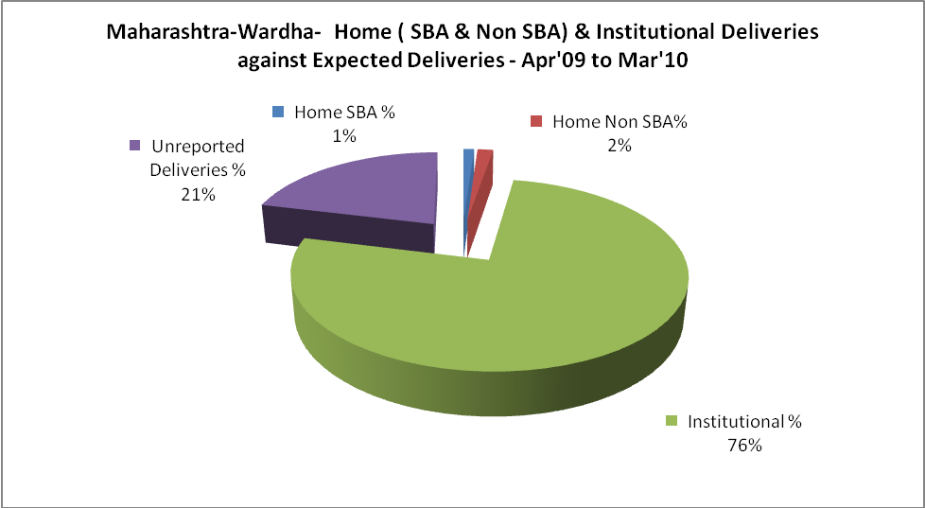

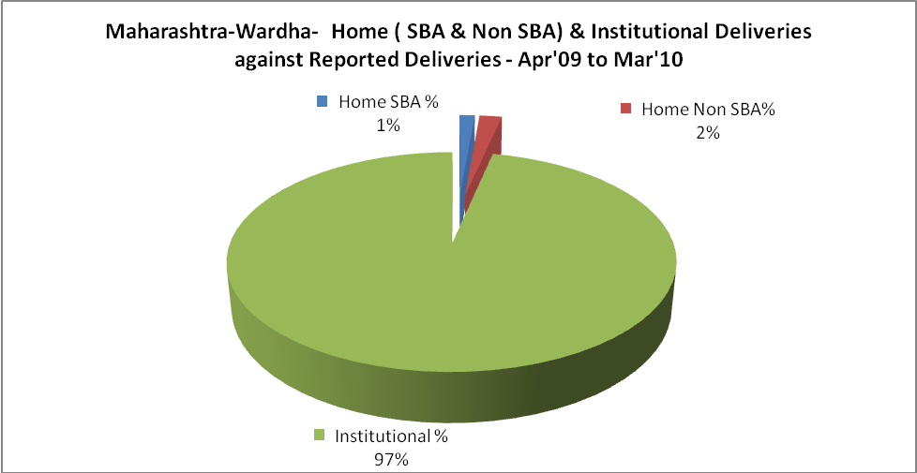

Maharashtra-Wardha- C sections & Complicated Deliveries Apr'09 to Mar'10
 | Institutional Deliveries (Public) | Institutional Deliveries (Pvt)
 | 16,773 | 3,369
C Section | 653 | 1,203
C Section% | 4% | 36%
Complicated Pregnancies attended | 1,058 | 949
Complicated Pregnancies attended % | 6% | 28%

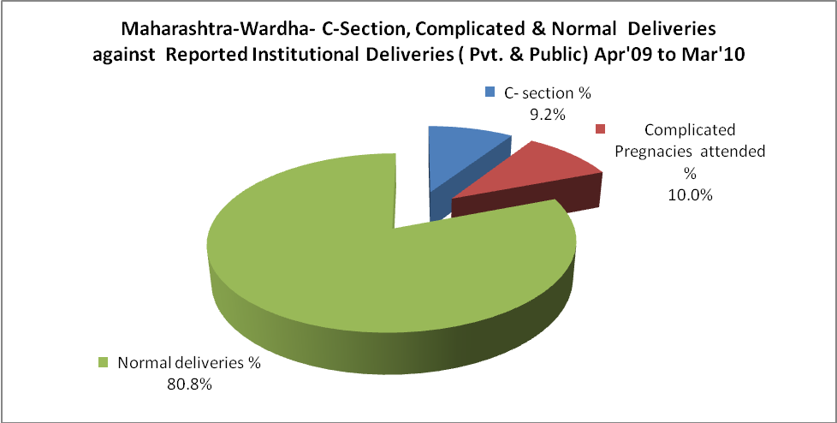

Maharashtra-Wardha- Complicated Pregnancies & Deliveries Treated - Apr'09 to Mar'10
Reported Deliveries |  |  | Reported ANC Registration
20,845 |  |  | 25,461
Complicated Pregnancies attended | Complicated Pregnancies Rate | C - Section Deliveries | PNC Maternal Complications | Abortions | Still Births
2,007 | 7% | 1,856 | 342 | 1,235 | 291
Complicated Deliveries Treated with |  |  |  | No Of Eclampsia cases Treated | No Of severe anemia cases treated
IV Antibiotics | IV antihypertensive/Magsulph injection | IV Oxytocis | Blood Transfusion | No Of Eclampsia cases Treated | No Of severe anemia cases treated
- | - | - | - | - | -

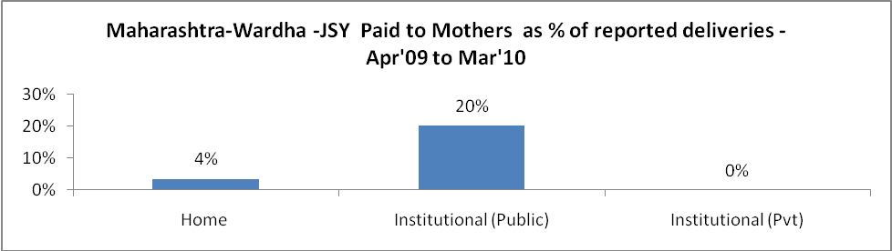

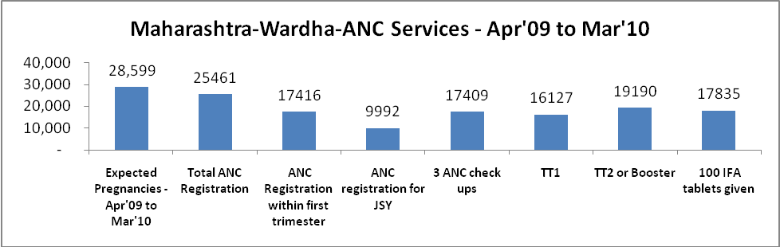

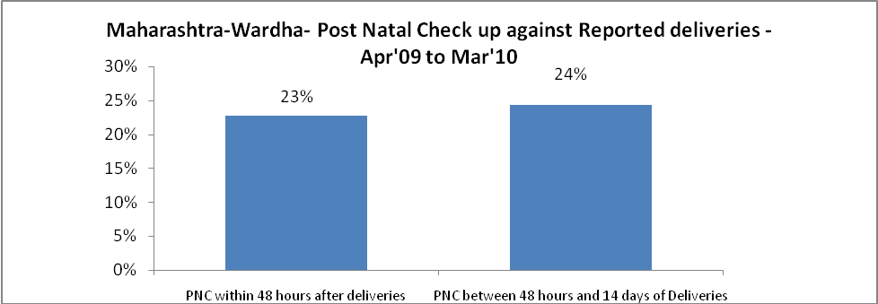

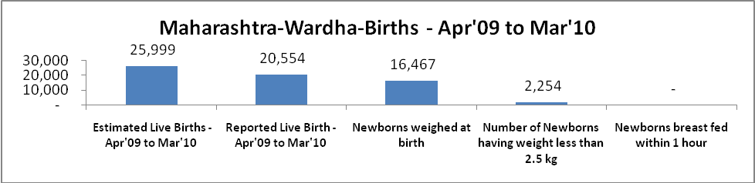

Maharashtra-Wardha - Births - Apr'09 to Mar'10
Live Birth - Males | Live Birth - females | Live Birth - Total | Sex Ratio at birth | Still Birth | Abortion( Induced/Spontaneous
10,861 | 9,693 | 20,554 | 892 | 291 | 1,235

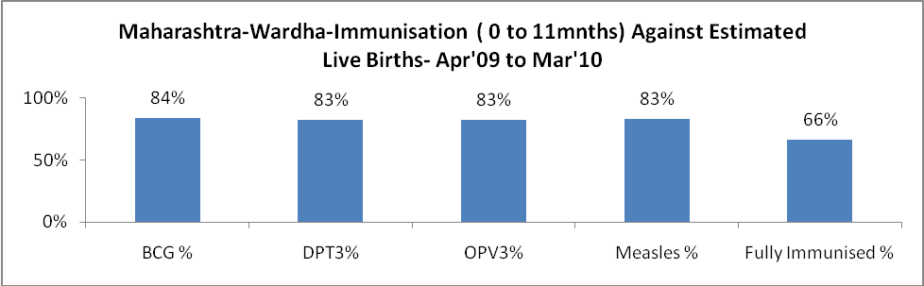

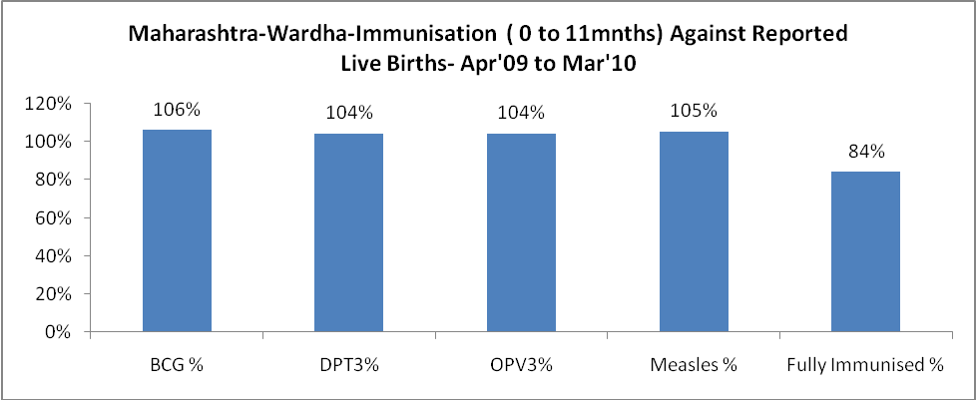

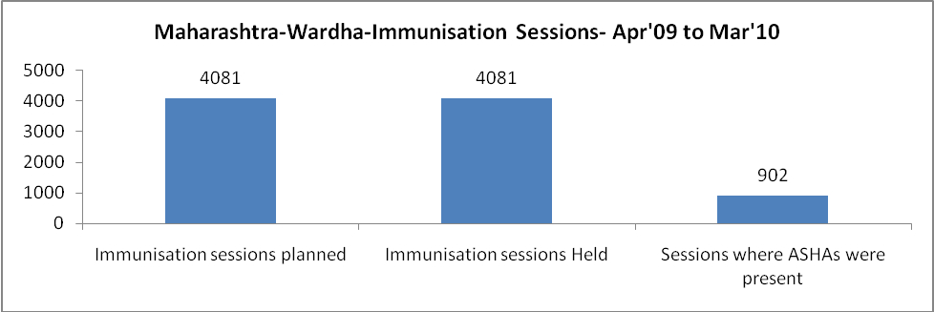

Maharashtra-Wardha- Apr'09 to Mar'10
Total Abortions | Abortion Rate
2,434 | 8.5%

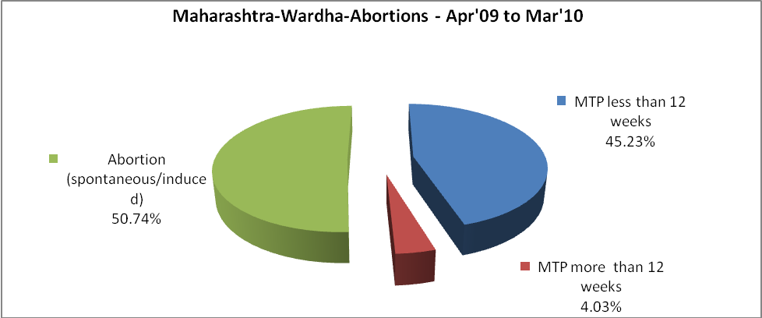

Maharashtra-Wardha- Apr'09 to Mar'10
Total OPD | Total RTI/STI cases
169,047 | 3,251

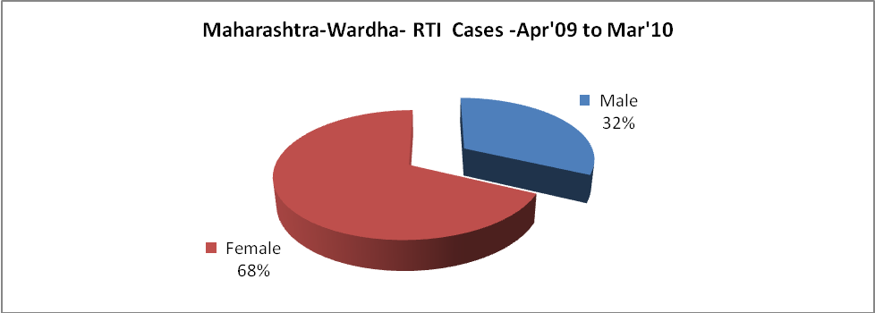

Maharashtra-Wardha-Sterilizations - Apr'09 to Mar'10
 | Reported | %age of Reported Sterilization
Total Sterilization | 5,234 | -
NSV | 371 | 7%
Laparoscopic | 1,170 | 22%
MiniLap | 1,843 | 35%
Post Partum | 1,850 | 35%
Male Sterilization | 371 | 7%
Female Sterilization | 4,863 | 93%

Maharashtra-Wardha-FP Methods - Apr'09 to Mar'10
 | Reported | %age of All Reported FP Methods
Total Reported FP Method (All types) Users | 31,273 | -
Sterilizations | 5,234 | 17%
IUD | 5,733 | 18%
Condom Users | 15,306 | 49%
OCP Users | 5,000 | 16%
Limiting Methods | 5,234 | 17%
Spacing Methods | 26,039 | 83%

Maharashtra-Wardha- Service Delivery - Apr'09 to Mar'10
Operation major (General and spinal anaesthesia) | Operation minor (No or local anaesthesia) | AYUSH | Dental Procedures | Adolescent counselling services | Total OPD | Total IPD
881 | 1,810 | - | - | - | 169,047 | -
Operation major (General and spinal anaesthesia) as %ge of OPD | Operation minor (No or local anaesthesia)as %ge of OPD | AYUSH as %ge of OPD | Dental Procedures as %ge of OPD | Adolescent counselling services as %ge of OPD | IPD as percentage of OPD
0.5% | 1.1% | 0.0% | 0.0% | 0.0% | 0%

Maharashtra-Wardha- Lab Services - Apr'09 to Mar'10
Total OPD | Total HB tested | Total HIV Tested | Total Population
169,047 | - | - | 1,452,444
HB test conducted as %age of OPD | HB<7gm as %age of HB tested | HIV test conducted as %age of OPD | HIV positive as %age of HIV tested | Blood Smear Examined as % of Population
0.0% | 0.0% | 0.0% | 0.0% | 11.4%

Maharashtra-Wardha- Childhood Disease - Vaccine Preventable -Apr'09 to Mar'10
Diphtheria | Pertussis | Tetanus Neonatorum | Tetanus others | Polio | Measles
0 | 0 | 0 | 0 | 0 | 0
Maharashtra-Wardha-Childhood Disease - Others - Apr'09 to Mar'10
Diarrhoea and dehydration | Malaria | Number admitted with Respiratory Infections
49 | - | -

Maharashtra-Wardha- Infant & Child Deaths - Apr'09 to Mar'10
Infant Deaths within 24 hrs of birth | Infant Deaths between 24hrs & under 1 week | Infant Deaths between 1 week & under 1 month | Child Deaths between 1 month & under 1 year | Child Deaths between 1yr under 5years | Total Deaths
11 | 0 | 0 | 0 | 0 | 11

Maharashtra-Wardha- Causes of Infant & Child Deaths - Apr'09 to Mar'10
Sepsis |  |  | Asphyxia |  |  | LBW
Up to 1 Weeks of Birth | Between 1 week & 4 weeks of birth | Total | Up to 1 Weeks of Birth | Between 1 week & 4 weeks of birth | Total | Up to 1 Weeks of Birth | Between 1 week & 4 weeks of birth | Total
0 | 0 | 0 | 0 | 0 | 0 | 0 | 0 | 0
Pneumonia |  |  | Diarrhoea |  |  | Fever related
Between 1 month and 11 months | Between 1 year & 5 years | Total | Between 1 month and 11 months | Between 1 year & 5 years | Total | Between 1 month and 11 months | Between 1 year & 5 years | Total
0 | 0 | 0 | 0 | 0 | 0 | 0 | 0 | 0
Others |  |  | Measles |  |  | Others
Up to 1 Weeks of Birth | Between 1 week & 4 weeks of birth | Total | Between 1 month and 11 months | Between 1 year & 5 years | Total | Between 1 month and 11 months | Between 1 year & 5 years | Total
0 | 0 | 0 | 0 | 0 | 0 | 0 | 0 | 0

Maharashtra-Wardha- Maternal Deaths & Causes - Apr'09 to Mar'10
Abortion |  |  | Obstructed/prolonged labour |  |  | Severe hypertension/fits
6-14 yrs | 15-55 yrs. | Total | 6-14 yrs | 15-55 yrs. | Total | 6-14 yrs | 15-55 yrs. | Total
0 | 0 | 0 | 0 | 0 | 0 | 0 | 0 | 0
Bleeding |  |  | High Fever |  |  | Other Causes
6-14 yrs | 15-55 yrs. | Total | 6-14 yrs | 15-55 yrs. | Total | 6-14 yrs | 15-55 yrs. | Total
0 | 0 | 0 | 0 | 0 | 0 | 0 | 0 | 0

Maharashtra-Wardha-Causes of Deaths in 6 to 55yrs age group - Apr'09 to Mar'10
Diarrhoel Diseases |  |  |  | Tuberculosis |  |  |  | Respiratory Diseases( Other than TB)
6-14 yrs | 15-55 yrs. | Above 55yrs | Total | 6-14 yrs | 15-55 yrs. | Above 55yrs | Total | 6-14 yrs | 15-55 yrs. | Above 55yrs | Total
0 | 0 | 0 | 0 | 0 | 0 | 0 | 0 | 0 | 0 | 0 | 0
Malaria |  |  |  | Other fever Related |  |  |  | HIV/Aids
6-14 yrs | 15-55 yrs. | Above 55yrs | Total | 6-14 yrs | 15-55 yrs. | Above 55yrs | Total | 6-14 yrs | 15-55 yrs. | Above 55yrs | Total
0 | 0 | 0 | 0 | 0 | 0 | 0 | 0 | 0 | 0 | 0 | 0
Heart Disease/Hypertension related |  |  |  | Neurological Disease including strokes |  |  |  | Trauma/Accidents/ Burn Cases
6-14 yrs | 15-55 yrs. | Above 55yrs | Total | 6-14 yrs | 15-55 yrs. | Above 55yrs | Total | 6-14 yrs | 15-55 yrs. | Above 55yrs | Total
0 | 0 | 0 | 0 | 0 | 0 | 0 | 0 | 0 | 0 | 0 | 0
Suicide |  |  |  | Animal Bites & Stings
6-14 yrs | 15-55 yrs. | Above 55yrs | Total | 6-14 yrs | 15-55 yrs. | Above 55yrs | Total
0 | 0 | 0 | 0 | 0 | 0 | 0 | 0

