NHSRC
Maharashtra – Washim
Analysis: Apr 2009 – Mar 2010

Maharashtra-Washim- Summary-Apr'09 to Mar'10
ANC
ANC Registration against Expected Pregnancies | 96% | TT1 given to Pregnant women against ANC Registration | 68%
3 ANC Check ups against ANC Registrations | 78% | 100 IFA Tablets given to Pregnant women against ANC Registration | 80%
Deliveries
Unreported Deliveries against Estimated Deliveries | 0.1% | HOME Deliveries( SBA& Non SBA) against Estimated Deliveries | 10.0%
Institutional Deliveries against Estimated Deliveries | 89.9% | HOME Deliveries( SBA& Non SBA) against Reported Deliveries | 10.0%
Institutional Deliveries against Reported Deliveries | 90.0% | C Section Deliveries against Institutional Deliveries( Pvt & Pub) | 7%
Births & Neonates Care
Live Births Reported against Estimated Live Births | 80% | New borns weighed against Reported Live Births | 87%
Still Births (Reported) | 245 | New borns weighed less than 2.5 kgs against newborns weighed | 14%
Sex Ratio at Birth | 821 | New borns breastfed within one hr of Birth against Reported live Births | 77%
Child Immunization( 0 to 11 months)
BCG given against Expected Live Births | 99% | Measles given against Expected Live Births | 97%
OPV3 given against Expected Live Births | 99% | Fully Immunized Children against Expected Live Births | 95%
DPT3 given against Expected Live Births | 99%
Family Planning
Family Planning Methods Users ( Sterilizations(Male &Female)+IUD+ Condom pieces/72 + OCP Cycles/13) | 16,896 | IUD Insertions against reported FP Methods | 28%
Sterilization against reported FP Methods | 37% | Condom Users against reported FP Methods | 19%
 |  | OCP Users against reported FP Methods | 15%
Other Services
OPD | 232,825 | Major Operations | 57
IPD | - | Minor Operations | 188
`

Maharashtra-Washim- Deliveries Apr'09 to Mar'10
Total Population | 1,197,396 | Expected Deliveries |  | 21,787
Home SBA | Home Non SBA | Institutional | Total Deliveries Reported | Unreported Deliveries
1,208 | 972 | 19,586 | 21,766 | 21
Home SBA % | Home Non SBA% | Institutional % | Total Deliveries Reported % | Unreported Deliveries %
6% | 4% | 90% | 100% | 0%

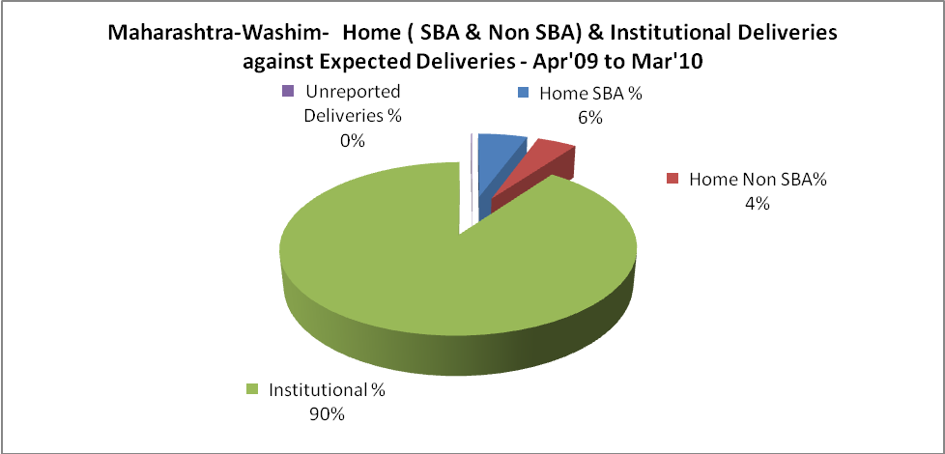

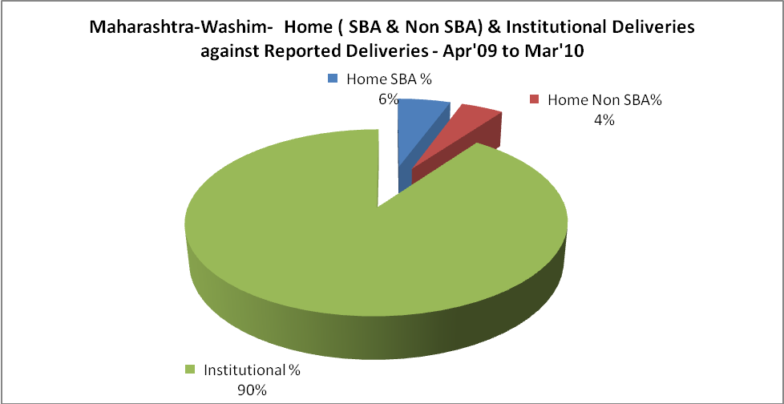

Maharashtra-Washim- C sections & Complicated Deliveries Apr'09 to Mar'10
 | Institutional Deliveries (Public) | Institutional Deliveries (Pvt)
 | 14,826 | 4,760
C Section | - | 1,311
C Section% | 0% | 28%
Complicated Pregnancies attended | 237 | 91
Complicated Pregnancies attended % | 2% | 2%

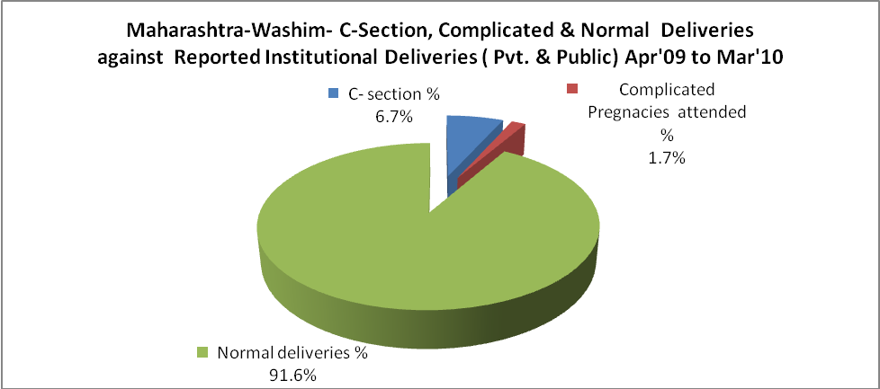

Maharashtra-Washim- Complicated Pregnancies & Deliveries Treated - Apr'09 to Mar'10
Reported Deliveries |  |  | Reported ANC Registration
21,766 |  |  | 22,607
Complicated Pregnancies attended | Complicated Pregnancies Rate | C - Section Deliveries | PNC Maternal Complications | Abortions | Still Births
328 | 1% | 1,311 | - | 710 | 245
Complicated Deliveries Treated with |  |  |  | No Of Eclampsia cases Treated | No Of severe anemia cases treated
IV Antibiotics | IV antihypertensive/Magsulph injection | IV Oxytocis | Blood Transfusion | No Of Eclampsia cases Treated | No Of severe anemia cases treated
- | - | - | - | - | -

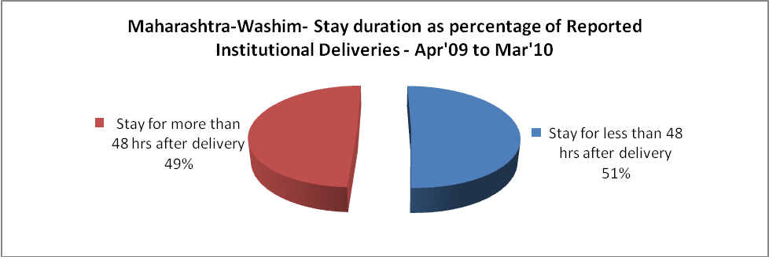

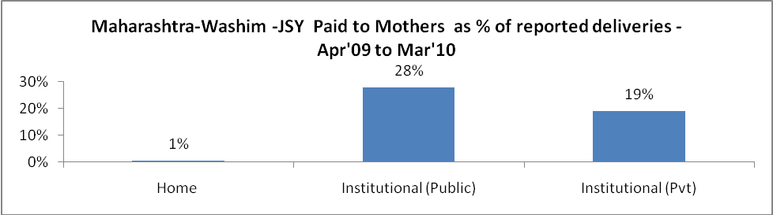

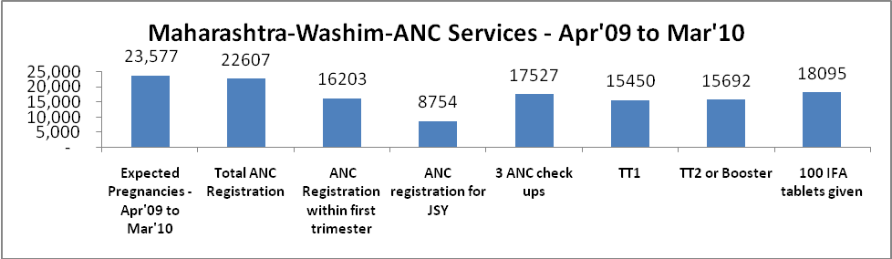

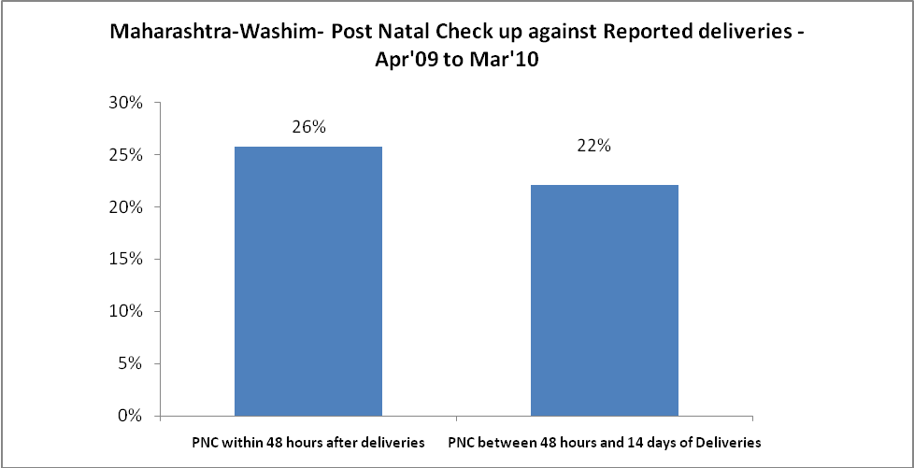

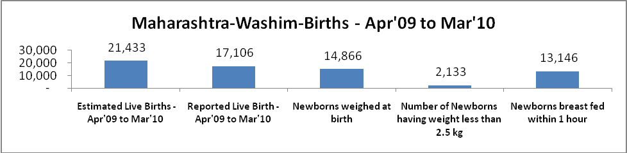

Maharashtra-Washim - Births - Apr'09 to Mar'10
Live Birth - Males | Live Birth - females | Live Birth - Total | Sex Ratio at birth | Still Birth | Abortion( Induced/Spontaneous
9,393 | 7,713 | 17,106 | 821 | 245 | 710

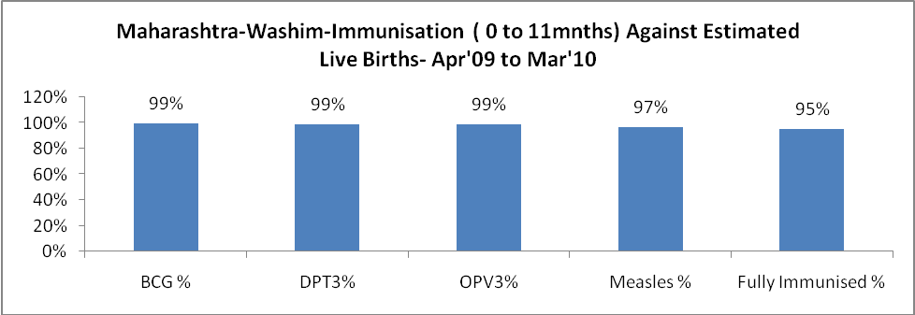

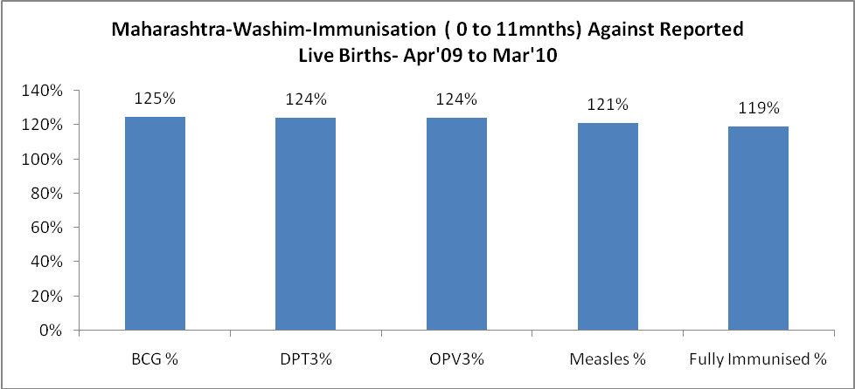

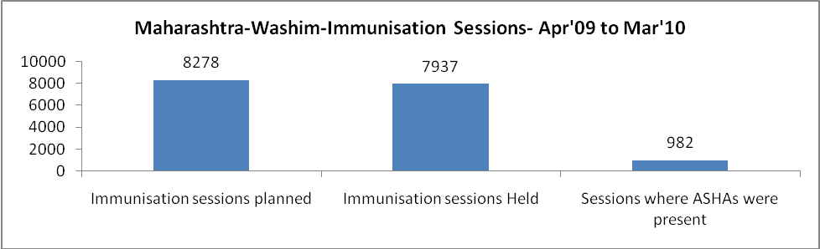

Maharashtra-Washim- Apr'09 to Mar'10
Total Abortions | Abortion Rate
1,164 | 4.9%

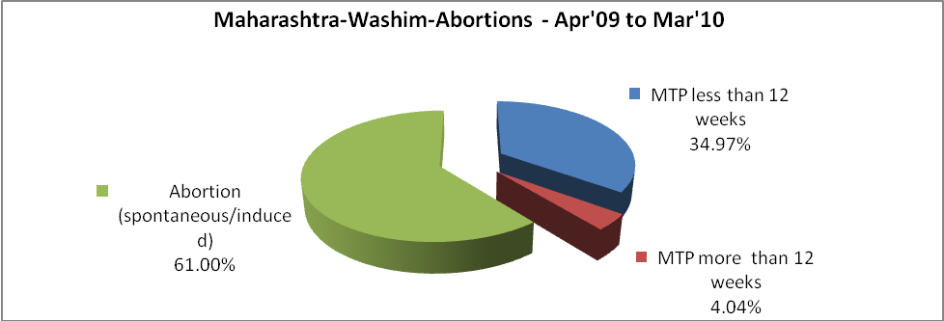

Maharashtra-Washim- Apr'09 to Mar'10
Total OPD | Total RTI/STI cases
232,825 | 3,145

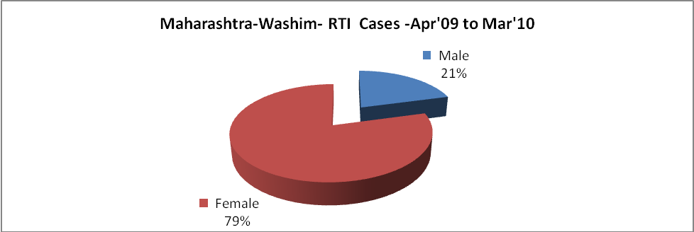

Maharashtra-Washim-Sterilizations - Apr'09 to Mar'10
 | Reported | %age of Reported Sterilization
Total Sterilization | 6,295 | -
NSV | 100 | 2%
Laparoscopic | 839 | 13%
Mini Lap | 5,249 | 83%
Post Partum | 107 | 2%
Male Sterilization | 100 | 2%
Female Sterilization | 6,195 | 98%

Maharashtra-Washim-FP Methods - Apr'09 to Mar'10
 | Reported | %age of All Reported FP Methods
Total Reported FP Method (All types) Users | 16,896 | -
Sterilizations | 6,295 | 37%
IUD | 4,784 | 28%
Condom Users | 3,202 | 19%
OCP Users | 2,616 | 15%
Limiting Methods | 6,295 | 37%
Spacing Methods | 10,601 | 63%

Maharashtra-Washim- Service Delivery - Apr'09 to Mar'10
Operation major (General and spinal anaesthesia) | Operation minor (No or local anaesthesia) | AYUSH | Dental Procedures | Adolescent counselling services | Total OPD | Total IPD
57 | 188 | 10,407 | 1,564 | 1,996 | 232,825 | -
Operation major (General and spinal anaesthesia) as %ge of OPD | Operation minor (No or local anaesthesia)as %ge of OPD | AYUSH as %ge of OPD | Dental Procedures as %ge of OPD | Adolescent counselling services as %ge of OPD | IPD as percentage of OPD
0.0% | 0.1% | 4.5% | 0.7% | 0.9% | 0%

Maharashtra-Washim- Lab Services - Apr'09 to Mar'10
Total OPD | Total HB tested | Total HIV Tested | Total Population
232,825 | 3,486 | - | 1,197,396
HB test conducted as %age of OPD | HB<7gm as %age of HB tested | HIV test conducted as %age of OPD | HIV positive as %age of HIV tested | Blood Smear Examined as % of Population
1.5% | 3.9% | 0.0% | 0.0% | 12.2%

Maharashtra-Washim- Childhood Disease - Vaccine Preventable -Apr'09 to Mar'10
Diphtheria | Pertussis | Tetanus Neonatorum | Tetanus others | Polio | Measles
1 | 0 | 0 | 0 | 0 | 6
Maharashtra-Washim-Childhood Disease - Others - Apr'09 to Mar'10
Diarrhoea and dehydration | Malaria | Number admitted with Respiratory Infections
517 | - | 326

Maharashtra-Washim- Infant & Child Deaths - Apr'09 to Mar'10
Infant Deaths within 24 hrs of birth | Infant Deaths between 24hrs & under 1 week | Infant Deaths between 1 week & under 1 month | Child Deaths between 1 month & under 1 year | Child Deaths between 1yr under 5years | Total Deaths
104 | 0 | 6 | 0 | 1 | 111

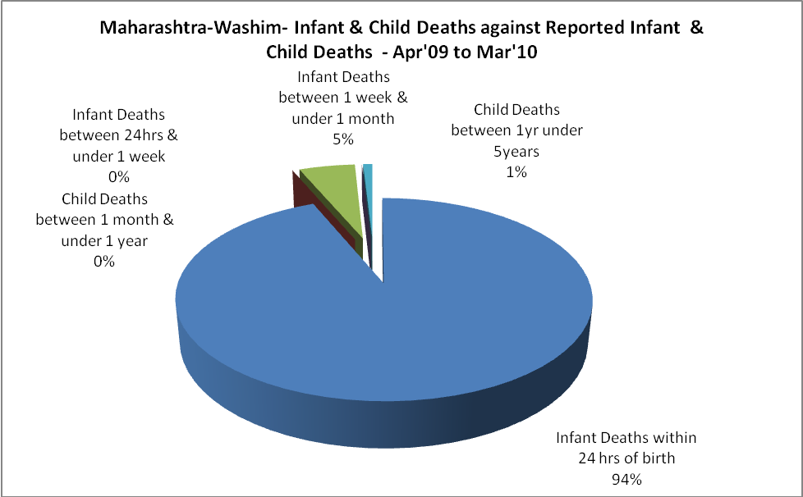

Maharashtra-Washim- Causes of Infant & Child Deaths - Apr'09 to Mar'10
Sepsis |  |  | Asphyxia |  |  | LBW
Up to 1 Weeks of Birth | Between 1 week & 4 weeks of birth | Total | Up to 1 Weeks of Birth | Between 1 week & 4 weeks of birth | Total | Up to 1 Weeks of Birth | Between 1 week & 4 weeks of birth | Total
0 | 0 | 0 | 0 | 0 | 0 | 0 | 0 | 0
Pneumonia |  |  | Diarrhoea |  |  | Fever related
Between 1 month and 11 months | Between 1 year & 5 years | Total | Between 1 month and 11 months | Between 1 year & 5 years | Total | Between 1 month and 11 months | Between 1 year & 5 years | Total
0 | 0 | 0 | 0 | 0 | 0 | 0 | 0 | 0
Others |  |  | Measles |  |  | Others
Up to 1 Weeks of Birth | Between 1 week & 4 weeks of birth | Total | Between 1 month and 11 months | Between 1 year & 5 years | Total | Between 1 month and 11 months | Between 1 year & 5 years | Total
0 | 6 | 6 | 0 | 0 | 0 | 0 | 1 | 1

Maharashtra-Washim- Maternal Deaths & Causes - Apr'09 to Mar'10
Abortion |  |  | Obstructed/prolonged labour |  |  | Severe hypertension/fits
6-14 yrs | 15-55 yrs. | Total | 6-14 yrs | 15-55 yrs. | Total | 6-14 yrs | 15-55 yrs. | Total
0 | 0 | 0 | 0 | 0 | 0 | 0 | 0 | 0
Bleeding |  |  | High Fever |  |  | Other Causes
6-14 yrs | 15-55 yrs. | Total | 6-14 yrs | 15-55 yrs. | Total | 6-14 yrs | 15-55 yrs. | Total
0 | 0 | 0 | 0 | 0 | 0 | 0 | 0 | 0

Maharashtra-Washim-Causes of Deaths in 6 to 55yrs age group - Apr'09 to Mar'10
Diarrhoel Diseases |  |  |  | Tuberculosis |  |  |  | Respiratory Diseases( Other than TB)
6-14 yrs | 15-55 yrs. | Above 55yrs | Total | 6-14 yrs | 15-55 yrs. | Above 55yrs | Total | 6-14 yrs | 15-55 yrs. | Above 55yrs | Total
0 | 0 | 0 | 0 | 0 | 0 | 0 | 0 | 0 | 0 | 0 | 0
Malaria |  |  |  | Other fever Related |  |  |  | HIV/Aids
6-14 yrs | 15-55 yrs. | Above 55yrs | Total | 6-14 yrs | 15-55 yrs. | Above 55yrs | Total | 6-14 yrs | 15-55 yrs. | Above 55yrs | Total
0 | 0 | 0 | 0 | 0 | 0 | 0 | 0 | 0 | 0 | 0 | 0
Heart Disease/Hypertension related |  |  |  | Neurological Disease including strokes |  |  |  | Trauma/Accidents/ Burn Cases
6-14 yrs | 15-55 yrs. | Above 55yrs | Total | 6-14 yrs | 15-55 yrs. | Above 55yrs | Total | 6-14 yrs | 15-55 yrs. | Above 55yrs | Total
0 | 0 | 0 | 0 | 0 | 0 | 0 | 0 | 0 | 0 | 0 | 0
Suicide |  |  |  | Animal Bites & Stings
6-14 yrs | 15-55 yrs. | Above 55yrs | Total | 6-14 yrs | 15-55 yrs. | Above 55yrs | Total
0 | 0 | 0 | 0 | 0 | 0 | 0 | 0

