NHSRC
Maharashtra – Yavatmal
Analysis: Apr 2009 – Mar 2010

Maharashtra-Yavatmal- Summary-Apr'09 to Mar'10
ANC
ANC Registration against Expected Pregnancies | 79% | TT1 given to Pregnant women against ANC Registration | 76%
3 ANC Check ups against ANC Registrations | 83% | 100 IFA Tablets given to Pregnant women against ANC Registration | 73%
Deliveries
Unreported Deliveries against Estimated Deliveries | 74.8% | HOME Deliveries( SBA& Non SBA) against Estimated Deliveries | 7.4%
Institutional Deliveries against Estimated Deliveries | 17.8% | HOME Deliveries( SBA& Non SBA) against Reported Deliveries | 29.3%
Institutional Deliveries against Reported Deliveries | 70.7% | C Section Deliveries against Institutional Deliveries( Pvt & Pub) | 12%
Births & Neonates Care
Live Births Reported against Estimated Live Births | 75% | New borns weighed against Reported Live Births | 74%
Still Births (Reported) | 524 | New borns weighed less than 2.5 kgs against newborns weighed | 49%
Sex Ratio at Birth | 1,003 | New borns breastfed within one hr of Birth against Reported live Births | 0%
Child Immunization( 0 to 11 months)
BCG given against Expected Live Births | 70% | Measles given against Expected Live Births | 73%
OPV3 given against Expected Live Births | 70% | Fully Immunized Children against Expected Live Births | 68%
DPT3 given against Expected Live Births | 63%
Family Planning
Family Planning Methods Users ( Sterilizations(Male &Female)+IUD+ Condom pieces/72 + OCP Cycles/13) | 27,378 | IUD Insertions against reported FP Methods | 27%
Sterilization against reported FP Methods | 45% | Condom Users against reported FP Methods | 9%
 |  | OCP Users against reported FP Methods | 19%
Other Services
OPD | 269,527 | Major Operations | 1,689
IPD | - | Minor Operations | 3,003
`
Maharashtra-Yavatmal- Deliveries Apr'09 to Mar'10
Total Population | 2,884,627 | Expected Deliveries |  | 52,487
Home SBA | Home Non SBA | Institutional | Total Deliveries Reported | Unreported Deliveries
1,693 | 2,189 | 9,347 | 13,229 | 39,258
Home SBA % | Home Non SBA% | Institutional % | Total Deliveries Reported % | Unreported Deliveries %
3% | 4% | 18% | 25% | 75%

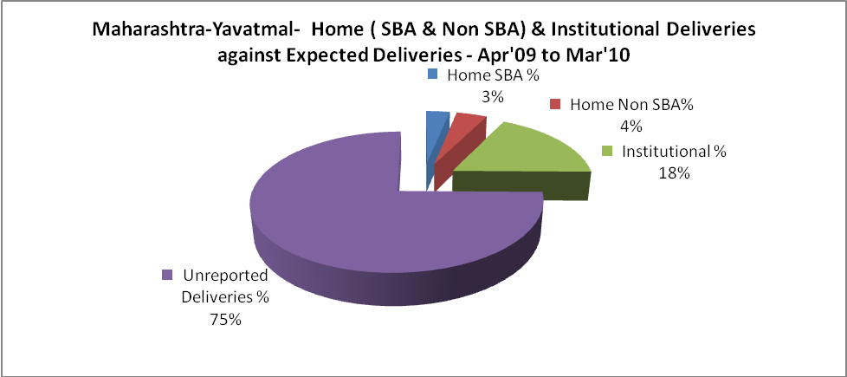

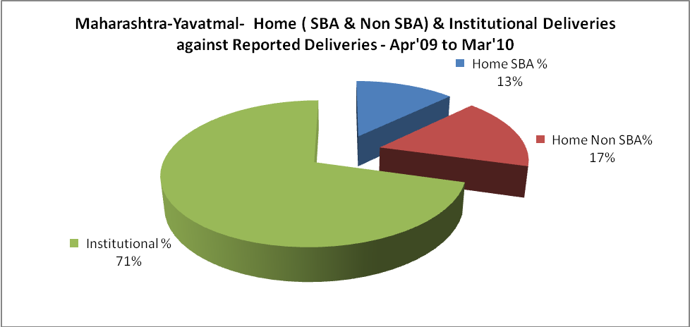

Maharashtra-Yavatmal- C sections & Complicated Deliveries Apr'09 to Mar'10
 | Institutional Deliveries (Public) | Institutional Deliveries (Pvt)
 | 9,225 | 122
C Section | 982 | 126
C Section% | 11% | 103%
Complicated Pregnancies attended | 412 | 432
Complicated Pregnancies attended % | 4% | 354%

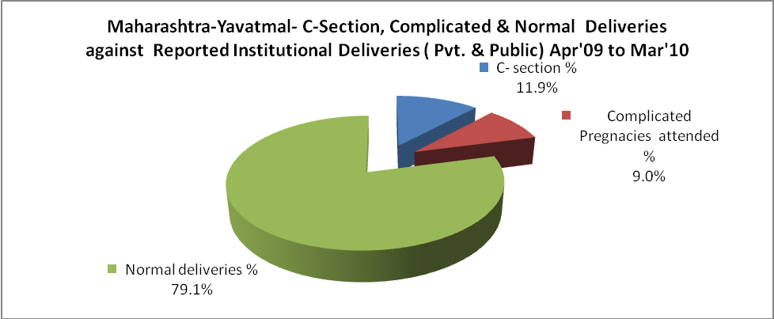

Maharashtra-Yavatmal- Complicated Pregnancies & Deliveries Treated - Apr'09 to Mar'10
Reported Deliveries |  |  | Reported ANC Registration
13,229 |  |  | 45,085
Complicated Pregnancies attended | Complicated Pregnancies Rate | C - Section Deliveries | PNC Maternal Complications | Abortions | Still Births
844 | 1% | 1,108 | 425 | 698 | 524
Complicated Deliveries Treated with |  |  |  | No Of Eclampsia cases Treated | No Of severe anemia cases treated
IV Antibiotics | IV antihypertensive/Magsulph injection | IV Oxytocis | Blood Transfusion | No Of Eclampsia cases Treated | No Of severe anemia cases treated
- | - | - | - | 613 | -

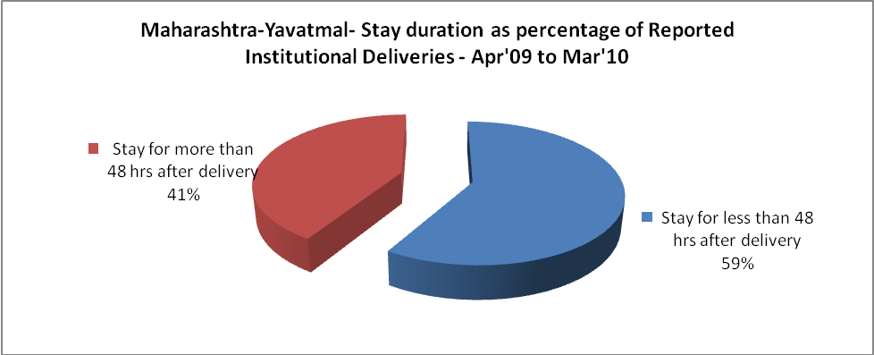

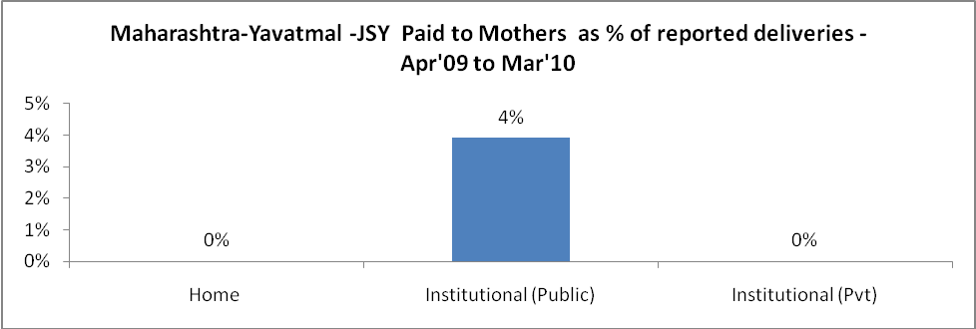

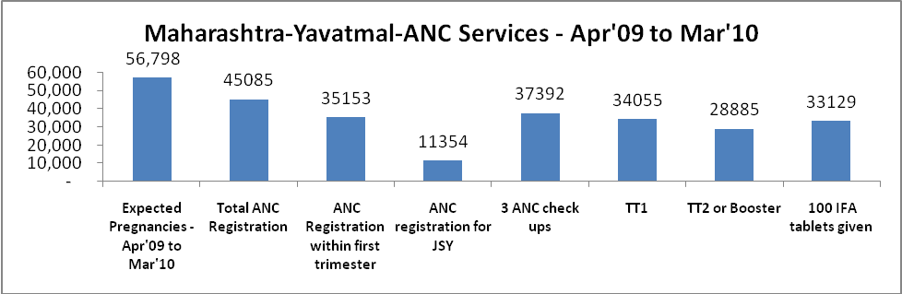

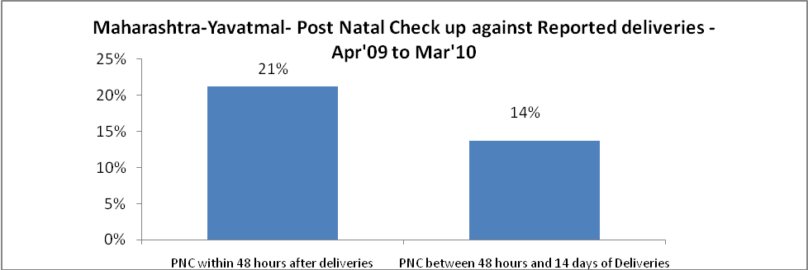

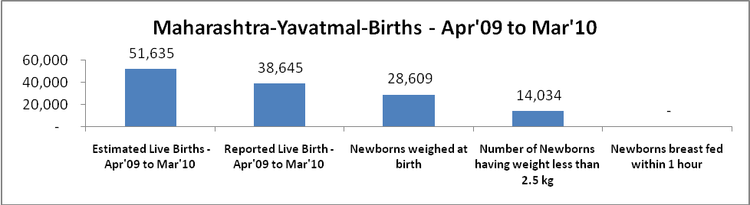

Maharashtra-Yavatmal - Births - Apr'09 to Mar'10
Live Birth - Males | Live Birth - females | Live Birth - Total | Sex Ratio at birth | Still Birth | Abortion( Induced/Spontaneous
19,296 | 19,349 | 38,645 | 1,003 | 524 | 698

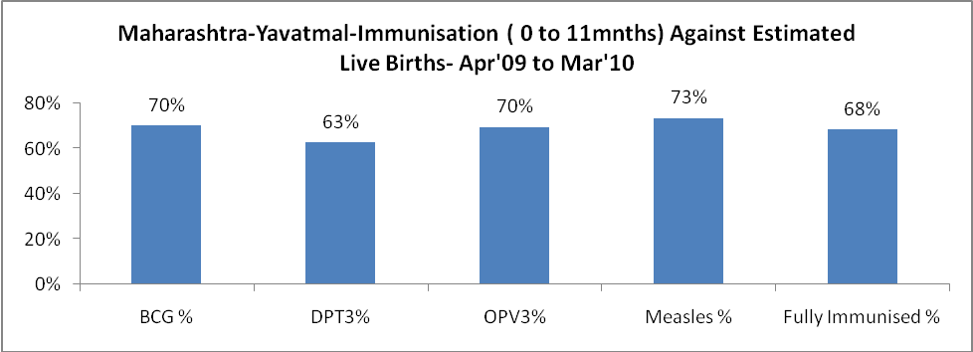

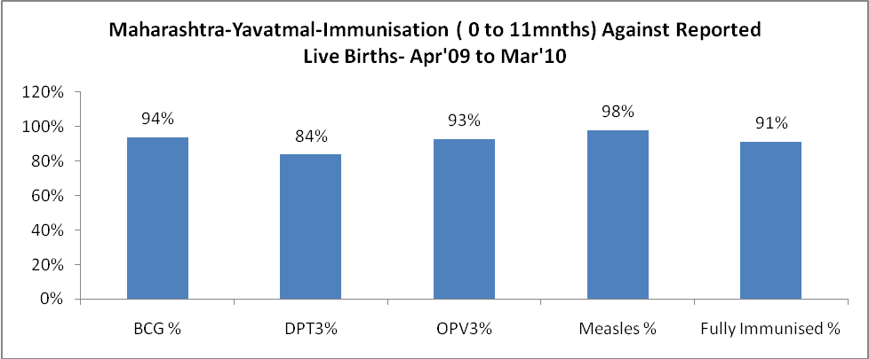

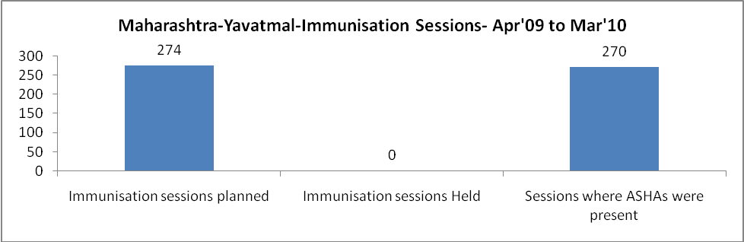

Maharashtra-Yavatmal- Apr'09 to Mar'10
Total Abortions | Abortion Rate
1,387 | 2.4%

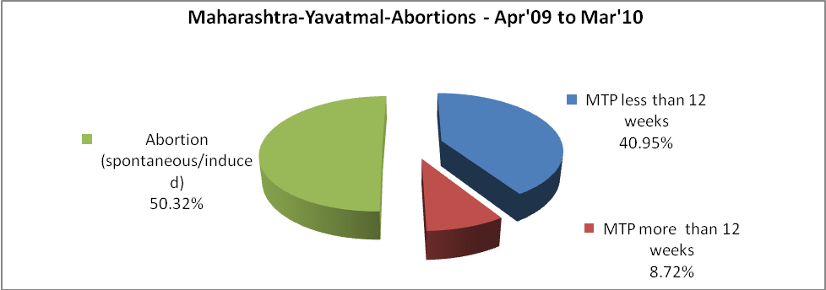

Maharashtra-Yavatmal- Apr'09 to Mar'10
Total OPD | Total RTI/STI cases
269,527 | 6,814

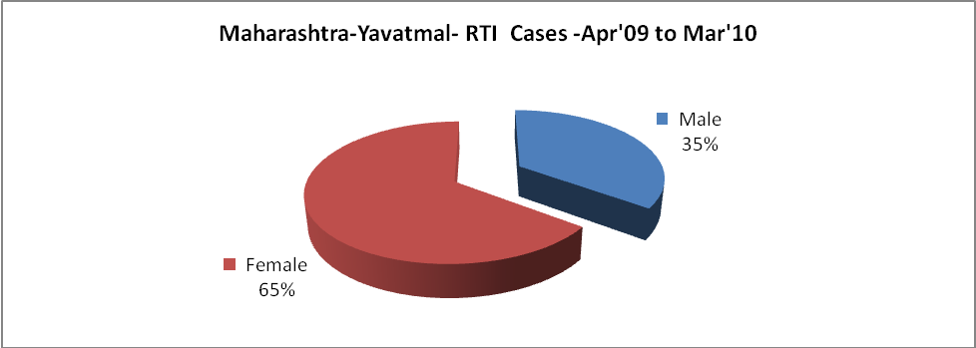

Maharashtra-Yavatmal-Sterilizations - Apr'09 to Mar'10
 | Reported | %age of Reported Sterilization
Total Sterilization | 12,391 | -
NSV | 516 | 4%
Laparoscopic | 424 | 3%
Mini Lap | 9,579 | 77%
Post Partum | 1,872 | 15%
Male Sterilization | 516 | 4%
Female Sterilization | 11,875 | 96%

Maharashtra-Yavatmal-FP Methods - Apr'09 to Mar'10
 | Reported | %age of All Reported FP Methods
Total Reported FP Method (All types) Users | 27,378 | -
Sterilizations | 12,391 | 45%
IUD | 7,367 | 27%
Condom Users | 2,403 | 9%
OCP Users | 5,217 | 19%
Limiting Methods | 12,391 | 45%
Spacing Methods | 14,987 | 55%

Maharashtra-Yavatmal- Service Delivery - Apr'09 to Mar'10
Operation major (General and spinal anaesthesia) | Operation minor (No or local anaesthesia) | AYUSH | Dental Procedures | Adolescent counselling services | Total OPD | Total IPD
1,689 | 3,003 | 7 | 2 | 2 | 269,527 | -
Operation major (General and spinal anaesthesia) as %ge of OPD | Operation minor (No or local anaesthesia)as %ge of OPD | AYUSH as %ge of OPD | Dental Procedures as %ge of OPD | Adolescent counselling services as %ge of OPD | IPD as percentage of OPD
0.6% | 1.1% | 0.0% | 0.0% | 0.0% | 0%

Maharashtra-Yavatmal- Lab Services - Apr'09 to Mar'10
Total OPD | Total HB tested | Total HIV Tested | Total Population
269,527 | 1,385 | - | 2,884,627
HB test conducted as %age of OPD | HB<7gm as %age of HB tested | HIV test conducted as %age of OPD | HIV positive as %age of HIV tested | Blood Smear Examined as % of Population
0.5% | 29.7% | 0.0% | 0.0% | 12.5%

Maharashtra-Yavatmal- Childhood Disease - Vaccine Preventable -Apr'09 to Mar'10
Diphtheria | Pertussis | Tetanus Neonatorum | Tetanus others | Polio | Measles
0 | 0 | 0 | 0 | 0 | 10
Maharashtra-Yavatmal-Childhood Disease - Others - Apr'09 to Mar'10
Diarrhoea and dehydration | Malaria | Number admitted with Respiratory Infections
272 | 24 | -

Maharashtra-Yavatmal- Causes of Infant & Child Deaths - Apr'09 to Mar'10
Sepsis |  |  | Asphyxia |  |  | LBW
Up to 1 Weeks of Birth | Between 1 week & 4 weeks of birth | Total | Up to 1 Weeks of Birth | Between 1 week & 4 weeks of birth | Total | Up to 1 Weeks of Birth | Between 1 week & 4 weeks of birth | Total
0 | 0 | 0 | 0 | 0 | 0 | 0 | 0 | 0
Pneumonia |  |  | Diarrhoea |  |  | Fever related
Between 1 month and 11 months | Between 1 year & 5 years | Total | Between 1 month and 11 months | Between 1 year & 5 years | Total | Between 1 month and 11 months | Between 1 year & 5 years | Total
0 | 0 | 0 | 0 | 0 | 0 | 0 | 0 | 0
Others |  |  | Measles |  |  | Others
Up to 1 Weeks of Birth | Between 1 week & 4 weeks of birth | Total | Between 1 month and 11 months | Between 1 year & 5 years | Total | Between 1 month and 11 months | Between 1 year & 5 years | Total
0 | 0 | 0 | 0 | 0 | 0 | 0 | 0 | 0

Maharashtra-Yavatmal- Maternal Deaths & Causes - Apr'09 to Mar'10
Abortion |  |  | Obstructed/prolonged labour |  |  | Severe hypertension/fits
6-14 yrs | 15-55 yrs. | Total | 6-14 yrs | 15-55 yrs. | Total | 6-14 yrs | 15-55 yrs. | Total
0 | 0 | 0 | 0 | 0 | 0 | 0 | 0 | 0
Bleeding |  |  | High Fever |  |  | Other Causes
6-14 yrs | 15-55 yrs. | Total | 6-14 yrs | 15-55 yrs. | Total | 6-14 yrs | 15-55 yrs. | Total
0 | 0 | 0 | 0 | 1 | 1 | 0 | 0 | 0

Maharashtra-Yavatmal-Causes of Deaths in 6 to 55yrs age group - Apr'09 to Mar'10
Diarrheal Diseases |  |  |  | Tuberculosis |  |  |  | Respiratory Diseases( Other than TB)
6-14 yrs | 15-55 yrs. | Above 55yrs | Total | 6-14 yrs | 15-55 yrs. | Above 55yrs | Total | 6-14 yrs | 15-55 yrs. | Above 55yrs | Total
0 | 0 | 0 | 0 | 0 | 0 | 0 | 0 | 0 | 0 | 0 | 0
Malaria |  |  |  | Other fever Related |  |  |  | HIV/Aids
6-14 yrs | 15-55 yrs. | Above 55yrs | Total | 6-14 yrs | 15-55 yrs. | Above 55yrs | Total | 6-14 yrs | 15-55 yrs. | Above 55yrs | Total
0 | 0 | 0 | 0 | 0 | 0 | 0 | 0 | 0 | 0 | 0 | 0
Heart Disease/Hypertension related |  |  |  | Neurological Disease including strokes |  |  |  | Trauma/Accidents/ Burn Cases
6-14 yrs | 15-55 yrs. | Above 55yrs | Total | 6-14 yrs | 15-55 yrs. | Above 55yrs | Total | 6-14 yrs | 15-55 yrs. | Above 55yrs | Total
0 | 0 | 0 | 0 | 0 | 0 | 0 | 0 | 0 | 0 | 0 | 0
Suicide |  |  |  | Animal Bites & Stings
6-14 yrs | 15-55 yrs. | Above 55yrs | Total | 6-14 yrs | 15-55 yrs. | Above 55yrs | Total
0 | 0 | 0 | 0 | 0 | 0 | 0 | 0

