|  |  |  |
| --- | --- | --- |
| **AGENDA- 1st Webinar**  **10/04/2025 (Thursday)** | | |
| **Time** | **Topic** | **Resource Person** |
| 1:30 PM to 2:00 PM | **Online Registration** | |
| 2:00 PM to 2:05 PM | Welcome and Objective of Webinar Series | Dr J. N. Srivastava  Advisor- QPS, NHSRC |
| 2:05 PM to 2:25 PM | Overview of the NQAS for Primary Health Facilities | Dr J. N. Srivastava  Advisor- QPS, NHSRC |
| 2:25 PM to 2: 50 PM | Measurement System under NQAS | Dr. Deepika Sharma  Lead Consultant – QPS |
| 2:50 PM to 3:00 PM | Q/ A Session | QPS, NHSRC |
| 3:00 PM to 3:05 PM | Vote of Thanks | QPS, NHSRC |

 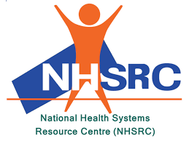

**National Quality Assurance Standards (NQAS): Implementation Support Webinar Series**